**Appendix A: Validity of the mixed effects Poisson model**

**1. Model**

We assume that the number of cancellations  of center (hospital) i, service j and day k is Poisson distributed with mean . We assume further that the dependence of  on hospital type and service type can be described by the following model:



 is the number of scheduled operations,  are dummy variables coding the hospital type and  are dummy variables for the service types. The random intercepts  and are independent normally distributed with mean 0 and variances  and , respectively.

**2. Model validity**

For the Poisson regression model several conditions must be met. One of these is that for each service the probability for cancellation remains constant over the 10 days considered.

We examined various degrees of violation of this assumption on the actual alpha error and the power.

For each simulation sample we first sampled probabilities for cancellation from a beta distribution with fixed expectation p and variance ranging from 0% up to 100% of the maximal achievable variance p(1-p). Using these probabilities the number of cancellations for each day and service is determined by random numbers in a second step. For each variance N=10,000 samples are generated.

Influence of variance on actual alpha error

We assume that for all services and days the common probability for cancellation is p=0.09 (empirical mean). We estimated the error of the first kind by counting the number of simulation samples where at least one of the nine contrasts (Table 4) has a P-value < 0.05/9=0.0056.

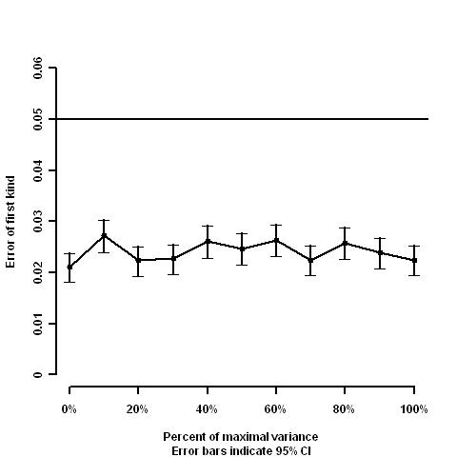

Results: We observed a negligible influence on the error of the first kind. So it is rather unlikely that the significant P-values of 0.0001 and 0.002 (Table 4) are due to model misspecification.

Influence of variance on the power of the test

We assumed that for each service the probability for cancellation equals the empirical cancellation rate. We regarded a simulation sample as significant if both significant contrasts from Table 3 have P-values < 0.05/9=0.0056.

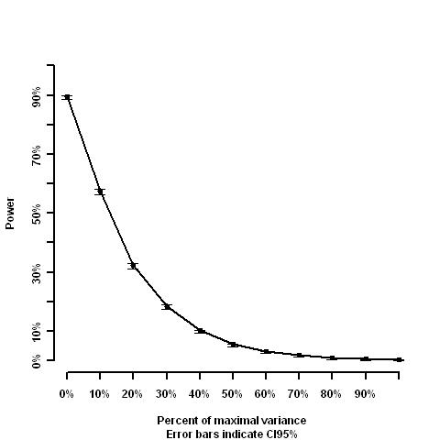

Results: The power of the Poisson regression model deteriorates with variance dramatically. However, since days with high cancellation rates are rare in our sample the variation of the daily cancellation probabilities must be small and therefore the distribution must be very close to Poisson distribution.