Supplementary digital content 2
Figure S1a: Heart rate distribution for all patients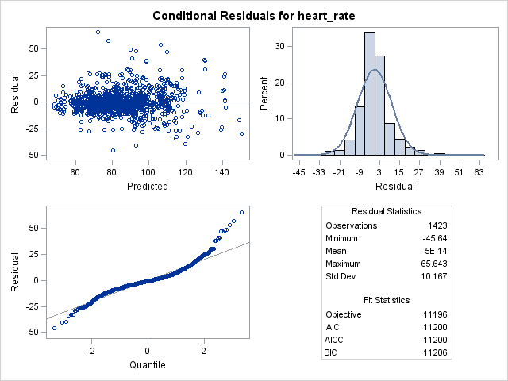
Figure S1b: Heart rate distribution in Down Syndrome patients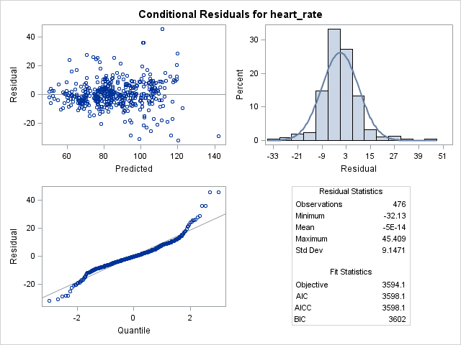
Figure S2a: Systolic blood pressure distribution for all patients
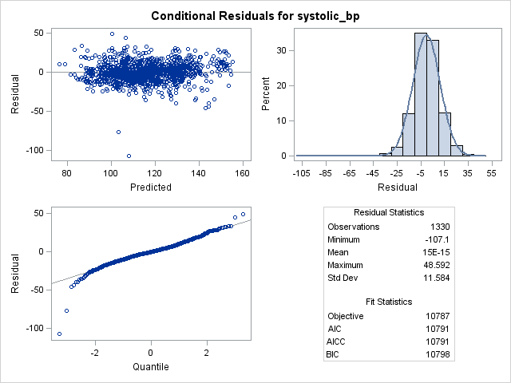
Figure S2b: Systolic distribution of Down Syndrome patients
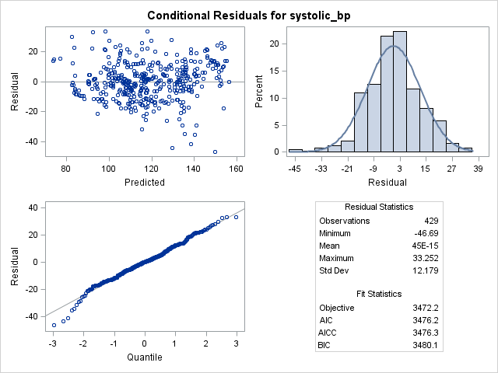
Figure S3a: Diastolic blood pressure distribution of all patients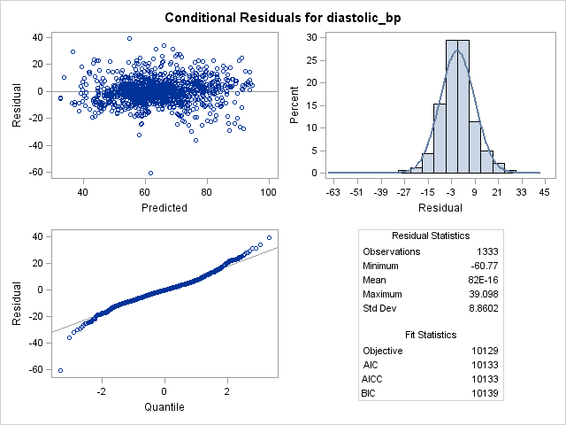
Figure S3b: Diastolic blood pressure distribution of Down Syndrome patients
