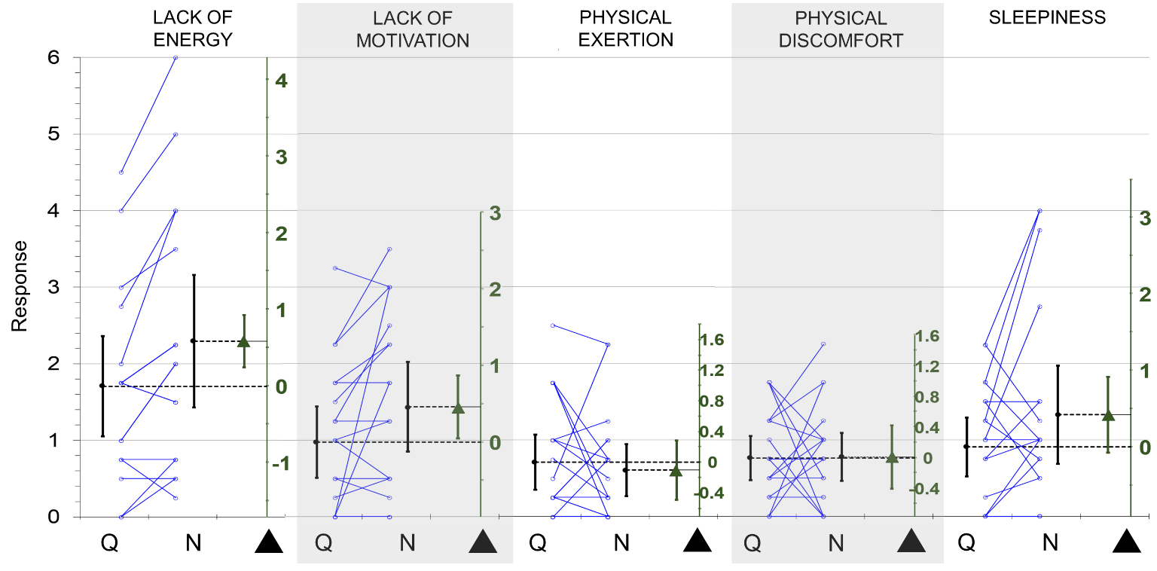
Effect of ‘Soundscape’ factor on the SOFI items following the data presentation format from Figure 4 in the main text. ‘Soundscape’ had an effect on items pertaining to mental fatigue, with subjects scoring these items higher in ‘Noise’, the most significant effect observed for the ‘Lack of Energy’ item (P = 0.001). The effect of ‘Soundscape’ on the physical fatigue items were negligible.

