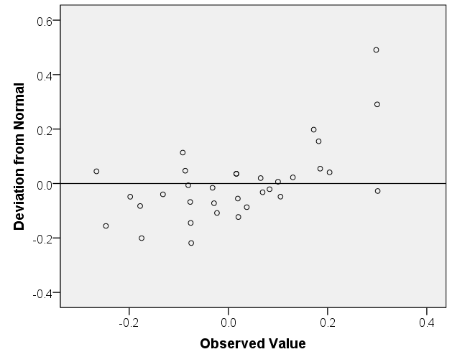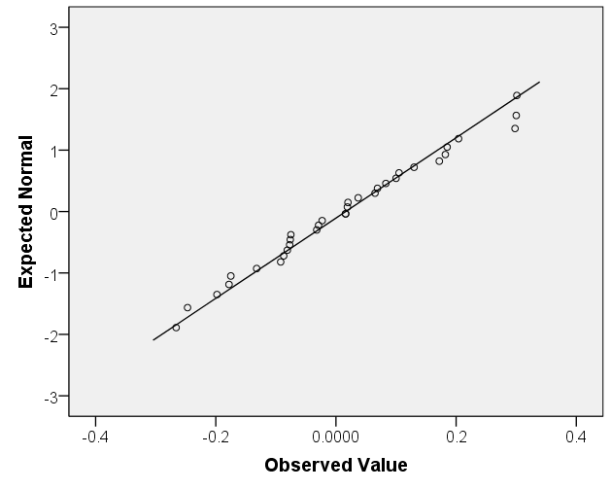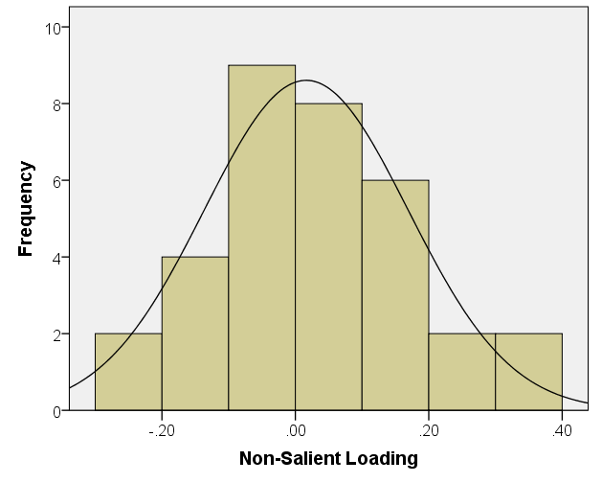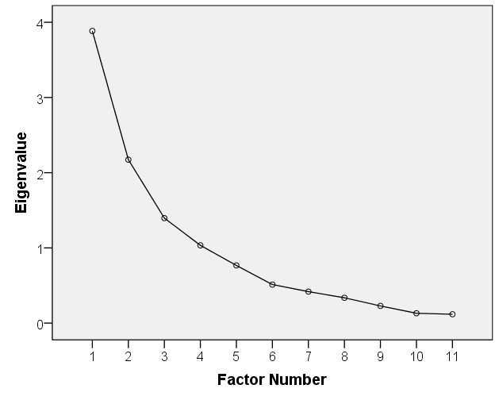

D

C

B

A

Plots showing some results of the partial confirmatory factor analysis of the 11 items from NASA-TLX and SOFI instruments. (A) Scree plot showing extracted factors. The first 4 factors have eigenvalues greater than 1 suggesting that they are significant. An additional step using Monte Carlo simulation/Parallel analysis, further supports the significance of factor 4. The non-salient loading distribution was approximately normal based on (B) histogram and (C) normal and (D) detrended Q-Q plots. Taken together with the other fit results from Table 7, a future confirmatory factor analysis is likely to be successful and the model depicted in Figure 6 of main text is plausible.