OPTIMAL SAMPLING DESIGN REPORT
Remifentanil

PURPOSE
The purpose of this report is to describe the development and assessment of an optimal sampling strategy for the evaluation of remifentanil population pharmacokinetic parameters, when used as an ultra-short acting analgesic. Mathematical optimization techniques have been utilized to identify when samples should be collected so as to maximize the reliability and accuracy of the data. The results of this study may then be used to develop a population pharmacokinetic model, which will enable the determination of how remifentanil is absorbed, distributed, metabolized, and excreted.

D-OPTIMAL DESIGN
Pharmacokinetic studies feature logistical and ethical limitations related to the number of samples that can feasibly be obtained.¹ Within the last decade, mathematical optimization techniques have attracted increasing attention for their ability to define the most informative sampling windows, which aid in balancing logistical and ethical considerations with the need to precisely define pharmacokinetic parameter estimates.²
In seeking to establish an optimal sampling strategy one may consider multiple design metrics.³ The most commonly utilized approach seeks to maximize the determinant of the Fisher Information Matrix (FIM), which is tautologous to minimizing the determinant of the variance-covariance matrix.^{4,5} This method is known as D-optimal design and has been extended to allow the user to also assess between-subject variability and evaluate the population distributions of parameters rather than the individual values.⁶
When developing a D-optimal sampling strategy existing data may be derived from pilot studies and from the published literature, which may be used to guide the development of an appropriate model. For this study of remifentanil, we required the following information to develop the D-optimal sampling strategy:
- The type of structural model (e.g., one or two compartment model with first-order absorption).
- Estimates of the pharmacokinetic parameters (e.g., absorption rate constant [k_{a}], clearance [CL], and the volume of distribution [V_{D}]).
- The distribution of between-subject variability for the pharmacokinetic parameters and estimates of the variance for each of the distributions.
- The residual variability model and its associated variance.
- Study design information for the prospective animal model experiments, including sampling constraints, the anticipated number of animals to be studied, the maximum number of samples allowed per animal, the minimum timing between samples, and logistical data related to venous/arterial access in study rats and cost limitations.
As optimal sampling strategies are built upon a framework of existing data they are therefore dependent upon the accuracy of earlier parameter estimates and structural and error model information. The impact of this information upon our prospective study can be decreased by considering and accounting for uncertainty in the pharmacokinetic parameter estimates and by careful evaluation of the derived models. When proposing a sampling strategy, it may be beneficial to consider multiple competing structural models. Consideration also needs to be given to design an optimal sampling strategy that may be implemented within the laboratory setting. Logistical factors and ethical restrictions must be weighed when evaluating sampling strategies.

A PRIORI DATA
To our knowledge there are no published reports that have investigated the pharmacokinetics of inhaled remifentanil. However, MacLeod et al. conducted a crossover study among 10 patients, each of whom received a 25 mcg dose of inhaled fentanyl and a 25 mcg dose of intravenous fentanyl, on separate occasions.⁷ An arterial catheter was placed and 26 blood samples were obtained from each participant over an 8-hour period following administration of the study drug. Fentanyl concentrations were established by liquid chromatography-tandem mass spectrometry. Summary pharmacokinetic parameters are featured in the table below:
TABLE 1. Plasma pharmacokinetic data from subjects who received a dose of 25 mcg of fentanyl administered via inhalation.
Parameter | Mean ± SD
T_{max} (sec) | 20.5 (range: 16-30)
Half-life (min) | 215 ± 73.5
k_{e} (hrs) | 0.217 ± 0.0864
CL/F (L/min) | 1.28 ± 0.295
AUC_{inf} (ng*min/mL) | 20.5 ± 4.9
AUC_{last} (ng*min/mL) | 16.6 ± 3.3
C_{max} | 4.7 ± 2.3
T_{max} – measured time of maximum concentration; CL/F – total body clearance divided by the fraction absorbed; k_{e} – elimination rate constant; AUC_{inf} – plasma area under the concentration-time curve extrapolated to infinity; AUC_{last} – last measurable concentration; C_{max} – maximum plasma concentration.

RESULTS
To investigate the pharmacokinetics of inhaled remifentanil for use as a short-acting analgesic, we assessed one-, two-, and three-compartment structural models using ADAPT V (Biomedical Simulations Resource, University of Southern California, Los Angeles, CA). A one-compartment model was selected with a single bolus injection of 1000 mcg of remifentail at time zero, with a 2.5 minute delayed absorption lag phase. The optimal sampling strategy was selected as it maximized the precision of the pharmacokinetic parameter estimates, was deemed experimentally feasible, and minimized the number of samples needed. The simulated remifentanil plasma concentration versus time curve is shown in Figure 1 and was used to visually confirm the selection of the sampling times identified in the D-optimal design (Table 2).
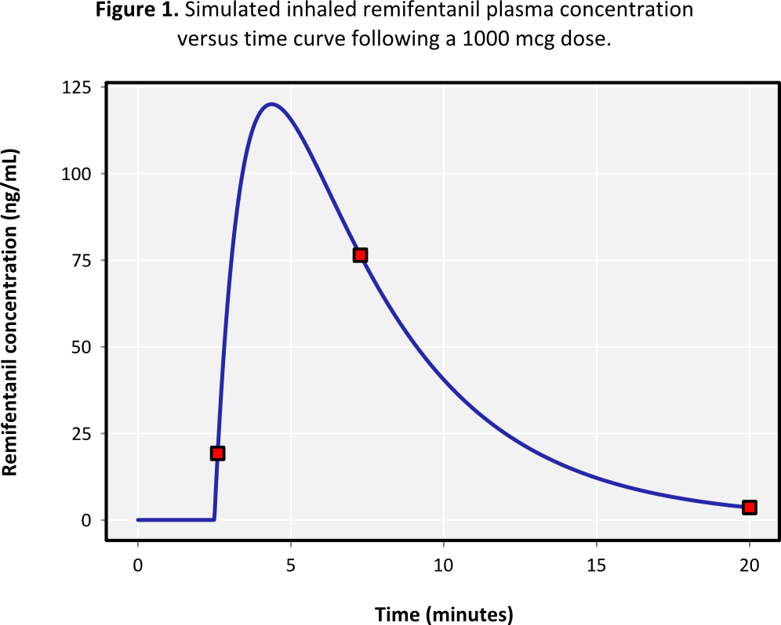
TABLE 2. D-optimal inhaled remifentanil sampling strategy.
Sample no. | Initial sampling time (mins) | Simulated sampling time (mins)
1 | 2.5 | 2.6
2 | 10 | 7.3
3 | 20 | 20

Using the simulated sampling times proposed above, we developed a model that incorporates a 20% coefficient of variation within an individual animal and an additional 20% coefficient of variation between animals. The variance in clearance is expected to be 15%, the variance in the volume of distribution is expected to be 24%, and the variance in the absorption rate constant k_{a} is expected to be 31%. However, due to the rapid clearance of remifentanil and the use of novel delivery system, we recommend that this sampling strategy be re-evaluated following testing of the first four to five animals. A Bayesian approach may then be utilized to determine if the sampling points identified as optimal in this analysis are appropriate for further experiments.

CONCLUSIONS
The simulations described in this report have characterized the development of a D-optimal sampling strategy for evaluating the population pharmacokinetics of a 1000 mcg dose of remifentanil administered via inhalation for use as a short-acting analgesic. These findings suggest that 3 samples should be obtained at approximately 2.5, 7, and 20 minutes following administration of the study drug. Further evaluation of this sampling method is strongly recommended after the first four to five animals have completed the study.
REFERENCES

1. Tam VH, McKinnon PS, Akins RL, Drusano GL, Rybak MJ. Pharmacokinetics and pharmacodynamics of cefepime in patients with various degrees of renal function. Antimicrobial agents and chemotherapy 2003;47:1853-61.
2. Hooker A, Vicini P. Simultaneous population optimal design for pharmacokinetic-pharmacodynamic experiments. The AAPS journal 2005;7:E759-85.
3. Duffull SB, Retout S, Mentre F. The use of simulated annealing for finding optimal population designs. Computer methods and programs in biomedicine 2002;69:25-35.
4. Retout S, Duffull S, Mentre F. Development and implementation of the population Fisher information matrix for the evaluation of population pharmacokinetic designs. Computer methods and programs in biomedicine 2001;65:141-51.
5. Retout S, Mentre F. Further developments of the Fisher information matrix in nonlinear mixed effects models with evaluation in population pharmacokinetics. Journal of biopharmaceutical statistics 2003;13:209-27.
6. Duffull SB, Mentre F, Aarons L. Optimal design of a population pharmacodynamic experiment for ivabradine. Pharmaceutical research 2001;18:83-9.
7. Macleod DB, Habib AS, Ikeda K, et al. Inhaled fentanyl aerosol in healthy volunteers: pharmacokinetics and pharmacodynamics. Anesthesia and analgesia 2012;115:1071-7.

