Supplemental Digital Content 1: Site of each device.
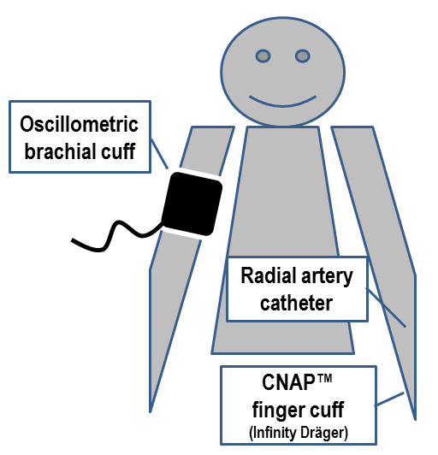

Supplemental Digital Content 2: Agreement between intra-arterial and noninvasive measurements of mean blood pressure (BP).
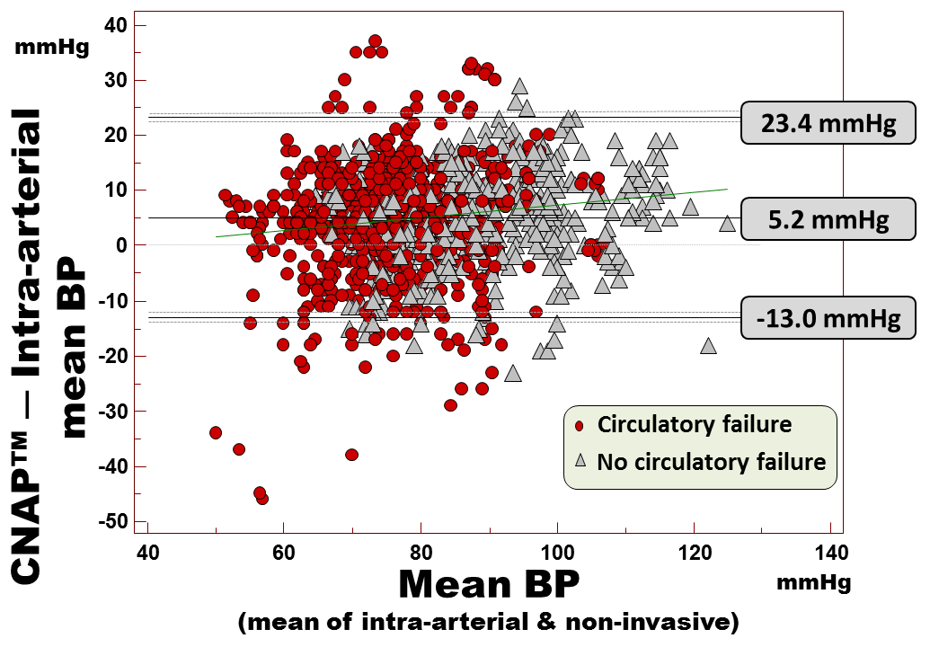
Legend: Bland-Altman analysis of the agreement of CNAP™ readings of mean BP with intra-arterial measurements over 15 minutes between 2 calibrations (1638 pairs of measurements).
The 3 thick horizontal lines represent the mean bias, the upper and the lower limits of agreement. The dotted lines represent their 95% confidence interval.

Supplemental Digital Content 3: Factors impacting the reliability of CNAP™ readings.
Clinical factor |  | N (patients) | ISO Mean bias±SD  (mmHg)
Cardiac rhythm | Regular rhythm | 114 | 6.7 ± 6.1
 | Arrhythmia | 68 | 5.7 ± 6.3
Gender | Male | 140 | 6.6 ± 6.2
 | Female | 42 | 5.2 ± 6.0
BMI | < 30 | 135 | 6.1 ± 5.9
 | ≥ 30 | 43 | 7.0 ± 7.2
Vascular disease | Established | 87 | 6.7 ± 5.4
 | Absent or Unknown | 95 | 6.0 ± 6.8
Mechnical ventilation | Yes | 144 | 6.6 ± 6.5
 | No | 38 | 5.3 ± 4.8
Circulatory failure | Yes | 111 | 6.9 ± 6.5
 | No | 71 | 5.5 ± 5.6
Tissue edema | None | 86 | 5.1 ± 5.9
 | Moderate | 59 | 7.3 ± 6.0
 | Important | 37 | 7.5 ± 6.7
Vasopressive drug | Yes | 69 | 7.4 ± 7.0
 | No | 113 | 5.6 ± 5.5
Mean BP | ≤ 65 mmHg | 43 | 7.8 ± 5.2
 | > 65 mmHg | 139 | 5.8 ± 6.4
Capillary refill time | < 2 seconds | 105 | 6.4 ± 5.2
 | 2 to 4 seconds | 62 | 6.3 ± 6.8
 | > 4 seconds | 12 | 6.0 ± 5.8
Hypothermia | ≤ 36ºC | 14 | 2.7 ± 5.7
 | >36ºC | 161 | 6.9 ± 6.0
Intra-arterial catheter Site | Radial artery | 154 | 6.5 ± 6.1
 | Femoral artery | 26 | 5.3 ± 6.8
Vascular disease: Coronary artery disease and/or Atherosclerosis of the lower limbs and/or Carotid stenosis and/or Aortic calcifications
Tissue edema: None ; Moderate (only ankles, hands, elbows, loin) ; Important
Vasopressive drug: norepinephrine or epinephrine

Supplemental Digital Content 4: Ability to detect hypotension, response to therapy and hypertension.
Detection of | Device | AUC_{ROC} | Cutoff | Se  (%) | Sp  (%) | Positive LR | Negative LR
Mean BP <65 mmHg | CNAP™ finger cuff  CNAP™ brachial cuff  Alternative brachial cuff | 0.94 [0.91-0.96]  0.94 [0.92-0.96]  0.92 [0.90-0.96] | 75 mmHg  78 mmHg  66 mmHg | 89 [82-94]  87 [80-93]  83 [75-90] | 85 [82-89]  87 [83-90]  90 [86-92] | 6.1 [4.8-7.8]  6.7 [5.2-8.6]  7.6 [5.7-10.0] | 0.13 [0.07-0.2]  0.15 [0.09-0.2]  0.19 [0.1-0.3]
Systolic BP <90 mmHg | CNAP™ finger cuff  CNAP™ brachial cuff  Alternative brachial cuff | 0.93 [0.91-0.95]  0.92 [0.89-0.94]  0.91 [0.88-0.93] | 99 mmHg  102 mmHg  106 mmHg | 83 [70-92]  89 [75-96]  88 [76-96] | 84 [81-87]  81 [77-84]  71 [67-75] | 5.3 [4.2-6.7]  4.6 [3.8-5.7]  3.0 [2.6-3.6] | 0.20 [0.1-0.4]  0.14 [0.06-0.3]  0.17 [0.08-0.4]
Systolic BP >140 mmHg | CNAP™ finger cuff  CNAP™ brachial cuff  Alternative brachial cuff | 0.88 [0.85-0.90]  0.90 [0.87-0.92]  0.89 [0.87-0.92] | 121 mmHg  122 mmHg  123 mmHg | 89 [81-94]  87 [79-92]  84 [76-91] | 75 [71-79]  78 [73-81]  80 [76-84] | 3.6 [3.0-4.3]  3.9 [3.2-4.7]  4.2 [3.4-5.2] | 0.15 [0.09-0.3]  0.17 [0.1-0.3]  0.19 [0.1-0.3]
>10% increase in mean BP | CNAP™ finger cuff  CNAP™ brachial cuff  Alternative brachial cuff | 0.92 [0.87-0.95]  0.89 [0.84-0.93]  0.90 [0.85-0.94] | 10 %  10 %  8 % | 79 [70-87]  80 [71-87]  81 [72-88] | 85 [77-91]  87 [80-93]  89 [82-94] | 5.2 [3.4-7.9]  6.2 [3.9-10.1]  7.4 [4.3-12.6] | 0.24 [0.2-0.4]  0.23 [0.2-0.3]  0.21 [0.1-0.3]

Legend: AUC_{ROC}: area under the receiver operating characteristic curve; Se: sensitivity; Sp: specificity; LR: likelihood ratio; BP: blood pressure. Intra-arterial measurements were reference BP.
Supplemental Digital Content 5: Consequence of CNAP™ drift: misclassification of patients who responded to therapy.
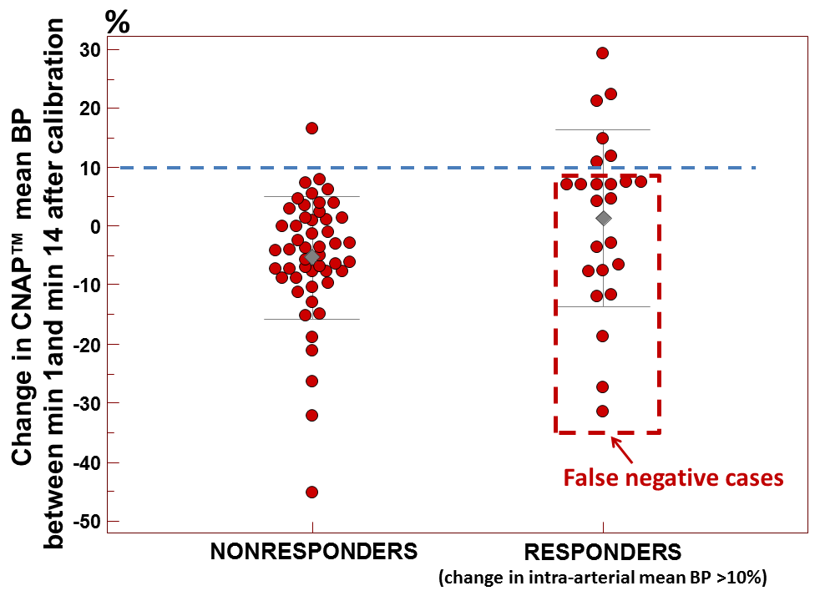

Responders were defined as patients who increased their intra-arterial mean blood pressure (BP) of more than 10% after a cardiovascular intervention.
The downward drift of CNAP™ readings between minute 1 and minute 14 after the calibration contributed to misclassify 18/24 (75%) of responders into nonresponders according to CNAP™ readings. The corresponding area under the ROC curve was
0.67 (95% CI: 0.55-0.77).

Supplemental Digital Content 6: If CNAP™ failed to display a beat-to-beat BP value, was the oscillometric brachial cuff measurement less reliable?

 | No CNAP™ beat-to-beat measurement displayed  n = 31 patientsª | CNAP™ beat-to-beat measurement could be displayed  n = 182 patients
CNAP™ brachial cuff (Dräger Infinity) | Mean bias ± SD  9.7 ± 9.1 mmHg | Mean bias ± SD  10.3 ± 7.0 mmHg
Alternative brachial cuff  (Philips MP70) | Mean bias ± SD  -1.6 ± 6.2 mmHg | Mean bias ± SD  -2.2 ± 7.1 mmHg

ª: in addition, one patient failed to display a value of CNAP brachial cuff measurement (but the alternative brachial cuff could display a BP measurement in this patient).
Mean bias: noninvasive minus intra-arterial measurement of blood pressure.

