Supplemental materials

Xenon as an adjuvant to propofol anesthesia in patients undergoing off-pump coronary artery bypass graft surgery: a pragmatic randomized controlled clinical trial

Layth Al Tmimi＊, MD, Sarah Devroe, MD, Gert Poortmans, MD, Marc Van de Velde, MD, PhD, Geertrui Dewinter, MD, Bart Meyns, MD, PhD, Bart Meuris, MD, PhD, Mark Coburn, MD, PhD, Steffen Rex, MD, PhD

＊ Corresponding author: Dr Layth Al tmimi, MD, University Hospitals Leuven, Department of Anesthesiology, Herestraat 49, 3000 Leuven, Belgium.
E-mail: layth.altmimi@uzleuven.be

Materials and methods
Consort checklist
Section/Topic | Item No | Checklist item | Reported on page No
Title and abstract
 | 1a | Identification as a randomised trial in the title | 1
 | 1b | Structured summary of trial design, methods, results, and conclusions (for specific guidance see CONSORT for abstracts) | 3
Introduction
Background and objectives | 2a | Scientific background and explanation of rationale | 4
 | 2b | Specific objectives or hypotheses | 4
Methods
Trial design | 3a | Description of trial design (such as parallel, factorial) including allocation ratio | 5
 | 3b | Important changes to methods after trial commencement (such as eligibility criteria), with reasons | n.a
Participants | 4a | Eligibility criteria for participants | 6
 | 4b | Settings and locations where the data were collected | 5
Interventions | 5 | The interventions for each group with sufficient details to allow replication, including how and when they were actually administered | 7
Outcomes | 6a | Completely defined pre-specified primary and secondary outcome measures, including how and when they were assessed | 9-11
 | 6b | Any changes to trial outcomes after the trial commenced, with reasons | n.a
Sample size | 7a | How sample size was determined | 11, 12
 | 7b | When applicable, explanation of any interim analyses and stopping guidelines | n.a
Randomisation:
Sequence generation | 8a | Method used to generate the random allocation sequence | 5,6
 | 8b | Type of randomisation; details of any restriction (such as blocking and block size) | 5
Allocation concealment mechanism | 9 | Mechanism used to implement the random allocation sequence (such as sequentially numbered containers), describing any steps taken to conceal the sequence until interventions were assigned | 5
Implementation | 10 | Who generated the random allocation sequence, who enrolled participants, and who assigned participants to interventions | 5
Blinding | 11a | If done, who was blinded after assignment to interventions (for example, participants, care providers, those assessing outcomes) and how | 5
 | 11b | If relevant, description of the similarity of interventions | n.a
Statistical methods | 12a | Statistical methods used to compare groups for primary and secondary outcomes | 12,13
 | 12b | Methods for additional analyses, such as subgroup analyses and adjusted analyses | n.a
Results
Participant flow (a diagram is strongly recommended) | 13a | For each group, the numbers of participants who were randomly assigned, received intended treatment, and were analysed for the primary outcome | 14, Figure 2
 | 13b | For each group, losses and exclusions after randomisation, together with reasons | Figure 2
Recruitment | 14a | Dates defining the periods of recruitment and follow-up | 14
 | 14b | Why the trial ended or was stopped | n.a
Baseline data | 15 | A table showing baseline demographic and clinical characteristics for each group | Table 1
Numbers analysed | 16 | For each group, number of participants (denominator) included in each analysis and whether the analysis was by original assigned groups | Figure 2
Outcomes and estimation | 17a | For each primary and secondary outcome, results for each group, and the estimated effect size and its precision (such as 95% confidence interval) | yes
 | 17b | For binary outcomes, presentation of both absolute and relative effect sizes is recommended | yes
Ancillary analyses | 18 | Results of any other analyses performed, including subgroup analyses and adjusted analyses, distinguishing pre-specified from exploratory | n.a
Harms | 19 | All important harms or unintended effects in each group (for specific guidance see CONSORT for harms) | Yes
Discussion
Limitations | 20 | Trial limitations, addressing sources of potential bias, imprecision, and, if relevant, multiplicity of analyses | 19 - 21
Generalisability | 21 | Generalisability (external validity, applicability) of the trial findings | 21
Interpretation | 22 | Interpretation consistent with results, balancing benefits and harms, and considering other relevant evidence | yes
Other information
Registration | 23 | Registration number and name of trial registry | 2,5
Protocol | 24 | Where the full trial protocol can be accessed, if available | www.clinical trials.gov
Funding | 25 | Sources of funding and other support (such as supply of drugs), role of funders | 2

Methods

Sample size estimation
The sample size was calculated to show a superiority of xenon-propofol vs. propofol alone for the requirement of intraoperative norepinephrine. We assumed a coefficient of variation of 0.5 that was derived from preliminary data in patients undergoing OPCAB-surgery at our institution. A minimal sample size of 24 patients per group was determined to detect a 33% reduction (corresponding to an effect size for the differences in means of 0.83) of the norepinephrine requirements in the xenon-propofol group compared to the propofol only group in order to have at least 80% power based on a two-sided t-test for independent groups with the level of significance set at 0.05.
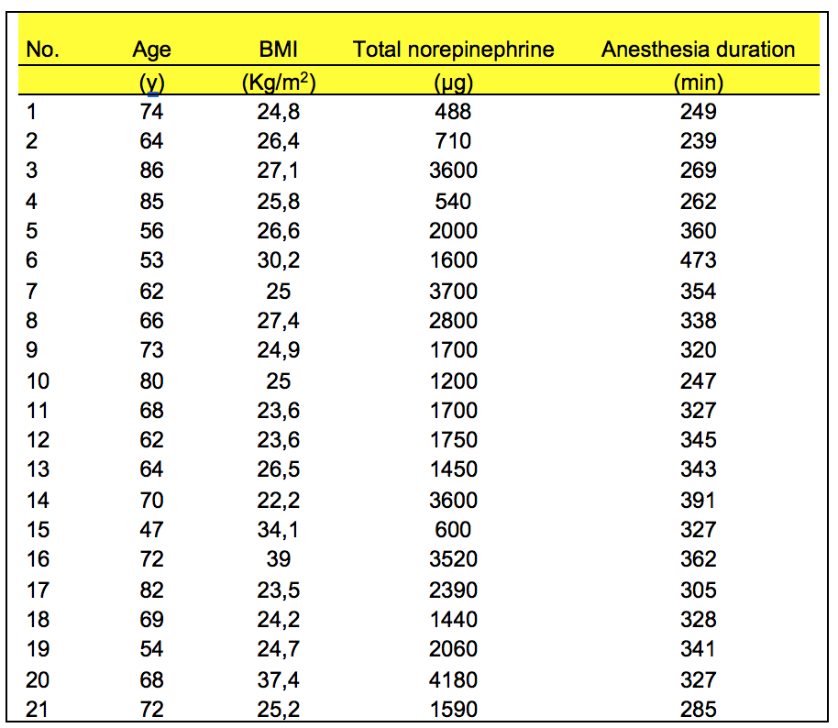

Results
Norepinephrine requirements
Intraoperatively, the xenon-propofol group required significantly less norepinephrine than the propofol-only group (supplemental figure 1) to achieve the pre-defined hemodynamic goals (Figure 1).

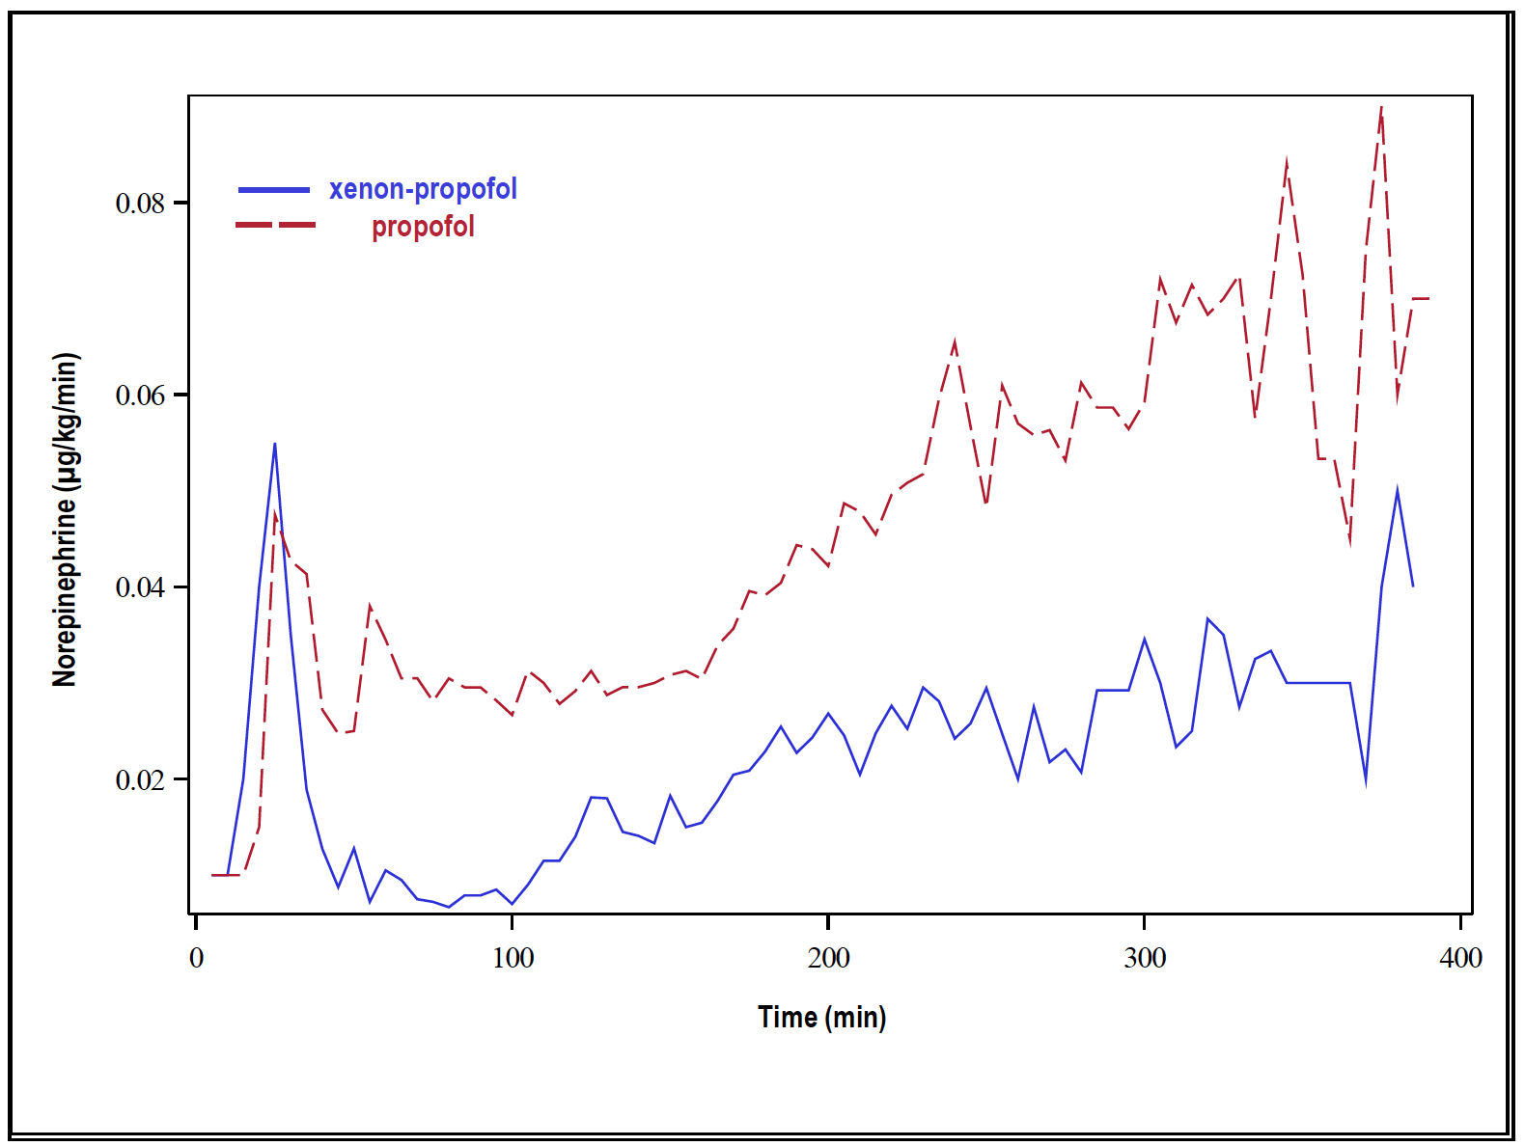

Supplemental figure 1
Comparison of mean intraoperative norepinephrine doses in the two study groups. Data were analyzed using a linear mixed model to analyze the longitudinal profiles over time. The model included fixed factors for treatment, time (as a 3rd degree polynomial) and their interaction. Within-patient correlations were accounted for by including a random intercept and slope per patient. The model yielded a statistical significance effect of time (p<0.0001).

Hemodynamic parameters
In general, intraoperative hemodynamic parameters were comparable between the two groups (supplemental figure 2)

Supplemental figure 2
Intraoperative hemodynamic parameters. A: heart rate, B: Cardiac index (CI), C: Mean arterial blood pressure (MAP) and D: Mixed venous oxygen saturation (SvO₂).
Data are represented as median and interquartile range. Data were analyzed using a multivariate linear model to enable a global test for the effect of treatment across the time points. The baseline values (T1) were used as a covariate (ANCOVA).
T1: after start of anesthesia; T2: post-sternotomy; T3: after stabilization of the ramus interventricularis anterior; T4: after dislocating the heart; T5: after infusion of protamine; T6: at the end of the surgical procedure

Data reflecting organ protection (laboratory findings)
Arterial blood samples were collected in both groups at baseline (BL) (before the start of anesthesia), at the end of surgery (EOS), and on postoperative day (PD) 1. These samples were required to determine the plasma level of troponin T hs and CK-MB (markers of myocardial ischemia) (Table 3, supplemental figure 3A and 3B, respectively) and serum protein S100β, a marker of blood-brain barrier dysfunction (supplemental figure 3C).

Supplemental figure 3
Intraoperative time course of plasma troponin T hs (A), plasma CK-MB (B), and serum protein S100 β (C) for the xenon–propofol and the propofol-only group at different time points. The lower boundary of the box indicates the 25th percentile, the line within the box marks the median, and the upper border of the box indicates the 75th percentile. Whiskers indicate the 90th and 10th percentiles, while closed circles represent outliers. The plus sign represents the mean. Data were analyzed using a multivariate linear model to enable a global test for the effect of treatment across the time points. The baseline values (BL) were used as a covariate (ANCOVA).
BL: baseline (prior to induction of anesthesia); EOS: end of surgery; PD1: postoperative day 1
Propofol requirements

The xenon-propofol group required significantly less propofol than the propofol-only group to achieve the same depth of anesthesia (supplemental figure 4). Also, a comparison of propofol plasma concentrations over time between the two groups using a linear mixed model showed a statistically significant difference (p<0.0001).

Supplemental figure 4
Comparison of total intraoperative propofol consumption between the two study groups. Columns represent mean values and error bars indicate SD (taking into account the normal distribution of the respective hemodynamic parameters, the independent samples t–test was used for statistical analysis).

