Supplemental digital content
Supplemental TABLE 1: Data collection protocol
On-site observation
Operating room area? (Choose name)
Emergency intervention? (Yes/No)

Information exchange (Yes/No) | Clinical performance (Yes/No)
Patient Name?  Date of birth?  Allergies?  Anesthesia consent?  Perioperative surgical medication?  Anesthesia procedure/surgery?  Monitoring?  IV functioning?  All drugs correct?  Airway?  Respirator function?  Suction device function? | Pressure limiting valve < 10cmH2O?  Oxygen flow > 8 L/min?  %FiO2 > 80%?  CO2-wave visible?  FeO2 > 0.8?  ECG visible on patient monitor?  SpO2 visible on patient monitor?  Blood pressure visible on patient monitor?  Blood pressure interval 2 minutes or less?  IV running correctly?  Suction device function checked?  Intended hypnotic available?  Intended opioid available?  Intended muscle relaxant available?
All team members present during entire observation? (Yes/No)
Checklist used? (Yes/No)
Team member who read the checklist? (Consultant, resident, nurse)
Intervention necessary for a safety critical incident? (Yes/No)
I confirm this data was obtained during a real observation. (Yes/No)
Team member survey (completed individually and privately by each participating team member)
My position? (Consultant, resident, nurse)
My anesthesia experience? (< 1, 1-5, 5-10, >10 years)
Knowledge of critical information (Mark if true)
During this induction I was aware of? (Allergies, anesthesia consent, perioperative
Surgical medication, anesthesia procedure/surgery, airway)
How safe did I feel during this induction? (continuous rating scale from 0% [very unsafe] – 100% [very safe])
How good was the teamwork during this induction? (continuous rating scale 0% [very poor] -100% [very good])
How many times have I previously worked with the pre-induction checklist? (Never, 1-10, 10-25, 25-50, >50 times)
How many times have I previously completed this team member survey? (Never, 1-5, 5-10, >10 times)

Legend for supplemental Table 1: The elements of the data collection protocol used during the on-site observations and the team member surveys. Certain criteria used to measure clinical performance were chosen because of institutional policy, e.g., oxygen flow > 8L/min, blood pressure interval 2 minutes or
Supplemental TABLE 2: Cross table analyses for subgroups of consultant-led teams

 | APIC group  n=99 | Control group  n=75 | Fishers exact test  p-value
Information exchange >90% | 98 (99%) | 4 (3%) | <0.001
Knowledge of critical information  > 90% | 85 (86%) | 39 (52%) | <0.001
Perception of safety > 90% | 55 (56%) | 18 (24%) | <0.001
All outcomes  > 90% | 49 (49%) | 27 (36%) | 0.092
4 outcomes > 90% | 76 (77%) | 51 (68%) | 0.23
3 outcomes > 90% | 25 (25%) | 0 (0%) | <0.001
2 outcomes > 90% | 29 (29%) | 4 (5%) | <0.001
1 outcome > 90% | 35 (35%) | 11 (14%) | 0.0029
No outcome > 90% | 8 (8%) | 32 (43%) | <0.001
Information exchange, knowledge of critical information, perception of safety, perception of teamwork > 90% | 1 (1%) | 25 (33%) | <0.001
Information exchange, knowledge of critical information and perception of safety > 90% | 32 (32%) | 0 (0%) | <0.001
Knowledge of critical information and perception of safety > 90% | 47 (47%) | 0 (0%) | <0.001
Legend for supplemental Table 2: Cross table analyses comparing the numbers and percentages of consultant-led teams in both study groups that scored 2,3,4 or all 5 outcomes above 90%. Also shown are the percentages numbers and percentages of teams in both study groups with certain combinations of outcomes above 90%.
Supplemental TABLE 3: Cross table analyses for subgroups of resident-led teams
 | APIC group  n=6 | Control group  n=25 | Fishers exact test  p-value
Information exchange >90% | 6 (100%) | 0 (0%) | <0.001
Knowledge of critical information  > 90% | 3 (50%) | 10 (40%) | 0.67
Perception of safety > 90% | 3 (50%) | 5 (20%) | 0.16
All outcomes  > 90% | 3 (50%) | 5 (20%) | 0.16
4 outcomes > 90% | 3 (50%) | 11 (44%) | 1.0
3 outcomes > 90% | 3 (50%) | 17 (68%) | 0.64
2 outcomes > 90% | 0 (0%) | 0 (0%) | 1.0
1 outcome > 90% | 2 (33%) | 0 (0%) | 0.032
No outcome > 90% | 2 (33%) | 5 (20%) | 0.60
Information exchange, knowledge of critical information, perception of safety, perception of teamwork > 90% | 2 (33%) | 9 (36%) | 1
Information exchange, knowledge of critical information and perception of safety > 90% | 0 (0%) | 10 (40%) | 0.14
Knowledge of critical information and perception of safety > 90% | 2 (33%) | 0 (0%) | 0.032
Legend for supplemental Table 3: Cross table analyses comparing the numbers and percentages of resident-led teams in both study groups that scored 2,3,4 or all 5 outcomes above 90%. Also shown are the percentages numbers and percentages of teams in both study groups with certain combinations of outcomes above 90%.
Supplemental TABLE 4: Cross table analyses for information exchange about an item and performance of the item.

Information exchanged | Performance of item | Fishers exact test  p-value
Basic monitoring | ECG visible on patient monitor?
 | SpO2 visible on patient monitor?
 | Blood pressure visible on patient monitor?
 | Blood pressure interval 2 minutes or less? | 0.06
IV functioning | IV running correctly?
All drugs correct | Intended hypnotic available?
 | Intended opioid available?
 | Intended muscle relaxant available?
Respirator function | Pressure limiting valve < 10cmH2O? | p=0.51
 | FiO2 setting > 0.8? | p=0.51
 | Oxygen flow > 8 l/min? | p=0.30
 | CO2-wave visible? | p=0.29
 | FeO2 > 0.8? | p=0.35
Suction device | Suction device function checked? | p<0.001

Legend for supplemental Table 4: Cross table analyses comparing information exchange about an item and performance of the respective subitem of clinical performance. The empty fields could not be calculated because the items had zero variance.
Supplemental TABLE 5: Cross table analyses for teams in both study groups with information exchange about an item and knowledge of the item by all team members.

APIC Item | Information about item exchanged using the APIC | Information about item exchanged without APIC
Allergies | 90%  (94/105) | 87%  (40/46) | OR 1.3  95%CI 0.44-3.7  p=0.78
Anaesthesia consent | 77%  (81/105) | 42%  (5/12) | OR 4.7  95%CI 1.37-16.25  p=0.014
Perioperative surgical medication | 74%  (76/103) | 29%  (4/14) | OR 7.0  95%CI 2-24.32  p=0.001
Anaesthesia procedure / operation | 96%  (98/102) | 87%  (41/47) | OR 3.6  95%CI 0.96-13.83  p=0.072
Airway | 86%  (90/105) | 76%  (22/29) | OR 1.9  95%CI 0.69-5.25  p=0.26

Legend for supplemental Table 5: When information was exchanged using the APIC the likelihood that all members of the team had knowledge about the critical information items anesthesia consent and perioperative surgical medication was significantly greater, than if the information was exchanged without the APIC.
Supplemental TABLE 6: Teams with information exchange about an item and performance of the respective subitem.

APIC Item |  | Information about item exchanged using pre-induction checklist | Information about item exchanged without pre-induction checklist
Monitoring | ECG visible on patient monitor? | 100%  (104/104) | 100%  (27/27) | OR 1.0
 | SpO2 visible on patient monitor? | 100%  (104/104) | 100%  (27/27) | OR 1.0
 | Blood pressure visible on patient monitor? | 100%  (104/104) | 100%  (27/27) | OR 1.0
 | Blood pressure interval 2 minutes or less? | 98%  (102/104) | 96%  (26/27) | OR 1.96  95%CI 0.17-22.5  p=1.0
IV functioning | IV running correctly? | 100%  (105/105) | 100%  (38/38) | OR 1.0
All drugs correct | Intended hypnotic available? | 100%  (104/104) | 100%  (47/47) | OR 1.0
 | Intended opioid available? | 100%  (104/104) | 100%  (47/47) | OR 1.0
 | Intended muscle relaxant available? | 100%  (104/104) | 100%  (47/47) | OR 1.0
Respirator function | Pressure limiting valve < 10cmH2O? | 99%  (104/105) | 100%  (38/38) | OR 0.9  95%CI 0.03-22.7  p=1.0
 | Oxygen flow > 8 l/min? | 99%  (104/105) | 100%  (38/38) | OR 0.9  95%CI 0.03-22.7  p=1.0
 | %FiO2 > 80%? | 99%  (104/105) | 100%  (38/38) | OR 0.9  95%CI 0.03-22.7  p=1.0
 | CO2-wave visible? | 79%  (83/105) | 76%  (29/38) | OR 1.17  95%CI 0.48-2.8  p=1.0
 | FeO2 > 0.8? | 38%  (40/105) | 58%  (21/38) | OR 0.5  95%CI 0.24-1.05  p=0.08
Suction device | Suction device function checked? | 100%  (104/104) | 100%  (42/42) | OR 1.0

Legend for supplemental Table 6: For the clinical performance items, there was no significant difference between information exchanges with the APIC vs. information exchange without APIC.
Supplemental FIGURE 1: The anesthesia-specific pre-induction checklist (APIC)
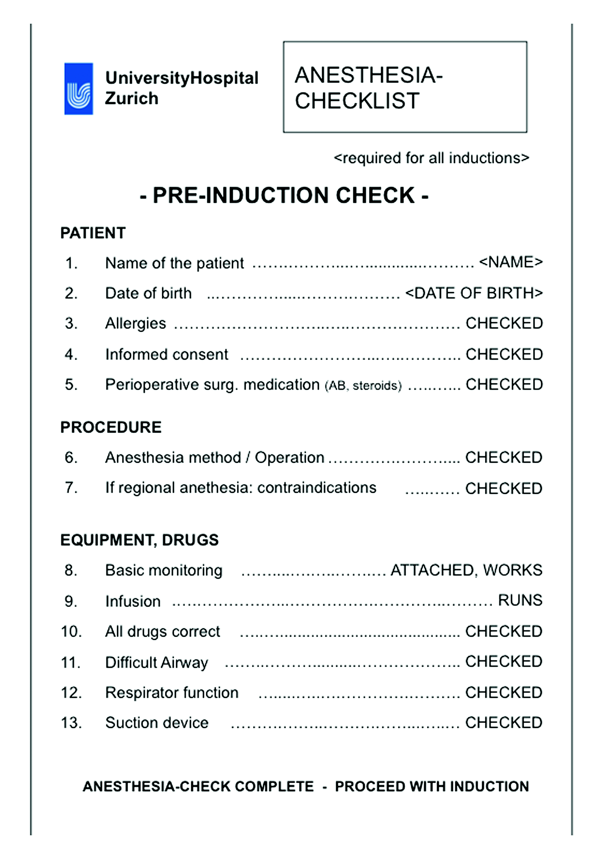
Legend for supplemental Figure 1: The design and the items of the anesthesia pre-induction checklist (APIC) evaluated in this study.
Supplemental FIGURE 2: Scatterplot showing the relationship between information exchange and clinical performance.
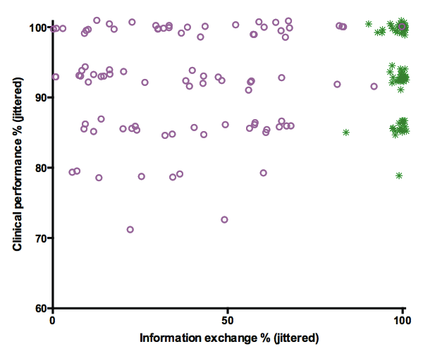
Legend for supplemental Figure 2: A scatterplot with "information exchange" on one axis and clinical performance on the other axis for both study groups. Random noise was added to the values to visualize multiple observations at the same places. Green stars=APIC group, magenta circles=Control group.

