Supplemental Digital Content 1
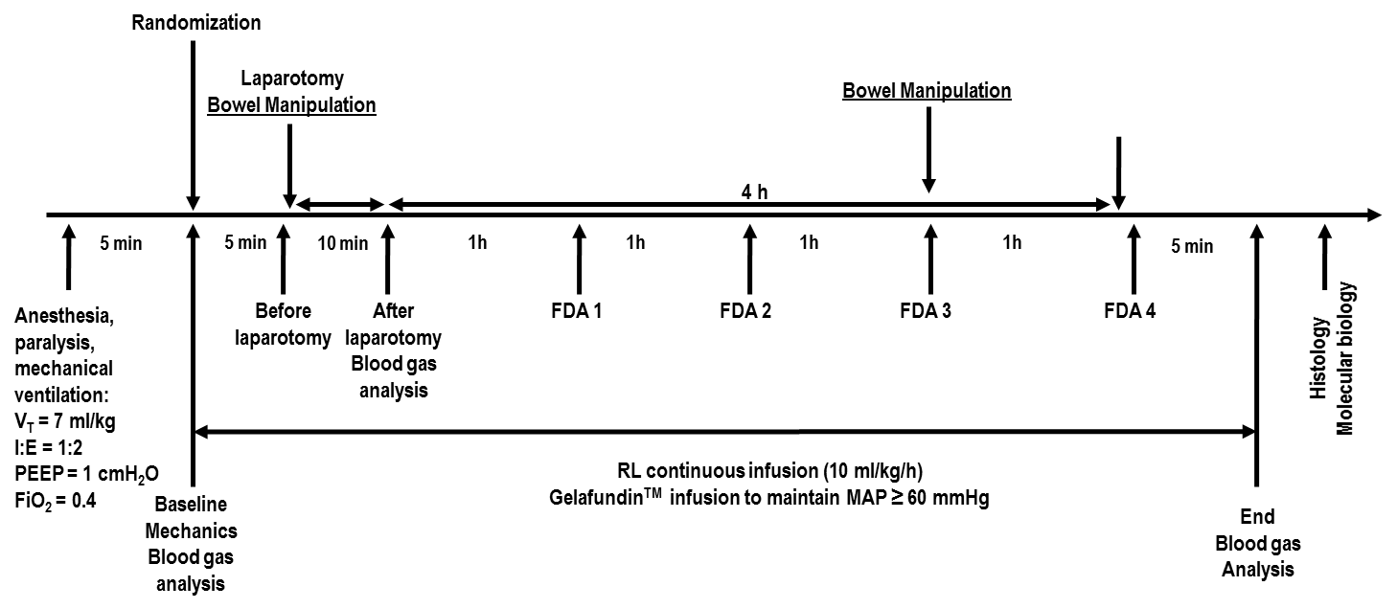
Supplemental Figure 1: Timeline of experiments. V_{T}: tidal volume; RR: respiratory rate; I:E: inspiratory-to-expiratory ratio; PEEP: positive end-expiratory pressure; FiO₂: fraction of inspired oxygen; FDA: functional data acquisition; RL: Ringer’s lactate; MAP: mean arterial pressure.

