Supplemental Digital Content 4
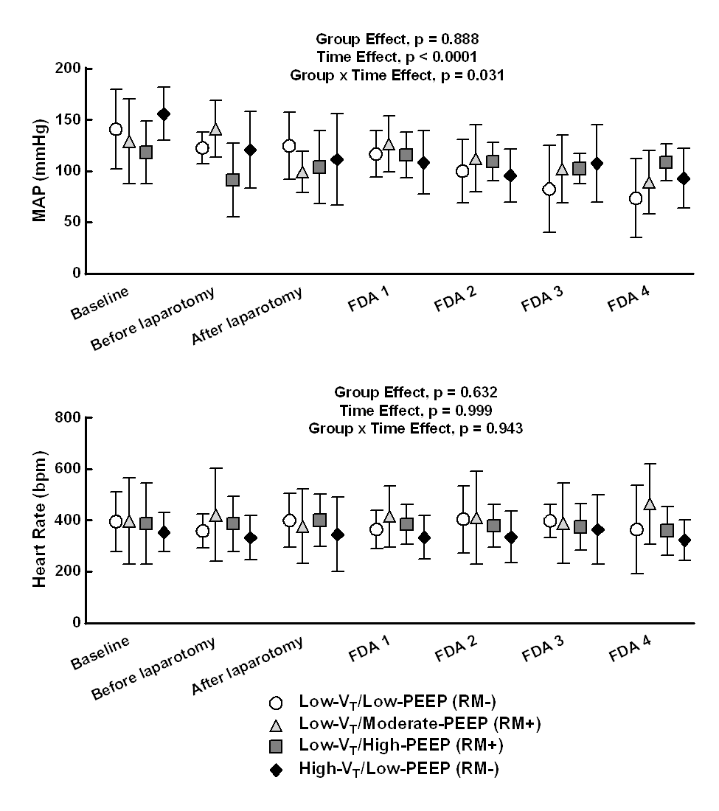
Low V_{T}/Low PEEP/RM-
Low V_{T}/Moderate PEEP/4RM+
Low V_{T}/High PEEP/1RM+
High V_{T}/Low PEEP/RM-

Supplemental Figure 2: Mean arterial blood pressure and heart rate over time in the four mechanically ventilated groups. Values are mean ± standard deviation (SD) of seven rats in each group. Low-V_{T}/Low-PEEP/RM-: V_{T} = 7 mL/kg with PEEP = 1 cmH₂O and no RMs; Low-V_{T}/Moderate-PEEP/4RM+: V_{T} = 7 mL/kg with PEEP = 3 cmH₂O and RMs before laparotomy and every 1 hour thereafter; Low-V_{T}/High-PEEP/1RM+: V_{T} = 7 mL/kg with PEEP = 6 cmH₂O and RMs before laparotomy; High-V_{T}/Low-PEEP/RM-: V_{T} = 14 mL/kg with PEEP = 1 cmH₂O and no RMs.

