Supplemental Digital Content 7

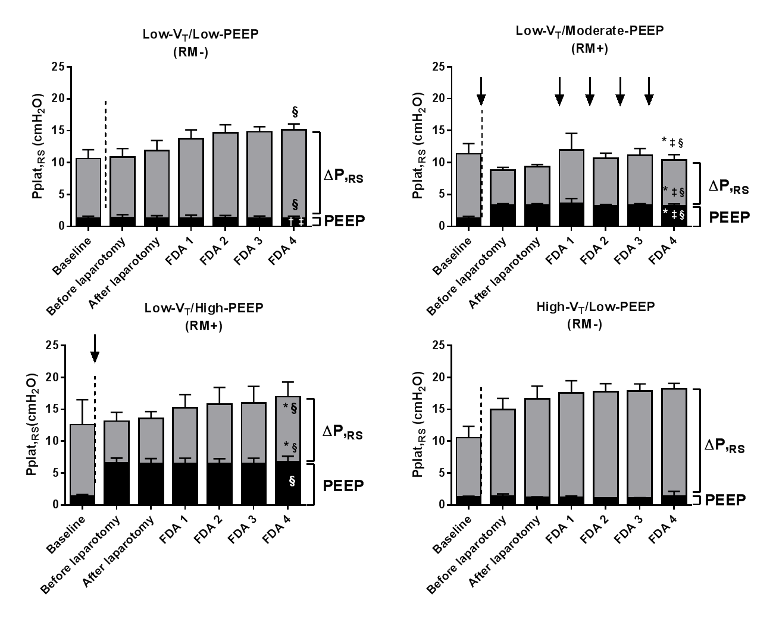
Low V_{T}/Low PEEP
RM-
Low V_{T}/Moderate PEEP
4RM+
Low V_{T}/High PEEP
1RM+
High V_{T}/Low PEEP
RM-

Supplemental Figure 3: Overview of respiratory system driving pressure (ΔP,_{RS}), positive end-expiratory pressure (PEEP), and plateau pressure (Pplat,_{RS}), in cmH₂O, over time in the four mechanically ventilated groups: 1) Low-V_{T}/Low-PEEP/RM-: V_{T} = 7 mL/kg with PEEP = 1 cmH₂O and no RMs; 2) Low-V_{T}/Moderate-PEEP/4RM+: V_{T} = 7 mL/kg with PEEP = 3 cmH₂O and RMs before laparotomy and every 1 hour thereafter; 3) Low-V_{T}/High-PEEP/1RM+: V_{T} = 7 mL/kg with PEEP = 6 cmH₂O and RMs before laparotomy; and 4) High-V_{T}/Low-PEEP/RM-: V_{T} = 14 mL/kg with PEEP = 1 cmH₂O and no RMs. Bars represent mean ± standard deviation (SD) of seven rats in each group. *p<0.05 vs. Low-VT/Low-PEEP/ RM-; †p<0.05 vs. Low-VT/Moderate-PEEP/RM+); ‡p<0.05 vs. Low-VT/High-PEEP/RM+; § vs. High-VT/Low-PEEP/RM-).

