Supplemental Digital Content 8
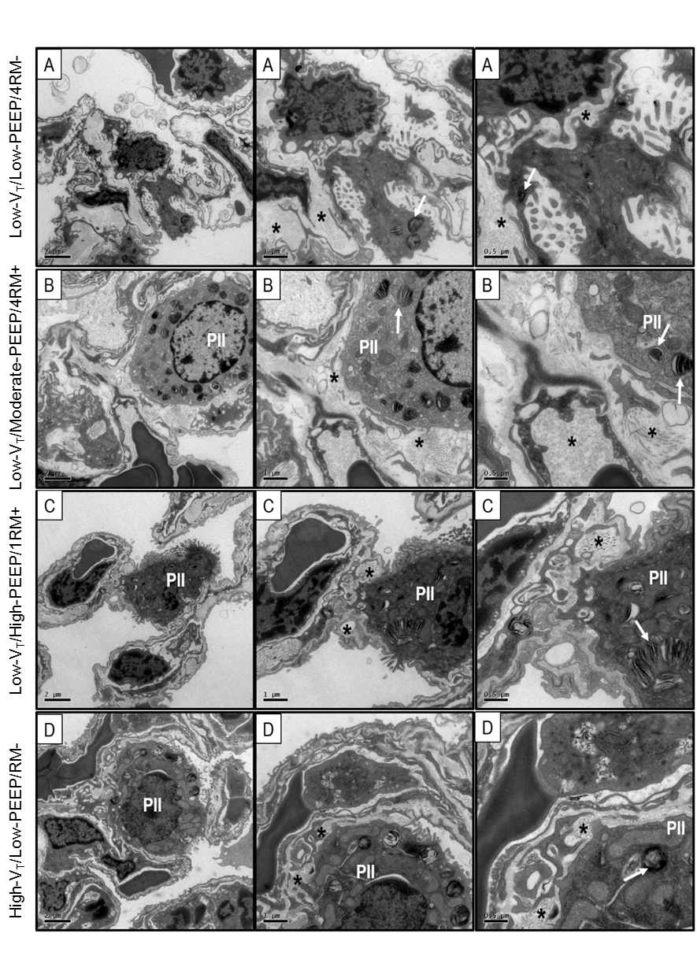
Supplemental Figure 4: Electron microscopy of lung parenchyma. Photomicrographs are representative of data obtained from lung sections of five animals per group. Low-V_{T}/Low-PEEP/RM-: V_{T} = 7 mL/kg with PEEP = 1 cmH₂O and no RMs; Low-V_{T}/Moderate-PEEP/4RM+: V_{T} = 7 mL/kg with PEEP = 3 cmH₂O and RMs before laparotomy and every 1 hour thereafter; Low-V_{T}/High-PEEP/1RM+: V_{T} = 7 mL/kg with PEEP = 6 cmH₂O and RMs before laparotomy; High-V_{T}/Low-PEEP/RM-: V_{T} = 14 mL/kg with PEEP = 1 cmH₂O and no RMs. Type II epithelial cell (PII) damage with bizarre lamellar bodies (arrows) was observed mainly in group High-V_{T}/Low-PEEP/RM-. No endothelial cell damage was observed. Moreover, Low-V_{T}/Moderate-PEEP/RM+ group presented less alveolar-capillary damage. No significant changes were observed in extracellular matrix (asterisk) animals.

