Supplemental Digital Content 10
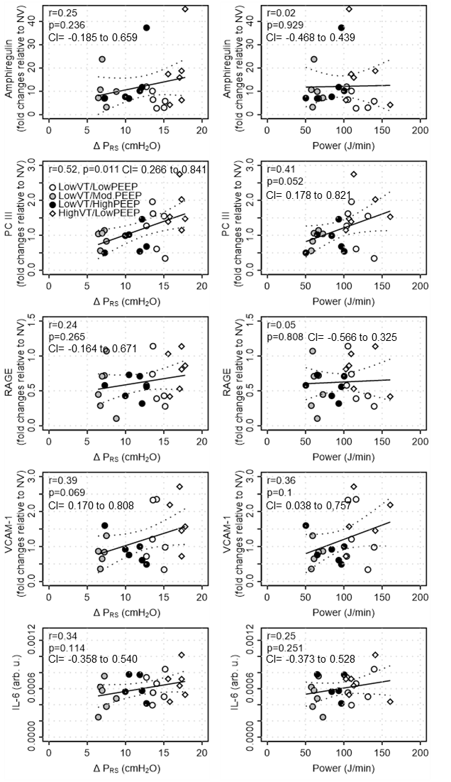
Supplemental Figure 5: Spearman correlations of respiratory system driving pressure (ΔP_{RS}) and mechanical power with amphiregulin, type III procollagen (PCIII), receptor for advanced glycation end products (RAGE), vascular cell adhesion molecule (VCAM)-1, and interleukin (IL)-6. r = correlation coefficient; p = P-value. CI: confidence interval. Statistical significance was accepted at p < 0.05.

