Supplemental Figure 1: Frequency versus Length of Stay Histogram.

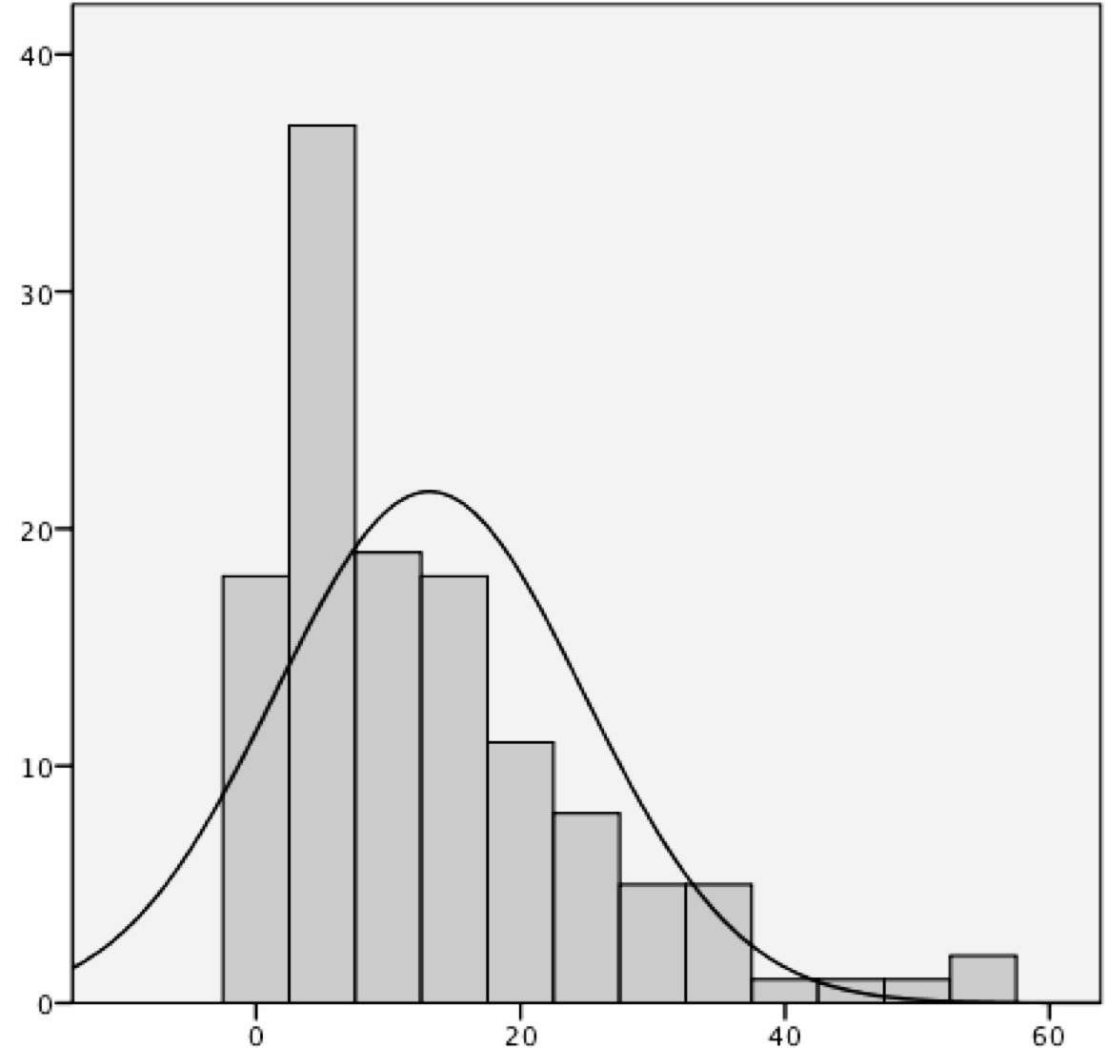
Frequency
Length of Stay

The continuous black line represents normality

