Supplementary Digital Content 2: Additional Results

Results
Initial results from the finalized tool, with bodyweight 70 kg, baseline hematocrit 40%, FII 100% and AT 100%. are shown in the main publication (Figure 1). A new set of baseline parameters was then used: bodyweight 120 kg, hematocrit 50%, FII 40% and AT 60%. Six units of therapeutic plasma and 3000 IU of PCC were modelled with volume resuscitation (150 mL per unit of PCC; zero with therapeutic plasma). The results are shown in Supplementary Figure 1A. Thirdly, the original scenario was re-assessed with a low baseline hematocrit (22%). In this simulation, a unit of RBC was added. Supplementary Figure 1B-1 shows the outcomes with respect to FII, AT and the FII:AT ratio, while the changes in hematocrit are shown in Figure 1B-2.
The tool was applied to simulate situations described in cardiovascular surgery, trauma and vitamin K antagonist reversal. In all three cases, values entered into the concentration simulator were consistent with published research,¹⁻⁸ and volume resuscitation was added to PCC in cardiovascular surgery and trauma. The results are shown in Supplementary Figure 2. All scenarios indicate that PCC produces a much greater increase in FII than therapeutic plasma. In cardiovascular surgery and trauma, AT was increased by therapeutic plasma whereas decreases were seen with PCC plus volume resuscitation. In vitamin K antagonist reversal, AT levels changed little in response to either treatment. The patient’s baseline levels of FII and AT and the dose of hemostatic agent affect the final FII:AT ratio. In the cardiovascular surgery example, with a low baseline FII level, the final ratio was 0.61 with therapeutic plasma and 1.26 with PCC; corresponding values in trauma were 1.10 and 3.21. In the simulation of vitamin K antagonist reversal, the final ratio was 0.40 with plasma and 1.05 with PCC.
Supplementary Figure 1. Results obtained with the finalized, theoretical FII-AT concentration simulator. A) 120 kg patient with 50% hematocrit, baseline plasma levels of FII and AT of 40% and 60%, respectively, and addition of 6 units of therapeutic plasma or PCC (additional volume resuscitation, 150 mL per unit of PCC). B) 70 kg patient with 22% hematocrit, baseline plasma levels of FII and AT of 100%, and addition of 4 units of PCC and therapeutic plasma (1. FII:AT and 2. hematocrit results).
A)
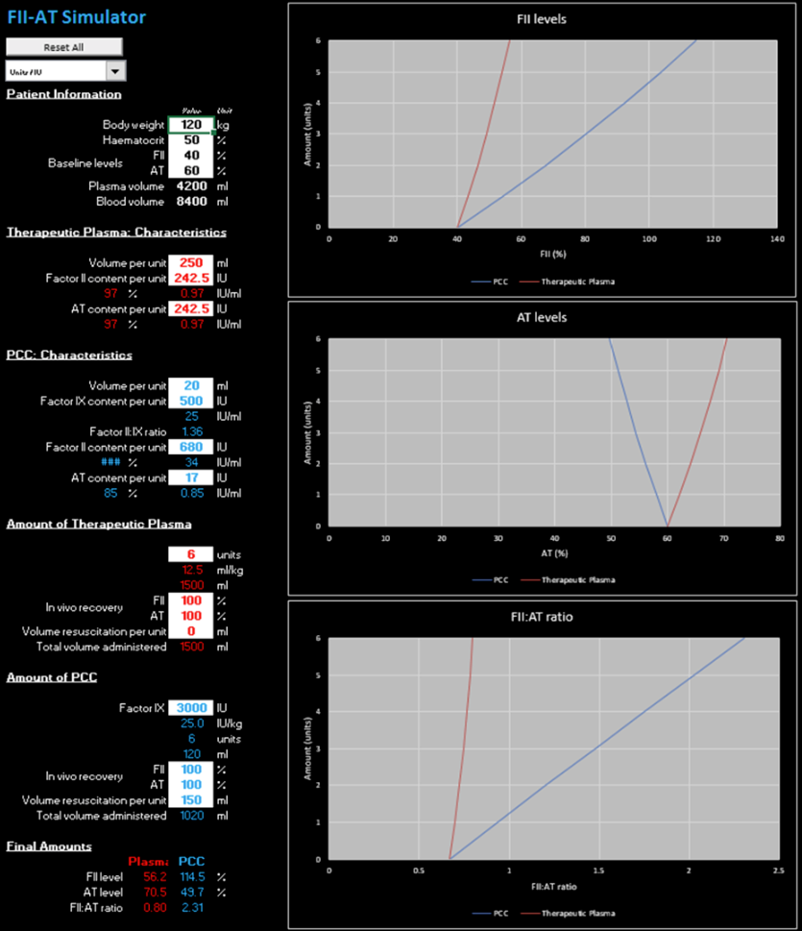
B-1) 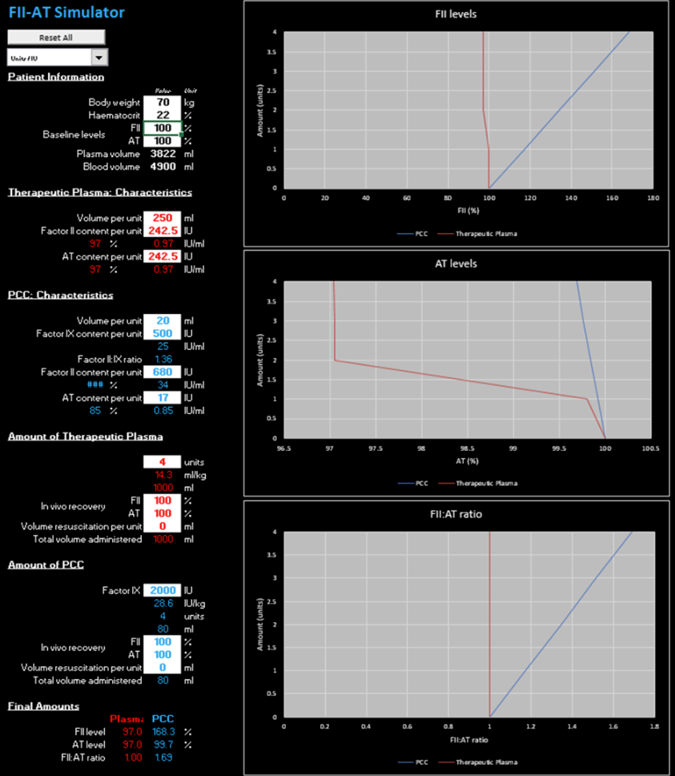

B-2)
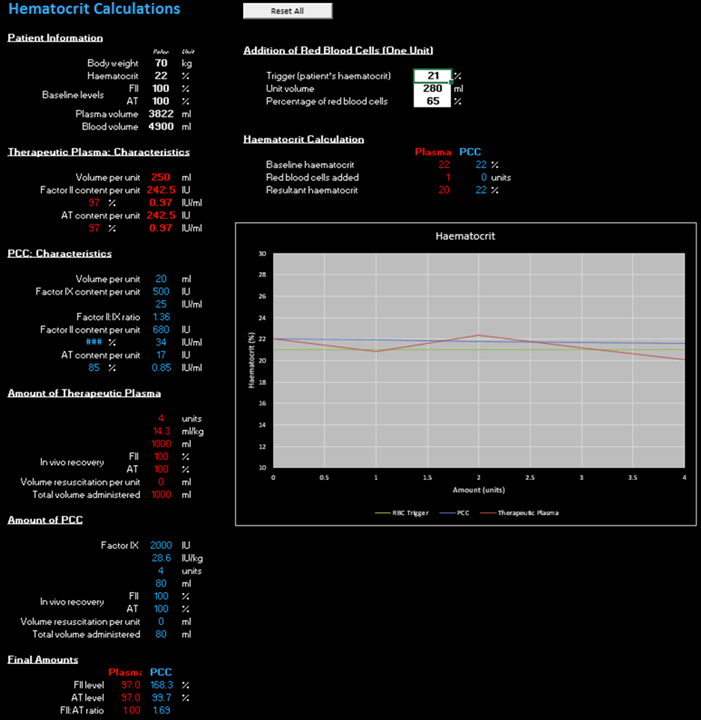

Supplementary Figure 2. Simulation of bleeding situations using the finalized, theoretical FII-AT concentration simulator. A) Cardiovascular surgery,^{1,5-7} B) Trauma,^{3,4,9,10} and C) Vitamin K antagonist reversal.^{2,8}
A)
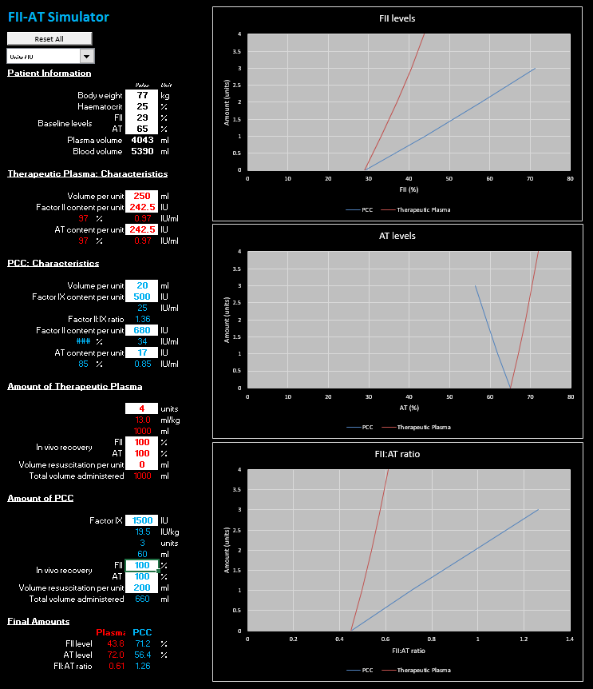
B) 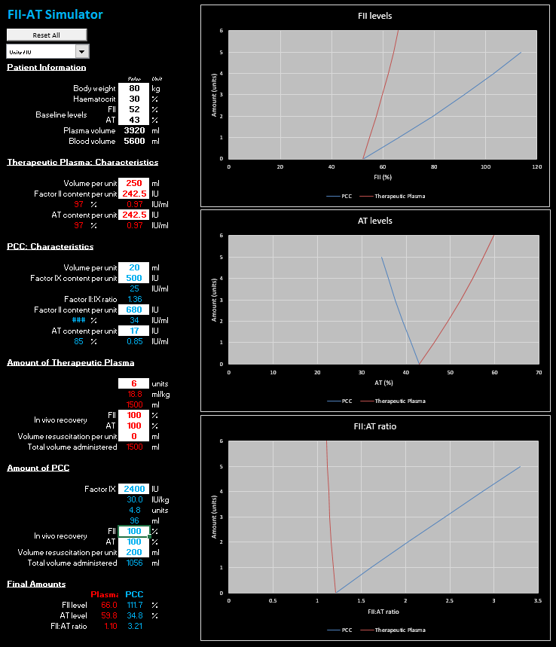

C)
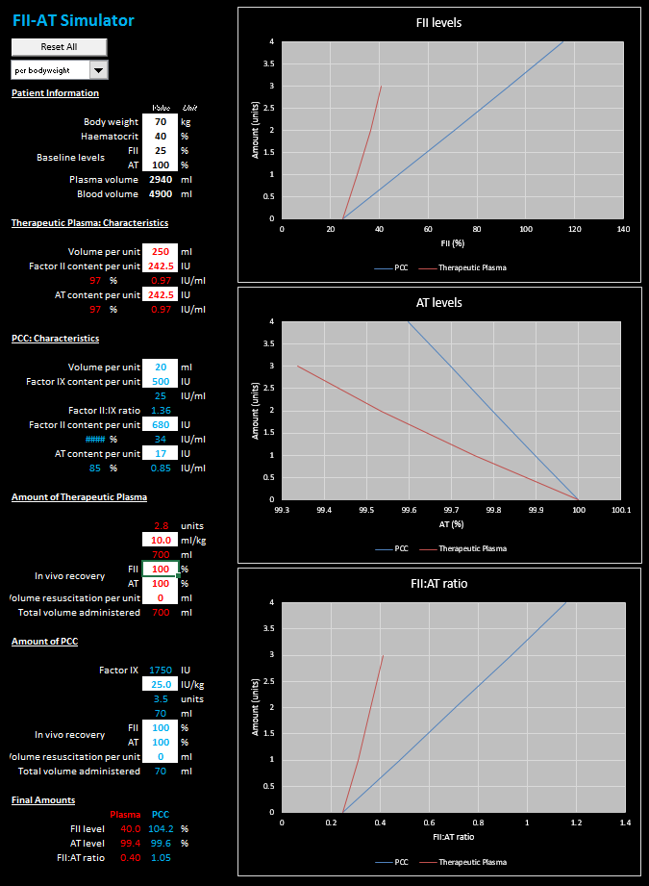

References
1. Chandler WL, Velan T. Estimating the rate of thrombin and fibrin generation in vivo during cardiopulmonary bypass. Blood 2003;101:4355-62.
2. Dargaud Y, Hoffman M, Lefrapper L et al. Bleeding risk in warfarinized patients with a therapeutic international normalized ratio: the effect of low factor IX levels. J Thromb Haemost 2013;11:1043-52.
3. Dunbar NM, Chandler WL. Thrombin generation in trauma patients. Transfusion 2009;49:2652-60.
4. Schochl H, Nienaber U, Maegele M et al. Transfusion in trauma: Thromboelastometry-guided coagulation factor concentrate-based therapy versus standard fresh frozen plasma-based therapy. Crit Care 2011;15:R83.
5. Weber CF, Gorlinger K, Meininger D et al. Point-of-care testing: a prospective, randomized clinical trial of efficacy in coagulopathic cardiac surgery patients. Anesthesiology 2012;117:531-47.
6. Bruce D, Nokes TJ. Prothrombin complex concentrate (Beriplex P/N) in severe bleeding: Experience in a large tertiary hospital. Crit Care 2008;12:R105.
7. Schick KS, Fertmann JM, Jauch KW, Hoffmann JN. Prothrombin complex concentrate in surgical patients: Retrospective evaluation of vitamin K antagonist reversal and treatment of severe bleeding. Crit Care 2009;13:R191.
8. Sarode R, Milling TJ, Jr., Refaai MA et al. Efficacy and safety of a 4-factor prothrombin complex concentrate in patients on vitamin K antagonists presenting with major bleeding: a randomized, plasma-controlled, phase IIIb study. Circulation 2013;128:1234-43.
9. Schochl H, Nienaber U, Hofer G et al. Goal-directed coagulation management of major trauma patients using thromboelastometry (ROTEM)-guided administration of fibrinogen concentrate and prothrombin complex concentrate. Crit Care 2010;14:R55.
10. Schochl H, Voelckel W, Maegele M, Kirchmair L, Schlimp CJ. Endogenous thrombin potential following hemostatic therapy with 4-factor prothrombin complex concentrate: A 7-day observational study of trauma patients. Crit Care 2014;18:R147.

