**Low versus high-chloride content intravenous solutions for critically ill and perioperative adult patients: a systematic review and meta-analysis**

Leticia Kawano-Dourado;1,2 Fernando Godinho Zampieri;1,3 Luciano Cesar Pontes Azevedo;4,5 Thiago Domingos Corrêa;6 Mabel Figueiro; 1 Matthew Semler, MD;7 John A. Kellum, MD;8 Alexandre Biasi Cavalcanti, MD. 1

1 Research Institute, Hospital do Coração (HCor), São Paulo, Brazil.

2 Pulmonary Division, Heart Institute (InCor), University of Sao Paulo Medical School, São Paulo, Brazil.

3 Intensive Care Unit, Hospital Alemão Oswaldo Cruz, São Paulo, Brazil.

4 Intensive Care Unit, Hospital Sirio Libanes, São Paulo, Brazil.

5 Emergency Medicine Discipline, University of São Paulo Medical School, São Paulo, Brazil.

6 Intensive Care Unit, Hospital Israelita Albert Einstein, São Paulo, Brazil.

7 Pulmonary and Critical Care Unit,Vanderbilt University Medical Center, Tennessee, USA.

8 The Center for Critical Care Nephrology, University of Pittsburgh, Pennsylvania, USA.

**Search Strategy:**

Pubmed Search ((("hartmann s solution" OR "Plasma-lyte 148"[Supplementary Concept] OR "plasma-lyte" OR Plasmalyte OR "ringer lactate" OR Ringer* OR "ringers lactate" OR "Balanced solution" OR "balanced saline" OR low chloride OR buffered crystalloid OR buffered solution))) AND ("Sodium Chloride"[Mesh] OR Saline OR NaCl 0.9%) AND ((randomized controlled trial[pt] OR controlled clinical trial[pt] OR randomized[tiab] OR placebo[tiab] OR drug therapy[sh] OR randomly[tiab] OR trial[tiab] OR groups[tiab] NOT (animals[mh] NOT humans[mh])))

**Additional search added in August/2016:**

(Therapy/Narrow[filter]) AND (balanced solution saline)

**sTable 1:** PRISMA Checklist

|  |  |  |  |
| --- | --- | --- | --- |
| **SECTION** | | | **Page in Text** |
| **TITLE** | | |  |
| Title | 1 | Identify the report as a systematic review, meta-analysis, or both. | **01** |
| **ABSTRACT** | | |  |
| Structured summary | 2 | Provide a structured summary including, as applicable: background; objectives; data sources; study eligibility criteria, participants, and interventions; study appraisal and synthesis methods; results; limitations; conclusions and implications of key findings; systematic review registration number. | **03** |
| **INTRODUCTION** | | |  |
| Rationale | 3 | Describe the rationale for the review in the context of what is already known. | **04** |
| Objectives | 4 | Provide an explicit statement of questions being addressed with reference to participants, interventions, comparisons, outcomes, and study design (PICOS). | **05** |
| **METHODS** | | |  |
| Protocol and registration | 5 | Indicate if a review protocol exists, if and where it can be accessed (e.g., Web address), and, if available, provide registration information including registration number. | **06** |
| Eligibility criteria | 6 | Specify study characteristics (e.g., PICOS, length of follow-up) and report characteristics (e.g., years considered, language, publication status) used as criteria for eligibility, giving rationale. | **06-07** |
| Information sources | 7 | Describe all information sources (e.g., databases with dates of coverage, contact with study authors to identify additional studies) in the search and date last searched. | **07** |
| Search | 8 | Present full electronic search strategy for at least one database, including any limits used, such that it could be repeated. | **Electronic appendix** |
| Study selection | 9 | State the process for selecting studies (i.e., screening, eligibility, included in systematic review, and, if applicable, included in the meta-analysis). | **Fig 1 + page 07** |
| Data collection process | 10 | Describe method of data extraction from reports (e.g., piloted forms, independently, in duplicate) and any processes for obtaining and confirming data from investigators. | **07-08** |
| Data items | 11 | List and define all variables for which data were sought (e.g., PICOS, funding sources) and any assumptions and simplifications made. | **06** |
| Risk of bias in individual studies | 12 | Describe methods used for assessing risk of bias of individual studies (including specification of whether this was done at the study or outcome level), and how this information is to be used in any data synthesis. | **09** |
| Summary measures | 13 | State the principal summary measures (e.g., risk ratio, difference in means). | **08** |
| Synthesis of results | 14 | Describe the methods of handling data and combining results of studies, if done, including measures of consistency (e.g., I2) for each meta-analysis. | **08** |
| Risk of bias across studies | 15 | Specify any assessment of risk of bias that may affect the cumulative evidence (e.g., publication bias, selective reporting within studies). | **07- 08** |
| Additional analyses | 16 | Describe methods of additional analyses (e.g., sensitivity or subgroup analyses, meta-regression), if done, indicating which were pre-specified. | **09** |
| **RESULTS** | | |  |
| Study selection | 17 | Give numbers of studies screened, assessed for eligibility, and included in the review, with reasons for exclusions at each stage, ideally with a flow diagram. | **Fig 1+ page 10** |
| Study characteristics | 18 | For each study, present characteristics for which data were extracted (e.g., study size, PICOS, follow-up period) and provide the citations. | **Table 1 + page 10** |
| Risk of bias within studies | 19 | Present data on risk of bias of each study and, if available, any outcome level assessment (see item 12). | **Page 10 + fig 2** |
| Results of individual studies | 20 | For all outcomes considered (benefits or harms), present, for each study: (a) simple summary data for each intervention group (b) effect estimates and confidence intervals, ideally with a forest plot. | **Page 11 + Fig 3 and table 2** |
| Synthesis of results | 21 | Present results of each meta-analysis done, including confidence intervals and measures of consistency. | **Fig 3 + table 2 and 3 and pag 11** |
| Risk of bias across studies | 22 | Present results of any assessment of risk of bias across studies (see Item 15). | **Fig 2** |
| Additional analysis | 23 | Give results of additional analyses, if done (e.g., sensitivity or subgroup analyses, meta-regression [see Item 16]). | **Eletronic appendix figures** |
| **DISCUSSION** | | |  |
| Summary of evidence | 24 | Summarize the main findings including the strength of evidence for each main outcome; consider their relevance to key groups (e.g., healthcare providers, users, and policy makers). | **13** |
| Limitations | 25 | Discuss limitations at study and outcome level (e.g., risk of bias), and at review-level (e.g., incomplete retrieval of identified research, reporting bias). | **15** |
| Conclusions | 26 | Provide a general interpretation of the results in the context of other evidence, and implications for future research. | **16** |
| **FUNDING** | | |  |
| Funding | 27 | Describe sources of funding for the systematic review and other support (e.g., supply of data); role of funders for the systematic review. | **02** |



**sFigure 1**: Funnel plot for death (left) and need for renal replacement therapy (right) of the included studies.

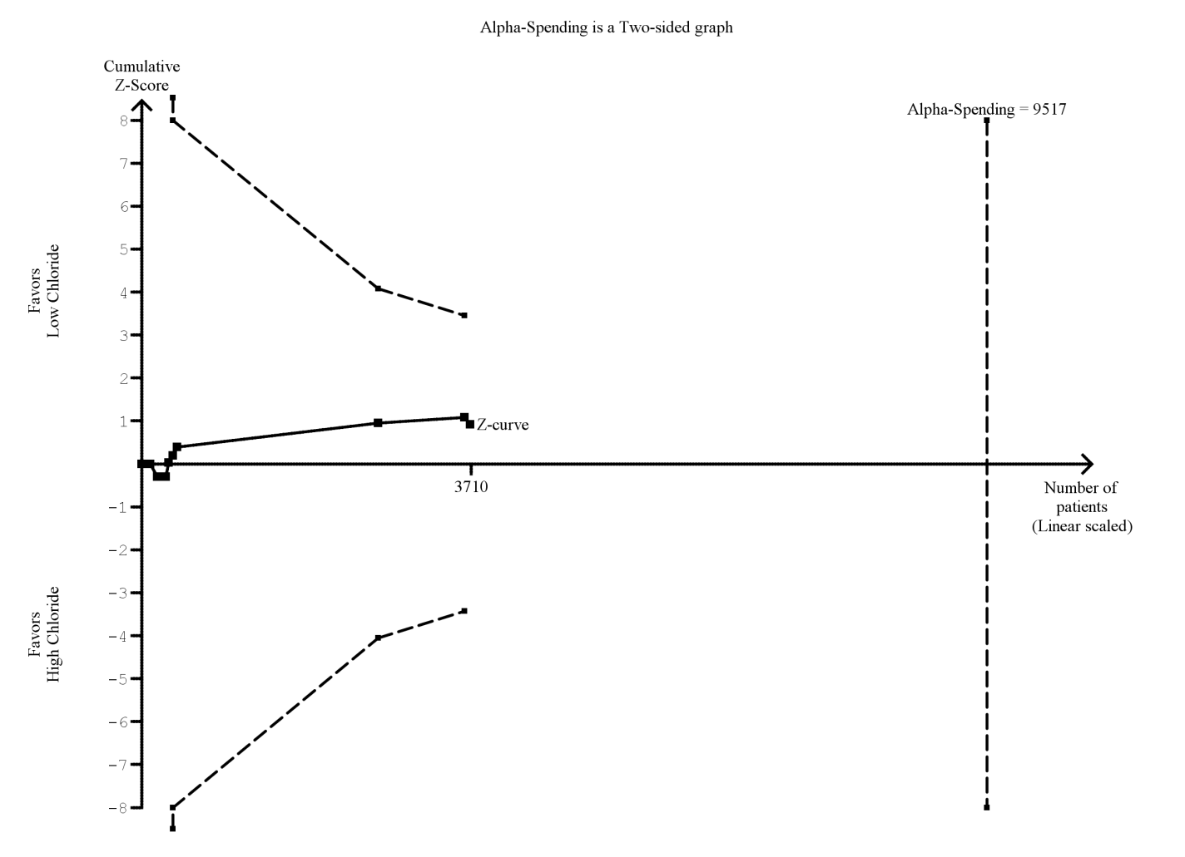

**sFigure 2:** Trial sequential analysis for mortality (solid black line with square filled icons. Each icon representing one trial) illustrating that the optimal effect size calculated with an alpha set at 0.05 and power of 80% to detect a 10% decrease in mortality is 9,517 patients when comparing low- versus high- chloride content solutions. The upper and lower dashed lines represent the trial sequential monitoring boundaries for benefit and harm, respectively, and those have not been crossed. The heterogeneity for information size calculation was set using the D2 measure. D2 represents the relative variance reduction when the model is changed from a random-effects to a fixed-effect model (its interpretation is similar to that of I2 because it is a proportion)

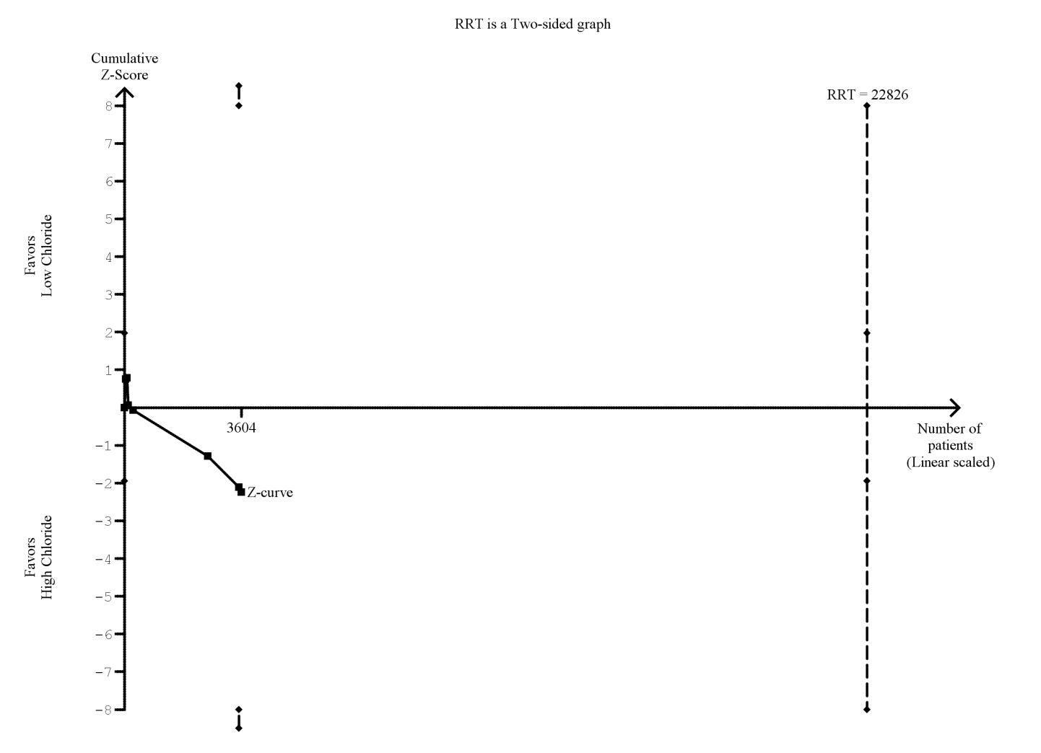

**sFigure 3:** Trial sequential analysis for Renal Replacement Therapy (solid black line with square filled icons. Each icon representing one trial) illustrating that the optimal sample size calculated with an alpha set at 0.05 and power of 80% to detect a 10% decrease in renal replacement therapy is 22,826 patients when comparing low- versus high- chloride content solutions. The upper and lower dashed lines represent the trial sequential monitoring boundaries for benefit and harm, respectively, and those have not been crossed. The heterogeneity for information size calculation was set using the D2 measure. D2 represents the relative variance reduction when the model is changed from a random-effects to a fixed-effect model (its interpretation is similar to that of I2 because it is a proportion).

**sTable 2:** GRADE evidence profile for the impact of low-chloride content solutions in critically ill and perioperative patients from randomized controlled trials that had data to be synthesized on mortality and renal replacement therapy (RRT) use:

|  |  |  |  |  |  |  |
| --- | --- | --- | --- | --- | --- | --- |
| **Outcome**  **No. studies (No. of participants)** | **Quality Assessment** | | | | | **Quality of Evidence** |
| **Study limitations** | **Consistency** | **Directness** | **Precision** | **Publication bias** |
| Mortality  11 studies (3710 patients) | No serious limitations | No important inconsistency | Indirectness (-1)a | Imprecision (-1)b | Unlikely | Low |
| Renal Replacement Therapy use  10 studies (3724 patients) | No serious limitations | No important inconsistency | Indirectness (-1)a | Imprecision (-1)b | Unlikely | Low |

a in the majority of the studies a low dose of balanced crystalloid was administered to relatively low-risk patients, therefore, high risk patients who need a significant amount of fluid was not adequately and directly represented in these studies

b the majority of the studies included few patients and few events were reported