Annex A: Inclusion and exclusion criteria

Inclusion criteria
- Bernstein-Parsonnet score > 7
- Age ≥ 18 years and ≤ 80 years
- Written informed consent to participate to the study
- Severe aortic stenosis (aortic valve area < 0.5 cm²/m²) scheduled for aortic valve replacement or coronary heart disease with poor left ventricular function (systolic function [ejection fraction < 40%], diastolic dysfunction [restrictive pattern, abnormal relaxation]) and/or previous/current heart failure, scheduled for coronary artery bypass grafting

Exclusion criteria
- Dementia or inability to understand the study protocol
- Off-pump and emergent cardiac surgery
- Poorly controlled diabetes mellitus (glucose > 12 or < 3 mM/L ≥ 3 episodes/week)
- Atrial fibrillation
- Severe renal insufficiency: creatinine clearance < 20 ml/min
- Abnormal liver function Child-Plugh – C stage
- Associated mitral valve surgery or ascending aortic root replacement
- Body Mass Index < 18 and > 35
- Critical preoperative state (ICU patient, preoperative cardiac massage, preoperative ventilation, preoperative inotropes or intra-aortic balloon pump)

Calculation of the Bernstein-Parsonnet score:
Risk Factor | Assigned weight
Female gender | 1
Morbid obesity | 3
Diabetes | 3
Hypertension | 3
Chronic pulmonary obstructive disease | 5
Peripheral arterial disease | 2
Antiplatelet therapy | 2
Mean pulmonary pressure > 30 mmHg | 10
Ejection fraction
≥ 50 | 0
30–49% | 2
< 30% | 4
Age
70–74 | 7
75–79 | 12
> 80 | 20
Aortic surgery | 5
Combined surgery | 7
Reoperation | 5

Annex B: Standardized approach for weaning from bypass

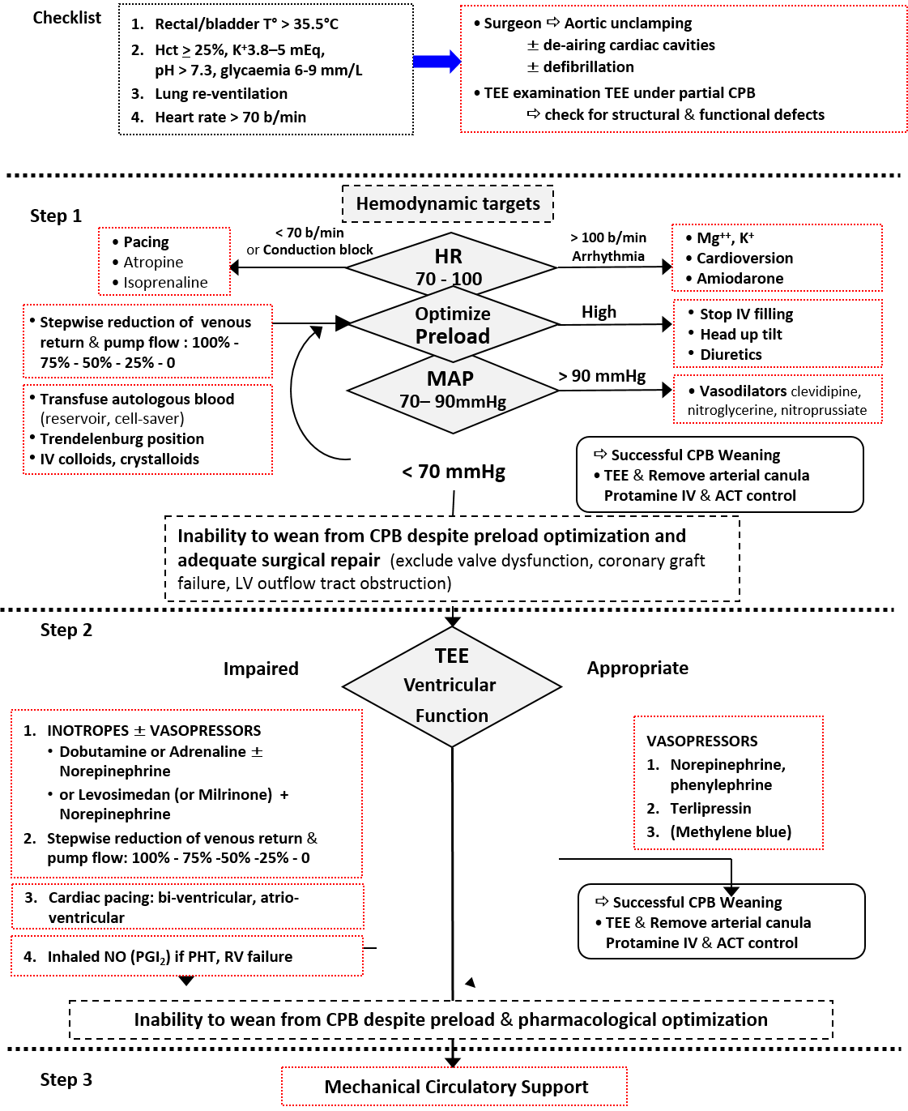
Annex C: modified classification system of postoperative complications¹
 | Cardiovascular | Pulmonary | Renal | Others
Grade I Transient, self-limiting AE | - Non-sustained arrhythmias  - Hypotension associated with anesthesia induction or mild hypovolemia | Mild hypoxemia responsive to O₂ therapy (< 0.3 FIO₂) | < 25% decrease in eGFR
Grade II AE requiring pharmacologic treatment or minor intervention | - Arrhythmias requiring pharmacologic treatment  - Hypotension associated with mild hypovolemia | Moderate hypoxemia, atelectasis requiring CPAP support |  | Superficial surgical site infection (SSI)
Grade IIIa AE event requiring intervention without sedation/general anesthesia or potentially causing disability | - Arrhythmias requiring electrical cardioversion  - Hypovolemia requiring aggressive fluid management  - Myocardial ischemia  - Transient cerebral ischemia | - Atelectasis requiring bronchoscopy or intense chest therapy  - Moderate-severe Hypoxemia requiring NIV support  - Pneumonia | 25-50% decrease in eGFR | Deep SSI
Grade IIIb AE requiring intervention under sedation/general anesthesia or causing disability | - Myocardial infarct  - Stroke  - New or worsening heart failure, LCOS requiring pharmacological support (1 drug) | Severe hypoxemia requiring NIV support (ALI/ARDS, pneumonia, heart failure, muscle failure) | > 50% decrease in eGFR | Mediastinitis
Grade IVa Admission in ICU for single organ dysfunction | - New or worsening heart failure, LCOS requiring intense pharmacological support (≥ 2 drugs) and/or mechanical assistance  - Recurrent or sustained arrhythmias  - Myocardial ischemia/infarct (extensive) | Severe hypoxemia requiring intubation and mechanical ventilator support (ALI/ARDS, pneumonia, heart failure, muscle failure) | Renal failure requiring hemodialysis or hemofiltration
Grade IVb | Cardiac arrest with resuscitation |  |  | Combined organ dysfunction

AE: adverse event; eGFR: estimated glomerular filtration rate; CPAP: continuous positive airway pressure; NIV: Non-invasive ventilation; ALI: acute lung injury; ARDS: acute respiratory distress syndrome; LCOS: low cardiac output syndrome

Secondary outcome definitions in the study (≥ grade II)

Myocardial infarct: modified myocardial infarct type 5 definition (post coronary artery bypass grafting (CABG))² :
- cTn values >10x99th percentile during the first 48 h following surgery
- with one or more items:
(i) new pathological ECG changes (Q-waves, new left bundle branch block, ST-segment abnormalities), [10 patients]
(ii) angiographically documented new graft or new native coronary artery occlusion, [3 patients]
(iii) imaging evidence of new loss of viable myocardium, new regional wall motion abnormality, or right or left heart dysfunction (TEE or TTE) [21 patients]
(iv) typical chest pain [1 patient]

New or worsening left ventricular failure: radiological evidence of pulmonary congestion and need for sympathomimetic support, and diuretics/vasodilators

Stroke: focal neurological deficit (transient or permanent)

Atrial fibrillation: atrial fibrillation on ECG requiring anti-arrhythmic medications and/or electrical cardioversion during the ICU stay

Atelectasis: Lobar collapse (Chest-X rays) and need for O2 therapy, CPAP/NIV and/or bronchoscopy

Pneumonia: new or progressive radiographic infiltrate (chest X-ray or computed tomography) plus at least two of the following: antibiotic treatment, central temperature > 38°C, leukocytosis or leucopenia (white blood cell count < 4,000cells/mm3 or > 12,000cells/mm3) and/or purulent secretions³
References
1. Seely AJ, Ivanovic J, Threader J, et al. Systematic classification of morbidity and mortality after thoracic surgery. Ann Thorac Surg. 2010;90(3):936-942; discussion 942.
2. Thygesen K, Alpert JS, Jaffe AS, et al. Third universal definition of myocardial infarction. Circulation. 2012;126(16):2020-2035.
3. Hemmes SN, de Abreu MG, Pelosi P, Schultz MJ. ESA Clinical Trials Network 2012: LAS VEGAS--Local Assessment of Ventilatory Management during General Anaesthesia for Surgery and its effects on Postoperative Pulmonary Complications: a prospective, observational, international, multicentre cohort study. European journal of anaesthesiology. 2013;30(5):205-207.

