Appendix 1: List of definitions of complications used by NSQIP (Source: https://www.facs.org/~/media/files/quality%20programs/nsqip/ug12.ashx)

- Superficial Incisional Superficial Surgical Site Infection
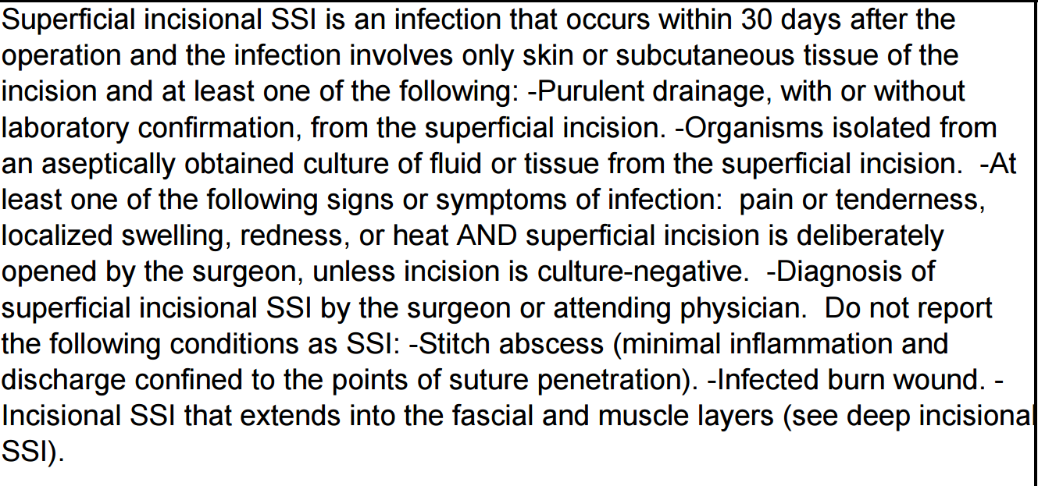
- Deep Incisional Superficial Surgical Site Infection
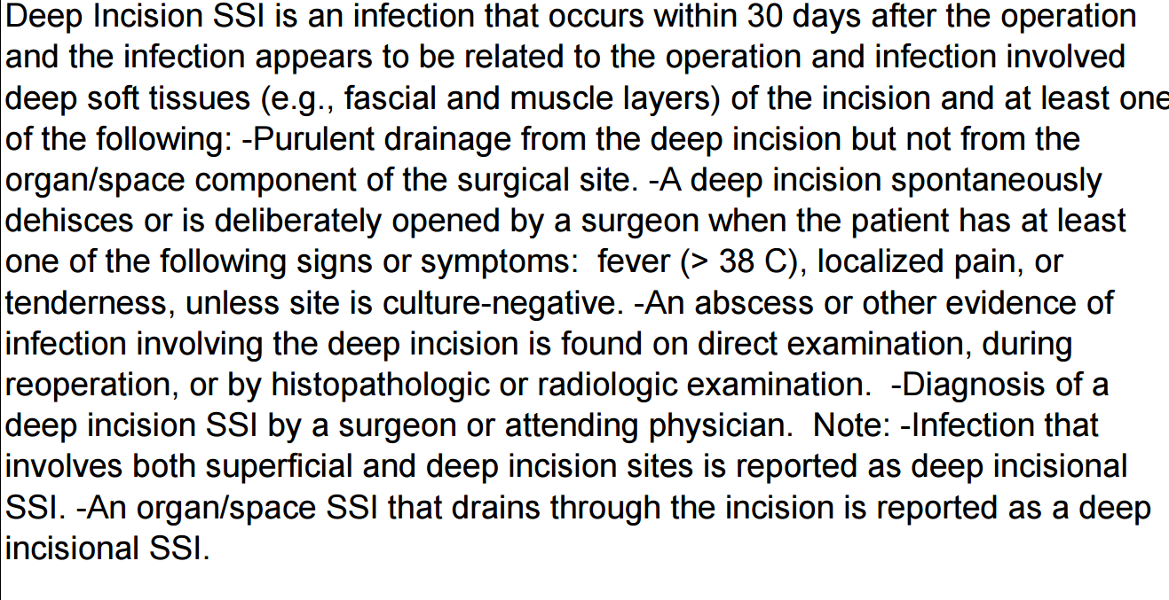
- Organ/Space Surgical Site Infection
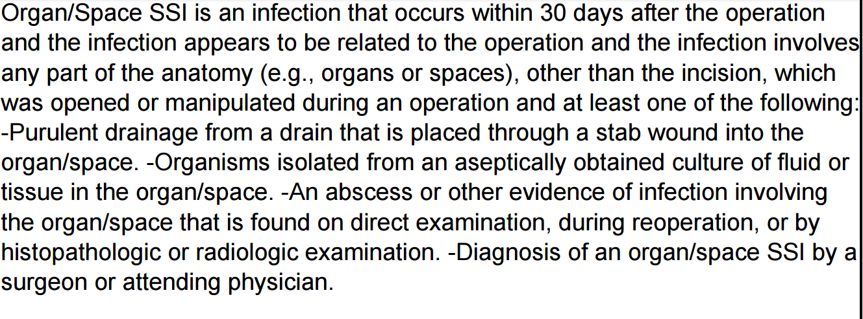
- Dehiscence
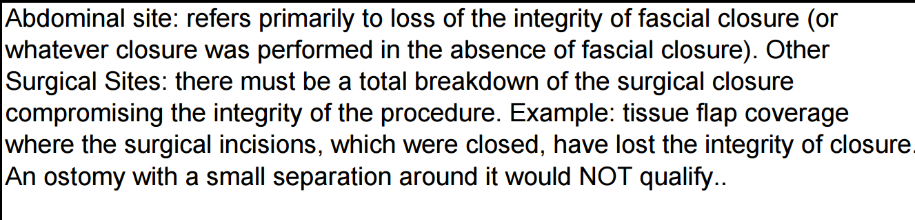
- Pneumonia
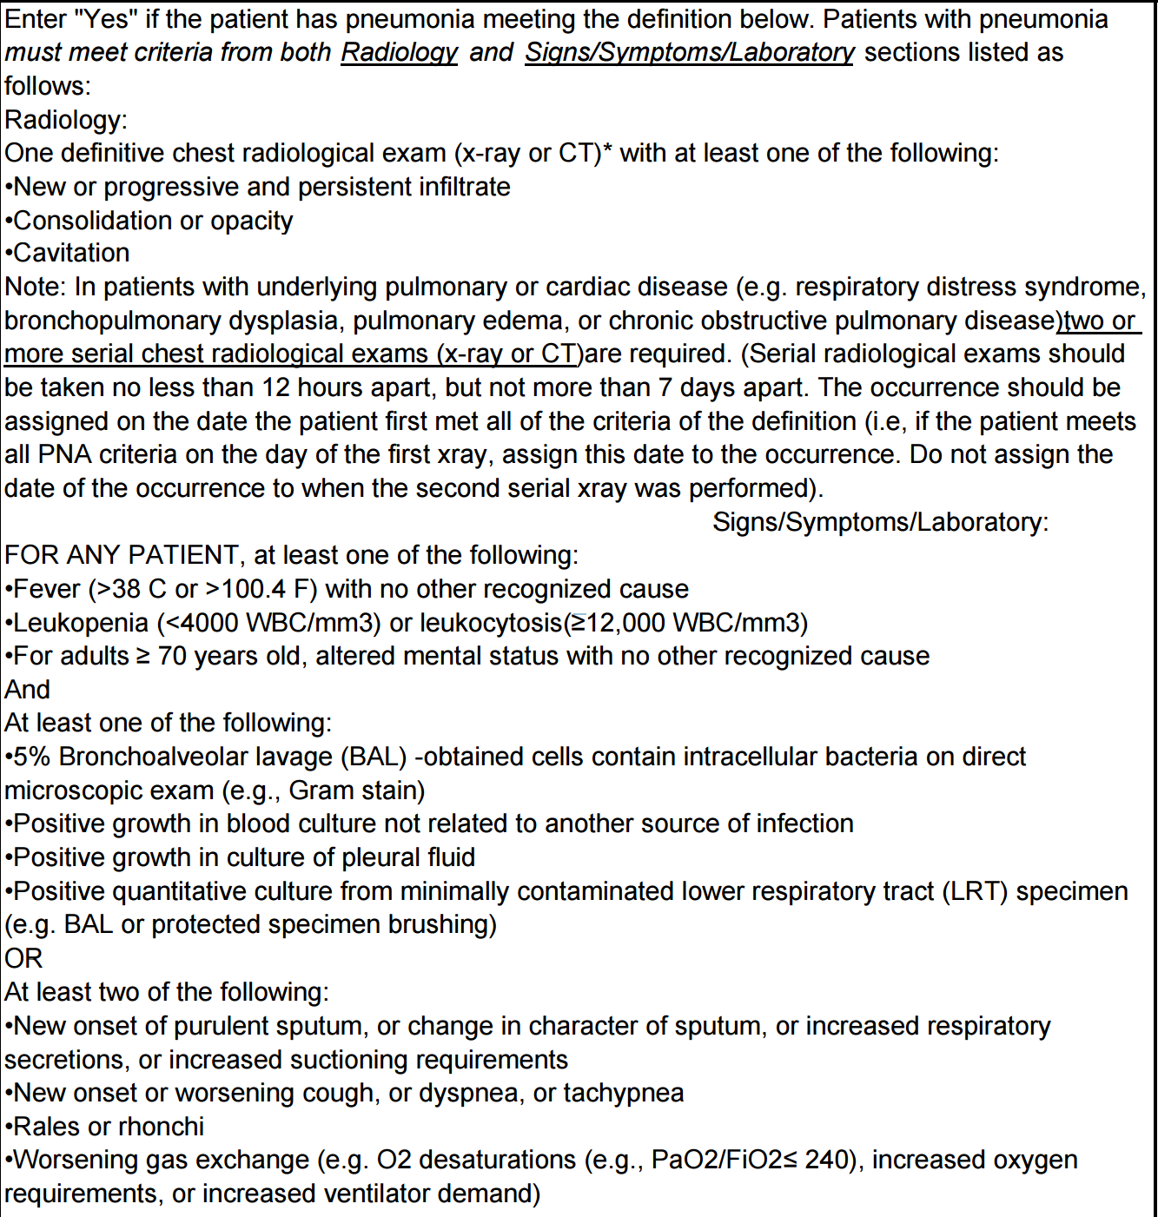
- Unplanned intubation
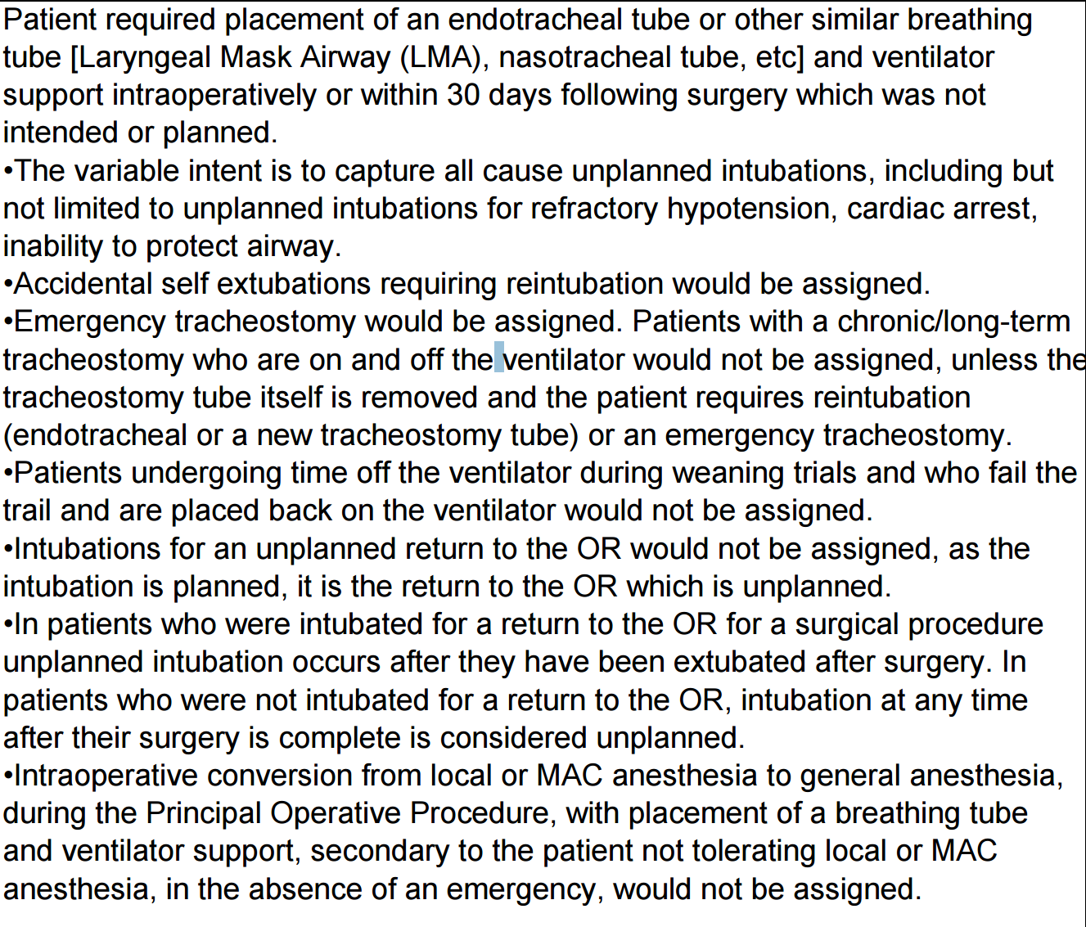
- Pulmonary embolism
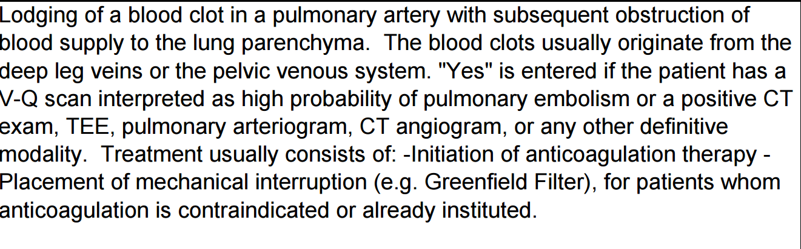
- Failure to wean
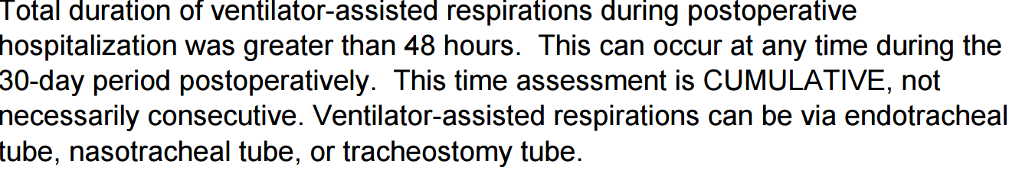
- Renal insufficiency
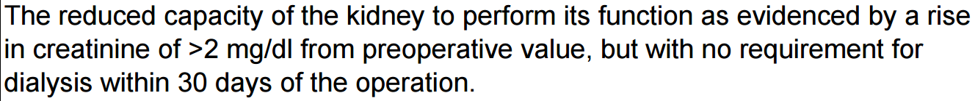
- Acute renal failure
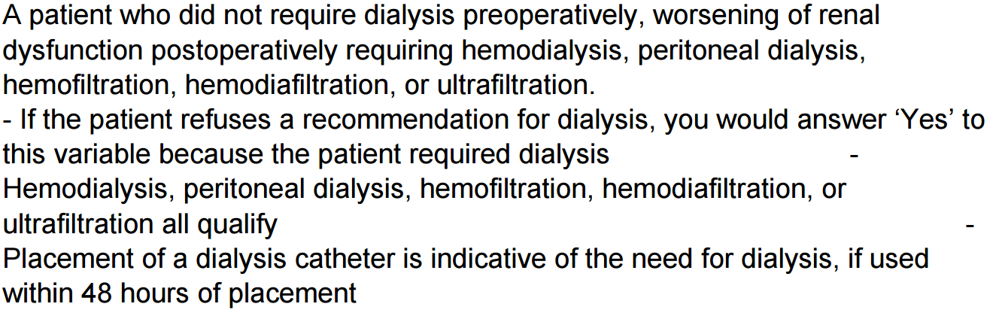
- Urinary tract infection
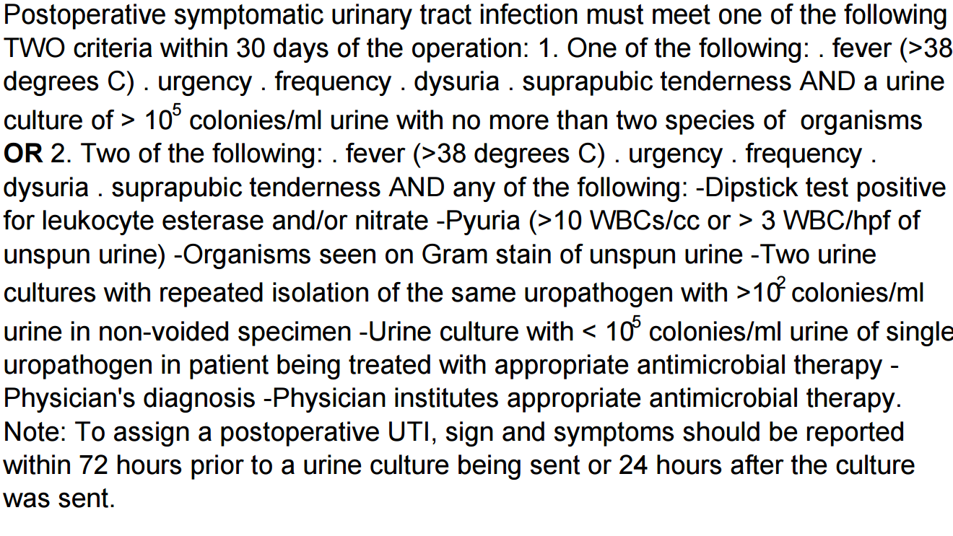
- Stroke/CVA
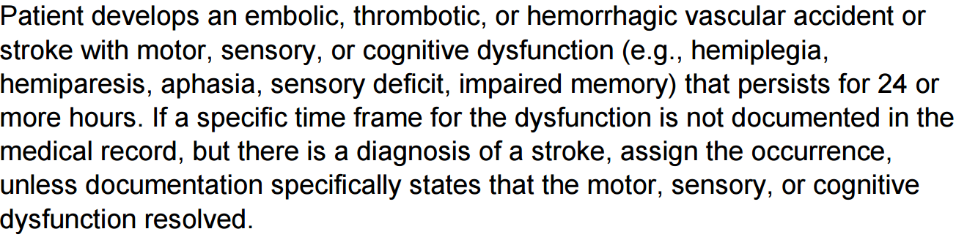
- Coma
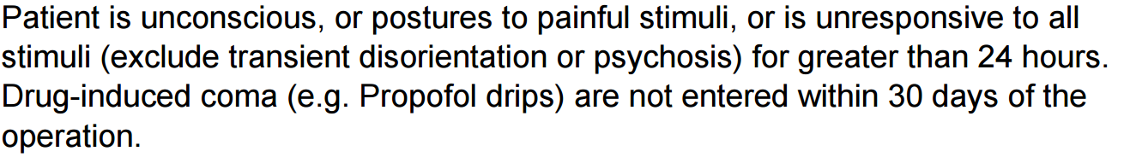
- Peripheral nerve injury
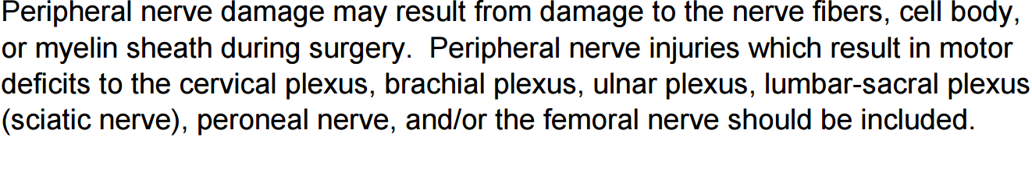
- Cardiac arrest requiring CPR
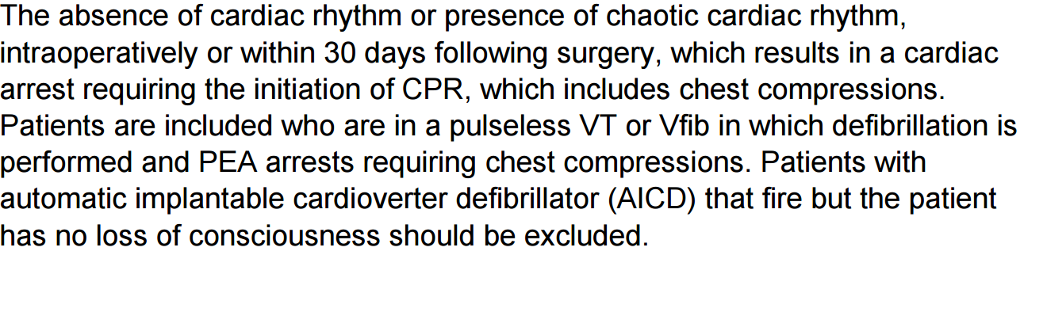
- Acute myocardial infarction
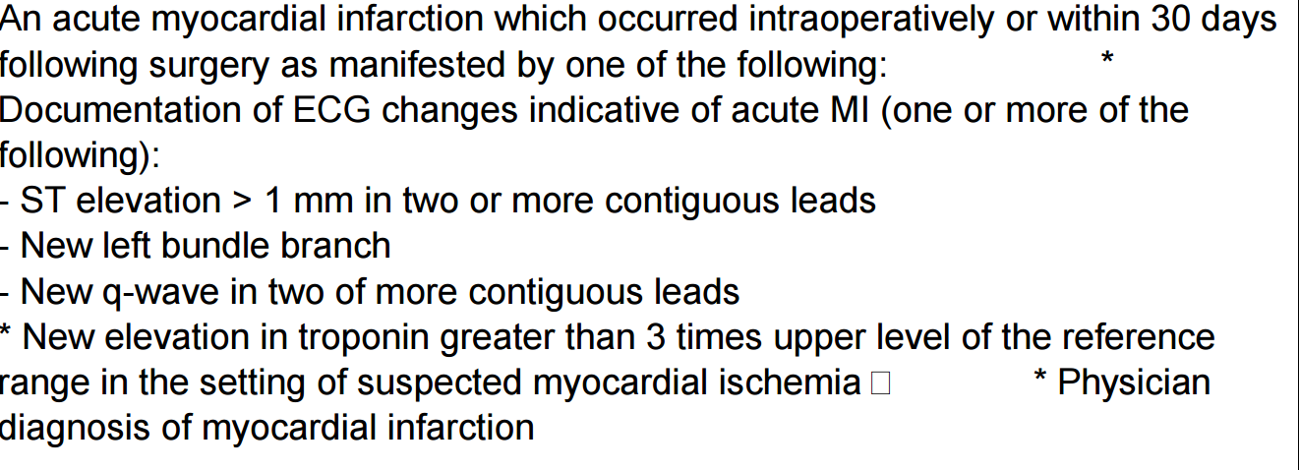
- Bleeding necessitating transfusion
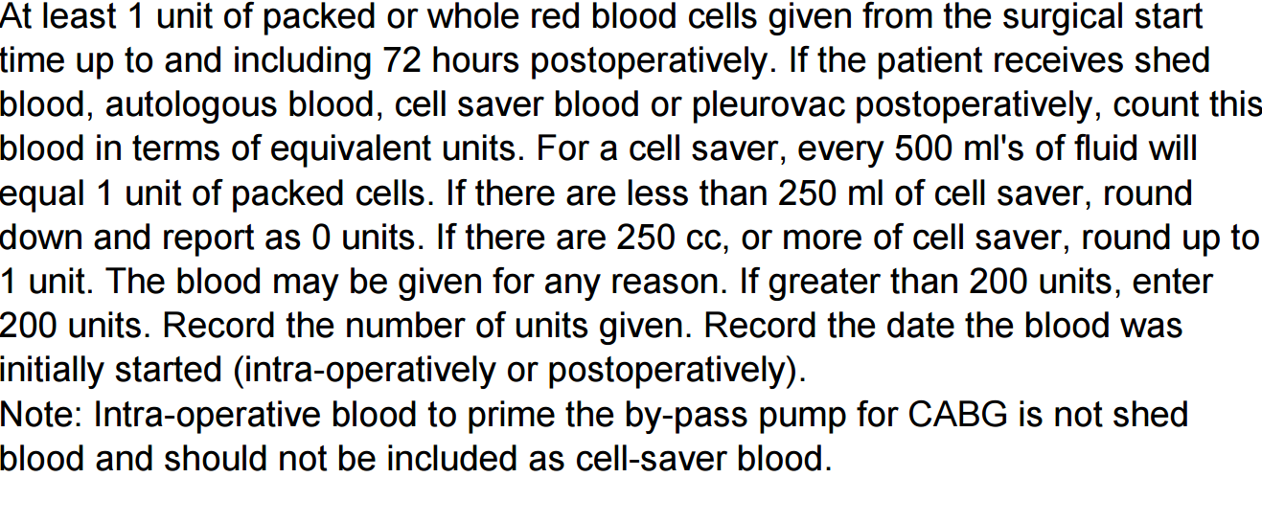
- Graft/prosthesis/free flap failure
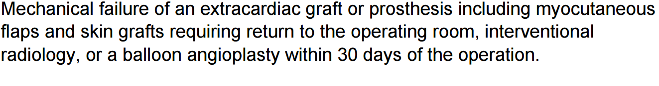
- Deep venous thrombosis
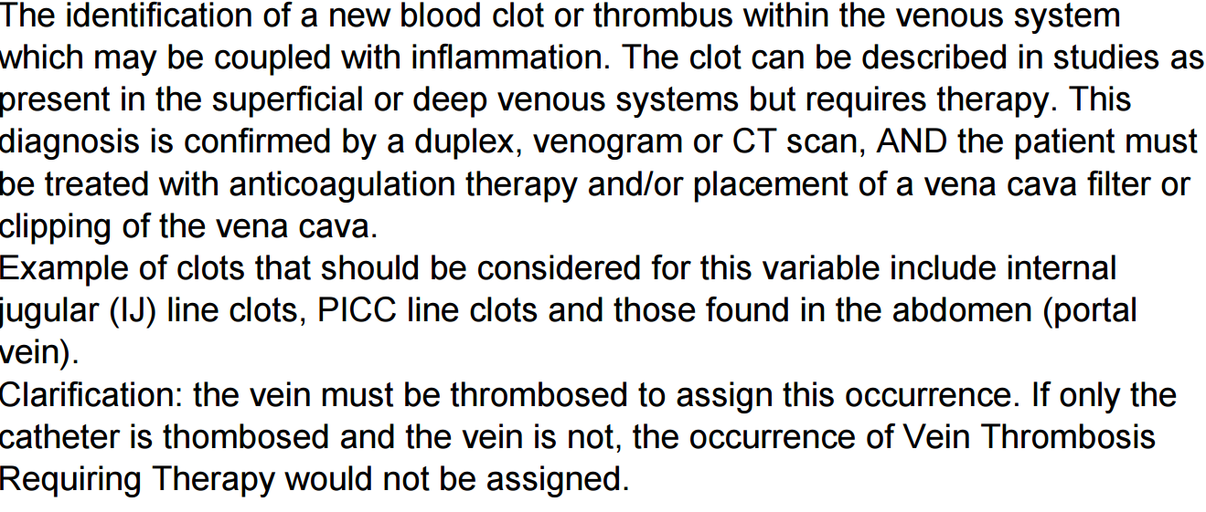
- Sepsis
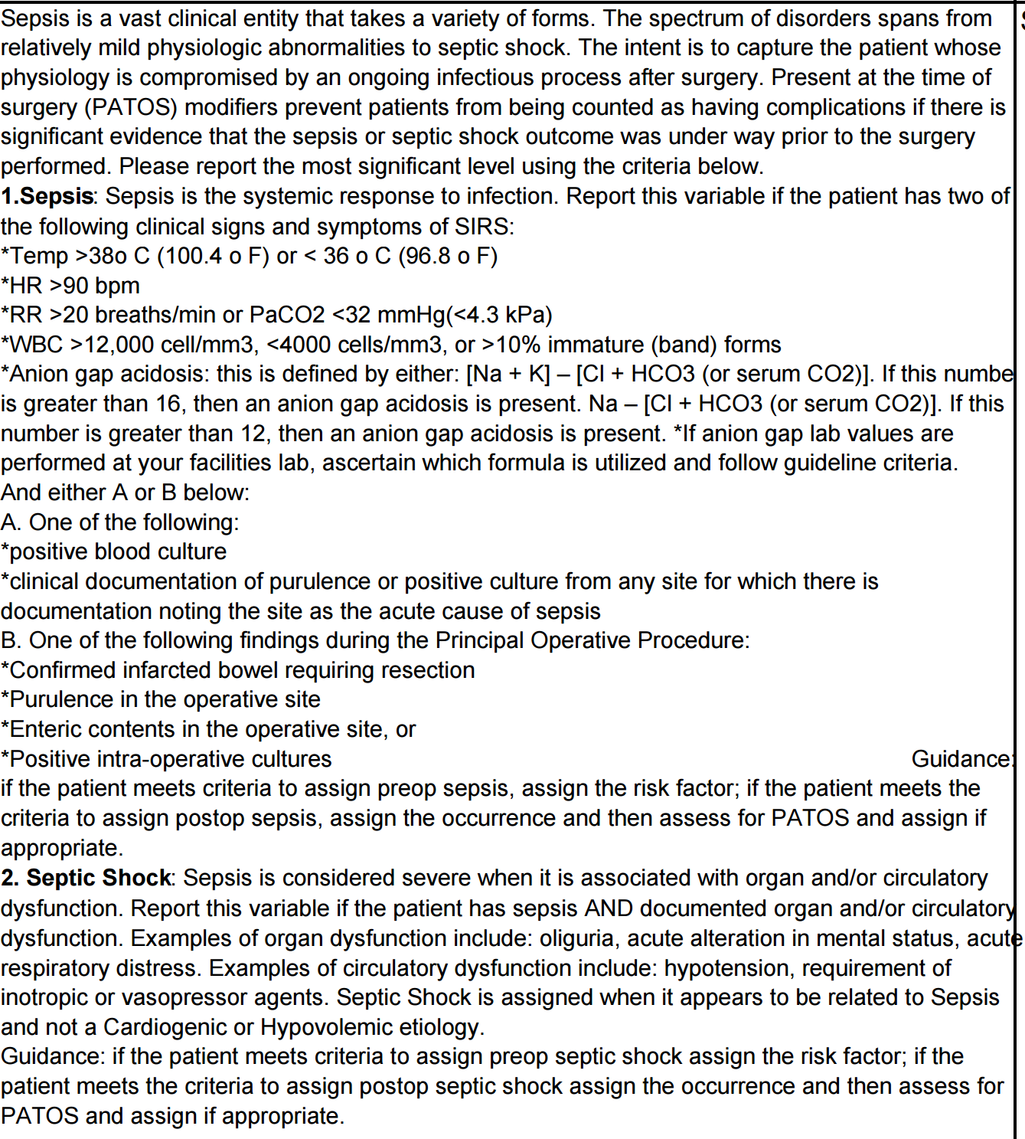
- Septic shock
