SUPPLEMENTARY MATERIAL

Pain and its Long-Term Interference of Daily Life Following Critical Illness

Christina J Hayhurst, MD;¹ Jim C Jackson, PsyD;² Kristin R Archer, PhD;³ Jennifer L Thompson MPH;⁴ Rameela Chandrasekhar, PhD;⁵ Christopher G Hughes, MD⁶

Table of Contents
- Supplementary Figure 1
- Supplementary Figure 2

A.
Supplementary Figure 1: Sensitivity Analysis of the Interaction between Pre-admission and ICU Opioid exposure on Pain intensity and Interference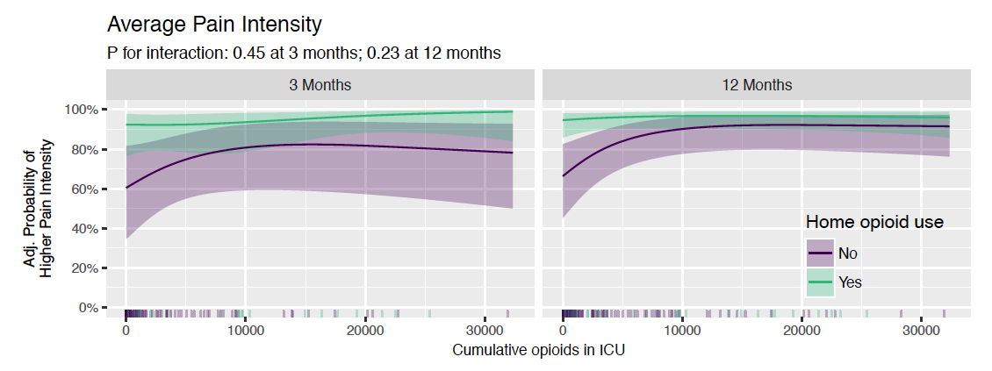
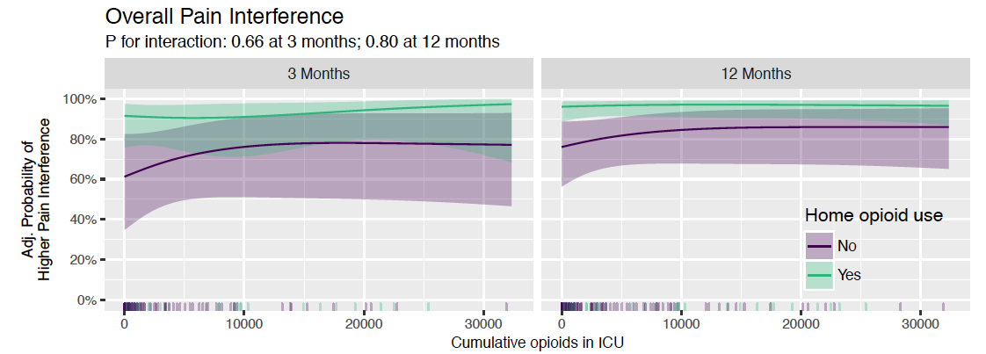
The effects of cumulative ICU opioid exposure on average pain intensity and pain interference at 3 and 12 months after discharge are shown in patients who had pre-admission opioid use in green and in those who did not in lavender. The number of patients in each group are represented on the rug plot at the bottom of the graph, with more patients corresponding to increased density of the squares. The solid line demonstrates the point estimates of the associations between ICU opioid exposure versus pain intensity or interference, with the light ribbon indicating the 95% confidence interval. Pre-admission opioid use did not significantly modify the relationship between cumulative ICU opioid exposure and BPI pain intensity or the relationship between cumulative ICU opioid exposure and overall pain interference at 3 or 12 months

B.
Supplementary Figure 2: Sensitivity Analysis of ICU Opioid Exposure on Pain Intensity and Interference Adjusting for Only Baseline Confounders 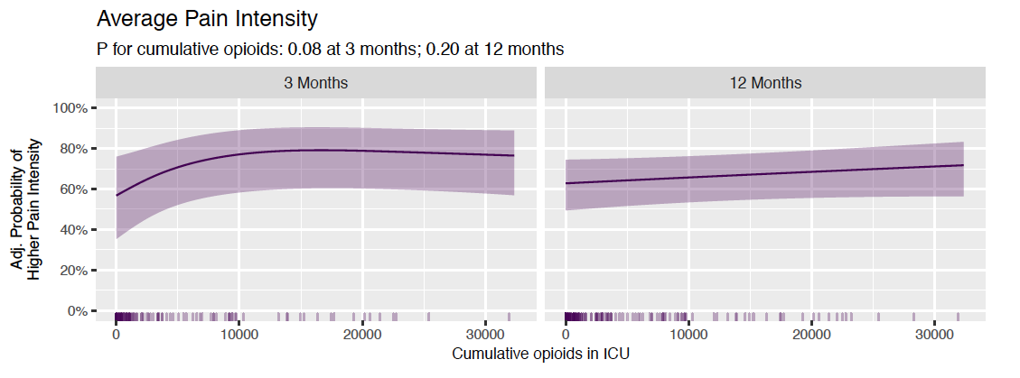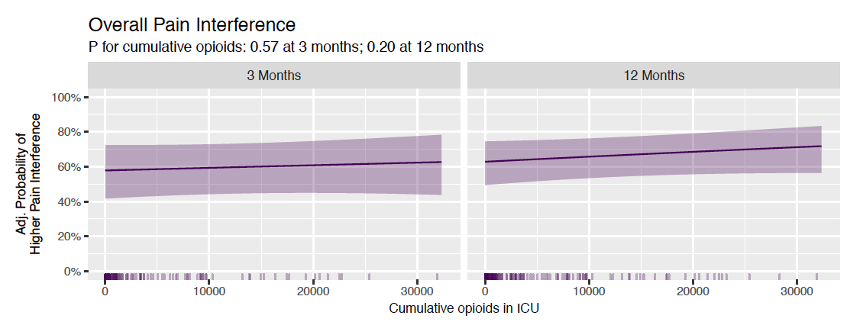
The effects of cumulative ICU opioid exposure on average pain intensity and pain interference at 3 and 12 months are shown using only confounders present prior to the ICU opioid exposure. The number of patients in each group are represented on the rug plot at the bottom of the graph, with more patients corresponding to increased density of the squares. The solid line demonstrates the point estimates of the associations between ICU opioid exposure versus pain intensity or interference, with the light ribbon indicating the 95% confidence interval. We found no significant association between cumulative ICU opioid exposure and BPI pain intensity or overall pain interference at 3 or 12 months.

