Supplemental Digital Contents (SDC)

Table of contents:
Table A. Literature search strategy.
Table B. Summary of included trials.
Table C. Unpublished data included in meta-analysis.
Table D. Literature search in trial registries.
Table E. Risk of bias assessment.
Table F. GRADE summary of findings.
Figure A. Funnel plot for risk of oxygen desaturation.
Figure B. Funnel plot for risk of arterial hypotension.
Figure C. Funnel plot for risk of rescue interventions for adverse events.
Figure D. Trial sequential analysis for risk of oxygen desaturation.
Figure E. Trial sequential analysis for risk of arterial hypotension.
Figure F. Trial sequential analysis for risk of bradycardia.
Figure G. Trial sequential analysis for risk of rescue intervention for adverse events.
Figure H. Risk of oxygen desaturation. Subgroup analysis for trials with propofol bolus regimens in both PCS and CCS groups.
Figure I. Risk of arterial hypotension. Subgroup analysis for trials with propofol bolus regimens in both PCS and CCS groups.
Figure J. Risk of rescue intervention for adverse events. Subgroup analysis for trials with propofol bolus regimens in both PCS and CCS groups.
Figure K. Risk of oxygen desaturation. Subgroup analysis for trials with local or locoregional anesthesia.
Figure L. Risk of rescue intervention for adverse events. Subgroup analysis for trials with local or locoregional anesthesia.
Figure M. Total propofol dose.
Figure N. Risk of oversedation.
Figure O. Operator satisfaction with sedation.
Figure P. Patient satisfaction with sedation.
Table A. Literature search strategy.

Database | Search platform | Search terms and Boolean operators | Article types | Search fields | Other limitations
Cochrane Library | Wiley® online library | (‘patient-controlled’ OR ‘patient-maintained’) AND ‘sedation’ AND ‘propofol’ | Trials, Reviews | All text | None
Medline | PubMed |  | No limitations | All fields
Embase | Ovid®, Expert Search |  | No limitations | Not specified

Table B. Summary of included trials.

Alhashemi 2006
Procedure | Extracorporeal shock wave lithotripsy
Patients | Number = 64  Males = 83%  Mean (SD) age PCS/CCS = 41(10)/45(11) years  Mean (SD) weight PCS/CCS = 81(15)/75(14) kg  Mean (SD) height PCS/CCS = 163(8)/163(5) cm  ASA physical status = I-II
PCS | Bolus 0.3 mg kg⁻¹ (lock-out time 3 min)
CCS | Clinician = anesthesiologist  Loading dose 200 μg kg⁻¹ min⁻¹ for 10 min  Continuous infusion 0.05-0.15 mg⁻¹ kg⁻¹ min as required
Recommended depth of sedation in CCS group | Patient comfort and lack of movement
Concomitant drugs and anesthesia | Preoperative midazolam 10 μg kg⁻¹  Preoperative fentanyl 1 μg kg⁻¹  Fentanyl 0.5 μg kg⁻¹ h⁻¹  Fentanyl 50 μg as required
Inclusion criteria | 18 - 80 years old  Renal or ureteric calculi  Scheduled for extracorporeal shock wave lithotripsy
Exclusion criteria | History of chronic analgesic or sedative use  History of alcohol abuse  Language barrier or mental disorder impeding use of pump  Allergy to study drugs
Primary endpoint(s) | Not specified
Endpoints used in meta-analysis | SpO₂ < 92% on O₂ 2 L min⁻¹  Intervention for adverse event
PCS device | IVAC PCAM TM (Alaris Medical Sytems, Hampshire, UK)
Sponsor | Departmental funds

Bell 2010
Procedure | Various
Patients | Number = 166  Males = 54%  Median (IQR) age PCS/CCS = 39 (25 -59.8)/39 (22.8 – 57.3) years  Mean weight PCS/CCS = 75/74.5 kg  ASA physical status = I-III
PCS | Loading dose 0.75 mg kg⁻¹ (0.5 mg kg⁻¹ if > 65 yrs)  Bolus 20 mg (lock-out time 1 min)
CCS | Clinician = emergency physician  Bolus as required
Recommended depth of sedation in CCS group | Clinician’s own judgment
Concomitant drugs and anesthesia | Fentanyl or morphine as required
Inclusion criteria | Patients requiring mild to moderate sedation for procedure in the emergency room
Exclusion criteria | History of propofol intolerance  History of allergy to eggs or soybeans  Communication barrier or cognitive or physical disability impeding use of pump  Pregnancy  Age < 16 years
Primary endpoint(s) | Not specified
Endpoints used in meta-analysis | SpO₂ < 92% on O₂ 2 L min⁻¹  Systolic blood pressure < 80 mmHg  Heart rate < 60 min⁻¹  Obstructed airway  Total propofol dose (mg)  Deepest sedation on Observer’s Assessment of Alertness/Sedation scale  Physician satisfaction  Patient satisfation
PCS device | Master PCA pumpTM (Fresenius Kabi, Homberg, Germany)
Sponsor | Queensland Emergency Medicine Research Foundation

Cork 1995
Procedure | Various
Patients | Number = 43  Males = 37%  Mean (SEM) age PCS/CCS = 44(4)/46(3) years  Mean (SD) weight PCS/CCS = 77(4)/81(4) kg  Mean (SD) height PCS/CCS = 166(2)/171(2) cm  ASA physical status = I-II
PCS | Loading dose 0.5 mg kg⁻¹  Continuous infusion 0.05 mg kg⁻¹ min⁻¹  Bolus 30 mg (lock-out time 3 min)
CCS | Clinician = anesthesiologist  Loading dose 0.5 mg kg⁻¹  Continuous infusion 0.05 mg kg⁻¹ min⁻¹  Bolus 30 mg (lock-out time 3 min)
Recommended depth of sedation in CCS group | Mild slowing and thickening of speech
Concomitant drugs and anesthesia | Preoperative fentanyl 1 μg kg⁻¹  Local anesthesia, spinal anesthesia, intravenous regional anesthesia
Inclusion criteria | Patients scheduled for ambulatory procedures
Exclusion criteria | History of allergy to propofol or soybeans  Intellectual impairment  Disability impeding use of pump  ASA physical status > II
Endpoints used in meta-analysis | Intervention for adverse event  SpO₂ < 90%  Cumulative propofol dose (mg)
Primary endpoint(s) | Not specified
Endpoints used in meta-analysis | SpO₂ < 90%  Intervention for adverse event
PCS device | Bard Ambulatory PCATM (CR Bard Inc, North Reading, Massachusetts, USA)
Sponsor | None reported

Crepeau 2005
Procedure | Colonoscopy
Patients | Number = 72  Males = 66%  Mean age PCS/CCS = 56.8/58.4 years  Mean BMI PCS/CCS = 26.3/26.1  ASA physical status = I-III
PCS | Bolus 20 mg (lock-out time 1 min)
CCS | Clinician = anesthesiologist  Target-controlled infusion as required
Recommended depth of sedation in CCS group | Patient comfort and adequate sedation
Concomitant drugs and anesthesia | Opiates as required
Inclusion criteria | Patients 18 – 80 years old, scheduled for colonoscopy
Exclusion criteria | ASA physical status > III  Contraindication for propofol  Pregnancy  Concomitant indication for upper endoscopy  Strong suspicion of colonic cancer  Emergency procedure  Therapeutic procedure and/or indication for coloration  Severe psychiatric disease  Inability to use pump, read French or sign consent
Primary endpoint(s) | Patient satisfaction
Endpoints used in meta-analysis | Heart rate decrease > 10%  Maximal depth of sedation on Wilson Sedation Scale
PCS device | AlarisTM
Sponsor | None reported

Heuss 2004
Procedure | Various
Patients | Number = 74  Males = 58%  Mean (SD) age PCS/CCS = 64(15)/64(15) years  Mean (SD) weight PCS/CCS = 74(18)/74(17) kg  Mean (SD) height PCS/CCS = 168.8(9.6)/170.4(8.4) cm  ASA physical status = I-III
PCS | Loading dose 20 mg  Bolus 10 mg (lock-out time 1 min)
CCS | Clinician = gastroenterologist  Loading dose 20 mg  Bolus 10 mg (lock-out time 20 sec)
Recommended depth of sedation in CCS group | Response to simple verbal commands with or without tactile stimulation
Concomitant drugs and anesthesia | Pethidine 0.4 mg kg⁻¹
Inclusion criteria | Elective endoscopy as a sole endoscopic procedure  Wish to be sedated  ASA physical status I – III  Age above 18 years  Informed consent of sedation with propofol and use of data for research
Exclusion criteria | Propofol intolerance, including sensitivity to eggs or soybeans  Intravenous drug abuse  Physical handicap impeding use of pump  Communication barrier impeding understanding of PCS and informed consent
Primary endpoint(s) | Not specified
Endpoints used in meta-analysis | SpO₂ < 90% on O₂ 2 L min⁻¹  Intervention for adverse event  Total propofol dose (mg)  Patient satisfaction (visual analogue scale 0-10 cm)  Endoscopist’s judgment (visual analogue scale 0-10 cm)
PCS device | Graseby 3’300TM (Graseby Medical, Watford, UK)
Sponsor | AstraZeneca

Mandel 2010
Procedure | Colonoscopy
Patients | Number = 50  Males = 60%  Mean (SD) age PCS/CCS = 58(9.5)/59.1(10.8) years  Mean (SD) weight PCS/CCS = 84.7(22.6)/76.8(18.9) kg  Mean (SD) height PCS/CCS = 174.1(9.8)/169.7(8.9) cm
PCS | Loading dose 4 mg as required until moderate sedation level  Bolus 3 mg (lock-out time 6 sec)
CCS | Clinician = anesthesiologist  Loading dose 4 mg as required until moderate sedation level  Bolus 3 mg (loading dose 6 sec)
Recommended depth of sedation in CCS group | Response to the loudly spoken question, “Are you sleepy?”. In addition, clinicians were assisted by a software designed to predict sedation depth according to propofol dose and stimulation intensity
Concomitant drugs and anesthesia | Remifentanil 3 μg/bolus (lock-out time 6 sec)
Inclusion criteria | Scheduled colonoscopy  18 – 90 years old
Exclusion criteria | Woman of child-bearing potential  Allergy to propofol or remifentanil  Inability to understand use of pump  Significant cardiac or pulmonary comorbidity
Primary endpoint(s) | Respiratory rate  Bispectral index
Endpoints used in meta-analysis | SpO₂ < 90% for > 30 sec on FiO₂ 100%  Intervention for adverse event  Total propofol dose (mg)
PCS device | Graseby 3’300TM (Marcal Medical Inc; Millersville, Maryland, USA)
Sponsor | Bioniche Pharma; Abott Laboratories; Merck

Maroof 1993
Procedure | Extracorporeal shock wave lithotripsy
Patients | Number = 32  Males = 90%  Mean (SD) age PCS/CCS = 40.7(8.3)/43.8(13.5) years  Mean (SD) weight PCS/CCS = 71(12.4)/72.2(18.1) kg  ASA physical status = I-II
PCS | Loading dose 0.5 mg kg⁻¹  Bolus 0.33 mg kg⁻¹ (lock-out time 3 min)
CCS | Clinician = anesthesiologist  Loading dose 0.5 mg kg⁻¹  Bolus 0.33 mg kg⁻¹ as required
Recommended depth of sedation in CCS group | Optimal sedation and analgesia
Concomitant drugs and anesthesia | Preoperative pethidine 1 mg kg⁻¹  Preoperative promethazine 0.25 mg kg⁻¹  Fentanyl 0.165 μg/bolus (lock-out time 3 min)
Inclusion criteria | Scheduled extracorporeal shock wave lithotripsy for renal or ureteric stones  18 – 90 years old
Exclusion criteria | Cardiorespiratory disease
Primary endpoint(s) | Not specified
Endpoints used in meta-analysis | SpO₂ < 95% on O₂ 4 L min⁻¹  Bradycardia  Intervention for adverse event  Total propofol dose (mg)  Patient satisfaction (numerical scale 1-10)  Patient cooperation (numerical scale 0-10)
PCS device | Bard PCA InfusorTM
Sponsor | None reported

Mazanikov 2013
Procedure | Endoscopic retrograde cholangiopancreatography
Patients | Number = 79  Males = 62%  Mean (SD) age PCS/CCS= 47(11)/46(13) years  Mean BMI PCS/CCS = 23.4/23.4  ASA physical status = I-III
PCS | Bolus 10 mg (no lock-out time)
CCS | Clinician = anesthesiologist  Target-controlled infusion 2 μg ml⁻¹ ± 0.5 μg ml⁻¹
Recommended depth of sedation in CCS group | Response to tactile stimulation
Concomitant drugs and anesthesia | Alfentanil 0.5 mg as required
Inclusion criteria | Not specified
Exclusion criteria | Allergy to propofol, alfentanil or lidocaine  ASA physical status > III  Chronic alcoholism or substance abuse  Inability to cooperate  Patient refusal
Primary endpoint(s) | Propofol consumption
Endpoints used in meta-analysis | SpO₂ < 90% on O₂ 4 L min⁻¹  Systolic blood pressure < 90 mmHg  Intervention for adverse events  Total propofol dose (mg)  Oversedation (absence of response to non-painful tactile stimulation)
PCS device | Syramed μSP6000TM (Arcomed AG, Regensdorf, Switzerland)
Sponsor | Departmental funding

Nilsson 2015
Procedure | Endoscopic retrograde cholangiopancreatography
Patients | Number = 181  Males = 60%  Mean (SD) age PCS/CCS = 67 (15)/69 (15) years  Mean (SD) weight PCS/CCS = 75 (14)/74 (14) kg  Mean (SD) BMI PCS/CCS = 25.3 (4.7)/27.1 (5.1)  ASA physical status = I-III
PCS | Loading dose 6-10 boluses  Bolus 5 mg (no lock-out time)
CCS | Clinician = anesthesia nurse  Loading dose 5-10mg kg⁻¹  Continuous infusion 2-8 mg kg⁻¹ h⁻¹
Recommended depth of sedation in CCS group | Patient response after calling name loudly and/or repeatedly
Concomitant drugs and anesthesia | Topical anesthesia of throat
Inclusion criteria | Not specified
Exclusion criteria | Allergy to propofol  Pregnancy  ASA physical status > III  Use of Spy-GlassTM equipment during ERCP  History of dementia, confusion or other communication problem
Primary endpoint(s) | Risk of insufficient sedation
Endpoints used in meta-analysis | SpO₂ < 90% on O₂ 3 L min⁻¹  Systolic blood pressure < 90 mmHg on two consecutive measurements  Heart rate < 40 beats per minute  Need of interventions by clinician  Total propofol dose  Patient’s overall comfort (visual analogue scale 0 – 100mm)  Risk of deep sedation (absence of response to loud commands)
PCS device | T34LTM, PCA, CME Ltd., Liechtenstein
Sponsor | None reported

Singh 2005
Procedure | Various
Patients | Number = 100  Mean (SD) age PCS/CCS = 35.1(12.1)/36.4(9.8) years  Mean (SD) weight PCS/CCS = 51.4(7.4)/51.1(8.9) kg  ASA physical status = I-II
PCS | Loading dose 0.5 mg kg⁻¹  Bolus 30 mg (lock-out time 3 min)
CCS | Clinician = anesthesiologist  Loading dose 0.5 mg kg⁻¹  Continuous infusion as required
Recommended depth of sedation in CCS group | Eyes closed, response to verbal command
Concomitant drugs and anesthesia | Spinal anesthesia
Inclusion criteria | Elective surgery under spinal anesthesia  ASA I-II
Exclusion criteria | Anticipated difficult airway  Significant respiratory or cardiovascular disease  Unable to understand PCS
Primary endpoint(s) | Not specified
Endpoints used in meta-analysis | SpO₂ < 90%  Systolic blood pressure < 80 mmHg  Intervention for adverse event  Oversedation (absence of response to loud commands)
PCS device | Not reported
Sponsor | None reported

Stonell 2006
Procedure | Colonoscopy
Patients | Number = 40  Males = 80%  Mean (SD) age PCS/CCS = 46(13)/47(13) years  Mean (SD) weight PCS/CCS = 79(14)/84(29) kg  ASA physical status = I-III
PCS | Target-controlled infusion 0.8 μg ml⁻¹ ± 0.1 μg ml⁻¹
CCS | Clinician = anesthesiologist  Bolus as required
Recommended depth of sedation in CCS group | Response to calling a patient’s name loudly
Concomitant drugs and anesthesia | Preoperative fentanyl 1 μg kg⁻¹
Inclusion criteria | Not specified
Exclusion criteria | ASA > III  Language barrier  Cognitive deficit, intellectual disability  Inability to use PCS handset  Inpatient
Primary endpoint(s) | Not specified
Endpoints used in meta-analysis | SpO₂ < 94% on O₂ 4 L min⁻¹  Systolic blood pressure < 90 mmHg  Airway obstruction  Total propofol dose (mg)  Over-sedation (unresponsive to loud command or mild prodding)  Patient satisfaction (visual analogue scale 0-100 mm)  Operator satisfaction (visual analogue scale 0-100 mm)
PCS device | Asena GH MkIIITM (Alaris Medical Systems, Basingstoke, UK)
Sponsor | None reported

Wahlen 2008
Procedure | Orthopedics
Patients | Number = 100  Males = 48%  Mean (SD) age PCS/CCS = 66(11)/68(10) years  Mean (SD) BMI PCS/CCS = 28.9(4.8)/30.3(4.3)  ASA physical status = I-III
PCS | Bolus 0.25 mg kg⁻¹ (no lock-out time)
CCS | Clinician = anesthesiologist  Loading dose 0.25 mg kg⁻¹  Continuous infusion as required
Recommended depth of sedation in CCS group | Eyes closed, responsive
Concomitant drugs and anesthesia | Spinal anesthesia
Inclusion criteria | Not specified
Exclusion criteria | Language barrier  Mental disorder  Allergy to propofol  Acute renal failure  Chronic renal insufficiency (≥ stage 2)  Acute hepatic failure (Child–Pugh classification ≥ A)  Pregnancy  Hiatus hernia  Acid reflux  Drug and alcohol dependence
Primary endpoint(s) | Not specified
Endpoints used in meta-analysis | SpO₂ < 90% on O₂ 3 L min⁻¹  Oversedation  Patient satisfaction (numerical scale 0-10)
PCS device | IVAC P5000TM, Alaris Medical Systems, Baesweiler, Germany
Sponsor | Departmental funding

Yun 2008
Procedure | Cataract
Patients | Number = 102  Males = 38%  Mean (SD) age PCS/CCS = 69(9.6)/66.9(7.4) years  Mean (SD) weight PCS/CCS = 58.9(10.8)/63.3(10.1) kg  Mean (SD) height PCS/CCS = 159.3(8.7)/159.2(10) cm  ASA physical status = I-III
PCS | Loading dose 10 mg  Bolus 10 mg (lock-out time 1 min)
CCS | Clinician = nurse anesthetist  Bolus 10 mg (lock-out time 1 min)
Recommended depth of sedation in CCS group | At clinician’s discretion
Concomitant drugs and anesthesia | Local anesthesia
Inclusion criteria | Not specified
Exclusion criteria | Clinical evidence of heart failure  Severe pulmonary disease  Sedative medication during the month prior to operation  Difficulty with language or communication  Poor vision in the non-operated eye
Primary endpoint(s) | Not specified
Endpoints used in meta-analysis | Blood pressure decrease > 30%  Intervention for adverse event  Total propofol dose (mg)  Oversedation (unarousable to non-painful tactile stimulation)  Patient comfort (numerical scale 0-10)  Operator satisfaction (numerical scale 0-10)
PCS device | Auto Med 3’200TM (Ace-medical, Co., Seoul, Korea)
Sponsor | None reported
ASA = American Society of Anesthesiologists; BMI = body mass index; CCS = clinician-controlled sedation; FiO₂ = inspiratory fraction of oxygen; IQR = interquartile range; PCS = patient-controlled sedation; SD = standard deviation; SEM = standard error of the mean; SpO2 = peripheral capillary oxygen saturation.
Table C. Unpublished data included in meta-analysis.

Trials | Unpublished data included in meta-analysis | Matching published data
Bell | Means and SDs for total propofol dose | Box –Whisker-Plots
Mandel | SDs for total propofol dose and patient satisfaction | Means
Nilsson | Event rates for oxygen desaturation, arterial hypotension, bradycardia and rescue interventions for adverse events for patients in PCS group | Event rates for randomized and non-randomized patients combined in PCS group
Stonell | Number of patients with at least one event of oxygen desaturation, arterial hypotension, need for rescue interventions for adverse events and oversedation | Mean number of events per patient
SD = standard deviation; PCS = patient-controlled sedation.
Table D. Risk of bias assessment.

 | Random sequence generation | Allocation concealment | Performance bias | Detection bias | Attrition bias | Reporting bias | Other biases
Alhashemi | - | ? | - | - | - | ? | -
Bell | - | - | + | + | ? | ? | -
Cork | - | ? | + | + | ? | ? | -
Crepeau | - | - | + | + | - | ? | -
Heuss | - | ? | + | + | ? | ? | -
Mandel | - | - | + | + | - | ? | -
Maroof | ? | + | + | + | ? | ? | -
Mazanikov | ? | ? | + | + | + | ? | +
Nilsson | - | ? | + | + | - | + | -
Singh | - | ? | + | + | - | ? | -
Stonell | - | - | - | - | - | ? | -
Wahlen | - | ? | + | - | - | ? | -
Yun | - | ? | + | + | - | ? | -
“-“ = low risk of bias, “?” = unclear risk of bias, “+” = high risk of bias

Table E. Literature search in trial registries (to October 2017).
Search terms and Boolean operator: ‘patient-controlled’ AND ‘sedation’ AND ‘propofol’
Trial register | No. of identified trials | No. of withdrawn trials prior to enrollment | No. of published trials not included in systematic review | No. of published trials included in systematic review
clinicaltrials.govª | 17 | 0 | 0 | 3^{6,8,9}
EU clinical trials register^{b} | 8 | 0 | 0 | 1⁸
Japan Primary Registries Network^{c} | 0 | 0 | 0 | 0
International Standard Randomised Controlled Trial Number^{d} | 0 | 0 | 0 | 0
Australian New Zealand Clinical Trials Registry^{e} | 0 | 0 | 0 | 0
ª https://clinicaltrials.gov; ^{b} https://www.clinicaltrialsregister.eu; ^{c} http://rctportal.niph.go.jp/en;
^{d} https://www.isrctn.com; ^{e} http://www.anzctr.org.au.

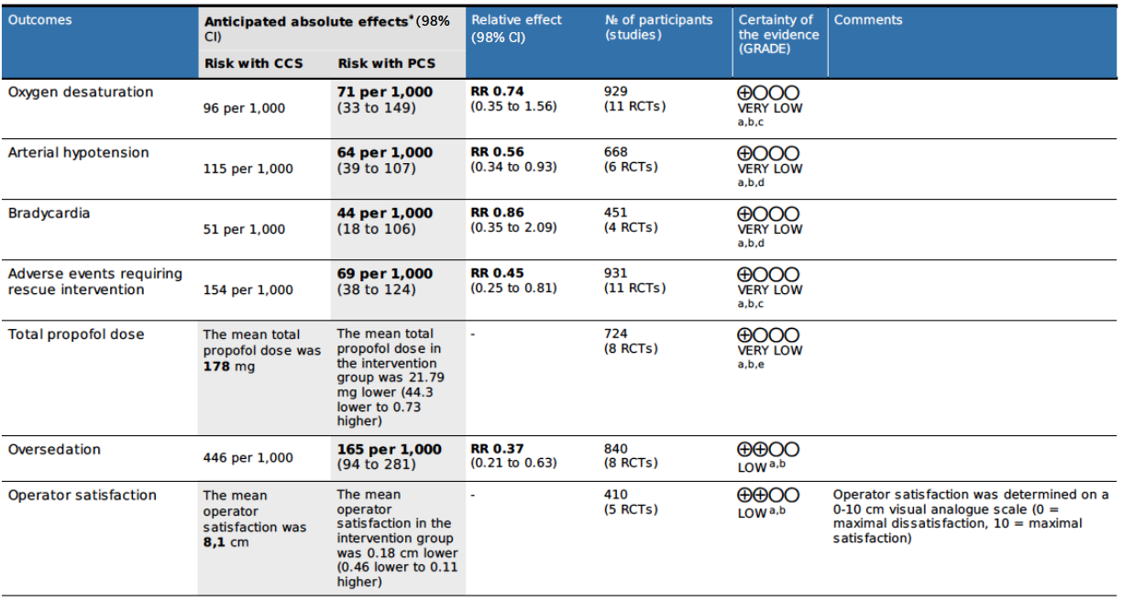
Table F. GRADE summary of findings.

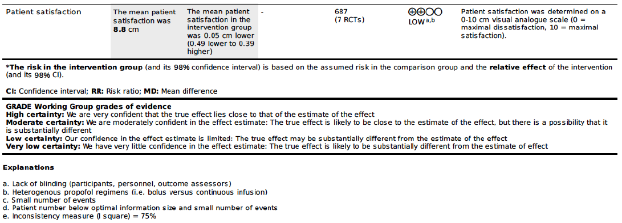

Figure A. Funnel plot for risk of oxygen desaturation. Risk ratio; SE = standard error. Dotted line indicates overall RR for oxygen desaturation (RR = 0.74)

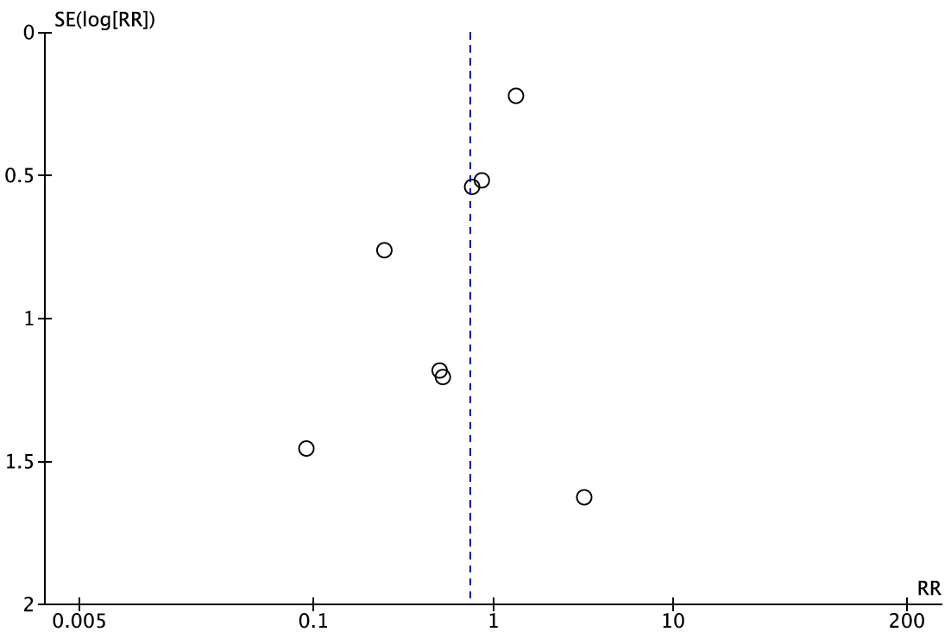

Figure B. Funnel plot for risk of arterial hypotension. RR = risk ratio; SE = standard error. Dotted line indicates overall RR for arterial hypotension (RR = 0.56)

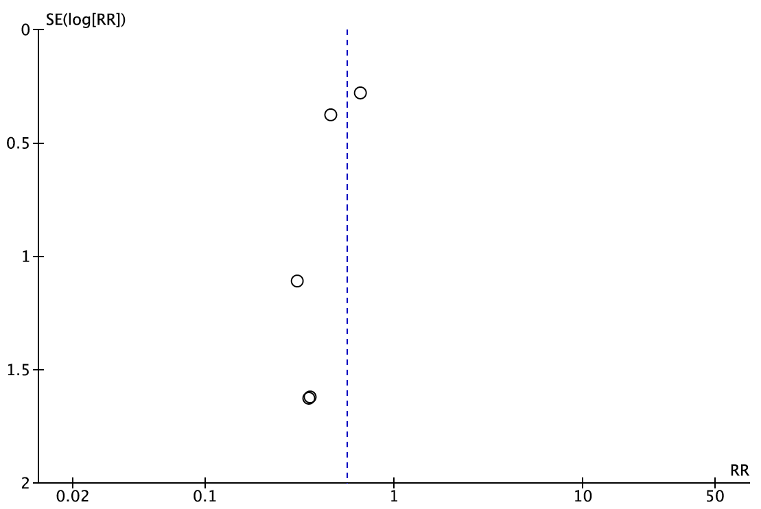

Figure C. Funnel plot for risk of rescue intervention for adverse events. RR = risk ratio; SE = standard error. Dotted line indicates overall RR for rescue intervention for adverse events (RR = 0.45).

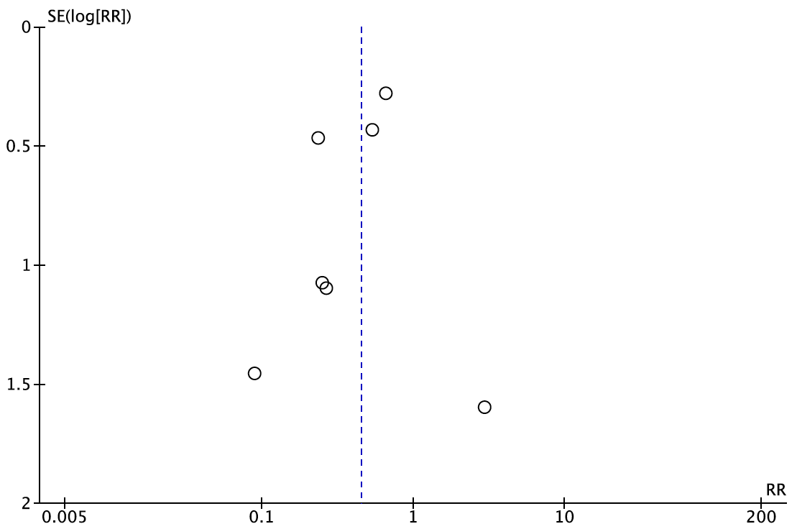

Figure D. Trial sequential analysis for risk of oxygen desaturation. PCS = patient-controlled sedation; CCS = clinician-controlled sedation.

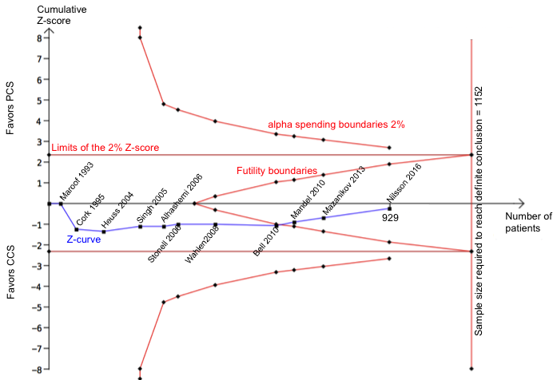

Trial sequential analysis suggests that the required sample size needed to reach a definitive conclusion regarding the capacity of PCS to reduce oxygen desaturation by 50% compared with CCS is 1152 patients, and is therefore not yet reached with 929 patients. However, the cumulative Z-line (in blue) has crossed the line for futility since the Mandel et al. trial in 2010,⁶ suggesting that future trials are unlikely to change our conclusion.

Figure E. Trial sequential analysis for risk of arterial hypotension. PCS = patient-controlled sedation; CCS = clinician-controlled sedation.

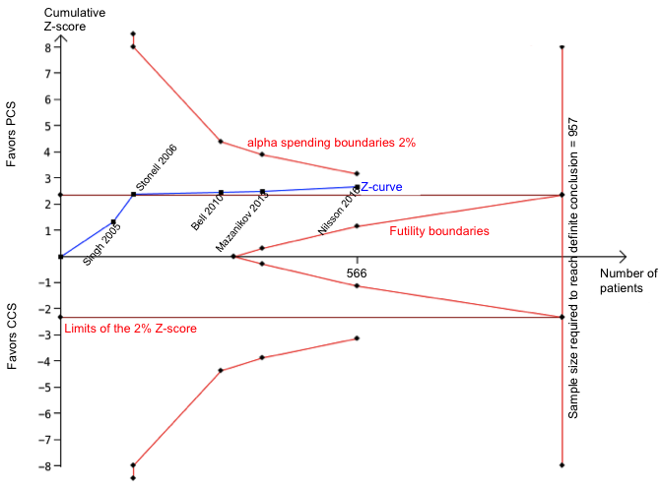

Trial sequential analysis suggests that the sample size required to reach a definitive conclusion on a decrease of 50% in the risk of arterial hypotension using PCS is 957 patients. Therefore, the required sample size is not yet reached with 566 patients, and although the pooled effect from the random effects meta-analysis is statistically significant (blue line crosses the horizontal red line), the Z-curve does not cross the alpha spending boundaries, suggesting that these results may be due to “chance”, and that no definitive conclusion can yet be reached concerning this endpoint.

Figure F. Trial sequential analysis for risk of bradycardia. PCS = patient-controlled sedation; CCS = clinician-controlled sedation.
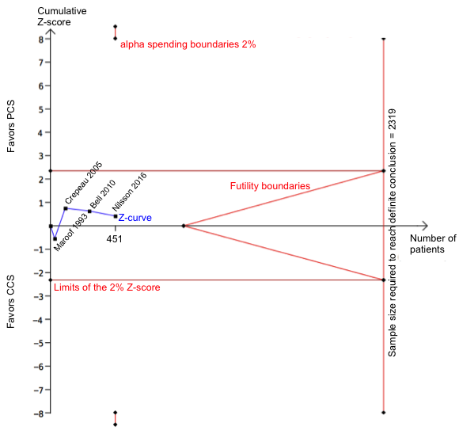

Trial sequential analysis suggests that the sample size required to reach a definitive conclusion on a decrease of 50% in the risk of bradycardia using PCS, is 2319 patients. Therefore, the required sample size is not yet reached with 451 patients. The Z-curve does not cross the alpha spending boundaries and therefore, no definitive conclusion can be reached concerning this endpoint.
Figure G. Trial sequential analysis for risk of rescue intervention for adverse event. PCS = patient-controlled sedation; CCS = clinician-controlled sedation.
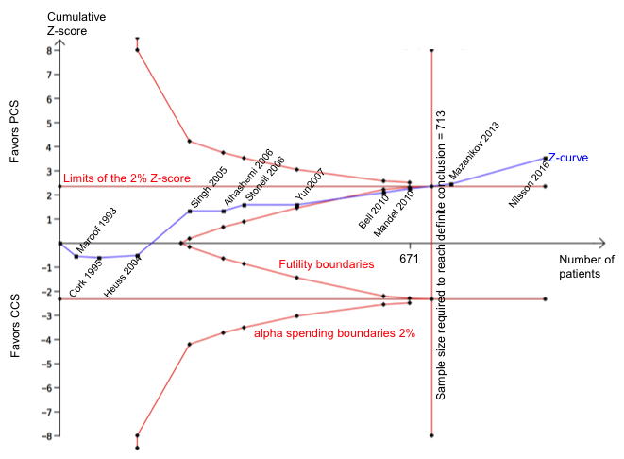
Trial sequential analysis suggests that a sample size of 713 patients is needed to reach a definitive conclusion on a 50% decrease in the risk of requiring a rescue intervention for an adverse event when using PCS compared with CCS. The present analysis has reached the required sample size with 931 patients, suggesting that further trials are unlikely to change our conclusion.

Figure H. Risk of oxygen desaturation. Subgroup analysis for trials with propofol bolus regimen in both PCS and CCS groups. PCS = patient-controlled sedation, CCS = clinician-controlled sedation, CI = confidence interval.

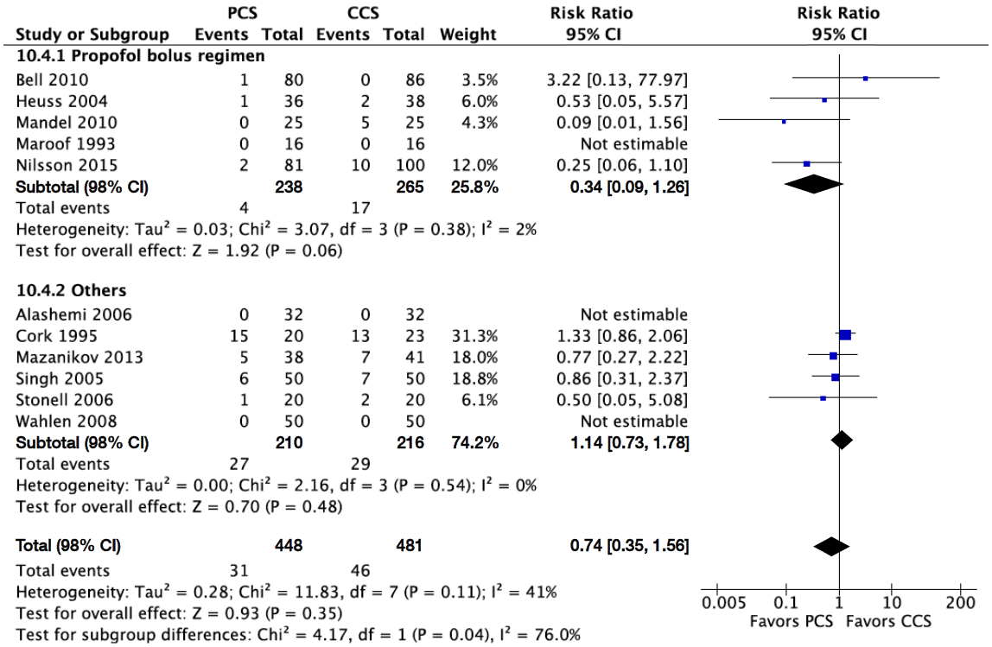

Figure I. Risk of arterial hypotension. Subgroup analysis for trials with propofol bolus regimen in both PCS and CCS groups. PCS = patient-controlled sedation, CCS = clinician-controlled sedation, CI = confidence interval.

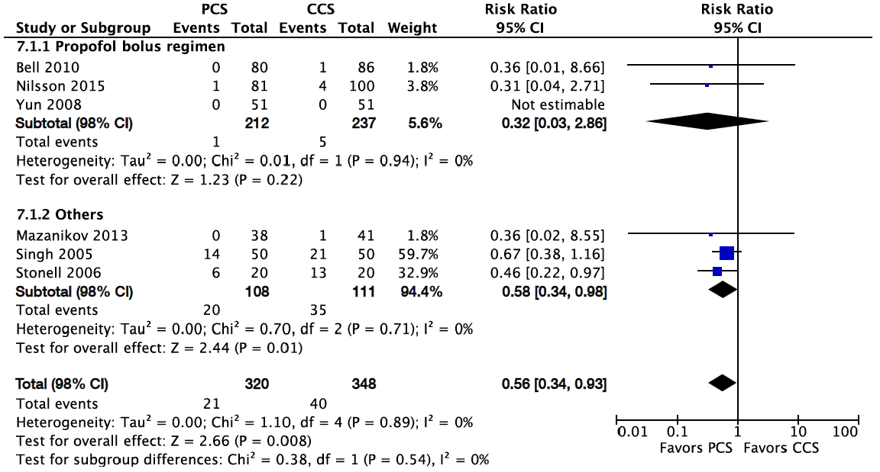

Figure J. Risk of rescue intervention for adverse event. Subgroup analysis for trials with propofol bolus regimen in both PCS and CCS groups. PCS = patient-controlled sedation, CCS = clinician-controlled sedation, CI = confidence interval.

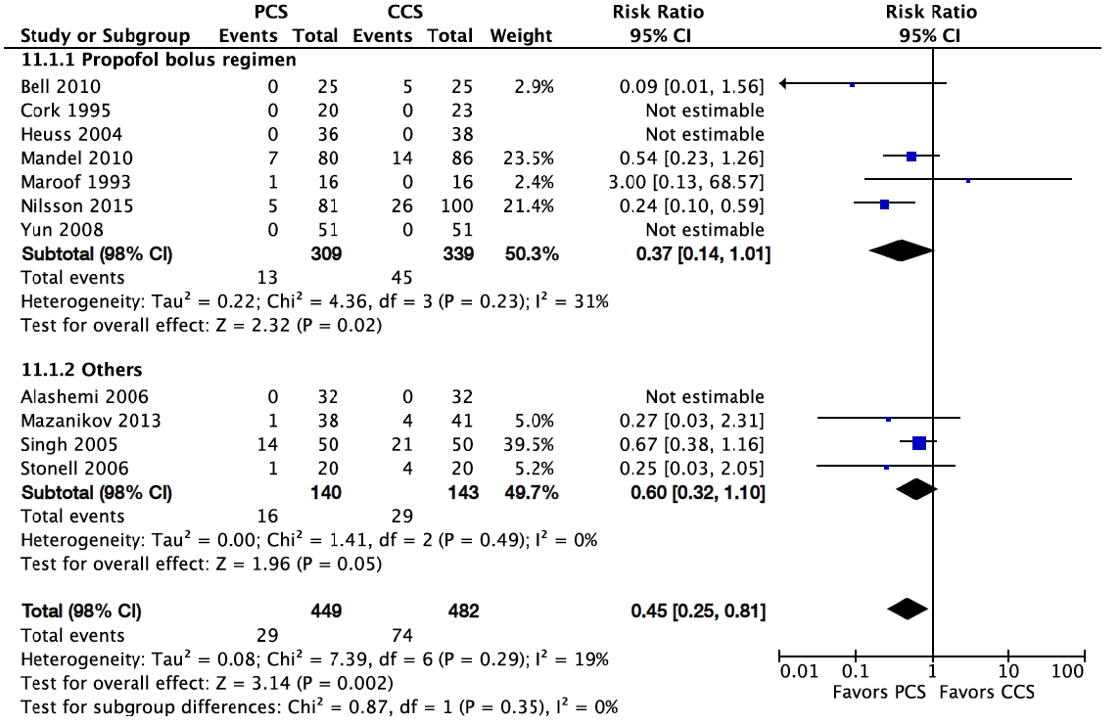

Figure K. Risk of oxygen desaturation. Subgroup analysis for trials with local or locoregional anesthesia. PCS = patient-controlled sedation, CCS = clinician-controlled sedation, CI = confidence interval.

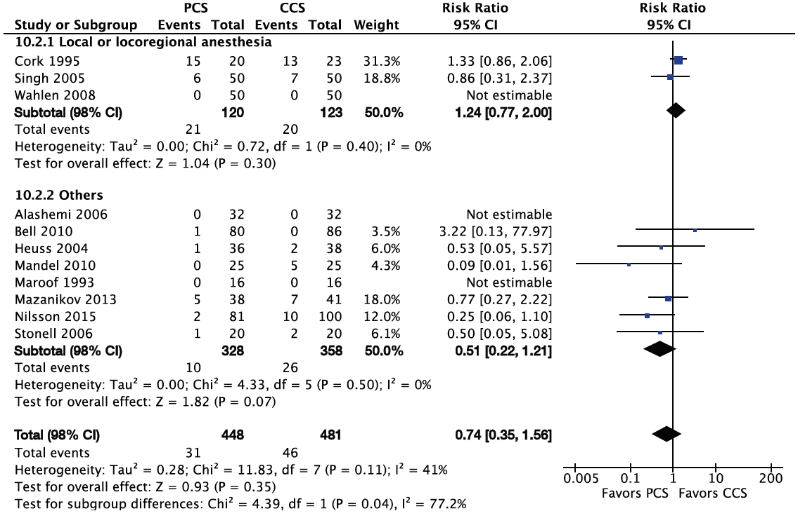

Figure L. Risk of rescue intervention for adverse event. Subgroup analysis for trials with local or locoregional anesthesia. PCS = patient-controlled sedation, CCS = clinician-controlled sedation, CI = confidence interval.

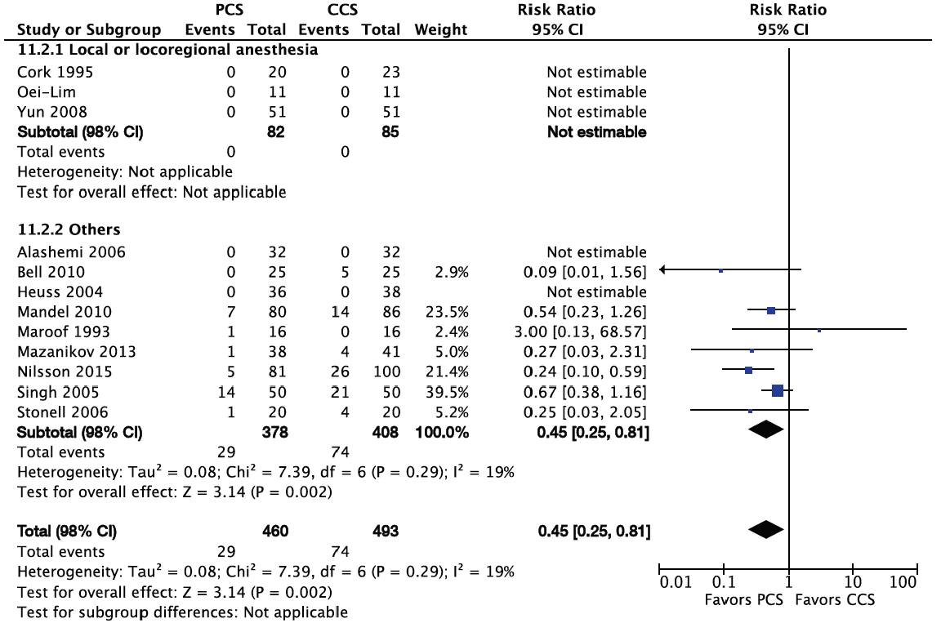

Figure M. Total propofol dose. PCS = patient-controlled sedation, CCS = clinician-controlled sedation, CI = confidence interval, SD = standard deviation.

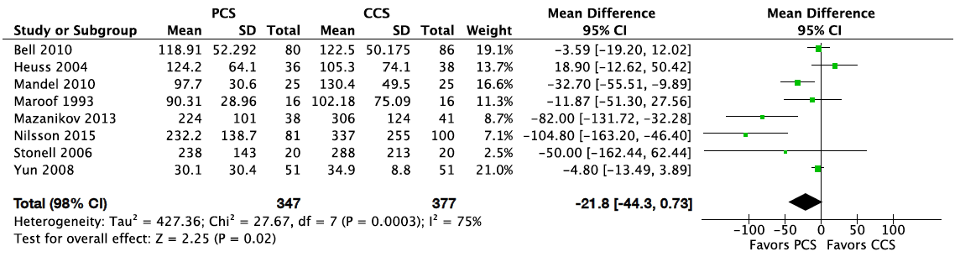

Figure N. Risk of oversedation. PCS = patient-controlled sedation, CCS = clinician-controlled sedation, CI = confidence interval.

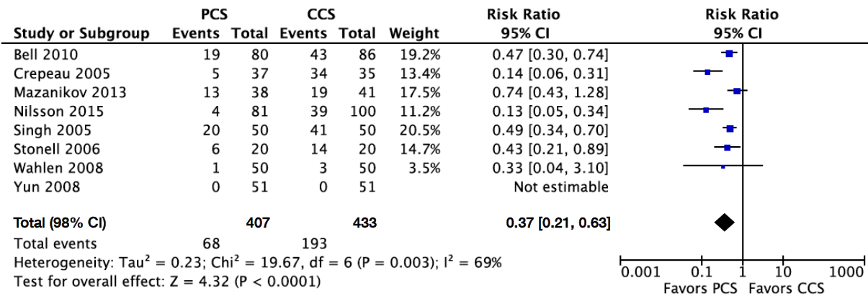

Figure O. Operator satisfaction with sedation. PCS = patient-controlled sedation, CCS = clinician-controlled sedation, CI = confidence interval, SD = standard deviation.

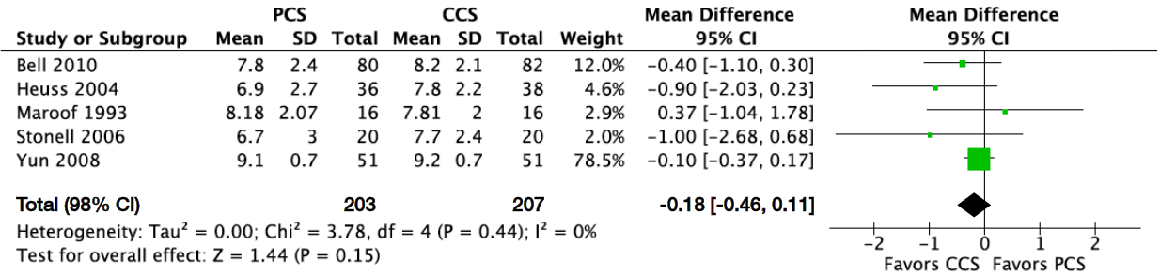

Figure P. Patient satisfaction with sedation. PCS = patient-controlled sedation, CCS = clinician-controlled sedation, CI = confidence interval, SD = standard deviation.

