APPENDIX A

Figure 1. Flow chart of patient enrollment and exclusion in this supplementary analysis.

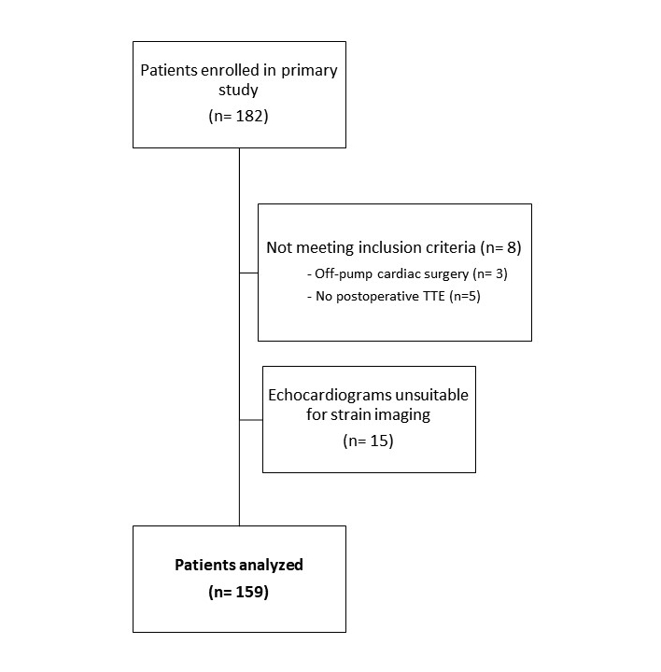
Figure 2. Left ventricular bullseye plots for regional segmental changes from pre-surgical to post-surgical myocardial strain values in patients undergoing combined cardiac surgery (CABG + other valvular surgery). The outer ring represents basal segments, the middle ring represents the mid-papillary segments, and the inner ring represents the apical segments. The last circle represents the true apex. Values in each segment represent the raw mean difference from pre- to postoperative strain values, with standard deviations in parentheses. Shaded areas represent statistically significant decreases in function from pre- to post-surgery (p<0.05). CABG = coronary artery bypass graft.

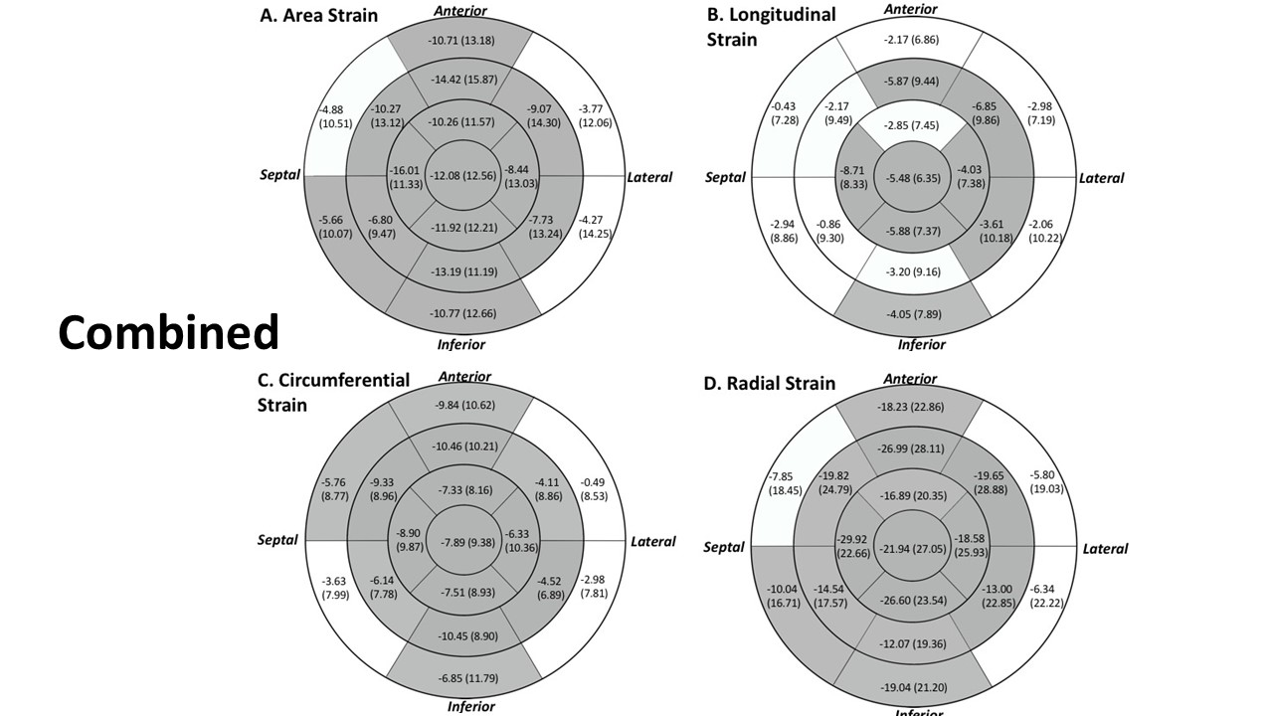
APPENDIX B

Table 1. Segmental Strain Values and Scoring System
 | Segment Classification and Score
 | Normal (0) | Mild-to-moderate (-1) |  | Severe (-2)
Strain Measure
Area | <-25 |  | -19 to -24 | >-18
Longitudinal | <-12 |  | -10 to -11 | >-9
Circumferential | <-16 |  | -12 to -15 | >-11
Radial | <35 |  | 25 to 34 | >24
Each of the 17 segments were scored using the following thresholds. Then, each patient had their scores for area, longitudinal, circumferential, and radial strain summed up for each of the 17 segments for pre-cardiac surgery, post-cardiac surgery, and for the differences between pre- and post. For example, the highest possible score for a particular patient (pre- or post-) would be 0 (all normal function), and the lowest possible score would be -34 (all severe dysfunction).

Table 2. Measures of regional LV function pre- and post-aortic valve replacement
 | Area Strain |  |  |  | Circumferential Strain |  |  |  | Longitudinal Strain |  |  |  |  | Radial Strain
 | Pre | Post |  | Pre |  |  | Post |  | Pre |  | Post |  | Pre |  |  | Post
Global Strain
AVR | -22.29 (7.36) |  | -16.98 (5.72) |  |  | -14.99 (4.68) |  | -10.43 (4.47) | -10.49 (4.38) | -8.91 (3.36) |  | 34.92 (14.28) |  |  | 24.49 (9.53)
Segmental Strain
AVR
Basal anterior | -20.24 (11.78) |  | -16.54 (10.40) |  |  | -16.02 (7.94) |  | -12.92 (7.07) | -8.54 (8.86) | -7.69 (6.47) |  | 29.55 (20.08) |  |  | 22.77 (16.56)
Basal anteroseptal | -17.47 (9.25) |  | -16.34 (9.01) |  |  | -14.63 (6.18) |  | -11.05 (5.57) | -7.39 (5.29) | -8.77 (6.41) |  | 23.74 (14.75) |  |  | 21.75 (13.80)
Basal inferoseptal | -18.42 (9.59) |  | -19.06 (7.57) |  |  | -12.26 (6.07) |  | -11.34 (4.65) | -10.05 (6.37) | -11.46 (5.73) |  | 24.93 (14.60) |  |  | 25.33 (11.60)
Basal inferior | -16.94 (10.92) |  | -14.07 (8.85) |  |  | -11.12 (7.94) |  | -8.90 (6.93) | -9.37 (7.65) | -8.11 (6.37) |  | 23.73 (17.99) |  |  | 18.95 (12.26)
Basal inferolateral | -12.92 (8.90) |  | -14.04 (9.84) |  |  | -11.31 (5.23) |  | -10.54 (5.83) | -6.45 (7.12) | -6.65 (8.54) |  | 17.59 (12.05) |  |  | 18.95 (15.43)
Basal anterolateral | -16.83 (10.49) |  | -17.31 (10.79) |  |  | -14.28 (6.06) |  | -14.52 (7.13) | -6.75 (7.03) | -6.97 (6.94) |  | 24.07 (17.81) |  |  | 26.03 (16.03)
Mid anterior | -23.22 (14.57) |  | -16.62 (8.80) |  |  | -17.47 (9.47) |  | -10.88 (6.65) | -9.49 (8.39) | -8.62 (7.07) |  | 35.41 (28.96) |  |  | 22.04 (13.91)
Mid anteroseptal | -26.48 (12.62) |  | -21.45 (11.41) |  |  | -17.43 (7.65) |  | -11.55 (7.19) | -13.40 (8.70) | -13.21 (7.30) |  | 41.49 (27.23) |  |  | 30.68 (19.76)
Mid inferoseptal | -28.06 (7.95) |  | -25.54 (10.24) |  |  | -16.13 (5.88) |  | -12.70 (7.01) | -16.71 (5.70) | -17.09 (6.91) |  | 41.42 (14.78) |  |  | 37.35 (18.93)
Mid inferior | -25.81 (9.92) |  | -19.09 (9.90) |  |  | -15.05 (7.40) |  | -9.41 (7.40) | -14.66 (6.46) | -13.53 (6.22) |  | 38.32 (18.36) |  |  | 26.40 (16.25)
Mid inferolateral | -21.81 (10.51) |  | -15.94 (9.58) |  |  | -13.86 (5.96) |  | -11.00 (6.08) | -11.36 (7.88) | -7.79 (7.33) |  | 31.49 (18.89) |  |  | 21.36 (14.16)
Mid anterolateral | -22.03 (11.49) |  | -18.70 (10.07) |  |  | -16.97 (6.09) |  | -15.16 (6.52) | -9.89 (7.94) | -7.43 (6.99) |  | 33.22 (20.57) |  |  | 26.49 (16.94)
Apical anterior | -20.88 (14.14) |  | -14.32 (7.30) |  |  | -15.32 (9.54) |  | -9.30 (7.04) | -8.83 (7.25) | -7.91 (4.08) |  | 33.51 (27.47) |  |  | 19.57 (11.24)
Apical septal | -30.43 (11.53) |  | -21.06 (12.28) |  |  | -17.68 (8.20) |  | -13.03 (8.90) | -18.20 (6.66) | -12.09 (6.75) |  | 50.32 (23.82) |  |  | 31.16 (21.97)
Apical inferior | -32.98 (11.82) |  | -20.80 (11.33) |  |  | -17.86 (9.40) |  | -10.79 (7.59) | -20.00 (6.11) | -14.03 (6.10) |  | 57.92 (28.81) |  |  | 30.81 (20.40)
Apical lateral | -27.13 (9.67) |  | -21.62 (9.97) |  |  | -18.32 (6.23) |  | -13.85 (7.18) | -12.90 (6.62) | -10.80 (5.16) |  | 43.30 (20.36) |  |  | 32.84 (18.41)
Apex | -26.84 (14.21) |  | -14.82 (10.48) |  |  | -16.65 (9.56) |  | -8.95 (6.48) | -16.69 (8.01) | -9.90 (6.49) |  | 56.09 (34.29) |  |  | 28.43 (22.75)

Table 3. Measures of regional LV function pre- and post-mitral valve repair or replacement
 | Area Strain |  |  |  | Circumferential Strain |  |  |  |  |  | Longitudinal Strain |  |  |  |  | Radial Strain
 | Pre | Post |  | Pre |  |  |  | Post |  | Pre |  |  | Post |  | Pre |  |  | Post
Global Strain
MVR | -30.08 (7.45) |  | -19.77 (6.87) |  |  | -19.41 (4.13) | -11.98 (4.68) |  | -15.33 (5.58) |  |  | -10.56 (4.12) |  | 51.39 (16.89) |  |  | 29.34 (12.10)
Segmental Strain
MVR
Basal anterior | -28.29 (13.83) |  | -18.72 (10.81) |  |  | -20.95 (8.22) | -13.04 (7.85) |  | -13.20 (9.88) |  |  | -9.57 (6.96) |  | 46.76 (29.96) |  |  | 26.69 (19.58)
Basal anteroseptal | -25.33 (11.90) |  | -18.50 (9.90) |  |  | -19.86 (6.96) | -13.84 (6.30) |  | -10.47 (8.84) |  |  | -8.21 (6.14) |  | 39.37 (24.12) |  |  | 25.48 (16.23)
Basal inferoseptal | -24.89 (9.67) |  | -20.90 (9.09) |  |  | -16.54 (6.88) | -13.28 (6.60) |  | -12.42 (7.42) |  |  | -11.74 (5.83) |  | 36.70 (18.31) |  |  | 28.94 (15.17)
Basal inferior | -23.53 (10.08) |  | -15.68 (10.31) |  |  | -16.62 (6.45) | -9.20 (6.84) |  | -11.04 (7.59) |  |  | -10.09 (7.15) |  | 35.21 (18.84) |  |  | 21.37 (15.22)
Basal inferolateral | -17.93 (12.06) |  | -17.33 (9.56) |  |  | -12.97 (6.90) | -11.97 (6.58) |  | -9.69 (9.18) |  |  | -9.33 (7.24) |  | 25.61 (19.13) |  |  | 24.22 (15.77)
Basal anterolateral | -24.86 (12.14) |  | -22.48 (9.52) |  |  | -17.49 (7.30) | -15.37 (7.33) |  | -13.11 (9.32) |  |  | -10.91 (7.63) |  | 40.92 (24.67) |  |  | 33.87 (17.56)
Mid anterior | -35.13 (12.55) |  | -20.40 (11.06) |  |  | -23.51 (7.00) | -11.53 (7.41) |  | -17.32 (9.81) |  |  | -11.50 (8.08) |  | 60.77 (29.48) |  |  | 29.01 (19.11)
Mid anteroseptal | -35.37 (12.72) |  | -25.05 (12.88) |  |  | -22.94 (7.42) | -13.34 (7.76) |  | -18.52 (8.60) |  |  | -15.43 (8.52) |  | 61.83 (31.74) |  |  | 38.39 (25.46)
Mid inferoseptal | -34.14 (9.06) |  | -27.67 (10.18) |  |  | -20.28 (5.93) | -13.97 (7.89) |  | -19.50 (7.32) |  |  | -18.10 (6.80) |  | 56.21 (19.87) |  |  | 41.78 (21.01)
Mid inferior | -34.18 (11.81) |  | -22.64 (10.17) |  |  | -22.01 (7.41) | -12.28 (6.03) |  | -17.76 (8.30) |  |  | -13.79 (7.15) |  | 59.00 (27.32) |  |  | 32.45 (18.07)
Mid inferolateral | -27.49 (11.13) |  | -19.47 (10.84) |  |  | -16.71 (6.21) | -12.96 (6.72) |  | -14.94 (9.44) |  |  | -9.40 (7.61) |  | 42.34 (21.90) |  |  | 27.78 (18.23)
Mid anterolateral | -28.34 (12.97) |  | -21.36 (10.16) |  |  | -19.70 (7.59) | -14.68 (7.37) |  | -13.79 (10.56) |  |  | -10.28 (6.92) |  | 47.59 (28.71) |  |  | 31.13 (18.12)
Apical anterior | -29.10 (12.49) |  | -14.98 (9.63) |  |  | -19.38 (7.72) | -8.82 (6.55) |  | -14.29 (7.71) |  |  | -8.48 (6.28) |  | 47.56 (26.11) |  |  | 20.95 (16.46)
Apical septal | -39.21 (9.22) |  | -22.41 (12.80) |  |  | -22.24 (6.52) | -13.67 (9.10) |  | -23.89 (6.77) |  |  | -12.82 (6.78) |  | 71.57 (26.23) |  |  | 34.17 (24.81)
Apical inferior | -38.94 (10.97) |  | -25.37 (11.02) |  |  | -22.12 (7.76) | -13.81 (7.38) |  | -23.23 (7.20) |  |  | -15.28 (6.92) |  | 73.94 (28.36) |  |  | 39.13 (21.64)
Apical lateral | -30.01 (12.93) |  | -21.87 (12.21) |  |  | -19.79 (9.60) | -14.30 (8.62) |  | -15.50 (7.11) |  |  | -11.35 (7.56) |  | 51.92 (26.29) |  |  | 33.66 (22.70)
Apex | -29.30 (10.76) |  | -15.16 (9.70) |  |  | -16.92 (7.64) | -9.84 (6.35) |  | -18.95 (6.16) |  |  | -9.44 (6.07) |  | 58.23 (28.21) |  |  | 28.73 (19.20)

Table 4. Measures of regional LV function pre- and post-coronary artery bypass graft
 | Area Strain |  |  |  | Circumferential Strain |  |  |  | Longitudinal Strain |  |  |  |  | Radial Strain
 | Pre | Post |  | Pre |  |  | Post | Pre |  |  | Post |  | Pre |  |  | Post
Global Strain
CABG | -23.82 (5.95) |  | -16.85 (6.68) |  |  | -15.60 (3.89) | -10.79 (4.51) | -11.66 (3.83) |  | -8.47 (3.60) |  | 36.82 (12.20) |  |  | 23.71 (10.80)
Segmental Strain
CABG
Basal anterior | -22.66 (9.11) |  | -15.08 (9.07) |  |  | -15.98 (6.65) | -10.94 (7.20) | -11.68 (7.54) |  | -7.74 (5.44) |  | 32.27 (15.92) |  |  | 20.24 (14.14)
Basal anteroseptal | -19.88 (10.08) |  | -16.11 (9.84) |  |  | -16.30 (6.73) | -11.84 (6.85) | -8.29 (6.77) |  | -7.92 (5.96) |  | 27.87 (16.91) |  |  | 21.93 (14.12)
Basal inferoseptal | -20.43 (8.97) |  | -19.17 (8.40) |  |  | -14.78 (6.73) | -12.25 (5.90) | -10.50 (5.27) |  | -10.33 (5.72) |  | 27.97 (14.68) |  |  | 25.86 (12.54)
Basal inferior | -17.92 (8.95) |  | -15.88 (8.92) |  |  | -12.32 (6.71) | -9.52 (5.56) | -9.27 (6.17) |  | -9.17 (6.86) |  | 24.26 (14.04) |  |  | 20.95 (13.19)
Basal inferolateral | -16.35 (9.50) |  | -15.34 (8.52) |  |  | -12.41 (5.51) | -11.02 (5.62) | -8.44 (6.62) |  | -7.75 (6.30) |  | 22.09 (14.55) |  |  | 20.43 (12.79)
Basal anterolateral | -18.65 (8.92) |  | -18.14 (9.35) |  |  | -15.31 (5.62) | -13.77 (6.94) | -8.82 (7.01) |  | -8.38 (6.03) |  | 27.38 (14.88) |  |  | 25.83 (14.84)
Mid anterior | -24.59 (12.23) |  | -14.72 (10.23) |  |  | -17.89 (7.73) | -9.68 (6.73) | -10.80 (7.88) |  | -7.80 (5.97) |  | 37.26 (23.62) |  |  | 19.88 (16.53)
Mid anteroseptal | -27.47 (12.15) |  | -18.41 (11.15) |  |  | -18.29 (8.17) | -11.05 (6.93) | -13.65 (7.53) |  | -10.26 (6.59) |  | 43.01 (25.39) |  |  | 26.12 (18.06)
Mid inferoseptal | -28.16 (7.44) |  | -25.09 (9.71) |  |  | -16.47 (5.73) | -12.93 (7.15) | -17.02 (5.21) |  | -16.80 (5.54) |  | 41.50 (14.89) |  |  | 36.08 (17.19)
Mid inferior | -26.19 (8.39) |  | -19.65 (7.96) |  |  | -15.18 (6.05) | -10.15 (5.81) | -14.60 (6.18) |  | -13.16 (5.86) |  | 38.62 (16.15) |  |  | 26.55 (12.64)
Mid inferolateral | -23.11 (8.55) |  | -17.39 (10.71) |  |  | -15.25 (4.72) | -12.78 (6.53) | -11.41 (6.98) |  | -7.73 (6.97) |  | 32.70 (16.18) |  |  | 24.16 (16.49)
Mid anterolateral | -24.77 (8.93) |  | -20.31 (10.32) |  |  | -18.86 (5.30) | -16.20 (7.81) | -10.46 (7.38) |  | -7.36 (6.93) |  | 36.92 (18.82) |  |  | 29.01 (17.67)
Apical anterior | -22.40 (14.36) |  | -11.90 (10.53) |  |  | -15.57 (9.48) | -8.14 (7.15) | -10.23 (7.78) |  | -5.94 (5.43) |  | 35.35 (28.20) |  |  | 16.36 (16.18)
Apical septal | -30.38 (11.84) |  | -16.81 (12.23) |  |  | -16.23 (8.24) | -10.15 (8.09) | -19.38 (6.95) |  | -9.76 (6.44) |  | 50.50 (27.15) |  |  | 24.67 (20.31)
Apical inferior | -33.46 (9.78) |  | -22.84 (9.51) |  |  | -17.80 (7.46) | -12.90 (5.81) | -20.58 (5.94) |  | -13.44 (6.89) |  | 56.54 (23.47) |  |  | 33.30 (17.14)
Apical lateral | -29.07 (9.83) |  | -23.70 (10.30) |  |  | -19.11 (7.91) | -15.48 (8.29) | -14.13 (5.96) |  | -11.26 (6.14) |  | 46.78 (20.35) |  |  | 35.93 (19.62)
Apex | -25.13 (13.15) |  | -13.77 (11.57) |  |  | -15.07 (8.42) | -8.77 (7.33) | -16.00 (7.40) |  | -8.68 (6.92) |  | 49.53 (33.48) |  |  | 27.25 (23.74)

Table 5. Measures of regional LV function pre- and post-combined cardiac surgery
 | Area Strain |  |  | Circumferential Strain |  |  |  |  | Longitudinal Strain |  |  |  | Radial Strain
 | Pre | Post |  | Pre |  |  | Post |  | Pre |  | Post |  | Pre |  | Post
Global Strain
Combined | -26.55 (7.13) |  | -15.63 (6.15) |  | -16.62 (5.02) | -8.85 (4.57) |  | -13.60 (4.27) |  | -9.07 (3.95) |  | 41.66 (13.31) |  | 22.25 (9.84)
Segmental Strain
Combined
Basal anterior | -26.41 (10.64) |  | -15.38 (11.75) |  | -19.04 (7.08) | -9.75 (8.58) |  | -11.54 (7.68) |  | -8.85 (6.49) |  | 40.07 (22.08) |  | 21.35 (18.06)
Basal anteroseptal | -23.31 (11.57) |  | -18.44 (10.55) |  | -16.04 (7.87) | -10.24 (7.21) |  | -11.38 (7.85) |  | -11.81 (5.77) |  | 34.15 (19.31) |  | 26.31 (17.42)
Basal inferoseptal | -21.92 (8.70) |  | -16.28 (7.89) |  | -13.95 (5.81) | -10.16 (5.82) |  | -12.17 (7.52) |  | -9.48 (5.52) |  | 31.09 (15.32) |  | 21.20 (11.86)
Basal inferior | -22.54 (11.34) |  | -11.24 (8.75) |  | -14.77 (7.28) | -7.52 (6.50) |  | -11.27 (8.50) |  | -6.46 (5.31) |  | 33.48 (19.96) |  | 12.99 (10.33)
Basal inferolateral | -18.44 (10.33) |  | -14.17 (10.29) |  | -12.85 (6.33) | -9.87 (6.41) |  | -9.31 (7.76) |  | -7.17 (6.92) |  | 25.57 (15.23) |  | 19.23 (15.34)
Basal anterolateral | -22.67 (9.03) |  | -18.77 (9.96) |  | -17.12 (6.17) | -16.27 (7.05) |  | -9.66 (7.51) |  | -6.92 (6.73) |  | 34.20 (15.91) |  | 28.37 (16.46)
Mid anterior | -30.82 (11.80) |  | -16.74 (10.00) |  | -19.80 (8.36) | -9.57 (6.03) |  | -15.44 (7.50) |  | -9.57 (7.04) |  | 48.83 (22.63) |  | 22.64 (15.61)
Mid anteroseptal | -30.26 (11.40) |  | -19.99 (10.92) |  | -18.64 (7.43) | -9.31 (6.53) |  | -15.99 (7.57) |  | -13.81 (7.78) |  | 47.85 (23.19) |  | 28.03 (19.62)
Mid inferoseptal | -29.95 (8.10) |  | -23.15 (9.32) |  | -16.51 (6.32) | -10.37 (6.19) |  | -18.42 (5.97) |  | -17.56 (7.37) |  | 45.47 (17.55) |  | 30.93 (18.16)
Mid inferior | -31.27 (9.42) |  | -18.07 (6.81) |  | -18.58 (7.66) | -7.79 (5.24) |  | -17.66 (5.98) |  | -14.45 (6.23) |  | 49.55 (21.51) |  | 22.95 (10.86)
Mid inferolateral | -26.03 (8.20) |  | -18.30 (9.03) |  | -14.92 (4.59) | -10.40 (6.33) |  | -14.48 (6.91) |  | -10.87 (7.04) |  | 37.55 (13.97) |  | 24.56 (15.19)
Mid anterolateral | -28.60 (11.04) |  | -20.02 (8.08) |  | -18.58 (7.84) | -14.75 (7.27) |  | -14.63 (7.45) |  | -8.07 (5.77) |  | 45.40 (21.97) |  | 26.67 (14.38)
Apical anterior | -21.59 (11.43) |  | -12.01 (8.57) |  | -14.60 (7.65) | -7.66 (6.12) |  | -10.26 (6.53) |  | -7.40 (5.30) |  | 31.99 (20.21) |  | 16.19 (12.99)
Apical septal | -30.45 (10.46) |  | -14.44 (7.16) |  | -17.47 (8.65) | -8.57 (7.11) |  | -17.95 (5.95) |  | -9.24 (5.84) |  | 48.66 (21.93) |  | 18.74 (11.02)
Apical inferior | -33.47 (9.88) |  | -21.55 (9.40) |  | -18.34 (6.82) | -10.83 (6.87) |  | -20.40 (6.06) |  | -14.51 (5.61) |  | 56.55 (24.64) |  | 30.98 (16.77)
Apical lateral | -30.75 (12.58) |  | -22.32 (10.50) |  | -19.75 (10.19) | -13.43 (7.66) |  | -16.08 (5.96) |  | -12.05 (5.41) |  | 51.76 (26.44) |  | 33.18 (18.84)
Apex | -23.26 (13.49) |  | -11.18 (7.69) |  | -14.67 (8.53) | -6.78 (4.70) |  | -13.81 (7.87) |  | -8.33 (5.67) |  | 43.55 (28.15) |  | 21.61 (13.87)

Howard-Quijano K, Salem A, Barkulis C, et al. Preoperative Three-Dimensional Strain Imaging Identifies Reduction in Left Ventricular Function and Predicts Outcomes After Cardiac Surgery. Anesth Analg. 2017;124(2):419-428.
Howard-Quijano K, Salem A, Barkulis C, et al. Preoperative Three-Dimensional Strain Imaging Identifies Reduction in Left Ventricular Function and Predicts Outcomes After Cardiac Surgery. Anesth Analg. 2017;124(2):419-428.
Howard-Quijano K, Salem A, Barkulis C, et al. Preoperative Three-Dimensional Strain Imaging Identifies Reduction in Left Ventricular Function and Predicts Outcomes After Cardiac Surgery. Anesth Analg. 2017;124(2):419-428.
Howard-Quijano K, Salem A, Barkulis C, et al. Preoperative Three-Dimensional Strain Imaging Identifies Reduction in Left Ventricular Function and Predicts Outcomes After Cardiac Surgery. Anesth Analg. 2017;124(2):419-428.
Howard-Quijano K, Salem A, Barkulis C, et al. Preoperative Three-Dimensional Strain Imaging Identifies Reduction in Left Ventricular Function and Predicts Outcomes After Cardiac Surgery. Anesth Analg. 2017;124(2):419-428.

