Hypertonic Saline in Human Sepsis:
A Systematic Review of Randomized Controlled Trials
Electronic supplementary material (ESM)
Diego Orbegozo, Jean-Louis Vincent, Jacques Creteur, Fuhong Su
Department of Intensive Care, Erasme University Hospital, Université Libre de Bruxelles, Brussels, Belgium

Figure S1. Study selection.

Figure S2. Forest plots of studies reporting administered fluid volumes when analyzed by subgroups comparing hypertonic saline (HS) vs normal saline (NS) or HS+hydroxyethyl starch (HES) vs HES.

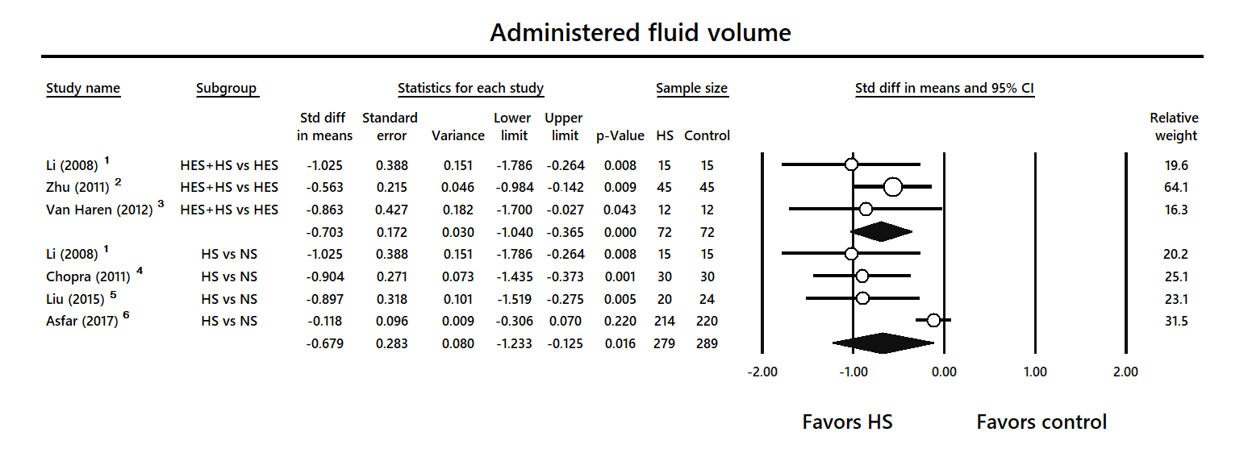

Figure S3. Funnel plot for studies reporting administered fluid volumes. Open circles represent published studies identified by our review, and filled circles represent imputed studies using Duval and Tweedie’s trim and fill methodology. The open diamond represents the estimated global effect considering only published studies, and the filled diamond represents the estimated global effect considering also the imputed studies.

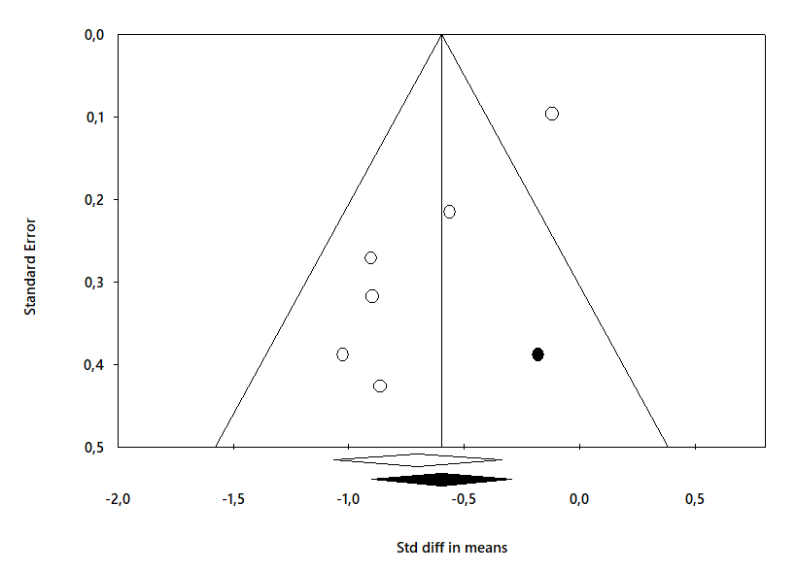

Figure S4. Forest plots of studies reporting mortality when analyzed by subgroups comparing hypertonic saline (HS) vs normal saline (NS) or HS+hydroxyethyl starch (HES) vs HES

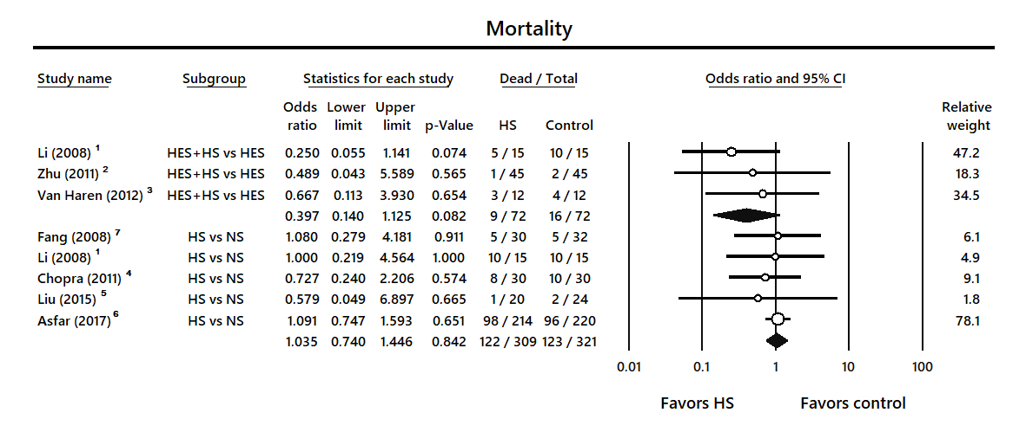

Figure S5. Funnel plot for studies reporting mortality. Open circles represent published studies found in our review, and filled circles represent imputed studies using Duval and Tweedie’s trim and fill methodology. The open diamond represents the estimated global effect considering only published studies, and the filled diamond represents the estimated global effect considering also the imputed studies.

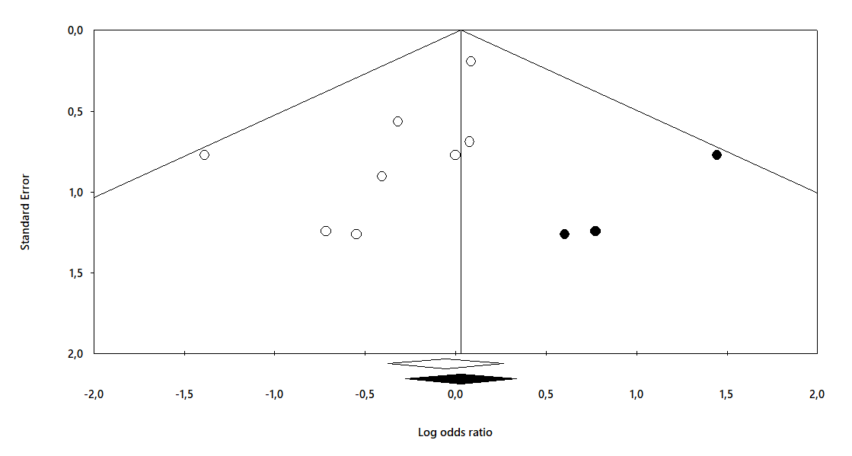

Table S1. Summary of results from studies with only one cohort
Author,  Year | Country, number of centers | Population | Exclusion criteria | Groups | HS Dose | Main focus | Main results
Muller,  2004⁸ | France,  1 | Adults with severe sepsis or septic shock + PAC + need for volume expansion | Na <130 or >145 mmol/L, renal replacement therapy, heart failure NYHA III or IV, PAOP >18, expected early death, cerebral pathologies | HS 7.5%  N=12 | 250 ml  in 15 min | Hemodynamics | PAOP and CO increased after HS bolus.  There were no changes in MAP, HR or CVP.
Siami,  2010⁹ | France,  2 | Adults with septic shock > 72 hours + vasopressors | Vasopressin use, neuroendocrine disease, neurosurgical patients, Na <130 or >140 mmol/L, CVP > 18 mmHg, severe heart failure | HS 5%  N=33 | 7.2 ml/Kg/h  in 2 h | Osmoregulation | Responders (N=16) increased AVP levels 6.2 pg/mL/hour.  Non-responders (N=17) increased AVP levels 0.7 pg/mL/hour.
Ding,  2012¹⁰ | China,  1 | Adults with sepsis | Pregnancy, psychological diseases | HS 5%  N=24 | NA | Immune system | Respiratory burst of PMN increased.  CD11b and L-selectin expression in PMN was reduced,  TNF-alpha decreased, IL-1beta did not change, IL-6 and sICAM-1 increased.
Siami,  2013¹¹ | France,  2 | Adults with septic shock 5 days after vasopressors discontinued | Vasopressin use, neuroendocrine disease, neurosurgical patients, Na <130 or >140 mmol/L, CVP > 18 mmHg, severe heart failure | HS 5%  N=30 | 7.2 ml/Kg/h  in 2 h | Osmoregulation | Responders (N=12) had ΔAVP/ΔNa > 0.5 pg/mmol.  Non-responders (N=18) had ΔAVP/ΔNa ≤ 0.5 pg/mmol.  Baseline AVP similar between two groups  Changes in Na, HR, SAP, MAP, and plasma BNP similar
Zhou,  2014¹² | China,  1 | Adults with septic shock | Shock time < 24 hrs, vasopressin use, Na ≥ 150 mmol/L | HS 3%  N=55 | 600 ml  in 2 h | Osmoregulation | Non-responders (N=30) had ΔAVP/ΔNa ≤ 0.5 pg/mmol.  Responders (N=25) had ΔAVP/ΔNa > 0.5 pg/mmol.  Non-responders had lower AVP at baseline  Non-responders had longer ICU stay and higher 28-day mortality.
PAC: pulmonary artery catheter; Na: sodium; NYHA: New York Heart Association; PAOP; pulmonary artery occlusion pressure; CVP: central venous pressure; HS: hypertonic saline; N: number of patients; CO: cardiac output; MAP: mean arterial pressure; SAP: systolic arterial pressure; HR: heart rate; AVP: arginine vasopressin; PMN: polymorphonuclear cell; CD: cluster of differentiation: TNF: tumor necrosis factor; IL: interleukin; sICAM: soluble intercellular adhesion molecule; Δ: change; BNP: brain natriuretic peptide; ICU: intensive care unit; NA: data not available.

References

- Li F, Sun H, Han XD. [The effect of different fluids on early fluid resuscitation in septic shock]. Zhongguo Wei Zhong Bing Ji Jiu Yi Xue 2008; 20:472-5.
- Zhu GC, Quan ZY, Shao YS, Zhao JG, Zhang YT. [The study of hypertonic saline and hydroxyethyl starch treating severe sepsis]. Zhongguo Wei Zhong Bing Ji Jiu Yi Xue 2011; 23:150-3.
- van Haren FM, Sleigh J, Boerma EC, et al. Hypertonic fluid administration in patients with septic shock: a prospective randomized controlled pilot study. Shock 2012; 37:268-75.
- Chopra A, Kumar V, Dutta A. Hypertonic versus normal saline as initial fluid bolus in pediatric septic shock. Indian J Pediatr 2011; 78:833-7.
- Liu S, Ren X, Gun L, Zhang Q, Zhang J, Zhu Y. [Effect of 3% hypertonic saline as early fluid resuscitation in pediatric septic shock]. Zhonghua Er Ke Za Zhi 2015; 53:599-604.
- Asfar P, Schortgen F, Boisrame-Helms J, et al. Hyperoxia and hypertonic saline in patients with septic shock (HYPERS2S): a two-by-two factorial, multicentre, randomised, clinical trial. Lancet Respir Med 2017; 5:180-90.
- Fang ZX, Li YF, Zhou XQ, et al. Effects of resuscitation with crystalloid fluids on cardiac function in patients with severe sepsis. BMC Infect Dis 2008; 8:50.
- Muller L, Lefrant JY, Jaber S, et al. [Short term effects of hypertonic saline during severe sepsis and septic shock]. Ann Fr Anesth Reanim 2004; 23:575-80.
- Siami S, Bailly-Salin J, Polito A, et al. Osmoregulation of vasopressin secretion is altered in the postacute phase of septic shock. Crit Care Med 2010; 38:1962-9.
- Ding WW, Li WQ, Tong ZH, Li N, Li JS. [The immunomodulatory effects of hypertonic saline on sepsis patients]. Zhongguo Wei Zhong Bing Ji Jiu Yi Xue 2012; 24:465-9.
- Siami S, Polito A, Porcher R, et al. Thirst perception and osmoregulation of vasopressin secretion are altered during recovery from septic shock. PLoS One 2013; 8:e80190.
- Zhou Q, Yang X, Sun J, Wang C, Li D. [Prognostic value of decreased vasopressin modulation in the late-phase of septic shock patients]. Zhonghua Wei Zhong Bing Ji Jiu Yi Xue 2014; 26:706-9.

