**Online Supplement**

This supplement contains 6 text sections:

Section 1: Postoperative measurements

Section 2: Postoperative TOF monitoring

Section 3: Anesthesia Information Management System

Section 4: Covariates with the highest impact on the adjusted effect of PRNB on hospital costs

Section 5: Covariates in confounder model for ICU admission

Section 6: Model description and rationale for using negative binomial regression for the primary analysis to assess for the effect of PRNB on hospital costs

Section 7: Outliers in primary regression model

1. Postoperative measurements

The anesthesia plan was at the discretion of the anesthesia provider who was not involved in this study. We performed standard anesthesia monitoring (i.e., pulse oximetry, electrocardiogram, oscillometric arterial blood pressure, and end-tidal carbon dioxide concentration). Peripheral nerve stimulators which were capable of delivering TOF stimuli for qualitative neuromuscular monitoring were available in each operating room. Anesthesia providers were familiar with operating these devices for monitoring of neuromuscular transmission. If not available in the operating room, quantitative neuromuscular monitors were available upon request. At extubation, we delivered 6 liters of oxygen to patients via facemask. In the PACU, oxygen titration and standard recovery room monitoring was performed by registered nurses.

1. Postoperative TOF monitoring

Within 10 min of PACU admission, we performed acceleromyography of the adductor pollicis muscle using a quantitative TOF monitor, i.e., the standard method to clinically diagnose PRNMB, although supramaximal stimulation (50 mA) is recommended to obtain the maximum muscle response. Ensuring the orientation of the electrode was perpendicular with the thumb trajectory on stimulation of adductor pollicis, the transducer was connected to the hand adapter with the flat side on the thumb. At the distal part of the forearm, we placed two surface electrodes on the cleaned skin superficial to the ulnar nerve; we used well-adherent electrodes from the operating room if they were still in place. According to our clinical practice, we set the stimulation current to 30 mA to maximize measurement precision and minimize patient discomfort. We then calibrated the TOF-watch SX to a T1-response of 100% (i.e., Calibration 1 mode). We obtained the resulting TOF ratios (T4/T1) by dividing the response magnitude of the fourth stimulation (T4) by the response magnitude of the first stimulation (T1). At PACU admission, two consecutive TOF stimuli were delivered to patients, which is the routine assessment for PRP. We used the data for analyses if the relative difference between T4/T1 values was not greater than 5%. If the relative difference between the two stimuli exceeded 5%, we applied additional TOF stimuli until two subsequent, consecutive TOF values differed by less than 5%. The mean value of two consecutive TOF ratios was used for the statistical analyses. PRNB was defined as a TOF ratio less than 0.9

1. Anesthesia Information Management System

We retrieved information about perioperative surgical and anesthesia related parameters as well as medication administration and physiologic data from patient monitors from the Anesthesia Information Management System (AIMS). This information includes the American Society of Anesthesiology (ASA) physical status score, inhalational anesthetics (mean alveolar concentration (MAC)), duration of surgery, packed red blood cell units (PRBCs), duration of intraoperative arterial hypotension (i.e., time with mean arterial blood pressure below 55 mmHg), colloid and crystalloid fluid volumes [13], estimated intraoperative blood loss, intraoperative heart rate, mechanical ventilator settings (positive end expiratory pressure (PEEP) and plateau pressure), work relative value units (i.e., a surrogate of procedural complexity), fraction of inspired oxygen (FiO2), mean alveolar concentration (MAC) of inhalational anesthetics, as well as total neostigmine, NMBA [10], vasopressor, and opioid doses.

1. Covariates in confounder model for hospital costs:

Age, gender, ASA class, emergency status, Charlson Comorbidity Index (CCI), work relative value units (RVU), admission type, night surgery, duration of surgery, intraoperative fluids, intraoperative long-acting opioid dose equivalents, hypotensive minutes with mean arterial pressure <55 mmHg, protective ventilation, intraoperative vasopressor dose, age-adjusted Minimum Alveolar Concentration (MAC), median FiO2, beta blocker use within 28 days, respiratory failure within seven preoperative days, use of neuraxial anesthesia, use of regional anesthesia, admission from a nursing home or skilled nursing facility (SNF) and home oxygen dependence.

At the suggestion of a reviewer, we have examined the individual adjusting effect of the covariates in our confounder model. As highlighted (in red), the four covariates that had the highest impact on the adjusted effect of PRNB on hospital costs were O2 dependence at home, surgical service, ASA class, and Charlson Comorbidity Index. **(Supplemental Table 1).**

Further, we incrementally included the previously identified covariates with the highest adjusting effect into the regression model. As highlighted in Supplemental Table 2, the association of PRNB and costs shifted with every additional variable towards insignificance.

**Supplemental Table 1:** Association of postoperative residual neuromuscular blockade and costs with each single covariate added individually to the unadjusted model

|  |  |
| --- | --- |
| **Included Covariate** | **Total costs, IRR [95% CI]** |
| Unadjusted analysis | 1.138 [1.061 - 1.221] |
| O2 Dependence at Home | 1.055 [0.984 - 1.13] |
| Surgical Service | 1.06 [0.993 - 1.133] |
| ASA physical status classification | 1.092 [1.02 - 1.168] |
| Charlson Comorbidity Index | 1.094 [1.021 - 1.173] |
| Adverse Admission Disposition | 1.116 [1.049 - 1.188] |
| Vasopressor Dose | 1.131 [1.054 - 1.214] |
| Neuraxial Anesthesia Use | 1.131 [1.055 - 1.213] |
| FiO2 | 1.131 [1.054 - 1.214] |
| Minimum Alveolar Concentration | 1.132 [1.055 - 1.214] |
| Duration of intraoperative hypotension | 1.133 [1.056 - 1.216] |
| Preoperative Beta Blocker Use | 1.134 [1.06 - 1.215] |
| Protective Ventilation | 1.138 [1.061 - 1.221] |
| Peripheral Block Placed | 1.139 [1.061 - 1.222] |
| Emergency Procedure | 1.139 [1.061 - 1.222] |
| Inpatient Night Surgery | 1.139 [1.062 - 1.223] |
| Age | 1.141 [1.063 - 1.225] |
| Gender | 1.142 [1.064 - 1.226] |
| Work relative value units | 1.146 [1.068 - 1.23] |
| Body mass index (kg/m2) | 1.147 [1.069 - 1.231] |
| Long-acting Opioids | 1.15 [1.072 - 1.233] |
| Intraoperative Fluids | 1.153 [1.075 - 1.236] |
| Duration of surgery | 1.153 [1.077 - 1.235] |
| Respiratory failure within 7 preoperative days | 1.158 [1.081 - 1.241] |
| Adverse Admission Disposition | 1.162 [1.087 - 1.243] |

**Supplemental Table 2:** Association of postoperative residual neuromuscular blockade and costs. Previously identified covariates with largest adjusting effect were included in the model in descending order.

|  |  |
| --- | --- |
| **Included Covariates** | **Total costs, IRR [95% CI]** |
| Unadjusted analysis | 1.138 [1.061 - 1.221] |
| O2 Dependence at Home | 1.055 [0.984 - 1.13] |
| O2 Dependence at Home + Surgical Service | 1.042 [0.976 - 1.112] |
| O2 Dependence at Home + Surgical Service + ASA physical status classification | 1.029 [0.966 - 1.096] |
| O2 Dependence at Home + Surgical Service + ASA physical status classification + Charlson Comorbidity Index | 1.013 [0.951 - 1.078] |

1. Covariates in confounder model for ICU admission:

As per the covariates in section 4. Sensitivity analyses were performed including pre- and postoperative opioid prescription as additional covariates. Further, the time of surgery completion was included in another sensitivity analysis.

6. Model description and rationale for using negative binomial regression for the primary analysis to assess for the effect of PRNB on hospital costs:

In our primary analysis, we utilized a zero-truncated negative binomial model. The response variable is costs, which also can be considered as the count of dollars (our outcome cost values were recorded as integers), which is always a positive number. Therefore, the truncation parameter is zero and our model is left-truncated. The analysis was conducted using Stata “tnbreg” command and the IRR was reported. The tnbreg command analyzed models that are left truncated on any value not just zero.

**References:**

https://stats.idre.ucla.edu/stata/output/zero-truncated-negative-binomial-regression/

https://stats.idre.ucla.edu/stata/dae/zero-truncated-negative-binomial/

https://www.stata.com/manuals13/rtnbreg.pdf

The rational to use negative binomial model as primary regression was based on the following considerations:

(1) Cost raw data distribution was first examined using histogram plot (shown below) which showed a highly skewed distribution (Figure R1)

(2) The cost measures were continuous and log-transformed OLS regression was first considered. The cost data in our dataset was recorded as only positive integers (no zeros, no decimal places) and the cost of dollars might also be viewed as the accumulated counts of each one dollar. The mean value and the standard deviation of the outcome indicated over-dispersion.

(3) The difficulty to interpret a log-transformed cost outcome:

We examined our analyses using a linear regression with log-transformed cost outcome. The results were very similar to the negative binomial model and our conclusion holds. There was no significant effect of residual neuromuscular blockade on costs. The cost variable data after log-transformation was approximately normally distributed (Figure R2a). Diagnostic plot (residual plot) of linear regression was also presented in this response (Figure R2b).

**Figure S1:** Cost Raw data distribution

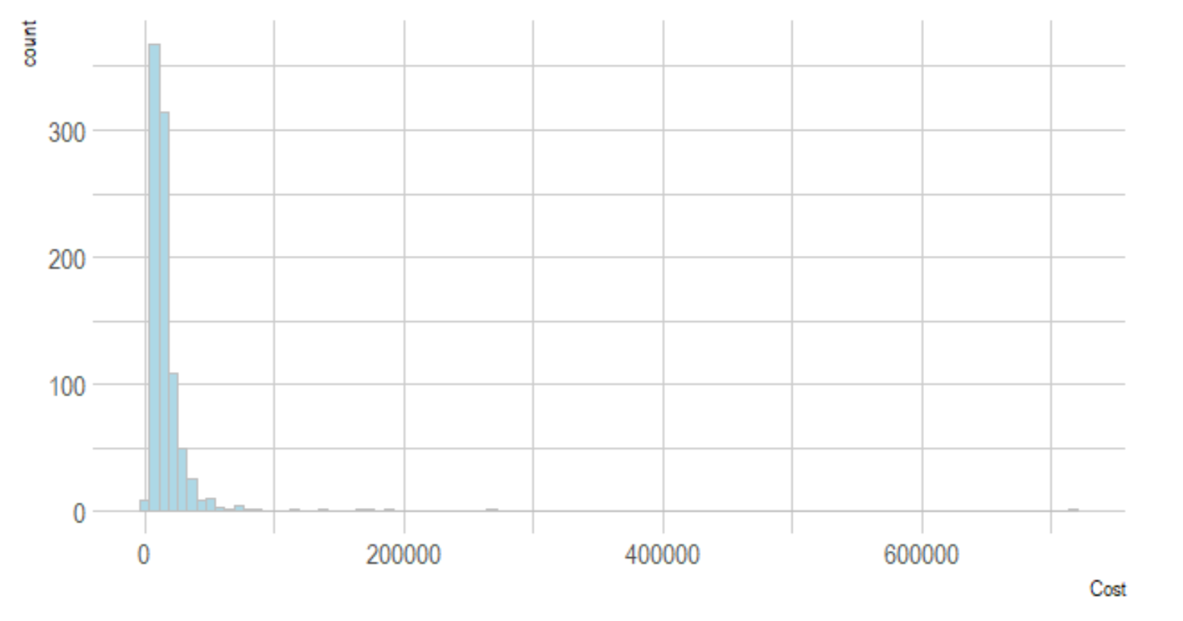

**Figure S2:** A) Log-transformed Cost Data and B) residual plot.

A) B)  
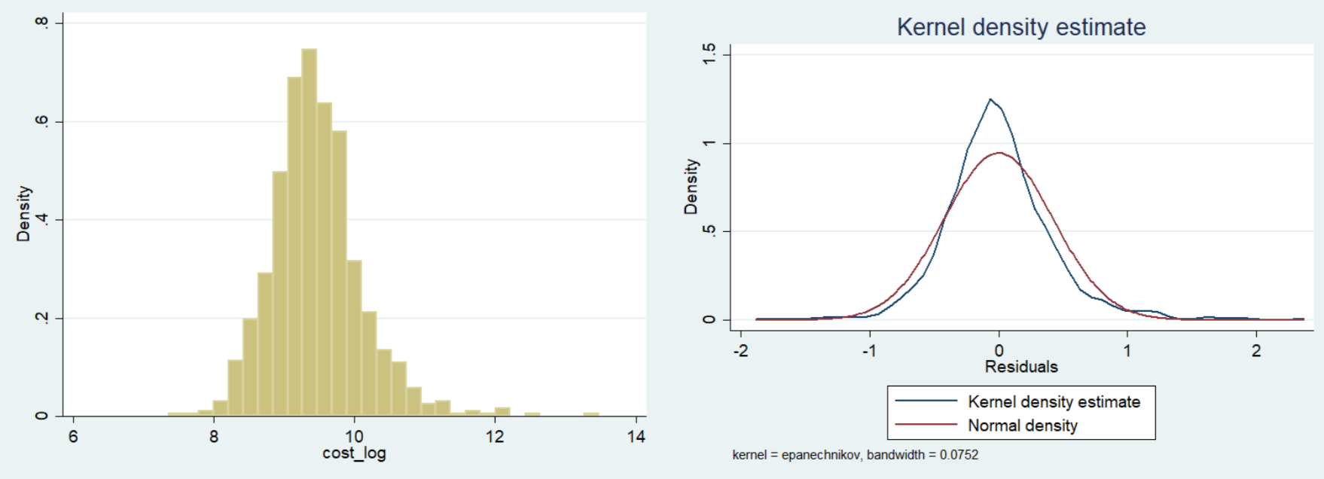

Additionally, hereby we provide the calibration curve to demonstrate the goodness of fit regarding our model:

**Figure S3:** Calibration curve of the negative binomial regression model



1. Outliers in primary regression model

By its nature, perioperative cost data are dominated by a few true outlier patients which make it hard to identify associations between preventable complication, such as PRNB, and costs. Given the highly skewed distribution of costs in our cohort, we conducted a sensitivity analysis excluding one true outlier patient. The main findings do not change when excluding this patient from the analysis: We again found no association of PRNB and costs in the adjusted analysis (aIRR 1.032, CI 0.968 - 1.100), whereas PRNB was significantly associated with postoperative ICU admission.