**Segal et al., Simplified intraoperative hand hygiene measurement**

**Sample departmental emails**

Dear Anesthesia Professionals,

Our recent work on hand hygiene in the OR has been really paying off:  in our last several weeks, we have been trending up towards our first goal of 4 times/hr (see the enclosed graph).  Thanks so much for your help.

In our most recent week of observations, we slipped a bit, and most worrisome were a few rooms with zero use.

Can I ask each of you to please pay personal attention to this important safety and quality measure?  This is an institutional and national safety goal.  At the very least, let’s not have zero use ever.  And please strive to use HH at least every time the Epic reminder comes up.

Dear Anesthesia Community,

We have made significant progress on our hand hygiene initiative over the several months.  Many of our monitored rooms are hitting or exceeding the evidence based target of 6 times/hour!

But about a quarter of our rooms continue to have zero or nearly zero use.  If we removed those from our analysis, we’d be almost at our target overall.

So, if you are using hand hygiene in the OR, **THANK YOU!**  You are making a great difference.

If you are not, please **help us eliminate zeros**.  Start using the product.  With your help, we will have achieved something really notable that will reflect extremely favorably on our departments.

Dear Anesthesia Community,

I’m coming to you with a plea to rejuvenate your enthusiasm for intraoperative hand hygiene.  As you can see from the graph below, our steadily improving performance over the last several months has fallen apart in recent weeks:

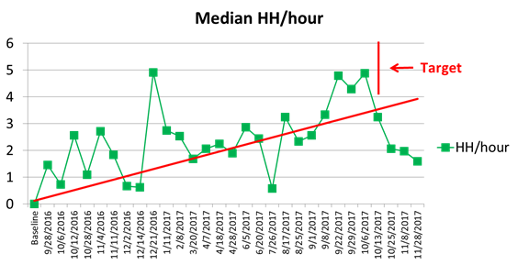

Many more of us than before are not using hand hygiene at all, and others are minimally using it.  To remind you, the evidence-based target is 4-6 times/hour.

To encourage you further consider this:  during the period we were working on this, there was a *substantial decrease in surgical site infections.*  Though of course we cannot claim responsibility alone for this achievement, we may very well have been part of it.  Let’s not slip back to our old ways, and even worse, risk harming our patients.