Supplemental Figure 1. Flow diagram of the study.
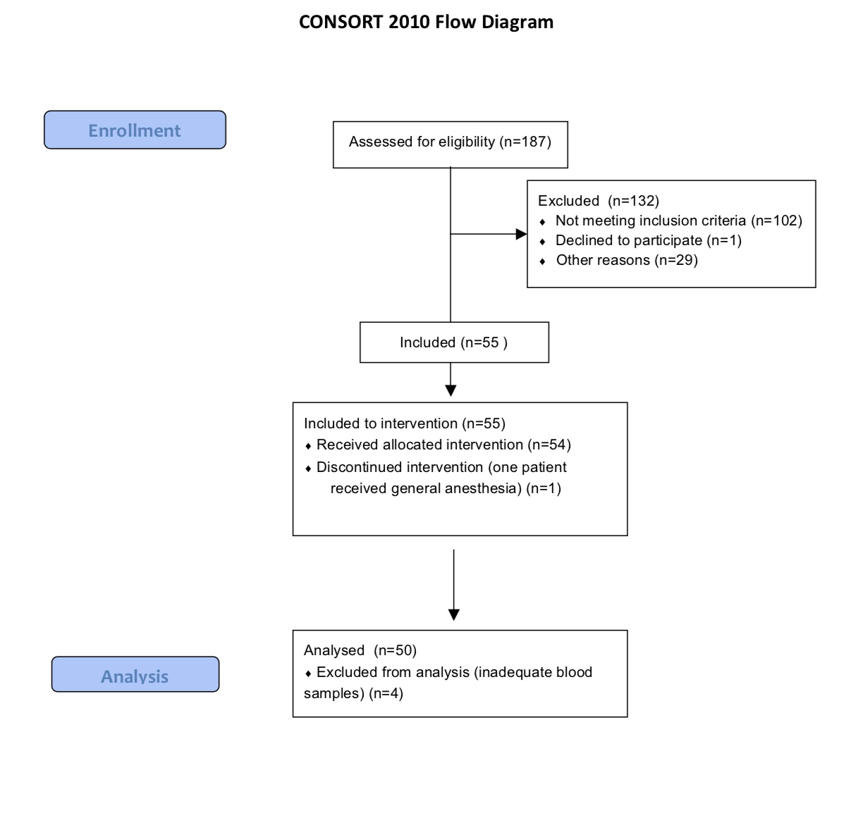

Supplemental Figure 2. Distribution of age, weight and sex in children aged between 1 to 24 months (AG1), from 24 months to 6 years (AG2) and over 6 to 11 years (AG3).
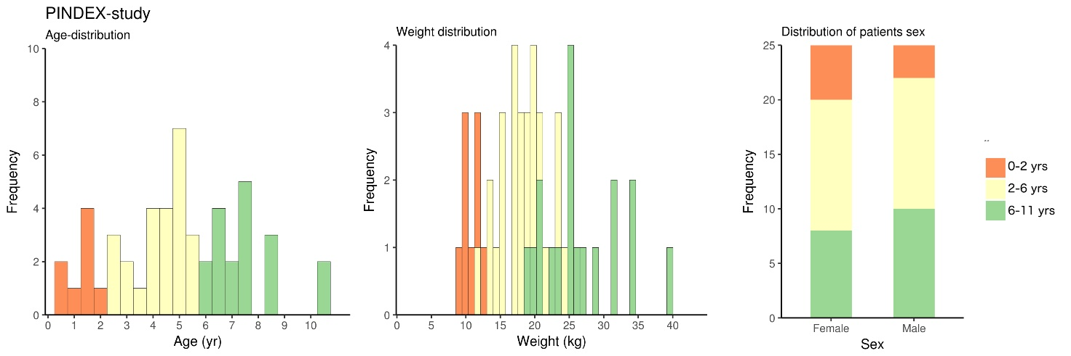

Supplemental Figure 3. Individual concentration-time curves after intranasal 2-3 µg⋅kg⁻¹ dosing of dexmedetomidine as nasal spray in children aged 0-2 y, 2-6 y and 6-11 y.

