SUPPLEMENTAL MATERIALS AND METHODS
Supplemental Figure 1. QuantumTM Clinical Navigation System Quality Assurance Sheet
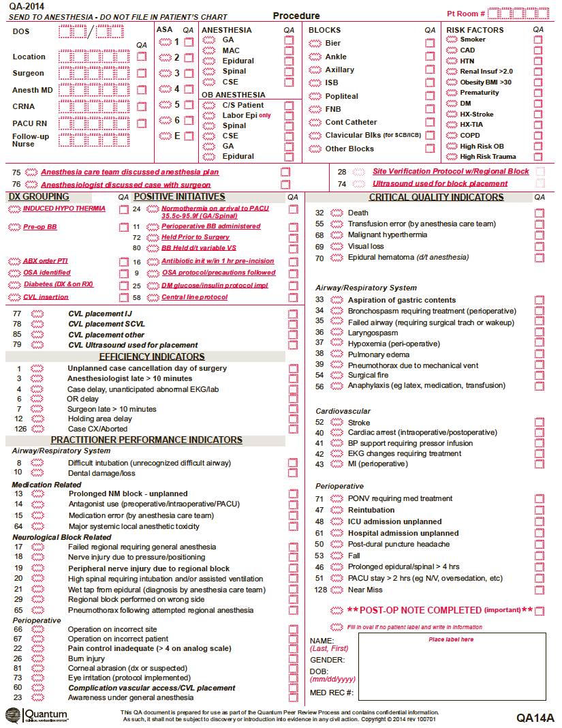
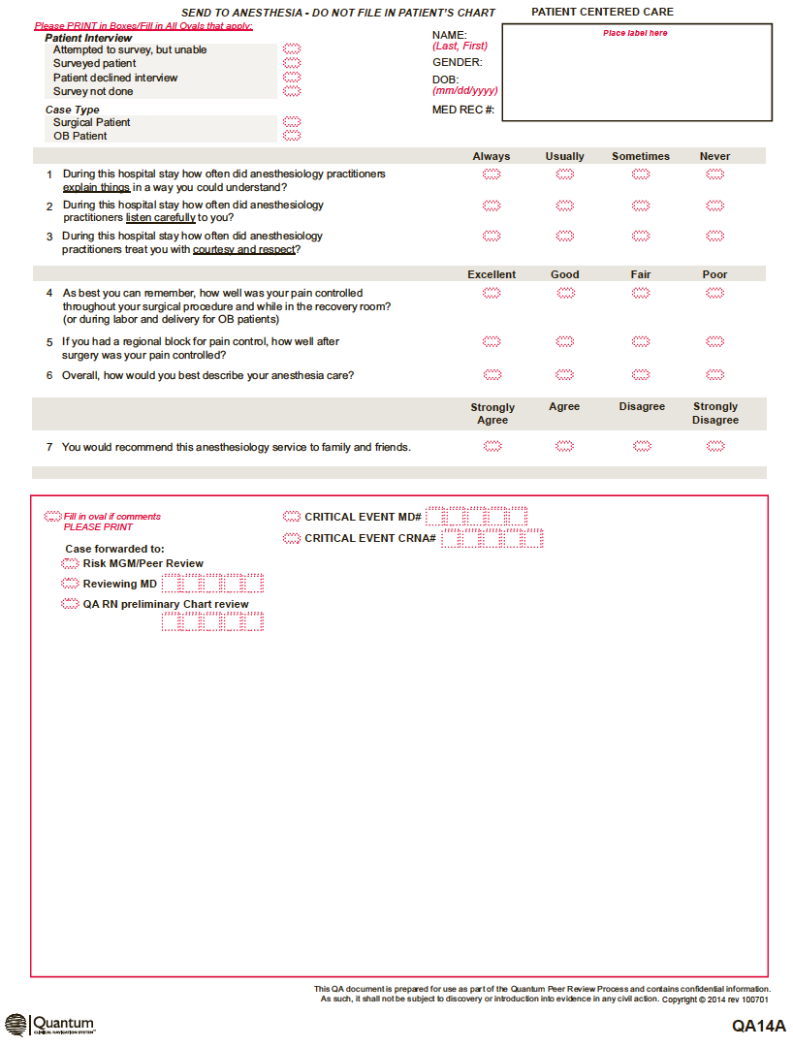
Supplemental Table 1. Definition of Individual Cardiovascular Related Critical Quality Indicators*
Term | Definition
Death | All deaths within 24 hours of receiving an anesthetic (This indicator will be measured within 24 hours, but may be reported up to 48 hours post anesthetic.)
Death related to anesthesia | All deaths within 24 hours of receiving an anesthetic that would necessitate evaluation by the peer review committee (This indicator will be measured at 24 hours, but may be reported up to 48 hours post anesthetic.)
Blood pressure support requiring vasopressor infusion | Patient was started on "pressor" infusion to maintain blood pressure within =/- 20% of pre-anesthesia care documented blood pressure. Infusion started after Anesthesia Care Team assumed care of the patient.
EKG changes requiring treatment | Electrocardiogram changes during the perioperative period including ST segment changes, new conduction delays, tachydysrhythmias, asystole or other, bradydysrhythmias, and ventricular ectopy resulting in an intervention by the anesthesia provider
Unplanned admission to the intensive care unit | Any patient who requires an unanticipated escalation in care related to the provision of anesthesia care and necessitating a transfer to an ICU within 24 hours of induction of anesthesia or start of monitored anesthesia care. Reasons for admission may include: need for postoperative ventilation, need for ongoing vasopressor support, unanticipated unstable airway, unanticipated potential for apnea, and unplanned prolonged anesthetic action or neuromuscular blockade. (This indicator will be measured within 24 hours, but may be reported up to 48 hours post induction.)
Post-anesthesia care unit stay > 2 hours | A stay in the recovery room longer than 2 hours due to clinical complications (Examples include, but are not limited to, nausea/vomiting and oversedation.)
Cardiac arrest | CPR required within 24 hours of receiving an anesthetic
Myocardial infarction | Patients that have myocardial infarction diagnosed by a qualified physician during the perioperative period up to 24 hours following surgery. Diagnosis may be supported by evidence obtained by physical or laboratory examination. Patients who present to the OR with an evolving MI are excluded.
*Definitions used by the QuantumTM Clinical Navigation System quality improvement program of American Anesthesiology Inc. within the MEDNAX National Medical Group

