Supplemental Figure 1. The simple radiologic images of the lumbar spine of representative study participants with anatomical alterations of the spine. A, Lumbar scoliosis. B, Previous spine surgery.
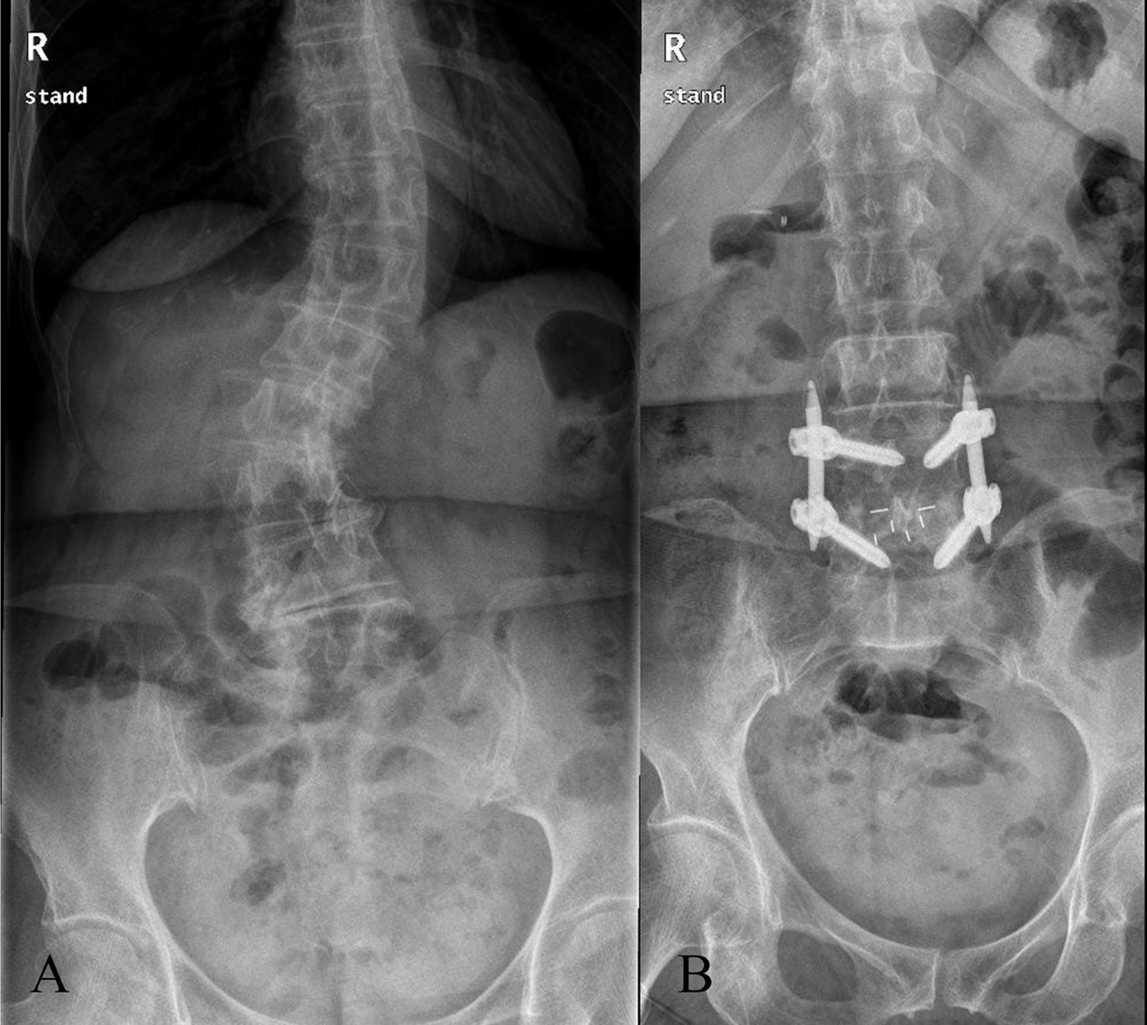
Supplemental Table 1. Analysis of number of needle passes and attempts by anesthesiologists who performed spinal anesthesia.
Both groups |  | Anesthesiologist A (n=15) | Anesthesiologist B (n=15) | Anesthesiologist C (n=14) | P value
 | Number of passes | 2 (1-4 [1-15]) | 2 (1-8 [1-12]) | 3 (1.8-9.2 [1-15]) | 0.561
 | Number of attempts | 1 (1-1 [1-5]) | 1 (1-3 [1-4]) | 1 (1-3.2 [1-5]) | 0.484
Landmark group |  | Anesthesiologist A (n=7) | Anesthesiologist B (n=8) | Anesthesiologist C (n=7)
 | Number of passes | 2 (1-9 [1-15]) | 7.5 (4.3-8.8 [2-12]) | 9 (3-10 [2-15]) | 0.234
 | Number of attempts | 1 (1-5 [1-5]) | 2.5 (1.3-3 [1-4]) | 3 (1-4 [1-5]) | 0.546
Ultrasound group |  | Anesthesiologist A (n=8) | Anesthesiologist B (n=7) | Anesthesiologist C (n=7)
 | Number of passes | 2 (1.3-3.8 [1-5]) | 1 (1-1 [1-2]) | 3 (1-3 [1-3]) | 0.057
 | Number of attempts | 1 (1-1 [1-2]) | 1 (1-1 [1-1]) | 1 (1-1 [1-2]) | 0.608
Values are median (IQR [range]).
P values are the results of Kruskal–Wallis test.
Supplemental Table 2. Adverse events related to the neuraxial procedure.
 | Landmark group (n=22) | Ultrasound group (n=22) | Relative Risk (95% CI) | P value
Radicular pain | 1 (4.5%) | 0 (0%) | - | 1.000
Paresthesia | 3 (13.6%) | 1 (4.5%) | 0.6 (0.3-1.2) | 0.607
Bloody tap | 2 (9.1%) | 1 (4.5%) | 0.7 (0.3-1.7) | 1.000
Periprocedural composite complications | 4 (18.2%) | 2 (9.1%) | 0.7 (0.4-1.4) | 0.664
Conversion to alternative technique | 2 (9.1%) | 0 (0%) | - | 0.488
Failure to perform spinal anesthesia | 0 (0%) | 0 (0%) | - | -
Conversion to general anesthesia | 0 (0%) | 0 (0%) | - | -
Values are number (proportion).
Abbreviations: CI, confidence interval.
Periprocedural composite complications were defined as radicular pain or paresthesia or bloody tap during the spinal procedure.
P values are the results of Fisher’s exact test.
Supplemental Table 3. Distribution of ease of landmark palpation in the landmark group and quality of ultrasound views in the ultrasound group.
 |  | Landmark group (n=22) |  |  | Ultrasound group (n=22)
 |  | Total (n=22) | Previous surgery (n=8) | Scoliosis (n=14) | Total (n=22) | Previous surgery (n=2) | Scoliosis (n=20)
Ease of landmark palpation | Grade 1 (Easy) | 7 (31.8%) | 1 (12.5%) | 6 (42.9%)
 | Grade 2 (Moderate) | 10 (45.5%) | 4 (50.0%) | 6 (42.9%)
 | Grade 3 (Difficult) | 5 (22.7%) | 3 (37.5%) | 2 (14.3%)
 | Grade 4 (Impossible) | 0 (0%) | 0 (0%) | 0 (0%)
Quality of ultrasound views
PSO view | Grade 1 (Good) |  |  |  | 20 (90.9%) | 2 (100.0%) | 18 (90.0%)
 | Grade 2 (Intermediate) |  |  |  | 2 (9.1%) | 0 (0%) | 2 (10.0%)
 | Grade 3 (Poor) |  |  |  | 0 (0%) | 0 (0%) | 0 (0%)
TM view | Grade 1 (Good) |  |  |  | 7 (31.8%) | 0 (0%) | 7 (35.0%)
 | Grade 2 (Intermediate) |  |  |  | 10 (45.5%) | 2 (100.0%) | 8 (40.0%)
 | Grade 3 (Poor) |  |  |  | 5 (22.7%) | 0 (0%) | 5 (25.0%)
Values are number (proportion).
Abbreviations: PSO, paramedian sagittal oblique; TM, transverse median.

Supplemental Table 4. The subgroup analyses by the types of anatomical abnormalities of the lumbar spine (scoliosis or previous spinal surgery).
Scoliosis | Landmark group (n=14) | Ultrasound group (n=20) | P value
Number of passes | 6 (2-9 [1-15]) | 2 (1-3 [1-5]) | 0.002
Number of attempts | 2 (1-4.3 [1-5]) | 1 (1-1 [1-2]) | 0.003
Successful dural puncture at the first pass | 2 (14.3%) | 9 (45.0%) | 0.063
Successful dural puncture at the first attempt | 5 (35.7%) | 18 (90.0%) | 0.001
Identifying time (sec) | 40 (29.5-51 [20-76]) | 95 (79.8-121.8 [30-305]) | <0.001
Performing time (sec) | 118.5 (47-277 [25-324]) | 37.5 (30-50.5 [25-151]) | 0.002
Total procedure time (sec) | 162.5 (92.3-316.5 [53-400]) | 141 (117.5-183 [101- 336]) | 0.769
Conversion to alternative technique | 2 (14.3%) | 0 (0%) | 0.162
Previous Spinal Surgery | Landmark group (n=8) | Ultrasound group (n=2) | P value
Number of passes | 5.5 (2.3-10 [2-15]) | 1 (1-1 [1-1]) | 0.034
Number of attempts | 2 (1-3.8 [1-4]) | 1 (1-1 [1-1]) | 0.236
Successful dural puncture at the first pass | 0 (0%) | 2 (100%) | 0.022
Successful dural puncture at the first attempt | 4 (50.0%) | 2 (100%) | 0.333
Identifying time (sec) | 27 (22-36 [18-52]) | 110 (85-136 [85-136]) | 0.036
Performing time (sec) | 93.5 (49-212.5 [42-362]) | 34 (28-40 [28-40]) | 0.037
Total procedure time (sec) | 122 (84.5-234.5 [68-404]) | 144.5 (113-176 [113-176]) | 0.794
Conversion to alternative technique | 0 (0%) | 0 (0%) | -
Values are number (proportion), mean (SD) or median (IQR [range]).
Identifying time, Time taken for identifying the landmarks by palpation or ultrasound scan; Performing time, Time taken for performing spinal anesthesia using the allocated method (Time to completion of injection or declaration to use alternative methods, and alternative technique was used in two patients in the landmark group); Total procedure time, the sum of the identifying time and the performing time.
P values are the results of of Student’s t test or Mann-Whitney U test for continuous variables and chi-square test or Fisher’s exact test for incidence variables between the groups.

