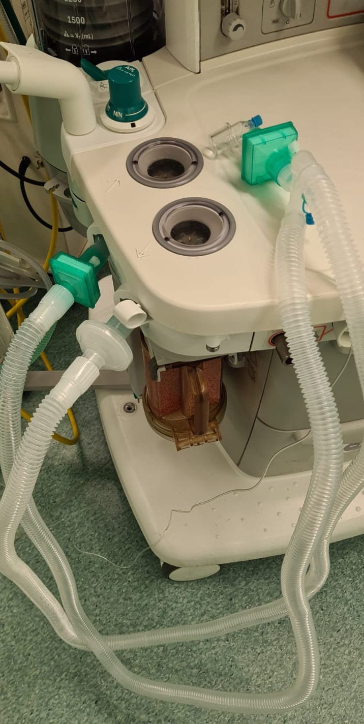
Supplementary Figure 1: Application of viral filters in both inspiratory and expiratory limbs of the circuit at the machine end to prevent erroneous placement of single filter in the inspiratory limb.

