**Supplemental Table 1**. STS ß-blocker table

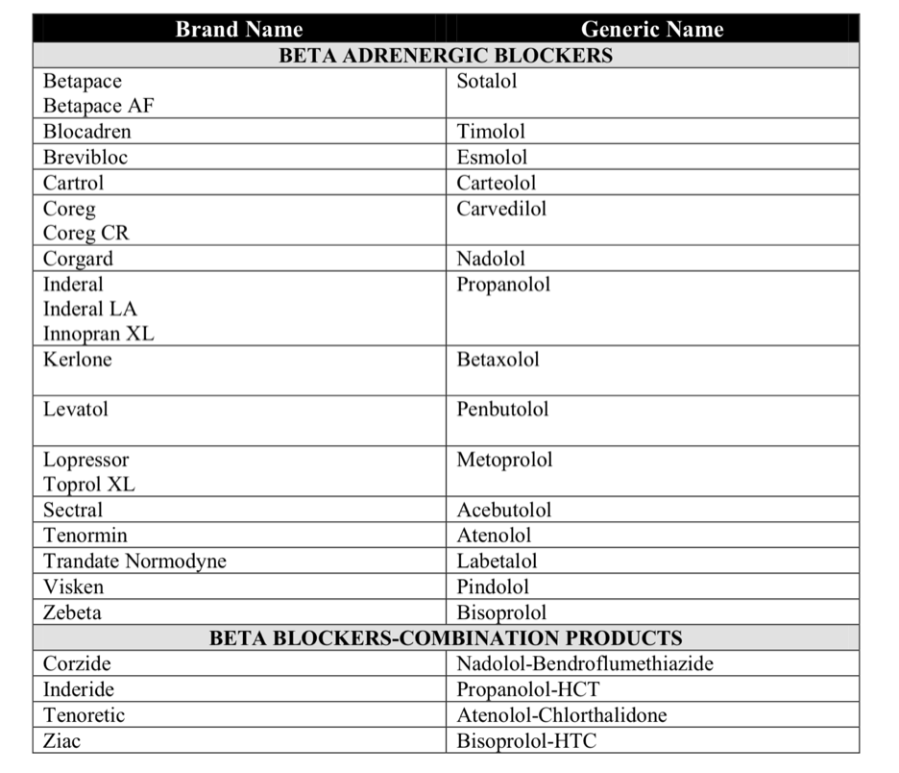

**Supplemental Figure 1.** Flowchart of patient analysis (patients on preoperative β-blockers)



**Supplemental Table 2.** STS Data Points

**Patient Info**

Patient ID

Gender Age

Height

Weight

**Patient Risk Factors**

Cerebrovascular Disease

CVA

TIA

Hypertension

Peripheral Vascular Disease

Chronic Lung Disease

Diabetes

Diabetes Control

Dialysis

**Pre-Op Cardiac Status**

Last Creatinine Level

Cardiac Symptoms at Surgery

Heart Failure

Heart Failure Timing

Heart Failure Type

BNP

Heart Failure Prior

NYHA

Ejection Fraction

Prior MI

Prior MI When

Arrhythmia

Arrhythmia Vtach/Vfib When

Arrhythmia Sick Sinus Syndrome When

Arrhythmia Aflutter When

Arrhythmia 2HB When

Arrhythmia 3HB When

Arrhythmia Perm Paced

Arrhythmia AFib

Arrhythmia AFib Duration

Cardiogenic Shock

Resuscitation

**Pre-Op Meds**

PreOp Med Beta Blockers AS [Within 24 Hours]

PreOp Med Beta Blocker Therapy AS [Within 2 weeks]

PreOp Med Inotropes

**Operative Information**

Surgery Date

Status

STS Procedure Name

CABG Performed

CPB Utilization

CPB Combination Plan

CPB Unplanned Combo Reason

Unplanned Procedure

Incidence

Valve

Aortic Valve

Aortic Procedure

Mitral Valve

Mitral Procedure

Cerebral Perfusion Utilized

Circulatory Arrest Time

Aortic Occlusion

Cross Clamp Time

IABP

IABP When

IABP Indication

**Post –Op**

PostOp Med Beta Blockers

PostOp EF Done

PostOp EF

Init HrsI CU

PostOp Imaging Study

**Post-Op Complications**

Complications Any

Reop Bleeding

Reop Valve Dysfunction

Reop Graft Occlusion

Reop Other Cardiac

Reop Other NonCardiac

PostOp NeuroStroke Permanent

PostOp NeuroStroke Transient TIA

Prolonged Ventilation

ReIntubated

Renal Failure

Renal Dialysis Required

**Patient Discharge Status**

Death

Mort30DayStatus

Mort DC Status

Mort Primary Cause

Discharge Mortality Status

Operative Death

Readmit Less Than 30Days

Readmit Reason

Readmit Reason Primary Procedure

Risk Coefficients Version

**Supplemental Table 3**. Sensitivity analysis for primary outcome

|  |  |  |  |
| --- | --- | --- | --- |
| **POD** | **N**  **Number of patients who did not receive ß-blocker** | **Primary Outcome**  **In-Hospital Mortality** | |
|  |  | Adjusted OR (99.5% CI) | p-value |
| 1 | 2994 | NA |  |
| 2 | 2617 | 1.0 (0.29-3.1) | 0.95 |
| 3 | 2219 | 1.1 (0.42-2.7) | 0.88 |
| 4 | 1759 | 0.79 (0.32-4.1) | 0.62 |
| 5 | 1394 | 1.6 (0.49-5.1) | 0.23 |
| 6 | 1159 | 0.84 (0.61-6.1) | 0.71 |

To explore the relationship between timing of β-blocker administration after surgery and outcome, a set of additional analyses were performed in which inverse probability of treatment weighting was done using absent or delayed β-blocker administration within each of 1 day, 2 days, 3 days, 4 days, 5 days, and 6 days after surgery as the treatment variable.

**Supplemental Table 4**. Odds ratio for the primary outcome in patients given preoperative β-blockers

|  |  |  |  |  |
| --- | --- | --- | --- | --- |
|  | **Early continuation of ß-blockers POD***a* **0-5**  **n= 1,086** | **Absent or delayed ß-blockers after POD 5**  **n= 585** | **Adjusted OR**  **(99.5% CI)** | **Adjusted P value** |
| In-hospital mortality | 8 (0.74%) | 5 (0.85%) | 1.3 (0.43-4.1) | 0.63 |

*a*POD = Postoperative day

Univariate logistic regression analyses were performed on the weighted sets using absent or delayed β-blocker administration as the independent variable. Propensity scores for absent or delayed β-blocker administration were estimated using a generalized boosted model based on preoperative characteristics and comorbidities and postoperative events. The number of iterations to achieve balance was visualized for each estimated propensity score. Balance was considered adequate for standardized mean difference less than 0.1. Covariate balance was assessed using standardized differences on the weighted samples. Inverse probability of treatment weighting was used to show the achieved balance between exposure groups by applying the weights to patients when comparing at baseline. A p-value < 0.005 was set for significance due to multiple comparisons. 99.5% confidence intervals were reported. All statistical operations were performed using the R statistical software (v. 3.1.1, The R Foundation for Statistical Computing, Vienna, Austria).

**Supplemental Table 5**. Odds ratios for secondary outcomes in patients who received preoperative β-blockers

|  |  |  |  |  |  |  |
| --- | --- | --- | --- | --- | --- | --- |
|  | **Early continuation of ß-blockers POD***a* **0-5**  **n= 1078** | **Absent or delayed ß-blockers after POD 5**  **n= 578** | **Adjusted OR**  **(99.5% CI)** | **P value** | **e-value** | **e-value lower CI** |
| Postoperative cerebrovascular event | 9 (0.83%) | 18 (3.1%) | 2.7 (0.82-9.0) | 0.019 |  |  |
| Postoperative atrial fibrillation | 170 (16%) | 146 (25%) | 1.6 (1.1-2.4) | <0.001 | 2.7 | 1.5 |
| Pulmonary complications | 39 (3.6%) | 77 (13%) | 2.8 (1.6-5.2) | <0.001 | 5.1 | 2.5 |
| Renal failure or new need for dialysis | 1 (0.09%) | 3 (0.52%) | 3.1 (0.32-30) | 0.32 |  |  |

*a*POD = Postoperative day

Univariate logistic regression analyses were performed on the weighted sets using absent or delayed β-blocker administration as the independent variable. The primary outcome (in-hospital mortality) and each of the 4 secondary outcomes (postoperative cerebrovascular accident, postoperative atrial fibrillation, postoperative pulmonary complications, and renal failure or new dialysis initiation) were dependent variables in separate analyses. A p-value of 0.005 was set for significance due to multiple comparisons. 99.5% confidence intervals were reported. All statistical operations were performed using the R statistical software (v. 3.1.1, The R Foundation for Statistical Computing, Vienna, Austria).

The E-value assesses the magnitude of an unmeasured confounding variable (or set of variables) that would be needed to reduce an observed relative risk estimate to 1.0, and to reduce the confidence limit to 1.0 (either the upper or lower limit). For example, an E-value of 2.0 for reducing an observed relative risk to 1.0 means that there would need to be an unmeasured confounding variable which was associated with the exposure with a relative risk of 2.0 and also associated with the outcome with relative risk of 2.0, both after adjusting for the confounding variables already included in the analyses.

**Supplemental Table 6**. Sensitivity analysis for secondary outcomes

|  |  |  |  |  |  |
| --- | --- | --- | --- | --- | --- |
| **POD** | **N**  **Number of patients who did not receive ß-blocker** | **Secondary Outcomes** | | | |
| **Atrial fibrillation** | | **Pulmonary complications** | |
|  |  | **Adjusted OR (99.5% CI)** | **p-value** | **Adjusted OR (99.5% CI)** | **p-value** |
| 1 | 2047 | NA |  | NA |  |
| 2 | 1745 | 1.3 (0.95-1.8) | 0.02 | 3.4 (1.5-7.7) | <0.001 |
| 3 | 1437 | 1.3 (0.99-1.8) | 0.007 | 2.5 (1.3-4.7) | <0.001 |
| 4 | 1093 | 1.4 (1.1-1.9) | <0.001 | 2.2 (1.3-3.8) | <0.001 |
| 5 | 815 | 1.5 (1.1-2.1) | <0.001 | 3.0 (1.8-5.2) | <0.001 |
| 6 | 651 | 1.5 (1.1-2.0) | <0.001 | 2.9 (1.7-4.8) | <0.001 |

To explore the relationship between timing of β-blocker administration after surgery and outcome, a set of additional analyses were performed in which inverse probability of treatment weighting was done using absent or delayed β-blocker administration within each of 1 day, 2 days, 3 days, 4 days, 5 days, and 6 days after surgery as the treatment variable. Like the primary analysis, each of these weighted sets was subsequently analyzed with univariate logistic regression using absent or delayed β-blocker as the independent variable, and postoperative atrial fibrillation and postoperative pulmonary complications as dependent variables in two separate analyses.