Supplemental Figure 1. Changes to the labor and delivery unit to accommodate patients with COVID-19. Four labor rooms and one operating room (shaded green areas) were isolated with doors (green lines) from the rest of the unit. Patients who had, or were suspected of having, COVID-19 were transported directly from the elevator to the COVID area labor room. The hallway between labor rooms and the operating room (OR) served as an anteroom where staff could don and doff personal protective equipment. The support personnel for procedures waited in this area.
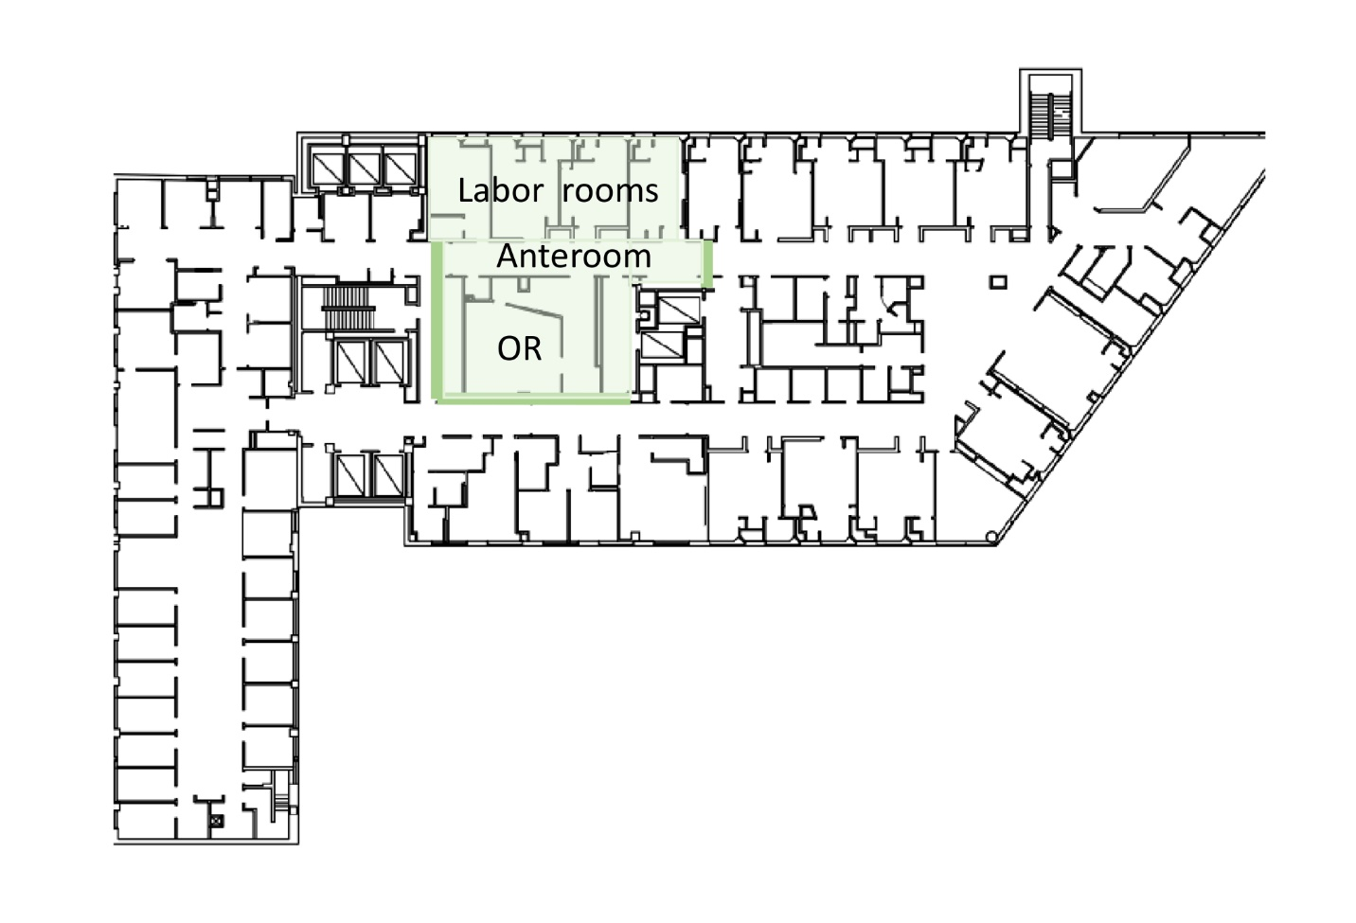
Supplemental Figure 2. Preparation of the operating room for versatile modes of anesthesia. (2A) shows the plastic sheeting of the anesthesia ventilator and monitor. This sheeting allows rapid decontamination of the surfaces. (2B) is an emergency cart used to stockpile equipment for the two rare urgent situations – conversion to general anesthesia of a patient under neuraxial, and postpartum hemorrhage. When needed, the plastic can be removed and the components used. The cart is metal with minimal crevices, allowing easy decontamination; the contents of the cart are discarded unless they are reusable (e.g. the vidoelaryngoscope handle). (2C) This is a cart used during a case for storage of the collected supplies. These supplies are kept in a procedure-specific pack that the clinician picks immediately before the case. At the end of the case, the remaining supplies are discarded, and the cart is decontaminated.
