Online Appendix 2

Development and evaluation of a risk-adjusted measure of intraoperative hypotension in patients having non-emergent, noncardiac surgery

Figure A.1. Calibration plot: Observed and predicted hypotension by risk decile, validation sample (n = 89,171 cases)
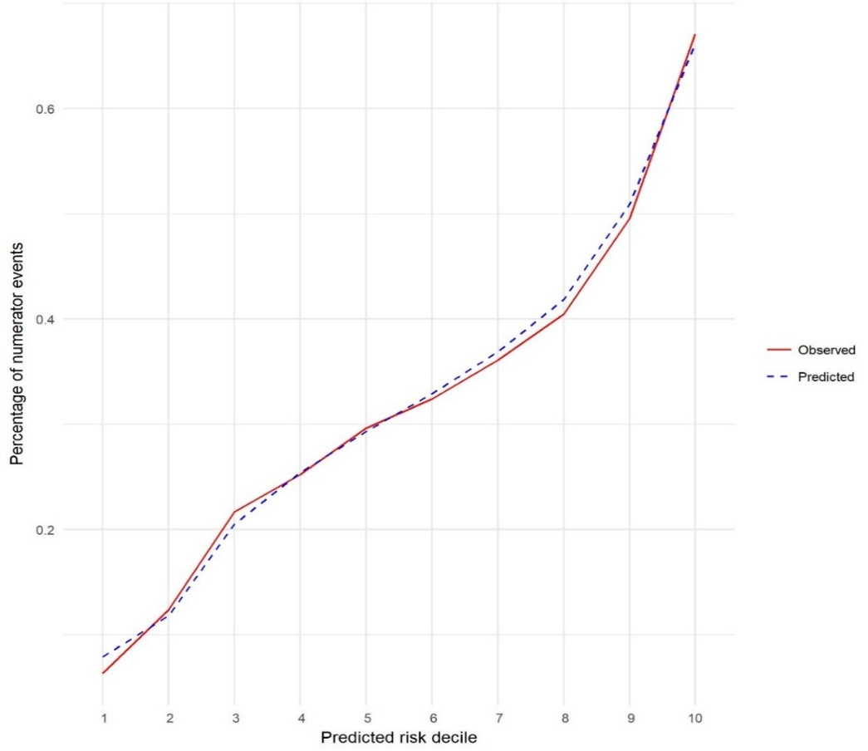
Proportion of numerator events

Figure A.2. Distribution of clinician-level risk-adjusted measure results (O:E ratios) for intraoperative hypotension, by hospital and measurement year.
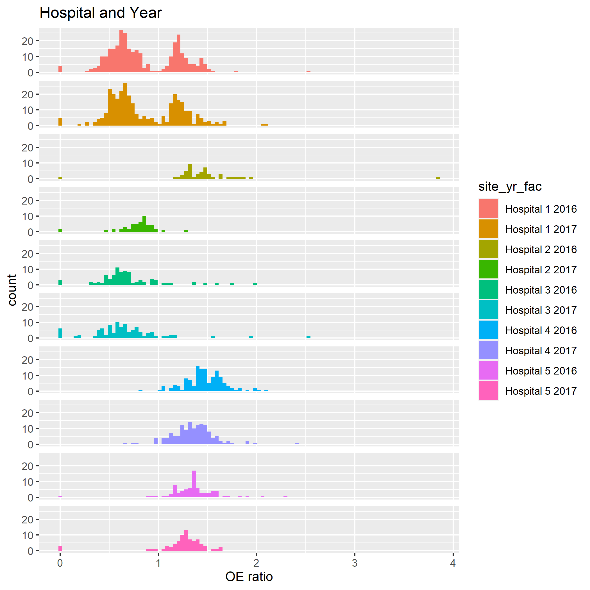
Sensitivity analyses in Hospital 1
Figure A.3. Hospital 1’s distribution of clinician-level risk-adjusted measure results (O:E ratios) for intraoperative hypotension, by staff type (CRNA, anesthesiology fellow, staff anesthesiologist).
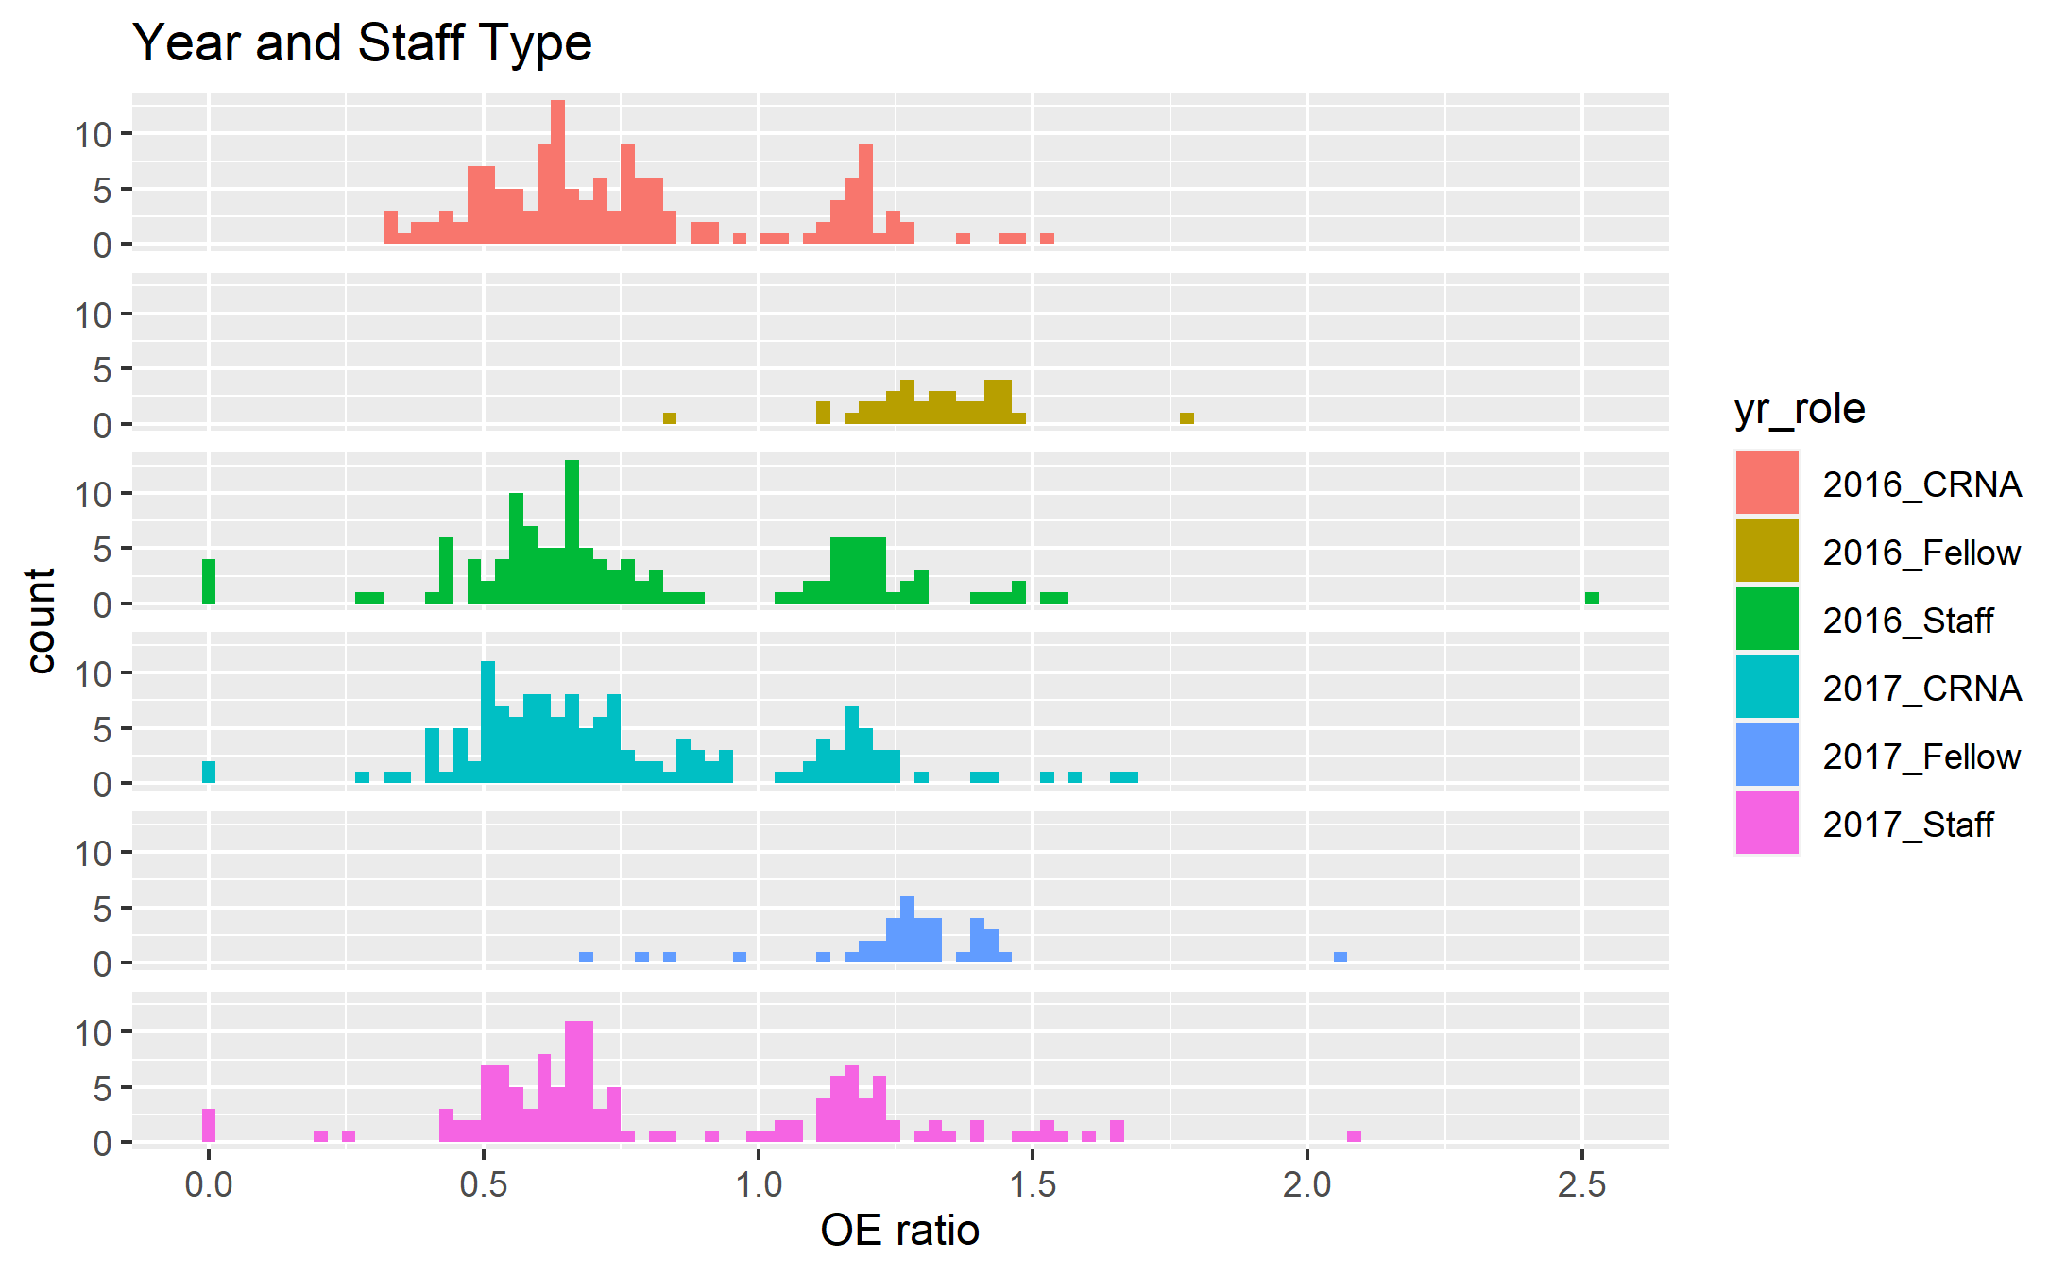

Figure A.4. Hospital 1’s distribution of clinician-level risk-adjusted measure results (O:E ratios) for intraoperative hypotension, by the percent of clinician’s surgeries that are inpatient.
