Comparative efficacy of 6 topical pharmacological agents for preventive interventions of postoperative sore throat after tracheal intubation: a systematic review and network meta-analysis

Ge Wang，*Yang Qi，*LiNa Wu，GuiChun Jiang

Supplementary appendix to the manuscript
Contents of supplementary appendix

Appendix 11
PRISMA NMA Checklist 1
Appendix 2
Search strategy 8
2.1 Search strategy for Pubmed 9
2.2 Search strategy for EMBASE 11
2.3 Search strategy for Cochrane Library 14
2.4 Search strategy for Web of Science 16
Appendix 3
Reference list of included studies 19
Appendix 4
Characteristics of included studies 26
Appendix 5
Risk of bias assessment 45
5.1 Risk of bias graph: it summarizes the authors’ judgments for each risk of bias entry for each study 46
5.2 Risk of bias table: it shows the distribution of judgments (Yes, No, Unclear) across studies for each risk of bias entry 47
Appendix 6
Direct comparison of drugs for preventing sore throat after endotracheal intubation 52
Appendix 7
Contribution plot for postoperative sore throat after tracheal intubation 57
Appendix 8
Plots of cumulative ranking probability on the impact of postoperative sore throat after tracheal intubation (SUCRA) 62
8.1 SUCRA: surface under the cumulative ranking curve 63
8.2 Ranking probability of different drugs on postoperative sore throat after tracheal intubation 67
Appendix 9
Assessment of transitivity 68
Appendix 10
Assessment of inconsistency results: local and from the node-splitting model
73
10.1 Evaluation of the local inconsistency: forest plots of inconsistency check for all closed loops in the network 74
10.2 Evaluation of the inconsistency by node-splitting model 78
Appendix 11
Predictive intervals plot for postoperative sore throat after tracheal intubation 85
Appendix 12
Comparison-adjusted funnel plot for postoperative sore throat after tracheal intubation 90
Appendix 13
Contribution summary of the risk of bias assessments 97
13.1 Summary of the risk of bias assessments for direct comparisons included in the meta-analysis on postoperative sore throat. 98
13.2 The contribution of direct comparisons to mixed or indirect comparisons by the risk of bias classification on postoperative sore throat.........................................................................................................104
Appendix 14
Evaluation of the quality of the evidence using GRADE framework 112

Appendix 1

PRISMA NMA Checklist

Section/Topic | Item # | Checklist Item | Reported on Page #
TITLE
Title | 1 | Identify the report as a systematic review incorporating a network meta-analysis (or related form of meta-analysis). | 1
ABSTRACT
Structured summary | 2 | Provide a structured summary including, as applicable:  Background: main objectives  Methods: data sources; study eligibility criteria, participants, and interventions; study appraisal; and synthesis methods, such as network meta-analysis.  Results: number of studies and participants identified; summary estimates with corresponding confidence/credible intervals; treatment rankings may also be discussed. Authors may choose to summarize pairwise comparisons against a chosen treatment included in their analyses for brevity.  Discussion/Conclusions: limitations; conclusions and implications of findings.  Other: primary source of funding; systematic review registration number with registry name. | 3-5
INTRODUCTION
Rationale | 3 | Describe the rationale for the review in the context of what is already known, including mention of why a network meta-analysis has been conducted. | 6
Objectives | 4 | Provide an explicit statement of questions being addressed, with reference to participants, interventions, comparisons, outcomes, and study design (PICOS). | 6-7
METHODS
Protocol and registration | 5 | Indicate whether a review protocol exists and if and where it can be accessed (e.g., Web address); and, if available, provide registration information, including registration number. | 7
Eligibility criteria | 6 | Specify study characteristics (e.g., PICOS, length of follow-up) and report characteristics (e.g., years considered, language, publication status) used as criteria for eligibility, giving rationale. Clearly describe eligible treatments included in the treatment network, and note whether any have been clustered or merged into the same node (with justification). | 7-8, Appendix 4
Information sources | 7 | Describe all information sources (e.g., databases with dates of coverage, contact with study authors to identify additional studies) in the search and date last searched. | 7-8, Appendix 2
Search | 8 | Present full electronic search strategy for at least one database, including any limits used, such that it could be repeated. | 7-8, Appendix 2
Study selection | 9 | State the process for selecting studies (i.e., screening, eligibility, included in systematic review, and, if applicable, included in the meta-analysis). | 8,  Appendix 3
Data collection process | 10 | Describe method of data extraction from reports (e.g., piloted forms, independently, in duplicate) and any processes for obtaining and confirming data from investigators. | 8
Data items | 11 | List and define all variables for which data were sought (e.g., PICOS, funding sources) and any assumptions and simplifications made. | 9
Geometry of the network | S1 | Describe methods used to explore the geometry of the treatment network under study and potential biases related to it. This should include how the evidence base has been graphically summarized for presentation, and what characteristics were compiled and used to describe the evidence base to readers. | 10
Risk of bias within individual studies | 12 | Describe methods used for assessing risk of bias of individual studies (including specification of whether this was done at the study or outcome level), and how this information is to be used in any data synthesis. | 11
Summary measures | 13 | State the principal summary measures (e.g., risk ratio, difference in means). Also describe the use of additional summary measures assessed, such as treatment rankings and surface under the cumulative ranking curve (SUCRA) values, as well as modified approaches used to present summary findings from meta-analyses. | 10-11
Planned methods of analysis | 14 | Describe the methods of handling data and combining results of studies for each network meta-analysis. This should include, but not be limited to:  - Handling of multi-arm trials;  - Selection of variance structure;  - Selection of prior distributions in Bayesian analyses; and  - Assessment of model fit. | 10-11
Assessment of Inconsistency | S2 | Describe the statistical methods used to evaluate the agreement of direct and indirect evidence in the treatment network(s) studied. Describe efforts taken to address its presence when found. | 11
Risk of bias across studies | 15 | Specify any assessment of risk of bias that may affect the cumulative evidence (e.g., publication bias, selective reporting within studies). | 11
Additional analyses | 16 | Describe methods of additional analyses if done, indicating which were pre-specified. This may include, but not be limited to, the following:  - Sensitivity or subgroup analyses;  - Meta-regression analyses;  - Alternative formulations of the treatment network; and  - Use of alternative prior distributions for Bayesian analyses (if applicable). | 9-11
RESULTS†
Study selection | 17 | Give numbers of studies screened, assessed for eligibility, and included in the review, with reasons for exclusions at each stage, ideally with a flow diagram. | 12, Figure 1, Appendix 3
Presentation of network structure | S3 | Provide a network graph of the included studies to enable visualization of the geometry of the treatment network. | 12, Figure 2
Summary of network geometry | S4 | Provide a brief overview of characteristics of the treatment network. This may include commentary on the abundance of trials and randomized patients for the different interventions and pairwise comparisons in the network, gaps of evidence in the treatment network, and potential biases reflected by the network structure. | 12, Figure 2, Appendix 4, Appendix 9
Study characteristics | 18 | For each study, present characteristics for which data were extracted (e.g., study size, PICOS, follow-up period) and provide the citations. | 13,  Appendix 4
Risk of bias within studies | 19 | Present data on risk of bias of each study and, if available, any outcome level assessment. | 18,  Appendix 5
Results of individual studies | 20 | For all outcomes considered (benefits or harms), present, for each study: 1) simple summary data for each intervention group, and 2) effect estimates and confidence intervals. Modified approaches may be needed to deal with information from larger networks. | 14, Figure 3
Synthesis of results | 21 | Present results of each meta-analysis done, including confidence/credible intervals. In larger networks, authors may focus on comparisons versus a particular comparator (e.g. placebo or standard care), with full findings presented in an appendix. League tables and forest plots may be considered to summarize pairwise comparisons. If additional summary measures were explored (such as treatment rankings), these should also be presented. | 14-16, Figure 4, Figure 5, Appendix 6
Exploration for inconsistency | S5 | Describe results from investigations of inconsistency. This may include such information as measures of model fit to compare consistency and inconsistency models, P values from statistical tests, or summary of inconsistency estimates from different parts of the treatment network. | 17-18, Appendix 7  Appendix 8
Risk of bias across studies | 22 | Present results of any assessment of risk of bias across studies for the evidence base being studied. | 18
Results of additional analyses | 23 | Give results of additional analyses, if done (e.g., sensitivity or subgroup analyses, meta-regression analyses, alternative network geometries studied, alternative choice of prior distributions for Bayesian analyses, and so forth). | 14-15, Appendix 10
DISCUSSION
Summary of evidence | 24 | Summarize the main findings, including the strength of evidence for each main outcome; consider their relevance to key groups (e.g., healthcare providers, users, and policy-makers). | 19-22
Limitations | 25 | Discuss limitations at study and outcome level (e.g., risk of bias), and at review level (e.g., incomplete retrieval of identified research, reporting bias). Comment on the validity of the assumptions, such as transitivity and consistency. Comment on any concerns regarding network geometry (e.g., avoidance of certain comparisons). | 22-23
Conclusions | 26 | Provide a general interpretation of the results in the context of other evidence, and implications for future research. | 24
FUNDING
Funding | 27 | Describe sources of funding for the systematic review and other support (e.g., supply of data); role of funders for the systematic review. This should also include information regarding whether funding has been received from manufacturers of treatments in the network and/or whether some of the authors are content experts with professional conflicts of interest that could affect use of treatments in the network. | 24

PICOS = population, intervention, comparators, outcomes, study design.
* Text in italics indicateS wording specific to reporting of network meta-analyses that has been added to guidance from the PRISMA statement.
† Authors may wish to plan for use of appendices to present all relevant information in full detail for items in this section.

Appendix 2

Search strategy

2.1 Search strategy for Pubmed
#1. "adrenal cortex hormones"[MeSH Terms]
#2. (corticoid* or corticosteroid* or Corticosteroid*) tw
#3. prednisone
#4. prednisolone
#5. methylprednisolone
#6. dexamethasone
#7. cortisone
#8. hydrocortisone
#9. riamcinolone
#10. beclomethasone
#11. #1 OR #2 OR #3 OR #4 OR #5 OR #6 OR #7 OR #8 OR #9 OR #10
#12. lidocaine
#13. ligocaine
#14. xylocaine
#15. #12 OR #13 OR #14
#16. magnesium
#17. "magnesium sulfate"
#18. mgso4
#19. #16 OR #17 OR #18
#20. Licorice
#21. Glycyrrhiza
#22. #20 OR #21
#23. "Anti-Inflammatory Agents, Non-Steroidal"
#24. benzydamine
#25. "tantum verde"
#26. difflam
#27. #23 OR #24 OR #25 OR #26
#28. ketamine
#29. ketalar
#30. #28 OR #29
#31. gargle
#32. mouthwash
#33. #31 OR #32
#34. #30 AND #33
#35. "Intubation, Intratracheal"[Mesh]
#36. "endotracheal intubation"
#37. (endotracheal OR intratracheal) near intub*
#38. postoperative
#39. Pharyngitis [Mesh]
#40. pharyngit*
#41. (sore* or inflamm* or infect*) near throat
#42. #39 OR #40 OR #41
#43. #38 AND #42
#44. "postoperative sore throat"
#45. "post-operative sore throat"
#46. #35 OR #36 OR #37 OR #43 OR #44 OR #45
#47. #11 OR #15 OR #19 OR #22 OR #27 OR #34
#48. #46 AND #47

2.2 Search strategy for EMBASE
#1 'corticosteroid'/exp
#2 'adrenal cortex hormone*'
#3 corticoid*
#4 corticosteroid*
#5 Corticosteroid*
#6 steroid*
#7 prednisone
#8 prednisolone
#9 methylprednisolone
#10 dexamethasone
#11 cortisone
#12 hydrocortisone
#13 triamcinolone
#14 beclomethasone
#15 betamethasone
#16 fluticasone
#17 budesonide
#18 mometasone
#19 #1 OR #2 OR #3 OR #4 OR #5 OR #6 OR #7 OR #8 OR #9 OR #10 OR #11 OR #12 OR #13 OR #14 OR #15 OR #16 OR #17 OR #18
#20 'lidocaine'/exp
#21 lidocain*
#22 lignocaine
#23 xylocaine
#24 #20 OR #21 OR #22 OR #23
#25 'magnesium'/exp
#26 magnesium
#27 'magnesium sulfate'
#28 mgso4
#29 #25 OR #26 OR #27 OR #28
#30 'glycyrrhiza'/exp
#31 glycyrrhiza
#32 licorice
#33 #30 OR #31 OR #32
#34 'nonsteroid antiinflammatory agent'/exp
#35 'nonsteroid antiinflammatory agent'
#36 'benzydamine'/exp
#37 benzydamine
#38 difflam
#39 tantum*
#40 #34 OR #35 OR #36 OR #37 OR #38 OR #39
#41 'ketamine'/exp
#42 ketamine
#43 ketalar
#44 #41 OR #42 OR #43
#45 #19 OR #24 OR #29 OR #33 OR #40 OR #44
#46 'endotracheal intubation'/exp
#47 'pharyngitis'/exp
#48 pharyngit*
#49 (sore* OR inflamm* OR infect*) NEAR/5 throat
#50 (endotracheal OR intratracheal) NEAR/5 intub*
#51 #46 OR #47 OR #48 OR #49 OR #50
#52 'crossover procedure':de OR 'double-blind procedure':de OR 'randomized controlled trial':de OR 'single-blind procedure':de OR random*:de,ab,ti OR factorial*:de,ab,ti OR crossover*:de,ab,ti OR ((cross NEXT/1 over*):de,ab,ti) OR placebo*:de,ab,ti OR ((doubl* NEAR/1 blind*):de,ab,ti) OR ((singl* NEAR/1 blind*):de,ab,ti) OR assign*:de,ab,ti OR allocat*:de,ab,ti OR volunteer*:de,ab,ti
#53 #45 AND #51 AND #52

2.3 Search strategy for Cochrane Library
#1 MeSH descriptor: [Adrenal Cortex Hormones] explode all trees
#2 ("Adrenal Cortex Hormones"):ti,ab,kw
#3 (corticoid*):ti,ab,kw
#4 (corticosteroid*):ti,ab,kw
#5 (Corticosteroid*):ti,ab,kw
#6 (Steroid*):ti,ab,kw
#7 (prednisone):ti,ab,kw
#8 (prednisolone):ti,ab,kw
#9 (methylprednisolone):ti,ab,kw
#10 (dexamethasone):ti,ab,kw
#11 (cortisone):ti,ab,kw
#12 (hydrocortisone):ti,ab,kw
#13 (triamcinolone):ti,ab,kw
#14 (beclomethasone):ti,ab,kw
#15 (Betamethasone):ti,ab,kw
#16 (fluticasone):ti,ab,kw
#17 (budesonide):ti,ab,kw
#18 (mometasone):ti,ab,kw
#19 #1 OR #2 OR #3 OR #4 OR #5 OR #6 OR #7 OR #8 OR #9 OR #10 OR #11 OR #12 OR #13 OR #14 OR #15 OR #16 OR #17 OR #18
#20 (lidocain*):ti,ab,kw
#21 (lignocaine):ti,ab,kw
#22 (xylocaine):ti,ab,kw
#23 #20 OR #21 OR #22
#24 (magnesium):ti,ab,kw
#25 (mgSO4):ti,ab,kw
#26 #24 OR #25
#27 (Glycyrrhiza):ti,ab,kw
#28 (Licorice):ti,ab,kw
#29 #27 OR #28
#30 MeSH descriptor: [Anti-Inflammatory Agents, Non-Steroidal] explode all trees
#31 ("Anti-Inflammatory Agents, Non-Steroidal"):ti,ab,kw
#32 (Benzydamine):ti,ab,kw
#33 (difflam):ti,ab,kw
#34 (tantum*):ti,ab,kw
#35 #31 OR #32 OR #33 OR #34
#36 (ketamine):ti,ab,kw
#37 (ketalar):ti,ab,kw
#38 #36 OR #37
#39 MeSH descriptor: [Pharyngitis] explode all trees
#40 MeSH descriptor: [Intubation, Intratracheal] explode all trees
#41 (Pharyngit*):ti,ab,kw
#42 (sore* or inflamm* or infect*) near throat
#43 (endotracheal OR intratracheal) near intub*
#44 #39 OR #40 OR #41 OR #42 OR #43
#45 #19 OR #23 OR #26 OR #29 OR 35 OR #38
#46 #44 AND #45

2.4 Search strategy for Web of Science
#1 TOPIC: ("Adrenal Cortex Hormones")
#2 TOPIC: ("adrenal cortex hormone*")
#3 TOPIC: (corticoid*)
#4 TOPIC: (corticosteroid*)
#5 TOPIC: (Corticosteroid*)
#6 TOPIC: (Steroid*)
#7 TOPIC: (prednisone)
#8 TOPIC: (prednisolone)
#9 TOPIC: (methylprednisolone)
#10 TOPIC: (dexamethasone)
#11 TOPIC: (cortisone)
#12 TOPIC: (hydrocortisone)
#13 TOPIC: (triamcinolone)
#14 TOPIC: (beclomethasone)
#15 TOPIC: (Betamethasone)
#16 TOPIC: (fluticasone)
#17 TOPIC: (budesonide)
#18 TOPIC: (mometasone)
#19 #1 OR #2 OR #3 OR #4 OR #5 OR #6 OR #7 OR #8 OR #9 OR #10 OR #11 OR #12 OR #13 OR #14 OR #15 OR #16 OR #17 OR #18
#20 TOPIC: (Lidocaine)
#21 TOPIC: (lidocaine)
#22 TOPIC: (lignocaine)
#23 TOPIC: (lidocain*)
#24 TOPIC: (xylocaine)
#25 #20 OR #21 OR #22 OR #23 OR #24
#26 TOPIC: (magnesium)
#27 TOPIC: ("magnesium sulfate")
#28 TOPIC: (mgSO4)
#29 #26 OR #27 OR #28
#30 TOPIC: (Glycyrrhiza)
#31 TOPIC: (Licorice)
#32 #30 OR #31
#33 TOPIC: ("Anti-Inflammatory Agents, Non-Steroidal")
#34 TOPIC: ('nonsteroid antiinflammatory agent')
#35 TOPIC: (Benzydamine)
#36 TOPIC: (difflam)
#37 TOPIC: (tantum*)
#38 #33 OR #34 OR #35 OR #36 OR #37
#39 TOPIC: (ketamine)
#40 TOPIC: (ketalar)
#41 #39 OR #40
#42 #19 OR #25 OR #29 OR #32 OR #38 OR #41
#43 TOPIC: ("Intubation,Intratracheal")
#44 TOPIC:('endotracheal intubation')
#45 TOPIC: (Pharyngitis)
#46 TOPIC: (pharyngit*)
#47 #43 OR #44 OR #45 OR #46
#48 TOPIC: (sore*) OR TOPIC: (inflamm*) OR TOPIC: (infect*)
#49 TOPIC: (throat)
#50 #48 AND #49
#51 TOPIC: (endotracheal) OR TOPIC: (intratracheal)
#52 TOPIC: (intub*)
#53 #51 AND #52
#54 #47 OR #50 OR #53
#55 TS=clinical trial* OR TS=research design OR TS=comparative stud* OR TS=evaluation stud* OR TS=controlled trial* OR TS=follow-up stud* OR TS=prospective stud* OR TS=random* OR TS=placebo* OR TS=(single blind*) OR TS=(double blind*)
#56 #42 AND #54 AND #55

Appendix 3

Reference list of included studies

1.Yang, H. L., Liu, F. C., Tsai, S. C., Tsay, P. K., Lin, H. T., & Liu, H. E. (2016). Ketorolac Tromethamine Spray Prevents Postendotracheal-Intubation-Induced Sore Throat after General Anesthesia. Biomed Res Int, 2016, 4582439.
2.Yang, C. Jung, S. M., Bae, Y. K., & Park, S. J. (2017). The effect of ketorolac and dexamethasone on the incidence of sore throat in women after thyroidectomy: A prospective double-blinded randomized trial. Korean J Anesthesiol, 70(1), 64-71.
3.Yadav, M., Chalumuru, N., & Gopinath, R. (2016). Effect of magnesium sulfate nebulization on the incidence of postoperative sore throat. J Anaesthesiol Clin Pharmacol, 32(2), 168-171.
4.Thomas, D., Bejoy, R., Zabrin, N., & Beevi, S. (2018). Preoperative ketamine nebulization attenuates the incidenceand severity of postoperative sore throat: A randomizedcontrolled clinical trial. Saudi Journal of Anaesthesia, 12(3), 440-445.
5.Thapa, P., Shrestha, R. R., Shrestha, S., & Bajracharya, G. R. (2017). Betamethasone gel compared with lidocaine jelly to reduce tracheal tube related postoperative airway symptoms: a randomized controlled trial. BMC Res Notes, 10(1), 361.
6.Teymourian, H., Mohajerani, S. A., & Farahbod, A. (2015). Magnesium and Ketamine Gargle and Postoperative Sore Throat. Anesth Pain Med, 5(3), e22367.
7.Tabari, M., Soltani, G., Zirak, N., Alipour, M., & Khazaeni, K. (2013). Comparison of Effectiveness of Betamethasone gel Applied to the Tracheal Tube and IV Dexamethasone on Postoperative Sore Throat: A Randomized Controlled Trial. Iran J Otorhinolaryngol, 25(73), 215-220.
8.Sumathi, P. A., Shenoy, T., Ambareesha, M., & Krishna, H. M. (2008). Controlled comparison between betamethasone gel and lidocaine jelly applied over tracheal tube to reduce postoperative sore throat, cough, and hoarseness of voice. Br J Anaesth, 100(2), 215-218.
9.Shrestha, S. K., Bhattarai, B., & Singh, J. (2010). Ketamine gargling and postoperative sore throat. JNMA J Nepal Med Assoc, 50(180), 282-285.
10.Shaaban, A. R., & Kamal, S. M. (2012). Comparison between betamethasone gel applied over endotracheal tube and ketamine gargle for attenuating postoperative sore throat, cough and hoarseness of voice. Middle East J Anaesthesiol, 21(4), 513-519.
11.Segaran, S., Bacthavasalame, A. T., Venkatesh, R. R., Zachariah, M., George, S. K., & Kandasamy, R. (2018). Comparison of Nebulized Ketamine with Nebulized Magnesium Sulfate on the Incidence of Postoperative Sore Throat. Anesth Essays Res, 12(4), 885-890.
12.Ruetzler, K., Fleck, M., Nabecker, S., Pinter, K., Landskron, G., Lassnigg, A., . . . Sessler, D. I. (2013). A randomized, double-blind comparison of licorice versus sugar-water gargle for prevention of postoperative sore throat and postextubation coughing. Anesth Analg, 117(3), 614-621.
13.Rudra, A., Ray, S., Chatterjee, S., Ahmed, A., & Ghosh, S. (2009). Gargling with ketamine attenuates the postoperative sore throat. Indian J Anaesth, 53(1), 40-43.
14.Rajan, S., Tosh, P., Paul, J., & Kumar, L. (2018). Effect of inhaled budesonide suspension, administered using a metered dose inhaler, on post-operative sore throat, hoarseness of voice and cough. Indian J Anaesth, 62(1), 66-71.
15.Rajan, S., Malayil, G. J., Varghese, R., & Kumar, L. (2017). Comparison of Usefulness of Ketamine and Magnesium Sulfate Nebulizations for Attenuating Postoperative Sore Throat, Hoarseness of Voice, and Cough. Anesth Essays Res, 11(2), 287-293.
16.Rahimi, M., & Makarem, J. (2009). Effects of diclofenac epolamine patch on postoperative sore throat in parturients after cesarean delivery under endotracheal general anesthesia. Acta Anaesthesiol Taiwan, 47(1), 17-21.
17.Navarro, R. M., & Baughman, V. L. (1997). Lidocaine in the endotracheal tube cuff reduces postoperative sore throat. J Clin Anesth, 9(5), 394-397.
18.Narimani, M., Seyed Mehdi, S. A., Gholami, F., Ansari, L., Aryafar, M., & Shahbazi, F. (2016). The Effect of Betamethasone Gel and Lidocaine Jelly Applied Over Tracheal Tube Cuff on Postoperative Sore Throat, Cough, and Hoarseness. J Perianesth Nurs, 31(4), 298-302.
19.Lee, J., Lee, Y. C., Son, J. D., Lee, J. Y., & Kim, H. C. (2017). The effect of lidocaine jelly on a taper-shaped cuff of an endotracheal tube on the postoperative sore throat: a prospective randomized study: A CONSORT compliant article. Medicine (Baltimore), 96(37), e8094.
20.Kiran, S., Goel, M., Singhal, P., Gupta, N., & Bhardwaj, M. (2012). Postoperative sore throat with 0.05% betamethasone gel and 2% lignocaine jelly used as a lubricant for ProSeal LMA (PLMA) insertion. Egyptian Journal of Anaesthesia, 28(2), 139-142.
21.Kati, I., Tekin, M., Silay, E., Huseyinoglu, U. A., & Yildiz, H. (2004). Does benzydamine hydrochloride applied preemptively reduce sore throat due to laryngeal mask airway? Anesth.Analg.,99(3),710-712,tableof contents.
22.Kajal, K., Dharmu, D., Bhukkal, I., Yaddanapudi, S., Soni, S. L., Kumar, M., & Singla, A. (2019). Comparison of Three Different Methods of Attenuating Postoperative Sore Throat, Cough, and Hoarseness of Voice in Patients Undergoing Tracheal Intubation. Anesth Essays Res, 13(3), 572-576.
23.Hung, N. K., Wu, C. T., Chan, S. M., Lu, C. H., Huang, Y. S., Yeh, C. C., . . . Cherng, C. H. (2010). Effect on postoperative sore throat of spraying the endotracheal tube cuff with benzydamine hydrochloride, 10% lidocaine, and 2% lidocaine. Anesth Analg, 111(4), 882-886.
24.Huang, Y. S., Hung, N. K., Lee, M. S., Kuo, C. P., Yu, J. C., Huang, G. S., . . . Wu, C. T. (2010). The effectiveness of benzydamine hydrochloride spraying on the endotracheal tube cuff or oral mucosa for postoperative sore throat. Anesth Analg, 111(4), 887-891.
25.Honarmand, A., Safavi, M., Safaei Arani, A., & Shokrani, O. (2016). The efficacy of different doses ofGlycyrrhiza gargling for attenuating postoperative sore throat and cough after tracheal intubation. Eur J Anaesthesiol, 33(8), 595-596.
26.Hara, K., & Maruyama, K. (2005). Effect of additives in lidocaine spray on postoperative sore throat, hoarseness and dysphagia after total intravenous anaesthesia. Acta Anaesthesiol Scand, 49(4), 463-467.
27. Gupta, D., Agrawal, S., & Sharma, J. P. (2013). Effect of preoperative licorice lozenges on incidence of postextubation cough and sore throat in smokers undergoing general anesthesia and endotracheal intubation. Middle East J Anaesthesiol, 22(2), 173-178.
28.Gulhas, N., Canpolat, H., Cicek, M., Yologlu, S., Togal, T., Durmus, M., & Ozcan Ersoy, M. (2007). Dexpanthenol pastille and benzydamine hydrochloride spray for the prevention of post-operative sore throat. Acta Anaesthesiol Scand, 51(2), 239-243.
29.Gojendra Rajkumar, L Eshwori, P Yanang Konyak, L Deban Singh, Thokchom Rupendra Singh, & Rani, M. B. (2012). Prophylactic ketamine gargle to reduce post-operative sore throat following endotracheal intubation.
30.Furqan, A., Fayyaz, A., Ahmad, S. S., & Ahmad, R. A. (2016). Effect of applying lignocaine gel, diclofenac gel or their combination on endotracheal tube on the hemodynamic response and incidence of postoperative complications in patients undergoing CABG surgery. Anaesthesia, Pain and Intensive Care, 20, S32-S36.
31.Fayyaz, A., Furqan, A., Ammar, A., & Akhtar, R. (2017). Comparing the effectiveness of Betamethasone Gel with Lidocaine Gel local application on endotracheal tube in preventing post-operative sore throat (POST). J Pak Med Assoc, 67(6), 873-876.
32.Doukumo, D., Faponle, A., Adenekan, A., Olateju, S., & Bolaji, B. (2011). Effects of lidocaine and k-y jellies on sore throat, cough, and hoarseness following endotracheal anaesthesia. J West Afr Coll Surg, 1(3), 44-61.
33.Charan, S. D., Khilji, M. Y., Jain, R., Devra, V., & Saxena, M. (2018). Inhalation of Ketamine in Different Doses to Decrease the Severity of Postoperative Sore Throat in Surgeries under General Anesthesia Patients. Anesth Essays Res, 12(3), 625-629.
34.Chang, J. E., Min, S. W., Kim, C. S., Han, S. H., Kwon, Y. S., & Hwang, J. Y. (2015). Effect of prophylactic benzydamine hydrochloride on postoperative sore throat and hoarseness after tracheal intubation using a double-lumen endobronchial tube: a randomized controlled trial. Can J Anaesth, 62(10), 1097-1103.
35.Canbay, O., Celebi, N., Sahin, A., Celiker, V., Ozgen, S., & Aypar, U. (2008). Ketamine gargle for attenuating postoperative sore throat. Br J Anaesth, 100(4), 490-493.
36.Borazan, H., Kececioglu, A., Okesli, S., & Otelcioglu, S. (2012). Oral magnesium lozenge reduces postoperative sore throat: a randomized, prospective, placebo-controlled study. Anesthesiology, 117(3), 512-518.
37. Banihashem, N., Alijanpour, E., Hasannasab, B., & Zarei, A. (2015). Prophylactic Effects of Lidocaine or Beclomethasone Spray on Post-Operative Sore Throat and Cough after Orotracheal Intubation. Iran J Otorhinolaryngol, 27(80), 179-184.
38.Ayoub, C. M., et al. (1998). "Widespread application of topical steroids to decrease sore throat, hoarseness, and cough after tracheal intubation." Anesth Analg 87(3): 714-716.
39.Ahuja, V., Mitra, S., & Sarna, R. (2015). Nebulized ketamine decreases incidence and severity of post-operative sore throat. Indian J Anaesth, 59(1), 37-42.
40.Agarwal, A., Nath, S. S., Goswami, D., Gupta, D., Dhiraaj, S., & Singh, P. K. (2006). An evaluation of the efficacy of aspirin and benzydamine hydrochloride gargle for attenuating postoperative sore throat: a prospective, randomized, single-blind study. Anesth Analg, 103(4), 1001-1003.
41.Agarwal, A., Gupta, D., Yadav, G., Goyal, P., Singh, P. K., & Singh, U. (2009). An evaluation of the efficacy of licorice gargle for attenuating postoperative sore throat: a prospective, randomized, single-blind study. Anesth Analg, 109(1), 77-81.
42.Akram, A., Ali, L., Aslam, M., Ali, S. K., & Shahzad, S. (2013). Comparison of frequency of postoperative sore throat, cough and hoarseness of voice with and without betamethasone gel application on endotracheal tube. Pakistan Journal of Medical and Health Sciences, 7(3), 820-823.
43.Chari VR, Paul A. Comparative study to analyze the incidenceof sore throat, cough, and hoarseness of voice after generalanesthesia with the use of topical benzydamine hydrochloride and 2% lignocaine gel with placebo. Medical Journal of Dr. DY Patil University 2016; 9: 61.
44.Gaikwad SM, Rupwate KR, Tendolkar BA. A prospective, ran-domized, double blind, placebo controlled clinical trial to study efficacy and safety of benzydamine 0.15% gargles in prevention of postoperative sore throat. International Journal of Research in Medical Sciences 2017; 4: 2420–7.
45.Muhammad M, Fuadi I, Mawawi AM. Perbandingan Penggunaan Topikal Spray Benzidamin HCl 0,15% dan Gel Lidokain 2% pada Pipa Endotrakeal terhadap Kejadian Nyeri Tenggorok Pascaintubasi Endotrakeal. Jurnal Anestesi Perioperatif 2015; 3: 123–30.
46.Mekhemar NA, El-Agwany AS, Radi WK, El-Hady SM. Comparative study between benzydamine hydrochloride gel, lidocaine 5% gel and lidocaine 10% spray on endotracheal tube cuff as regards postoperative sore throat. Brazilian Journal of Anesthesiology 2016; 66: 242–8.
47.Ibrahim AN, Anis S. Licorice versus ketamine gargle for postoperative sore throat due to insertion of a double-lumen endobronchial tube. Egypt J Cardiothorac Anesth 2016;10:45.
48.Firza TA, Umar N, Ihsan M. Perbandingan Obat Kumur Benzydamine Hydrochloride 22,5 mg dan Ketamin 40 mg dalam Mengurangi Nyeri Tenggorok dan Suara Serak Akibat Intubasi Endotrakeal. Jurnal Anestesi Perioperatif 2017; 5: 57–66.
49.Soltani, H. A., & Aghadavoudi, O. (2002). The effect of different lidocaine application methods on postoperative cough and sore throat. J Clin Anesth, 14(1), 15-18.
50.Sharma M, Goyal MK, Purohit S, Maniyar F, Gupta D.Comparison of magnesium sulfate and normal saline (placebo) nebulization for prevention of postoperative sore throat in patients undergoing lumbar spine surgeries under general anaesthesia with endotracheal intubation in prone position. Int J Sci Res 2017;6:656-8.
51.Jain S, Barasker SK. A comparative study of preoperative ketamine and MgSO4 nebulisation for incidence of postoperative sore throat after endotracheal intubation. Int J Contemp Med Res 2017;4:1356-9.
52.Wu X, Ji L, Wang S, Shen R, Guo X, Gao Q. Effects of prophylactic magnesium sulphate on the sore throat after tracheal extubation with a double-lumen endobronchial tube (Chinese).Modern Medical Journal 2013; 41: 474-7.
53.Lin S, Jin X, Shen S. Comparison of the effect of magnesium sulfate gargle and compound lidocaine cream smeared in preventing postoperative sore throat. Chin J Mod Appl Pharm 2016; 33: 1587-91.
54.Shen S, Xie Y, Chen Y. Comparison of the effect of ketamine and magnesium sulfate gargle in preventing sore throat after removal of a double-lumen endobronchial tube (Chinese). Chinese Journal of General Practice 2018; 16: 188-91.
55. Sarki.A.Adamu Muhammad Sarki, Alhassan Datti Mohammed. A comparison of betamethasone gel and lidocaine jelly as prophylaxis against intubation‑associated throat complications. Nigerian Journal of Basic and Clinical Sciences. 2015;12;105-110.
56.Zheng Y, Wu M, Bai Y. Effect of betamethasone gel on postoperative sore throat, cough and hoarseness after tracheal intubation. China Medicine 2016; 11: 1852–4.
57.Ren D. Zhang C [The clinical research of tetracycline cortisone eye ointment applied over tracheal tube to prevent postoperative airway complications]. Modern Journal of Integrated Traditional Chinese and Western Medicine 2013; 22: 3505–7.
58.Dong L, Zeng J, Cao JB, Chen L, Huang Y, Gong Y. Effects of budesonide plus lidocaine inhalation on relieving postoperative sore throat after tracheal intubation with a double‐lumen endotracheal tube. J Clin Res. 2015;32:661‐664.
59.Kazemi, A., & Amini, A. (2007). The effect of betamethasone gel in reducing sore throat, cough, and hoarseness after laryngo-tracheal intubation. Middle East J Anaesthesiol, 19(1), 197-204.
60.Ashwini H, Seema Kumari K, Lavanya R. Comparative study of dexamethasone nebulisation with magnesium sulphate nebulisation in preventing post operative sore throat following endotracheal intubation. Indian Journal of Clinical Anaesthesia. 2018;5(3):341-347.
61.Bashir I, Masood N. Prophylaxis of postintubation sore throat by the use of single puff inhalation of beclomethasone dipropionate preoperatively. Pak Armed Forces Med J. 2014;64:145‐149.
62.Tazeh-Kand, N. F., Eslami, B., & Mohammadian, K. (2010). The effect of betamethasone gel in reducing sore throat, cough, and hoarseness after laryngo-tracheal intubation. Anesth Analg, 111(4), 895-898.

Appendix 4

Characteristics of included studies
Study/Year | Country | Age/Mean Age | Sample size（F%） | ASA-PS | ETT Size(mm) | Dosage | Time of application and frequency | Model of application | Surgey
Agarwal,A 2006 | India | P:40.5±14.2 N1:45.7±15.9 N2:39.3±13.8 | P:20 N1:19 N2:19 | I, II | 7 | P:mineral water N1:tab aspirin 350 mg N2: 15 mL of benzydamine hydrochloride (0.15%) | 30s after the arrival in the operation room/—— | Gargle for 30s | ——
Agarwal,A 2009 | India | G:42.7±15.5 P:43.4±15.1 | G:20(4) P:20(5） | I, II | M:8–8.5  F:7–7.5 | G:0.5 g licorice in 30ml water  P:30ml water | 5 min before induction of anesthesia/—— | Gargle for 30s | ——
Ahuja,V 2015 | India | K:42.6±15.1 P:40.1±13.2 | K:50(20) P:50(14) | I, II | M:8–8.5  F:7–7.5 | K:ketamine 50 mg+5ml saline  P:5ml saline | 25 min before induction of anesthesia/—— | Nebulize for 15 min | ——
Akram,A 2013 | Pakistan | C:35±11 P:32±12 | C:50(23) P:50(26) | I, II | M:7.5  F:7.0 | C:Betamethasone gel 0.05%  P:Placebo | dotracheal intubation.  At the time of induction of anesthesia  /—— | Smear | ——
Ashiwini 2018 | India | C:36.88±9.053 M:37.65±10.060 | C:40(14) M:40(15) | I, II | M:8.0  F:7.0 | C:dexamethasone 8mg with 3ml of normal saline M:MgSo4 with 3ml of normal saline | 30 min before induction of anesthesia/—— | Nebulisation for 30 min | Elective surgery
Ayoub,C 1998 | America | —— | C:43 P:44 | I-III | M:7.5  F:7.0 | C:0.05% betamethasome P:normal saline | 5 min before induction of anesthesia/—— | Smear | ——
Banihashem,N 2015 | Iran | C:43.70±10.73 P:42.10±13.35 | C:30 (all female) P:30 (all female) | I, II | —— | C:beclomethasome P:normal saline | ——/—— | Spray | Elective mastoidectomy
Bashir 2014 | Pakistan | C:33.6±3.2 P:32.2 ± 2.9 | C:100(37) P:100(46) | I, II | —— | C:beclomethasone P:no treatment | 30 min before induction of anesthesia/—— | Nebulisation for 30 min | ——
Borazan,H 2012 | Turkey | M:38±7 P:41±9 | M:35(11) P:35(10) | I, II | M:8.5  F:7.5 | M:magnesium lozenge P:placebo | 30 min  Preoperatively/—— | Sucking | Elective orthopedic surgery
Canbay,O 2008 | Turkey | P:23.6 K:25.6 | P:23 K :23 | I, II | M:8.0-9.0 F:7.0-8.0 | P:saline 30 ml K:ketamine 40 mg+saline 30 ml. | 30s after the arrival in the operation room/—— | Gargle | Septorhinoplasty
Chang JE 2015 | Korea | N:55 P:56 | N:46(15) P:46(16) | —— | 7.0-8.0 | N:benzydamine P:Placebo | ——/—— | Spray 3 puffs | ——
Charan SD 2018 | India | 18-60 | K:100 P:50 | I, II | M:8–8.5  F:7–7.5 | K:ketamine+normal saline P:normal saline | for 15 min preoperative/—— | nebulize | Elective
Chari,VR 2016 | Japan | N:39.53±10.10 L:39.53±10.10 P:38.25±10.77 | N:30 L:30 P:30 | I, II | —— | N:benzydamine hydrochloride L:2% lignocaine gel P:normal saline | ——/—— | Smear | ——
Dong 2015 | China | C:52.5±7.5 L:55.5±6.6 P:53.3±7.3 | C:40(10) L:40(12) P:40(11) | I, II | —— | C:1mg budesonide L:2% lidocaine P: no treatment | 30 min before induction of anesthesia/—— | Nebulisation for 20 min | Thoracic surgery
Doukumo, D 2011 | Nigeria | L:42.40 ± 15.74 P:41.07 ± 12.29 | L:43(27) P:43(28) | I, II | M: 8.0  F: 7.0 | L:2% lidocaine jelly P:K-Y jelly | ——/—— | Smear | ——
Fayyaz A，2017 | Pakistan | C:41.58±6.37 L:40.68±5.72 | C:60(6) F:60(7) | I, II | —— | C:betamethasone gel (0.05%) L: 4.0% lidocaine gel | ——/—— | Smear | ——
Firza,I 2017 | Indonesia | —— | K:26(20) N:26(17) | I, II | 7.0-7.5 | K:ketamine N:Benzydamine | before induction of anesthesia/—— | Gargle for 60s | Elective surgery
Furqan,A 2016 | Pakistan | N:55.4±8.82 P:55.02±9.50 | N:50(8) P:50(9) | —— | —— | N:diclofenac sodium gel 2.0 %  P:diclofenac sodium gel 2.0 % | ——/—— | Smear | CABG surgery
Gaikwad,S 2017 | India | C:38.08±9.819 P:35.45±10.556 | C:100(61) P:100(69) | I, II | —— | C:benzydamine  hydrochloride (0.15%) 15 ml in 30 ml mineral water P:30 ml mineral water | ——/—— | Gargle for 30 seconds | ——
Gojendra,R 2012 | India | K:42.31±12.46 P:41.8±12.98 | K:45(40) P:45(40) | I-II | M: 7.5–8.5  F: 7–8 | K:40 mg ketamine+30 ml NS  P:30 mlNS | 5 min before induction anaesthesia | Gargle for 30s | Elective open cholecystectomy surgery
Gupta,D 2013 | India | G:39.48±11.15 P:41.60±14.63 | G:50(5) P:50(4) | I-II | M: 8–8.5  F: 7–7.5 | G:Licorice lozenge (97 mg)  P:Sugar candy | 30 minutes prior to induction /—— | Suck | ——
Gulhas,N 2007 | Turkey | N: 39.48±13.60 P: 40.18±14.71 | N:50(19) P:50(16) | I-II | M: 8.0  F: 7.0 | N:benzydamine P:Distilled Water | N:30 min before the operation and 5 min before induction anaesthesia/ two  P：30 min before the operation/—— | Spray | Elective
Hara K,2005 | Japan | L:54.0±19.7 P:53.6±16.7 | L:35(20) P:36(21） | I-III | M:8-9  F:7-9 | L:4% lidocaine P:normal saline 1ml | ——/—— | Spray | ——
Honarmand,2015 | Iran | —— | G:108 P:36 | —— | —— | G:Gargling licorice in 30ml of water  P:30ml water | 5 minutes prior to induction /—— | Gargle for 30s | ——
Huang,Y 2010 | Taiwan | B:48.33 P:45.5 | B:284(146) P:94(50) | I-II | M:7.0 F:6.5 | B:1.5 mg benzydamine P:Distilled water | 5 minutes prior to induction /—— | Spray | Elective
Hung,N 2010 | Taiwan | B: 48.5±16 L: 45.3±17 P: 46.3±17 | B: 94(49) L :92(45) P:93(45) | I-III | M:7.5 F:7.0 | B:1.5 mg benzydamine hydrochloride. L:2% lidocaine hydrochloride  P:normal saline | 5 minutes prior to induction /—— | Spray | Elective
Ibrahim 2017 | Egypt | K:45.4±3.7 G:47.3±4.2 P:46.7±3.9 | K:30(8) G:30(6) P:30(7) | —— | —— | K:ketamine in 30ml G:500mg licorice 30ml  P:30ml dextrose water | 5 min before induction of anesthesia/—— | Gargle for 1-15min | ——
Jain 2017 | India | 20-50 | M:50 K:50 P:50 | I, II | 7.0-7.5 | M:3ml of 225mg isotonic MgSO4 K:3ml containing 50mg ketamine and saline  P:3ml normal saline | 15 min before induction of anesthesia/—— | Nebulisation for 10min | Elective
Kajal K，2019 | India | P:38±4.9 C:39.6±16 K:39.7±15.5 | P:25(13) C:25(11) K:25(15) | I, II | M:8.5 F:7.5 | P:none of the above agents were used C:2.5 ml of 0.05% betamethasone gel K:40 mg of ketamine gargles mixed with 30 ml of saline was given 5 minutes prior to induction | 5 minutes prior to induction /—— | P:no invention  C:Nebulize  K:Gargle | Elective
Kati, I，2004 | Turkey | N: 39.48±13.60 P: 40.18±14.71 | N:50(19) P:50(16) | I, II | —— | N:benzydamine P:Distilled Water | 30 min before the operation and 5 min before induction anaesthesia/ two | Spray | ——
Kazema,A 2007 | Iran | C:54.7±8.6 P:55.2±7.9 | C:50 (23)  P:50 (23) | I, II | —— | C:betamethasome P:normal saline | before induction of anesthesia/—— | Smear | ——
Kiran,S 2011 | India | C:32.12 ± 15.29 L:30.84 ± 8.87 | C:30(16) L:30(13) | I, II | —— | C:2.5 ml of 0.05% of betamethasone gel applied on the cuff of PLMA. Patients L: had 2.5 ml of 2% lignocaine jelly applied on the cuff of PLMA. | ——/  —— | Smear | Elective
Lee,J 2017 | Korea | L:58±15 P:56 ±16 | L:104(71) P:104(65) | I, II | M:7.5 F:7.0 | L:2% lidocaine jelly P:Normal saline | ——/  —— | Smear | Elective
Lin 2016 | China | L:42.91±11.73 M:41.73±31.24 P:43.42±12.32 | L:38 M:38 P:39 | I-III | —— | L:2% lidocaine in 30ml 5% glucose solution M:MgSO4 in 30ml 5% glucose solution P:2ml normal saline in30ml 5% glucose solution | 15 min before induction of anesthesia/—— | Gargle for 1 min | Laparoscopic removal of ovarian cysts
Mekhemar,NA2016 | Egypt | 35-60 | N:31 L:31 P:31 | I, II | —— | N:benzydamine hydrochloride gel L:lidocaine 5% gel P: Placebo | ——/—— | Smear | ——
Muhamad,M 2015 | Indonesia | L:36.33±13.32 N:36.17±12.24 P:36.07±11.54 | L:30 N:30 P:30 | I, II | M:7.5  F:7.0 | L:2% lidocaine N:benzydamine P:Placebo | ——/—— | Smear | Elective
Narimar,M 2016 | Iran | C:31.6±20.1 L:35.8±6.20 P:33.1±19.8 | C:33(21) L:33(18) P:33(21) | I, II | M:8.0 F:7.0 | C:Betametasone 0.05% gel  L:Lidocaine 2% jelly  P:Distilled water | ——/—— | Smear | Elective
Navarro, R. M，1997 | America | L:39.0 ±13.4  P:41.3±14.4 | L:53(45) P:53(42) | I, II | M:7.5 F:7.0 | L:4%Lidocane 8ml cuff P:air | The prefilled with 8 ml of 4% lidocaine for 90 minutes prior to intubation/—— | Air | Elective
Rahimi M,2009 | Iran | N:26.4±4.8 P:28.1 ± 5.5 | N:110 P:110 | I, II | 7.0 | N:the diclofenac epolamine patch group P:the placebo group. | ——/—— | Smear | Elective repetition
Rajan,S/2017 | India | 18-80 | M1:15 M2:15 K:15 P:15 | I–III | M:8–8.5  F:7–7.5 | M1:Nebulized MgSO 4  250 mg in saline 5  mL  M2:Nebulized MgSO 4  500 mg in saline 5mL  K:Nebulized ketamine  50 mg in saline 5 mL  P:Saline given 15 min  before surgery | 15 min before intubation, | Nebulize | Short elective laparoscopic surgeries  (laparoscopic sterilization and  diagnostic laparoscopy
Rajan,S/2018 | India | C:44.2±12.2 P:39.7±10.6 | C:23(13) P: 23(16) | I, II | M:8.0  F:7.0 | C:Budesonide (200 μg) at  10 min before intubation &6 h after extubation  P:None | C:10 min before intubation, / two  P:——/—— | C:inhalation  P:no intervention | Short elective laparoscopic surgeries  (laparoscopic sterilization and  diagnostic laparoscopy
Ren, 2013 | China | C:36.8±13.4 P:37.8±11.4 | C:30(12) P:30(13) | I, II | 7–7.5 | C:2g Dexamethasone P: no treatment | before induction ofanesthesia/—— | Smear | Elective surgery
Rudra A，2009 | India | K:36.7±12.9 P: 37.5±12.5 | K:20(12) P:20(9) | —— | M:8.5  F:7.5 | K:1 mL (50mg) of preservative free ketamine in 29 mL of drinking water. P:Control group, 30 mL of drinking water. | after arrival in the operation room | Gargle for 40s | Undergoing abdominal and pelvic surgery  under general anesthesia
Ruetzler/2013 | Austria | G:57±15 P:58 ± 16 | G:118(50） P:117(44) | I-III | Double-  lumen | G:Gargling licorice (0.5 g) in 30 cc of water  P:Gargling sugar (5g) in 30cc of water | Used for gargling/ | Used for gargling | Elective thoracic surgery
Sarki 2015 | Nigeria | L:39.07±8.2 C:37.50±7.22 P39.27±8.82 | L:30(19) C:30(13) P:30(14) | I, II | M:7.5–8.0  F:7–7.5 | L:2% lidocaine jelly C:0.05% betamethasone gel  P:K-Y jelly | before induction of anesthesia/—— | Smear | ——
Segaran,S2018 | India | P:32.95±11.631 K:35.93±11.326 | P:40(24) K:40(18) | I, II | M:8-8.5  F:7-7.5 | P:sulfate 250 mg in 5 ml saline k:ketamine 50 mg in 5 ml saline nebulization | 5 min before the induction of anaesthesia/—— | Nebulize | ——
Shaaban AR，2012 | Egypt | K:35.2 ± 11.6  P:31.9 ± 12.2 | K:40 P:40 | I, II | —— | K:Ketamine gargle, 50 mg (1 mL) of ketamine in 29 mL of drinking water. Gargled for 30 secs, 5 minutes before P:Control group, gargle 30 mL of drinking water. Gargled for 30 seconds, 5 minutes before  induction | 5 min before the induction of anaesthesia/—— | K：Gargling for 60 min  P：none | Abdominal and orthopedics
Sharma,M 2017 | India | P:39.9±12.29 M:37.9±12.37 | P:70(19) M:70(23) | I, II | M:8–8.5  F:7–7.5 | P:5 ml of normal saline M:5 ml of 225 mg isotonic nebulized magnesium | 25 min before induction of anesthesia/—— | Nebulisation mask for 15 min | Lumbar spine surgery
Shen 2018 | China | P:24.7±8.6 K:26.2±9.1 M:25.2±7.9 | P:40(11) K:39(9) M:39(12) | I, II | —— | K:ketamine in 30ml 5% glucose solution M:MgSO4 in 30ml 5% glucose solution P:2ml normal saline in30ml 5% glucose solution | 15 min before induction of anesthesia/—— | Gargle for 1 min | Thoracoscopic bullae resection
Shrestha SK，2010 | Nepal | 20-50 | K:75 P:75 | I, II | —— | K:Ketamine group, 40 mg in 30 mL saline for 60 seconds as repeated smaller attempts, 5 minutes before induction of anesthesia. P:Control group, no intervention. | 5 min before the induction of anaesthesia/—— | Gargling for 30 min | Elective
Soltani 2012 | Iran | 63±0.8 | L:34 P:34 | I, II | M:8–8.5  F:7–7.5 | L: 2.5 g of 2% lidocaine jelly P:normal saline | ——/—— | Spray | ——
Sumathi,P 2008 | India | C:32±10 L:33±9 P:32±10 | C:50 (23)  L:50 (22)  P:50 (23) | I-II | M:8.0 F:7.0 | C:Betametasone 0.05% gel  L:Lidocaine 2% jelly  P:No lubrication | At induction of  Anaesthesia/—— | Smear | ——
Tabari M，2013 | Iran | C:42.35±11.15 P:40.52±11.57 | C:75(68) P:75 (63) | I, II | M:8.0 F:7.0 | C:0.05% betamethasone gel applied over the tracheal tube.  P:standard saline applied over the tracheal tube. | ——/—— | Smear | Elective abdominal surgery
Tazeh-kand,N2009 | Iran | C:26.32±5.18 P:26.70±5.26 | C:60(all Female) P:60(all Female) | I, II | 7.0 | C:500μg inhaled  fluticasone propionate P:no treatment | before induction of anesthesia/—— | Nebulisation | Elective cesarean delivery
Teymourian,H 2015 | Iran | M:27.6 ± 11.5 K:26.3 ± 10.2 | M:50(27) K:50(24) | I, II | —— | M:Gargling with 20 mg/kg magnesium sulfate in 30 mL  20% dextrose water  K:Gargling with 0.5 mg/kg ketamine in 30 mL 20% dextrose water | 15 min before induction of anesthesia/—— | Gargle | Elective
Thapa,P 2017 | Nepal | C:41.7 ± 12 L:37.58 ± 12.8 P:41.48 ± 13.29 | C:40 (35)  L:40 (38)  P:40 (33) | I, II | M:7.5 F:7.0 | C:0.05% betamethasone gel; L:2% lidocaine jelly P:unlubricated tubes. | Before intubation/—— | Smear | Elective
Thomas,D 2018 | India | K:38.94±14.58 P:35.17±13.41 | K:48(26) P:48(26) | I, II | M:8-8.5 F:7-7.5 | K: ketamine 50 mg (1 ml) with saline (4 ml) nebulization P:saline nebulization (5 ml) | 15 min before induction of anesthesia/—— | Nebulize for 15 min | Elective
Wu 2013 | China | M:56.8±9.3 P:55.2±9.1 | M:24 P:24 | I, II | —— | M:MgSO4 P:normal saline | 30s before tracheal intubation after induction of anesthesia | Spray 2ml | Thoracic surgery
YadaV,M 2016 | India | M:42.3±10.0 P:39.4±10.7 | M:50(24) P:50(23) | I, II | M:8 F:7.5 | M:Nebulisation with 3 ml of 225 mg isotonic magnesium sulfate  P:Nebulisation with 3 ml of normal saline | 5 min before induction of anesthesia/—— | Nebulize for 15 min | Elective
Yang,C | Korea | N:49.5±9.2 C:46.±11.1  P:48.2 ± 10.1 | N:47 C:43 P:45 | I, II | 7.0-7.5 | N: ketorolac 30 mg C:dexamethasone 10 mg P:normal saline | 5 min before induction of anesthesia/—— | Spray | Thyroidectomy
Yang, HL,2016 | Taiwan | N:53.66 ± 15.57 P:51.09 ± 15.80 | K:95(58) P:95(56) | I-III | 7.5 | N:treated with 5% ketorolac tromethamine spray P:treated with distilled water spray | Before intuition/  —— | Spray（10 times） | Abdominal  and orthopedic surgery
Zheng 2016 | China | C:34.50±11.34 L:35.40±12.71 | C:30(14) L:30(15) | I, II | 7.0 | C:2g Dexamethasone L:2g Lidocaine | before induction of anesthesia/—— | Smear | Uni-lateral  tympanoplasty

Appendix 5

Risk of bias assessment

5.1 Risk of bias graph: it summarizes the authors’ judgments for each risk of bias entry for each study

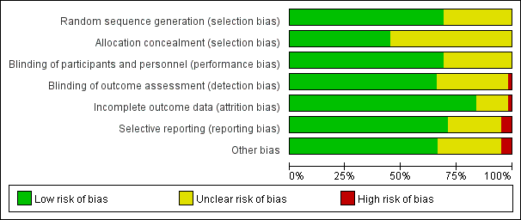

5.2 Risk of bias table: it shows the distribution of judgments (Yes, No, Unclear) across studies for each risk of bias entry

Study/Year | Random sequence generation (selection bias) | Allocation concealment (selection bias) | Blinding of participants and personel (performance bias) | Blinding of outcome asessment (detection bias) | Incomplete outcome data (attrition bias) | Selective reporting (reporting bias) | Other bias
Agarwal,A 2006 | Low risk | Unclear | Low risk | Low risk | Low risk | High risk | Low risk
Agarwal,A 2009 | Low risk | Unclear | Unclear | Low risk | Low risk | Low risk | Low risk
Ahuja,V 2015 | Low risk | Unclear | Low risk | Low risk | Low risk | Unclear | Unclear
Akram,A 2013 | Low risk | Low risk | Unclear | Unclear | Low risk | Low risk | Low risk
Ashiwini 2018 | Unclear | Unclear | Unclear | Low risk | Low risk | Low risk | Low risk
Ayoub,C 1998 | Unclear | Unclear | Low risk | Low risk | Unclear | Low risk | Unclear
Banihashem,N 2015 | Unclear | Unclear | Low risk | Low risk | Low risk | Low risk | Unclear
Bashir 2014 | Low risk | Unclear | Low risk | Low risk | Low risk | Low risk | Low risk
Borazan,H 2012 | Low risk | Unclear | Unclear | Low risk | Low risk | Unclear | Low risk
Canbay,O 2008 | Low risk | Low risk | Low risk | Low risk | Low risk | Unclear | Unclear
Chang JE 2015 | Low risk | Low risk | Low risk | Low risk | Low risk | Unclear | Low risk
Charan SD 2018 | Low risk | Low risk | Low risk | Low risk | Low risk | Unclear | Unclear
Chari,VR 2016 | Unclear | Unclear | Unclear | Low risk | Low risk | Low risk | Low risk
Dong 2015 | Unclear | Unclear | Unclear | Unclear | Low risk | Low risk | Low risk
Doukumo, D 2011 | Low risk | Low risk | Low risk | Unclear | Low risk | Low risk | High risk
Fayyaz A，2017 | Low risk | Low risk | Unclear | Low risk | Low risk | Low risk | Low risk
Firza,I 2017 | Unclear | Unclear | Low risk | Low risk | Low risk | Low risk | Low risk
Furqan,A 2016 | Unclear | Unclear | Low risk | Unclear | Low risk | Low risk | Unclear
Gaikwad,S 2017 | Low risk | Low risk | Low risk | Low risk | Low risk | Low risk | Low risk
Gojendra,R 2012 | Unclear | Unclear | Unclear | Unclear | Low risk | Low risk | Low risk
Gulhas,N 2007 | Low risk | Unclear | Low risk | Low risk | Unclear | Low risk | Low risk
Gupta,D 2013 | Low risk | Low risk | Low risk | Unclear | Low risk | Low risk | Low risk
Hara K,2005 | Low risk | Low risk | Low risk | Low risk | High risk | Unclear | Unclear
Honarmand,2015 | Low risk | Low risk | Low risk | Unclear | Low risk | High risk | Unclear
Huang,Y 2010 | Unclear | Unclear | Low risk | Low risk | Low risk | Low risk | Low risk
Hung,N 2010 | Low risk | Low risk | Low risk | Low risk | Low risk | Low risk | Low risk
Ibrahim 2017 | Low risk | Low risk | Low risk | Low risk | Low risk | Low risk | Low risk
Jain 2017 | Low risk | Unclear | Low risk | Unclear | Low risk | Low risk | Low risk
Kajal K，2019 | Low risk | Low risk | Low risk | Unclear | Low risk | Unclear | Unclear
Kati, I，2004 | Unclear | Unclear | Low risk | Low risk | Low risk | Low risk | Unclear
Kazema,A 2007 | Unclear | Unclear | Unclear | Low risk | Low risk | Low risk | Low risk
Kiran,S 2011 | Low risk | Low risk | Low risk | Low risk | Low risk | Unclear | Low risk
Lee,J 2017 | Low risk | Low risk | Low risk | Low risk | Low risk | Low risk | Low risk
Lin 2016 | Low risk | Low risk | Unclear | Unclear | Low risk | Low risk | Low risk
Mekhemar,NA2016 | Low risk | Low risk | Low risk | Unclear | Unclear | Low risk | Low risk
Muhamad,M 2015 | Unclear | Unclear | Low risk | Unclear | Unclear | Low risk | Low risk
Narimar,M 2016 | Low risk | Low risk | Low risk | Low risk | Low risk | Low risk | Low risk
Navarro, R. M，1997 | Low risk | Low risk | Low risk | Unclear | Unclear | Unclear | Unclear
Rahimi M,2009 | Low risk | Low risk | Low risk | Low risk | Low risk | Unclear | Unclear
Rajan,S/2017 | Low risk | Low risk | Low risk | Low risk | Low risk | Low risk | Unclear
Rajan,S/2018 | Low risk | Unclear | Unclear | Unclear | Low risk | Low risk | Low risk
Ren, 2013 | Unclear | Unclear | Low risk | Unclear | Low risk | Low risk | Low risk
Rudra A，2009 | Unclear | Unclear | Unclear | Low risk | Low risk | Unclear | Unclear
Ruetzler/2013 | Low risk | Low risk | Low risk | Low risk | Low risk | Low risk | Low risk
Sarki 2015 | Low risk | Low risk | Low risk | Low risk | Low risk | Low risk | Low risk
Segaran,S2018 | Low risk | Low risk | Low risk | Low risk | Low risk | Unclear | Unclear
Shaaban AR，2012 | Low risk | Unclear | Unclear | Low risk | Low risk | Low risk | Low risk
Sharma,M 2017 | Unclear | Low risk | Low risk | Low risk | Low risk | Low risk | Low risk
Shen 2018 | Low risk | Low risk | Unclear | Unclear | Low risk | Low risk | Low risk
Shrestha SK，2010 | Low risk | Low risk | Unclear | Unclear | Low risk | Low risk | Low risk
Soltani 2012 | Low risk | Unclear | Low risk | Unclear | Unclear | Low risk | High risk
Sumathi,P 2008 | Low risk | Unclear | Low risk | Unclear | Unclear | Low risk | High risk
Tabari M，2013 | Unclear | Unclear | Unclear | Low risk | Low risk | Low risk | Low risk
Tazeh-kand,N2009 | Low risk | Unclear | Unclear | Low risk | Unclear | Low risk | Low risk
Teymourian,H 2015 | Low risk | Unclear | Unclear | Low risk | Low risk | High risk | Low risk
Thapa,P 2017 | Low risk | Unclear | Unclear | High risk | Low risk | Low risk | Unclear
Thomas,D 2018 | Low risk | Unclear | Low risk | Low risk | Low risk | Unclear | Unclear
Wu 2013 | Unclear | Unclear | Low risk | Unclear | Low risk | Low risk | Low risk
YadaV,M 2016 | Low risk | Low risk | Low risk | Low risk | Unclear | Low risk | Unclear
Yang,C | Low risk | Unclear | Low risk | Low risk | Low risk | Low risk | Low risk
Yang,HL,2016 | Unclear | Unclear | Low risk | Low risk | Low risk | Low risk | Low risk
Zheng 2016 | Unclear | Unclear | Low risk | Low risk | Low risk | Low risk | Low risk
Agarwal,A 2006 | Low risk | Unclear | Low risk | Low risk | Low risk | High risk | Low risk
Agarwal,A 2009 | Low risk | Unclear | Unclear | Low risk | Low risk | Low risk | Low risk

Appendix 6

Direct comparison of drugs for preventing sore throat after endotracheal intubation

(a) Direct comparison of drugs for preventing sore throat after endotracheal intubation 0-1h.

treatment comparisons | result of pair-wise meta-analysis | I2(%) | P
Lidocaine vs Corticosteroid | 1.6 （1.23， 2.06） | 46 | 0.1
Lidocaine vs NSAIDs | 1.81（1.08， 3.03） | 0 | 0.59
Lidocaine vs Placebo | 0.98 (0.87, 1.10) | 84 | 0.001
Lidocaine vs Magnesium | 1.98（0.97, 3.70） | NA | NA
NSAIDs vs Placebo | 0.41 (0.35， 0.49） | 67 | 0.002
NSAIDs vs Corticosteroid | 1.07 (0.97, 1.19) | NA | NA
NSAIDs vs ketamine | 1.29 (0.83, 1.99) | NA | NA
Corticosteroid vs Placebo | 0.51 (0.44, 0.59) | 93 | 0.001
Corticosteroid vs ketamine | 0.61 (0.32, 1.17) | 69 | 0.07
Corticosteroid vs Magnesium | 0.44 (0.20, 0.95) | NA | NA
Magnesium vs ketamine | 1.02 (0.69, 1.51) | 0 | 0.97
Magnesium vs Placebo | 0.35 (0.27, 0.46) | 27 | 0.21
ketamine vs Glycyrrhiza | 0.66 (0.18, 2.36) | NA | NA
ketamine vs Placebo | 0.45 (0.36, 0.57) | 0 | 0.93
Glycyrrhiza vs Placebo | 0.39 (0.30, 0.49) | 0 | 0.8

(b) Direct comparison of drugs for preventing sore throat after endotracheal intubation 2-3h.

2-3h
Lidocaine vs Corticosteroid | 1.09 (0.55, 2.18) | NA | NA
Lidocaine vs NSAIDs | 1.81 (1.08, 3.03) | 0 | 0.59
Lidocaine vs Placebo | 0.60 (0.39, 0.92) | 0 | 0.42
NSAIDs vs Placebo | 0.42 (0.35, 0.50) | 48 | 0.11
Corticosteroid vs Placebo | 0.40 (0.27, 0.59) | 0 | 0.67
Magnesium vs ketamine | 2.00 (0.94, 4.28) | 59 | 0.09
Magnesium vs Placebo | 0.50 (0.37, 0.67) | 44 | 0.13
ketamine vs Glycyrrhiza | 1.00 (0.28, 3.63) | NA | NA
ketamine vs Placebo | 0.35 (0.27, 0.47) | 4 | 0.41
Glycyrrhiza vs Placebo | 0.14 (0.07, 0.27) | 0 | 0.46

(c) Direct comparison of drugs for preventing sore throat after endotracheal intubation 4-6h.

4-6h
Lidocaine vs Corticosteroid | 1.97 (1.56, 2.49) | 81 | 0.001
Lidocaine vs NSAIDs | 2.16 (1.48, 3.15) | 0 | 0.97
Lidocaine vs Magnesium | 2.40 (1.34, 4.31) | NA | NA
Lidocaine vs Placebo | 0.84 (0.64, 1.09) | 57 | 0.007
NSAIDs vs Placebo | 0.46 (0.40, 0.54) | 91 | 0.001
NSAIDs vs Corticosteroid | 1.06 (0.83, 1.36) | NA | NA
NSAIDs vs ketamine | 2.20 (0.72, 6.73) | NA | NA
Corticosteroid vs Placebo | 0.36 (0.30, 0.44) | 78 | 0.001
Corticosteroid vs ketamine | 0.43 (0.18, 1.03) | 46 | 0.17
Corticosteroid vs Magnesium | 0.30 (0.15, 0.63) | NA | NA
Magnesium vs ketamine | 1.04 (0.69, 1.55) | 73 | 0.01
Magnesium vs Placebo | 0.37 (0.29, 0.48) | 0 | 0.66
ketamine vs Glycyrrhiza | 0.50 (0.05, 5.22) | NA | NA
ketamine vs Placebo | 0.46 (0.37, 0.56) | 28 | 0.16
Glycyrrhiza vs Placebo | 0.39 (0.30, 0.51) | 0 | 0.77

(d) Direct comparison of drugs for preventing sore throat after endotracheal intubation 24h.

24h
Lidocaine vs Corticosteroid | 2.22 (1.82, 2.71) | 40 | 0.12
Lidocaine vs NSAIDs | 3.50 (1.91, 6.41) | 24 | 0.26
Lidocaine vs Placebo | 1.01 (0.91, 1.13) | 48 | 0.01
Lidocaine vs Magnesium | 2.83 (1.25, 6.40) | NA | NA
NSAIDs vs Placebo | 0.32 (0.25, 0.40) | 72 | 0.001
NSAIDs vs Corticosteroid | 1.05 (0.67, 1.65) | NA | NA
NSAIDs vs ketamine | 0.96 (0.80, 1.14) | NA | NA
Corticosteroid vsPlacebo | 0.38 (0.32, 0.44) | 41 | 0.05
Corticosteroid vsketamine | 0.60 (0.15, 2.40) | 40 | 0.2
Corticosteroid vsMagnesium | 1.00 (0.06, 15.44) | NA | NA
Magnesium vs ketamine | 0.37 (0.22, 0.62) | 38 | 0.2
Magnesium vs Placebo | 0.29 (0.19, 0.42) | 0 | 0.84
ketamine vs Placebo | 0.47 (0.36, 0.62) | 15 | 0.28
Glycyrrhiza vs Placebo | 0.33 (0.23, 0.50) | 1 | 0.4

Appendix 7

Contribution plot for postoperative sore throat after tracheal intubation

(a)
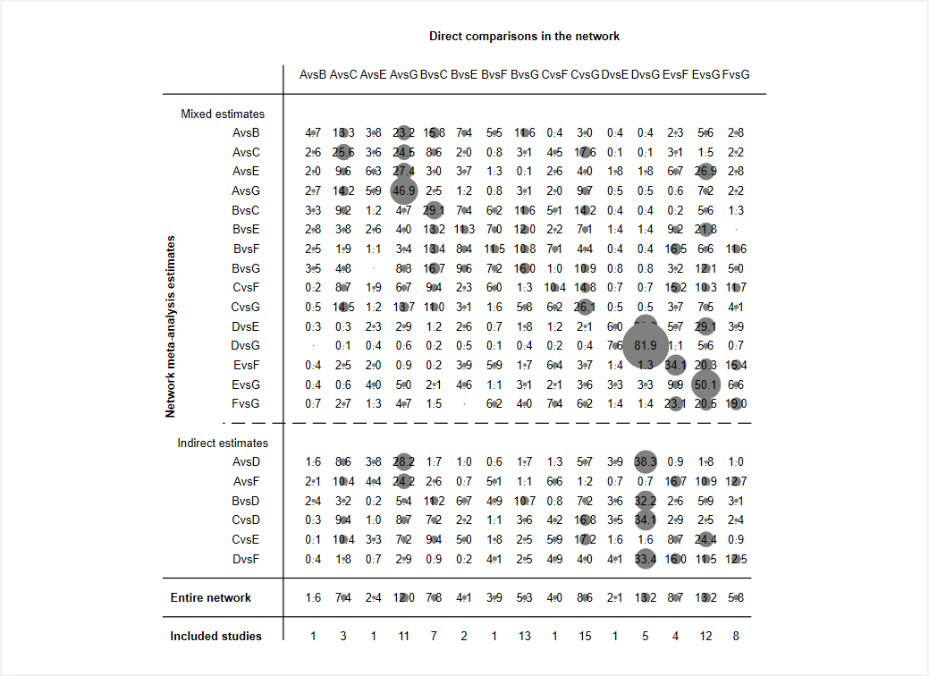
Note: 0-1h Contribution plot for postoperative sore throat after tracheal intubation. The size of the squares is proportional to the contribution percentage of the column-defining direct comparison to the row-defining network estimate. A= NSAIDs, B= Corticosteroid, C= Lidocaine, D= Glycyrrhiza, E= Ketamine, F= Magnesium, G= Placebo
(b)
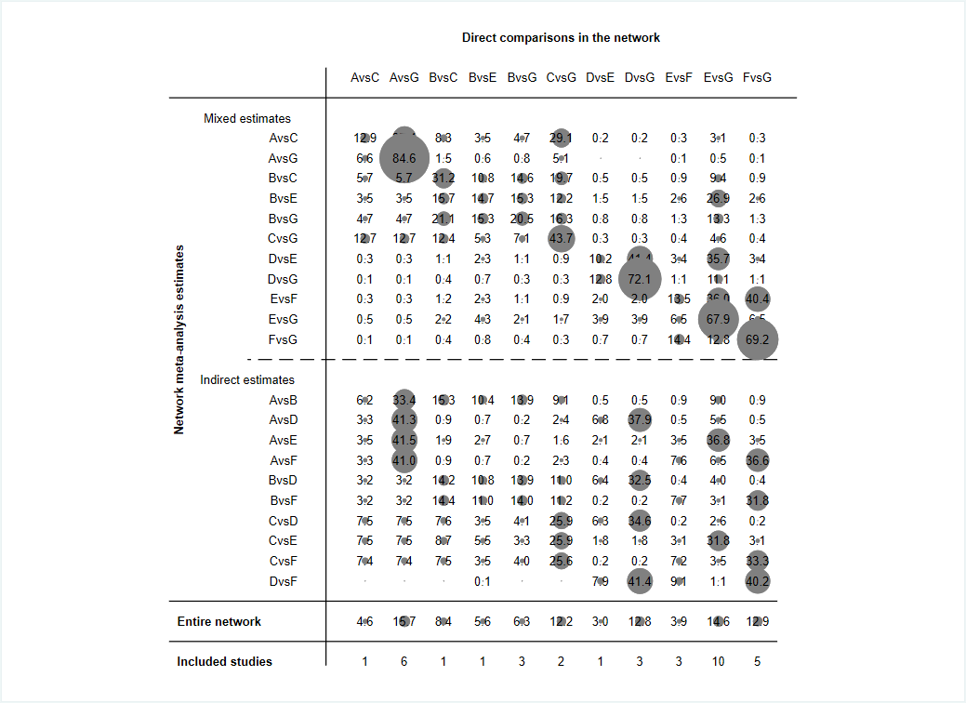

Note: 2-3h Contribution plot for postoperative sore throat after tracheal intubation. The size of the squares is proportional to the contribution percentage of the column-defining direct comparison to the row-defining network estimate. A= NSAIDs, B= Corticosteroid, C= Lidocaine, D= Glycyrrhiza, E= Ketamine, F= Magnesium, G= Placebo

(c)
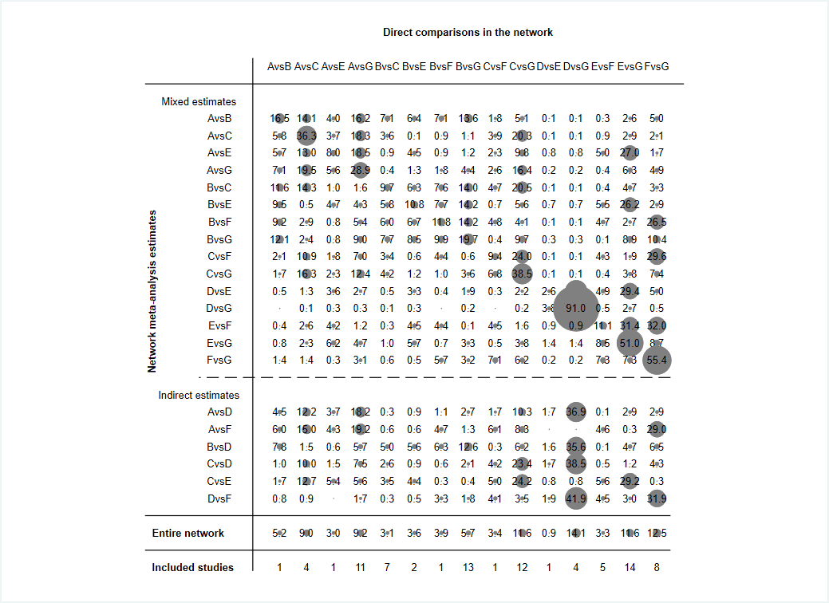
Note: 4-6h Contribution plot for postoperative sore throat after tracheal intubation. The size of the squares is proportional to the contribution percentage of the column-defining direct comparison to the row-defining network estimate.A= NSAIDs, B= Corticosteroid, C= Lidocaine, D= Glycyrrhiza, E= Ketamine, F= Magnesium, G= Placebo
(d)
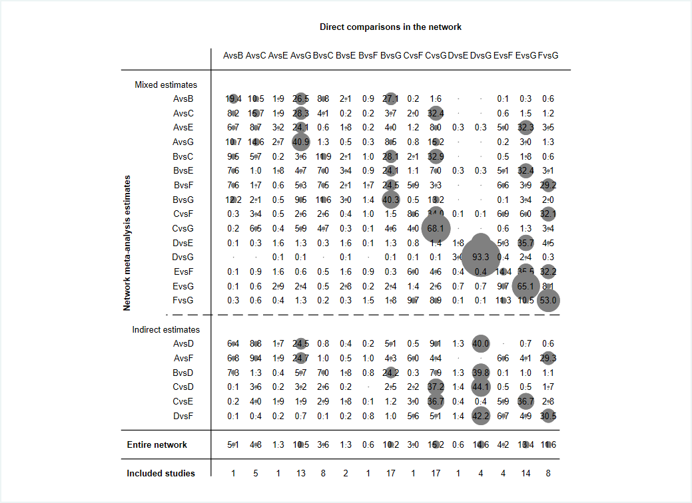
Note: 24h Contribution plot for postoperative sore throat after tracheal intubation. The size of the squares is proportional to the contribution percentage of the column-defining direct comparison to the row-defining network estimate. A= NSAIDs, B= Corticosteroid, C= Lidocaine, D= Glycyrrhiza, E= Ketamine, F= Magnesium, G= Placebo

Appendix 8

Plots of cumulative ranking probability on the impact of postoperative sore throat after tracheal intubation (SUCRA)

8.1 SUCRA: surface under the cumulative ranking curve.
(a) 0-1h
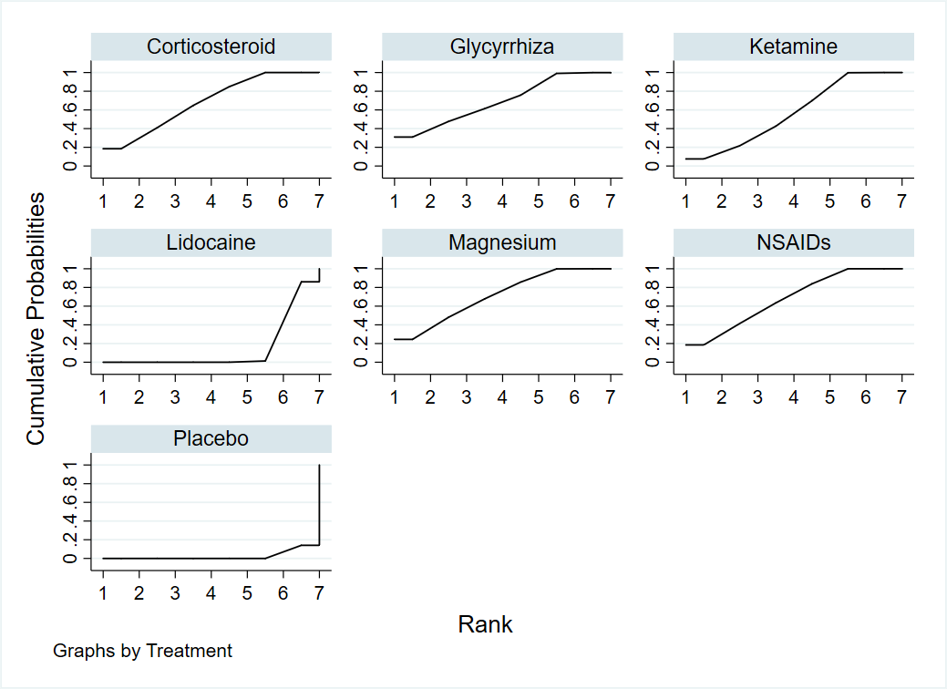

Note: Ranking: the probability of being the best, the second best, or the third best treatment, and so on, among the 7 comparisons. SUCRA: surface under the cumulative ranking curve.

(b) 2-3h
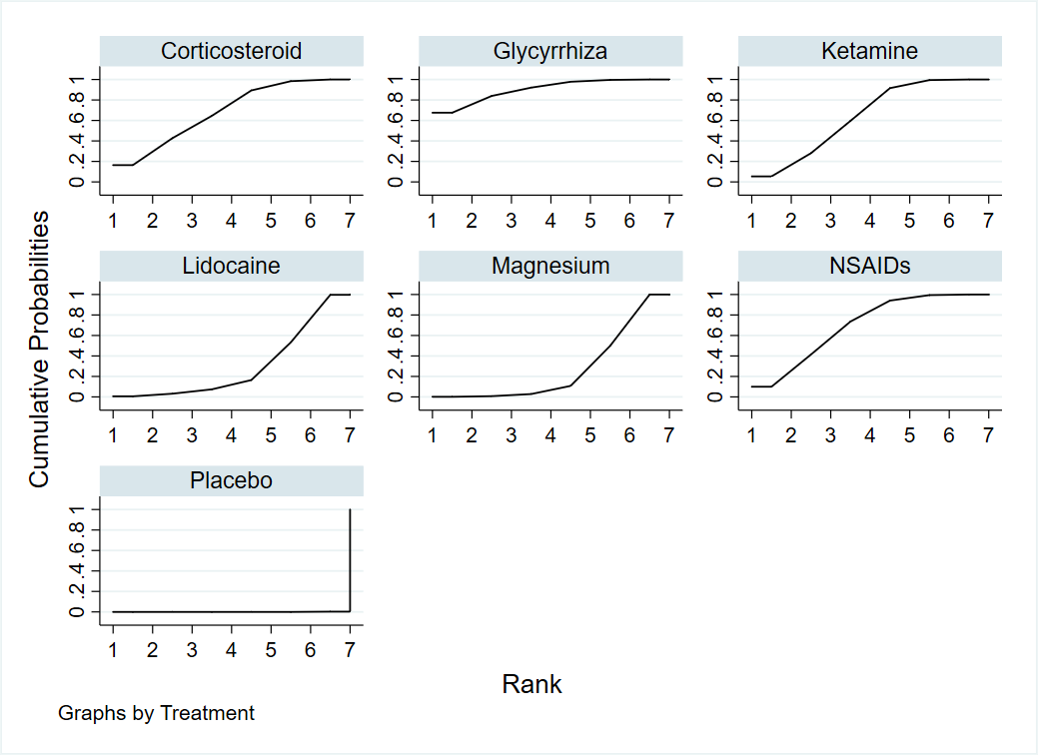
Note: Ranking: the probability of being the best, the second best, or the third best treatment, and so on, among the 7 comparisons. SUCRA: surface under the cumulative ranking curve.
(c) 4-6h
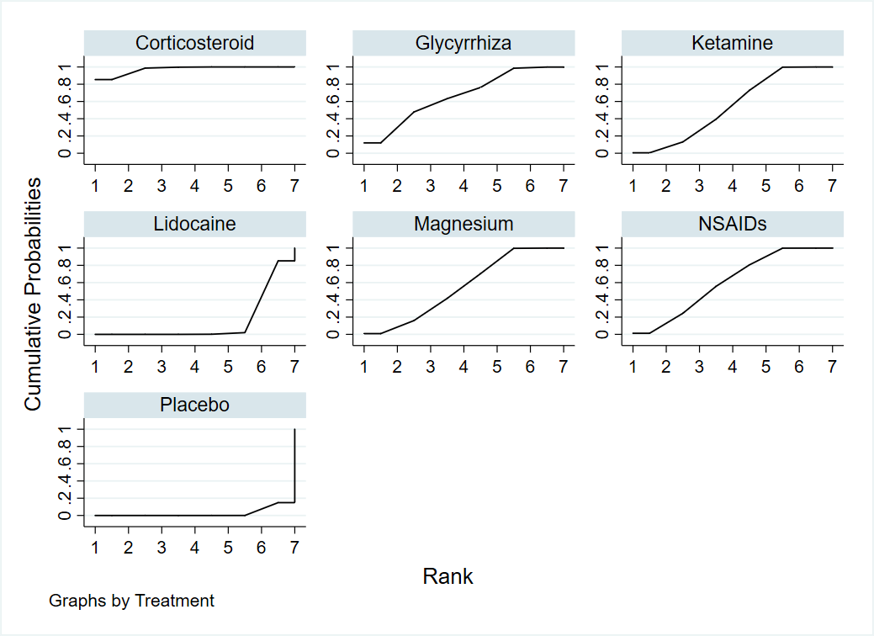

Note: Ranking: the probability of being the best, the second best, or the third best treatment, and so on, among the 7 comparisons. SUCRA: surface under the cumulative ranking curve.

(d) 24h
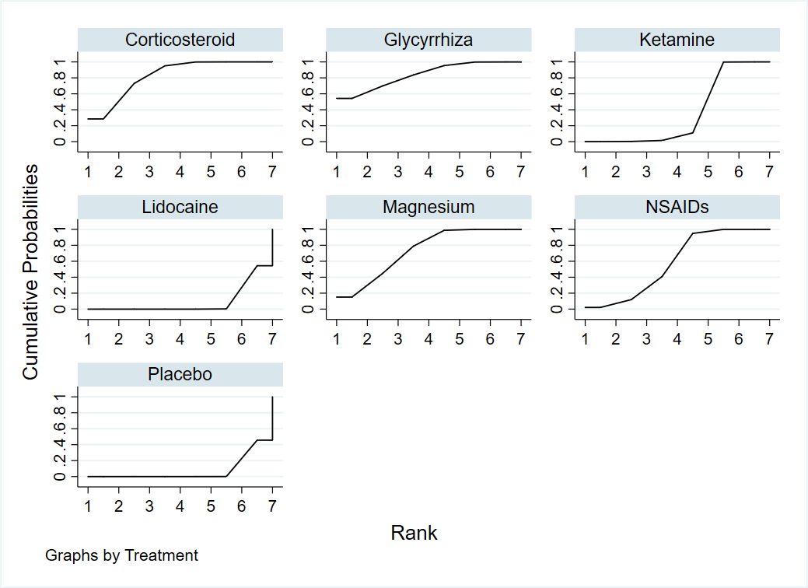

Note: Ranking: the probability of being the best, the second best, or the third best treatment, and so on, among the 7 comparisons. SUCRA: surface under the cumulative ranking curve.

8.2 Ranking probability of different drugs on postoperative sore throat after tracheal intubation
Treatment | 0-1h |  | 2-3h |  | 4-6h |  | 24h
 | SUCRA | Rank | SUCRA | Rank | SUCRA | Rank | SUCRA | Rank
Corticosteroid | 68.2 | 3 | 68.5 | 3 | 97.3 | 1 | 82.7 | 2
Ketamine | 56.9 | 5 | 64.0 | 4 | 54.3 | 5 | 35.4 | 5
Lidocaine | 14.6 | 6 | 30.1 | 5 | 14.6 | 6 | 9.1 | 6
Glycyrrhiza | 69.1 | 2 | 90.2 | 1 | 66.3 | 2 | 83.8 | 1
Magnesium | 71.0 | 1 | 27.4 | 6 | 54.8 | 4 | 73.0 | 3
NSAIDs | 67.9 | 4 | 69.7 | 2 | 60.3 | 3 | 58.3 | 4
Placebo | 2.3 | 7 | 0.0 | 7 | 2.5 | 7 | 7.6 | 7

Note: Ranking probability of different drugs on postoperative sore throat after tracheal intubation. Ranking: the probability of being the best, the second best, or the third best treatment, and so on, among all treatments. Rank 1 is the best, and Rank N is the worst.

Appendix 9

Assessment of transitivity
(a)
Assessments of transition results on six drugs to prevent postoperatively sore throat performed 0-1h after operation

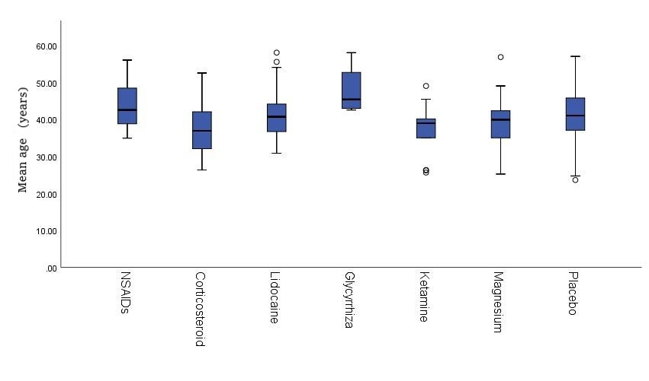

Note: The ordinate represents the mean age, and the abscissa represents each of the seven interventions.

(b)
Assessments of transition results on six drugs to prevent postoperatively sore throat performed 2-3h after operation

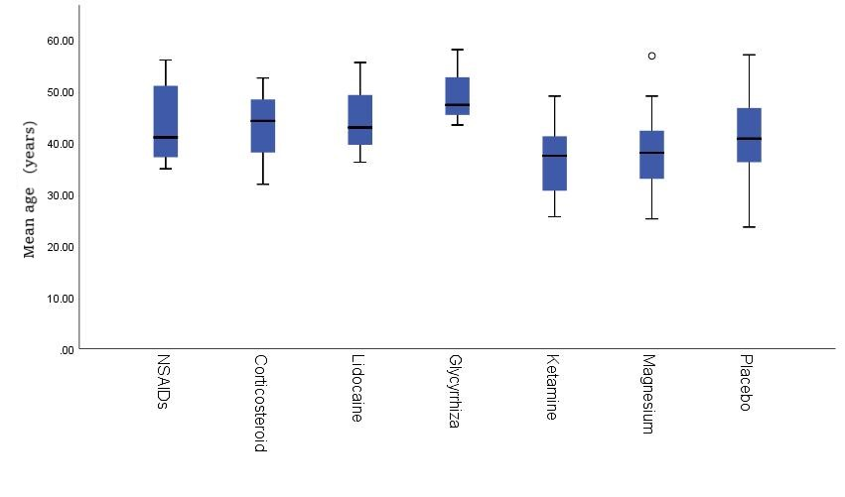

Note: The ordinate represents the mean age, and the abscissa represents each of the seven interventions.

(c)
Assessments of transition results on six drugs preventing postoperative sore throat performed 4-6h after operation

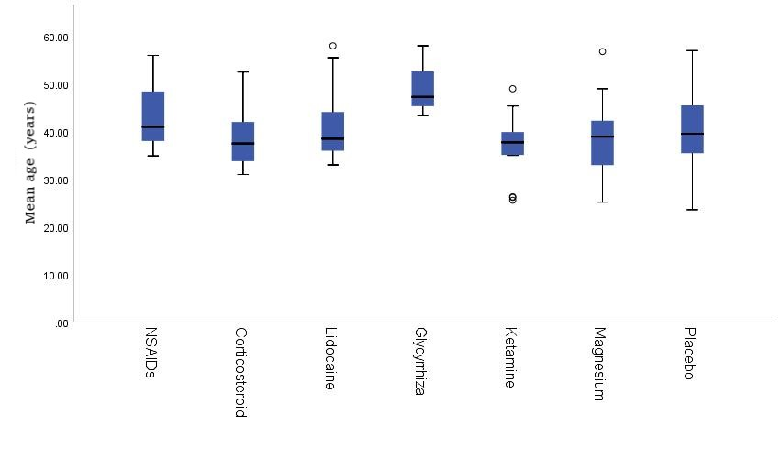

Note: The ordinate represents the mean age, and the abscissa represents each of the seven interventions.

(d)
Assessments of transition results on six drugs to prevent postoperatively sore throat performed 24h after operation

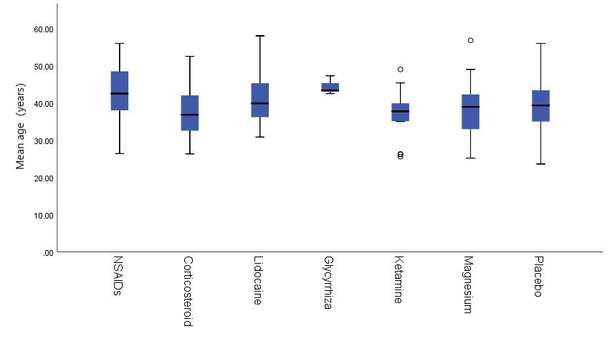

Note: The ordinate represents the mean age, and the abscissa represents each of the seven interventions.

Examination of possible effective modifiers indicated that age was evenly distributed across the comparisons but not baseline severity.

Appendix 10

Assessment of inconsistency results: local and from the node-splitting model

10.1 Evaluation of the local inconsistency: forest plots of inconsistency check for all closed loops in the network
(a) 0-1h
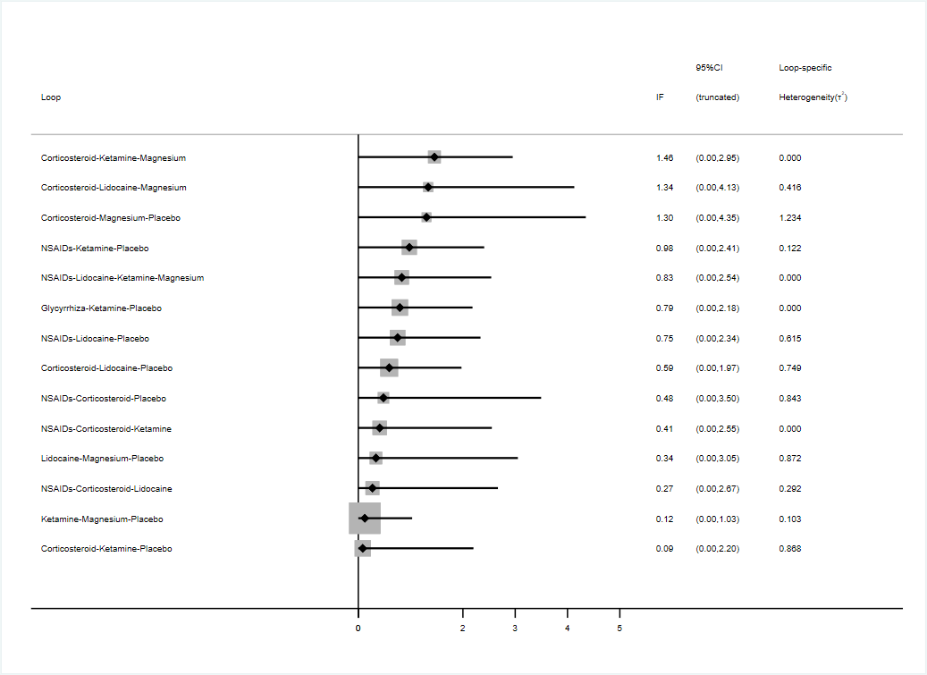

Note: Calculation of the Inconsistency Factor (IF) for each loop is based on loop specific approach. The IF 95% CI of each loop includes 0, indicating that the loop is consistent. Test for local inconsistency showed that all loops were consistent within 0-1h.

(b) 2-3h
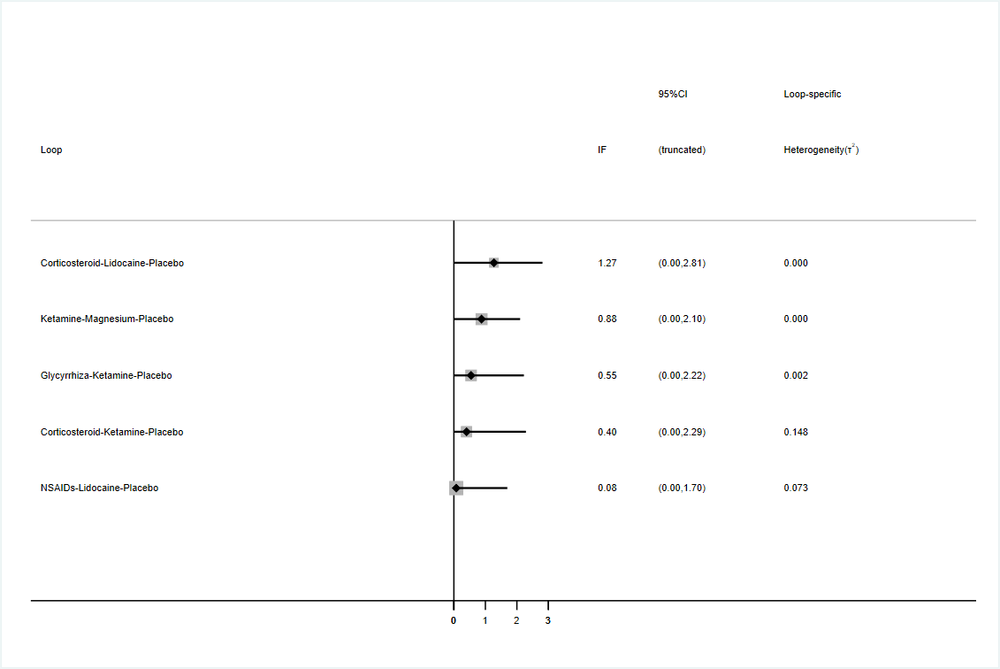

Note: Calculation of the Inconsistency Factor (IF) for each loop is based on loop specific approach. The IF 95% CI of each loop includes 0, indicating that the loop is consistent. Test for local inconsistency showed that all loops were consistent within 2-3h.

(c) 4-6h
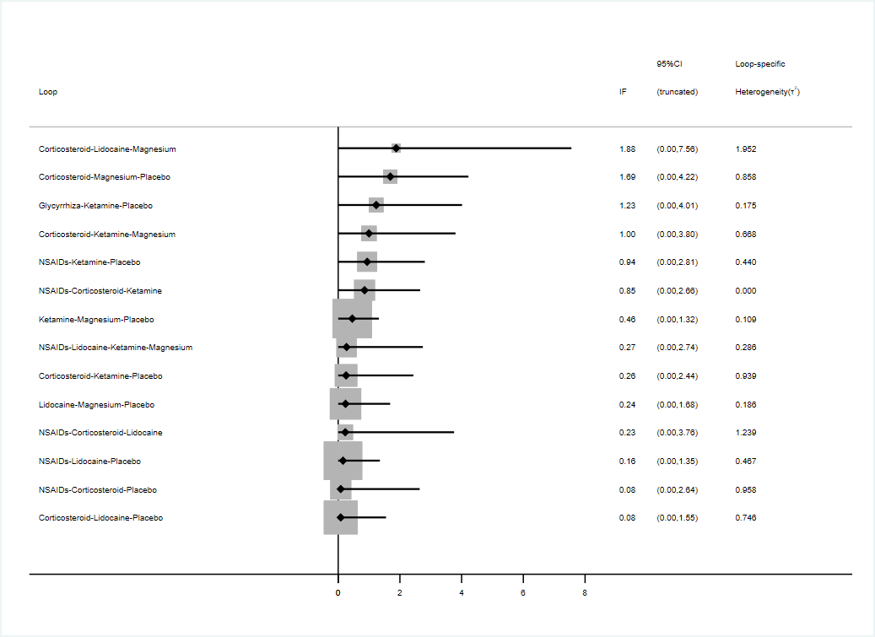

Note: Calculation of the Inconsistency Factor (IF) for each loop is based on loop specific approach. The IF 95% CI of each loop includes 0, indicating that the loop is consistent. Test for local inconsistency showed that all loops were consistent within 4-6h.

(d) 24h
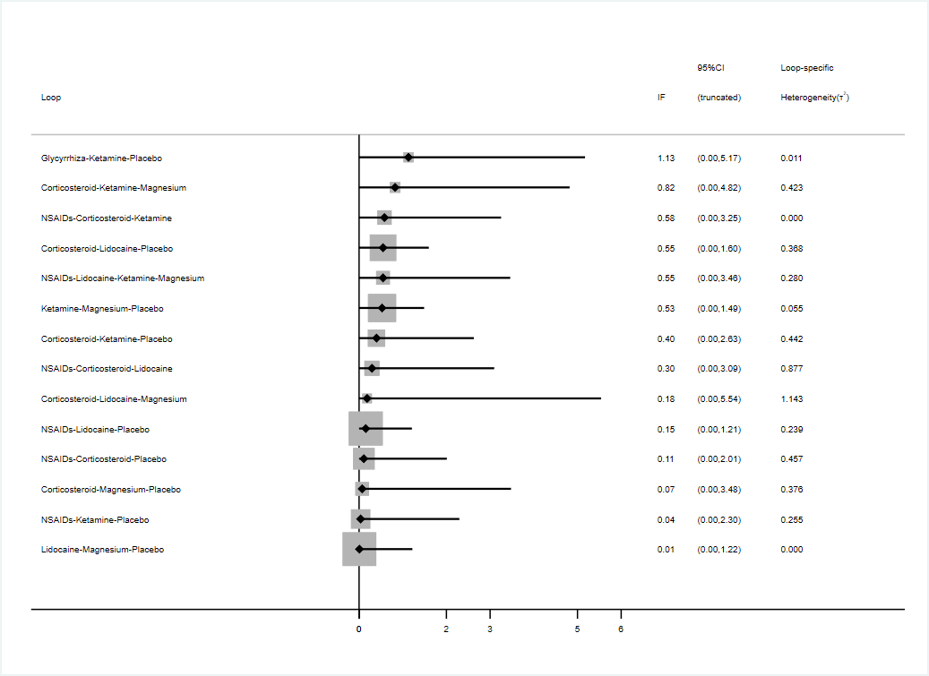

Note: Calculation of the Inconsistency Factor (IF) for each loop is based on loop specific approach. The IF 95% CI of each loop includes 0, indicating that the loop is consistent. Test for local inconsistency showed that all loops were consistent at 24h.

10.2 Evaluation of the inconsistency by node-splitting model
(a) 0-1h
Name | Direct Effect | Indirect Effect | Overall | P-Value
Corticosteroid, Ketamine | -0.26 (-2.49, 1.93) | 0.18 (-0.62, 0.97) | 0.13 (-0.63, 0.89) | 0.7
Corticosteroid, Lidocaine | 1.01 (0.26, 1.77) | 1.52 (0.69, 2.34) | 1.21 (0.60, 1.83) | 0.35
Corticosteroid, Magnesium | 1.19 (-0.81, 3.28) | -0.25 (-1.11, 0.62) | -0.03 (-0.84, 0.77) | 0.2
Corticosteroid, NSAIDs | -0.01 (-2.50, 2.54) | -0.02 (-0.81, 0.74) | 0.00 (-0.73, 0.75) | 0.99
Corticosteroid, Placebo | 1.47 (0.86, 2.07) | 1.31 (0.52, 2.12) | 1.48 (0.94, 2.01) | 0.76
Ketamine ,Glycyrrhiza | 0.34 (-1.77, 2.53) | -0.30 (-1.45, 0.85) | -0.16 (-1.18, 0.85) | 0.59
Ketamine , Magnesium | -0.41 (-1.46, 0.67) | 0.11 (-0.90, 1.13) | -0.16 (-0.91, 0.60) | 0.48
Ketamine , NSAIDs | 0.12 (-1.44, 1.67) | -0.21 (-1.02, 0.63) | -0.13 (-0.86, 0.62) | 0.71
Ketamine , Placebo | 1.35 (0.73, 2.01) | 1.38 (0.46, 2.27) | 1.34 (0.78, 1.91) | 0.97
Lidocaine, Magnesium | -0.97 (-3.04, 1.04) | -1.31 (-2.18, -0.48) | -1.24 (-2.04, -0.45) | 0.76
Lidocaine, NSAIDs | -0.74 (-1.97, 0.53) | -1.37 (-2.19, -0.56) | -1.21 (-1.91, -0.52) | 0.4
Lidocaine, Placebo | 0.24 (-0.25, 0.75) | 0.66 (-0.08, 1.43) | 0.27 (-0.22, 0.75) | 0.33
Magnesium, Placebo | 1.65 (0.88, 2.43) | 1.30 (0.33, 2.28) | 1.51 (0.85, 2.17) | 0.56
NSAIDs, Placebo | 1.55 (0.95, 2.15) | 1.16 (0.20, 2.12) | 1.47 (0.92, 2.02) | 0.48

Note: The node splitting method was used to assess model inconsistency by separating evidence into indirect and direct categories and then the P values were calculated. The consistency model was used when the P value of the node-splitting analysis is greater than 0.05.

(b) 2-3h
Name | Direct Effect | Indirect Effect | Overall | P-Value
Corticosteroid, Ketamine | -0.00 (-1.43, 1.46) | 0.03 (-0.82, 0.95) | 0.03 (-0.79, 0.85) | 0.95
Corticosteroid, Lidocaine | 0.36 (-0.89, 1.42) | 1.12 (-0.23, 2.47) | 0.61 (-0.30, 1.60) | 0.36
Ketamine , Glycyrrhiza | 0.09 (-1.63, 1.59) | -0.66 (-1.69, 0.33) | -0.38 (-1.27, 0.48) | 0.41
Ketamine , Magnesium | 0.80 (-0.03, 1.74) | 0.32 (-0.58, 1.23) | 0.57 (-0.04, 1.20) | 0.42
Ketamine , Placebo | 1.63 (1.17, 1.99) | 2.13 (1.26, 2.82) | 1.63 (1.22, 2.06) | 0.23
Lidocaine, NSAIDs | -0.51 (-2.08, 0.75) | -0.72 (-1.68, 0.24) | -0.64 (-1.53, 0.21) | 0.79
Magnesium, Placebo | 1.30 (0.71, 1.92) | 0.07 (-1.20, 1.10) | 1.06 (0.53, 1.61) | 0.06

Note: The node splitting method was used to assess model inconsistency by separating evidence into indirect and direct categories and then the P values were calculated. The consistency model was used when the P value of the node-splitting analysis is greater than 0.05.

(c) 4-6h
Name | Direct Effect | Indirect Effect | Overall | P-Value
Corticosteroid, Ketamine | 0.41 (-1.91, 2.69) | 0.94 (0.15, 1.72) | 0.92 (0.18, 1.65) | 0.65
Corticosteroid, Lidocaine | 2.05 (1.22, 2.95) | 2.16 (1.18, 3.14) | 2.03 (1.37, 2.68) | 0.88
Corticosteroid, Magnesium | 1.91 (-0.13, 3.97) | 0.73 (-0.12, 1.60) | 0.90 (0.13, 1.69) | 0.27
Corticosteroid, NSAIDs | 0.82 (-1.19, 2.81) | 0.71 (-0.08, 1.52) | 0.83 (0.10, 1.57) | 0.91
Corticosteroid, Placebo | 2.26 (1.58, 2.94) | 2.44 (1.56, 3.32) | 2.32 (1.76, 2.89) | 0.74
Ketamine , Glycyrrhiza | 0.20 (-2.76, 2.92) | -0.30 (-1.59, 0.96) | -0.24 (-1.40, 0.90) | 0.74
Ketamine , Magnesium | 0.10 (-0.82, 1.07) | -0.07 (-1.06, 0.94) | -0.01 (-0.68, 0.67) | 0.79
Ketamine , NSAIDs | -0.06 (-1.63, 1.50) | -0.12 (-0.92, 0.68) | -0.09 (-0.80, 0.63) | 0.95
Ketamine , Placebo | 1.34 (0.78, 1.91) | 1.62 (0.71, 2.56) | 1.41 (0.91, 1.93) | 0.57
Lidocaine, Magnesium | -1.62 (-3.60, 0.38) | -1.04 (-1.89, -0.18) | -1.12 (-1.90, -0.35) | 0.59
Lidocaine, NSAIDs | -1.14 (-2.23, -0.08) | -1.19 (-2.05, -0.34) | -1.20 (-1.90, -0.51) | 0.94
Lidocaine, Placebo | 0.42 (-0.18, 1.04) | 0.13 (-0.64, 0.91) | 0.30 (-0.26, 0.84) | 0.53
Magnesium, Placebo | 1.63 (0.90, 2.35) | 1.10 (0.22, 2.00) | 1.43 (0.80, 2.03) | 0.34
NSAIDs, Placebo | 1.49 (0.92, 2.08) | 1.45 (0.56, 2.38) | 1.50 (0.95, 2.04) | 0.94
Note: The node splitting method was used to assess model inconsistency by separating evidence into indirect and direct categories and then the P values were calculated. The consistency model was used when the P value of the node-splitting analysis is greater than 0.05.

(d) 24h
Name | Direct Effect | Indirect Effect | Overall | P-Value
Corticosteroid, Ketamine | -1.16 (-4.91, 1.55) | 1.20 (0.46, 1.96) | 1.07 (0.34, 1.81) | 0.1
Corticosteroid, Lidocaine | 2.06 (1.28, 2.88) | 2.17 (1.38, 3.00) | 2.11 (1.55, 2.73) | 0.83
Corticosteroid, Magnesium | 0.04 (-4.01, 4.20) | 0.20 (-0.68, 1.11) | 0.18 (-0.68, 1.03) | 0.94
Corticosteroid, NSAIDs | 0.62 (-1.30, 2.52) | 0.32 (-0.43, 1.07) | 0.45 (-0.23, 1.15) | 0.76
Corticosteroid, Placebo | 2.17 (1.62, 2.74) | 1.92 (1.13, 2.79) | 2.14 (1.67, 2.67) | 0.62
Ketamine ,Glycyrrhiza | -51.37 (-128.36, -2.29) | -1.10 (-2.70, 0.45) | -1.27 (-2.84, 0.21) | 0.06
Ketamine , Magnesium | -1.17 (-2.31, -0.03) | -0.66 (-1.81, 0.42) | -0.88 (-1.71, -0.08) | 0.51
Ketamine , NSAIDs | -0.77 (-2.96, 1.10) | -0.59 (-1.42, 0.20) | -0.60 (-1.37, 0.13) | 0.87
Ketamine , Placebo | 1.13 (0.53, 1.77) | 0.87 (-0.21, 1.97) | 1.08 (0.53, 1.65) | 0.64
Lidocaine, Magnesium | -1.53 (-3.66, 0.56) | -2.03 (-2.96, -1.12) | -1.94 (-2.78, -1.11) | 0.66
Lidocaine, NSAIDs | -1.73 (-2.90, -0.65) | -1.61 (-2.43, -0.82) | -1.66 (-2.31, -1.01) | 0.86
Lidocaine, Placebo | 0.09 (-0.41, 0.60) | 0.03 (-0.71, 0.79) | 0.03 (-0.42, 0.50) | 0.89
Magnesium, Placebo | 1.80 (1.00, 2.65) | 2.18 (1.12, 3.30) | 1.97 (1.26, 2.71) | 0.53
NSAIDs, Placebo | 1.68 (1.11, 2.27) | 1.64 (0.76, 2.58) | 1.69 (1.17, 2.26) | 0.94
Note: The node splitting method was used to assess model inconsistency by separating evidence into indirect and direct categories and then the P values were calculated. The consistency model was used when the P value of the node-splitting analysis is greater than 0.05.

Appendix 11

Predictive intervals plot for postoperative sore throat after tracheal intubation

- 0-1h
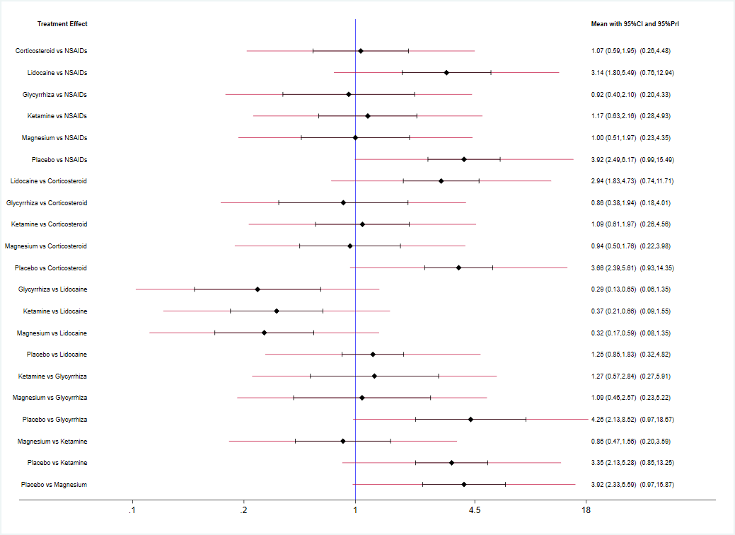
Note: The graph presents the network estimates for all pairwise comparisons. The length of the red lines represent the predictive intervals. Black lines terminating in vertical bars represent the credible intervals.
- 2-3h

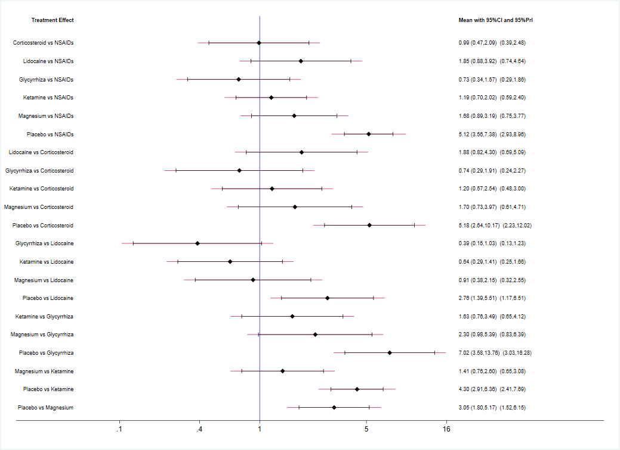
Note: The graph presents the network estimates for all pairwise comparisons. The length of the red lines represent the predictive intervals. Black lines terminating in vertical bars represent the credible intervals.
- 4-6h
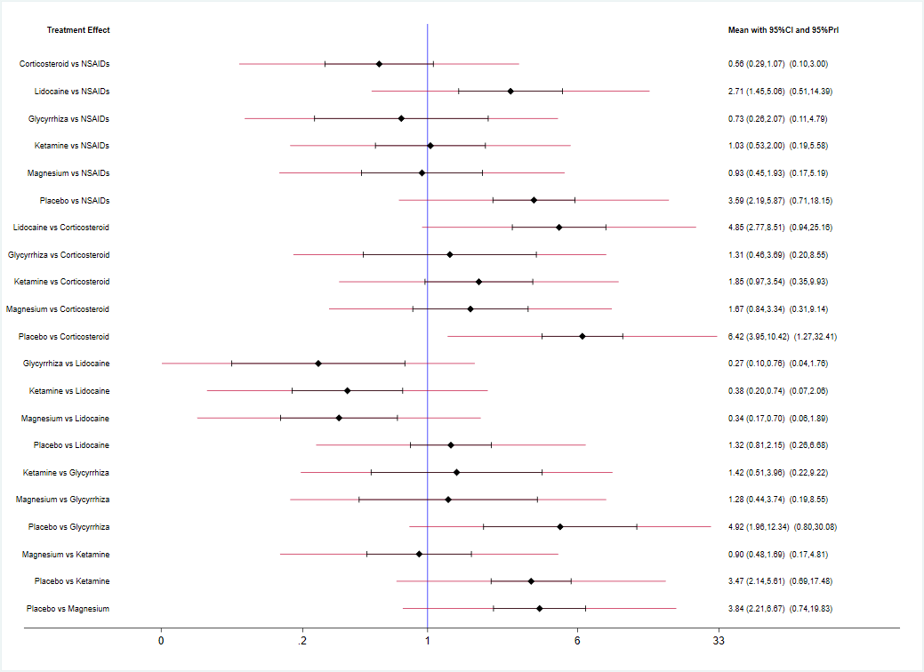
Note: The graph presents the network estimates for all pairwise comparisons. The length of the red lines represent the predictive intervals. Black lines terminating in vertical bars represent the credible intervals.
- 24h

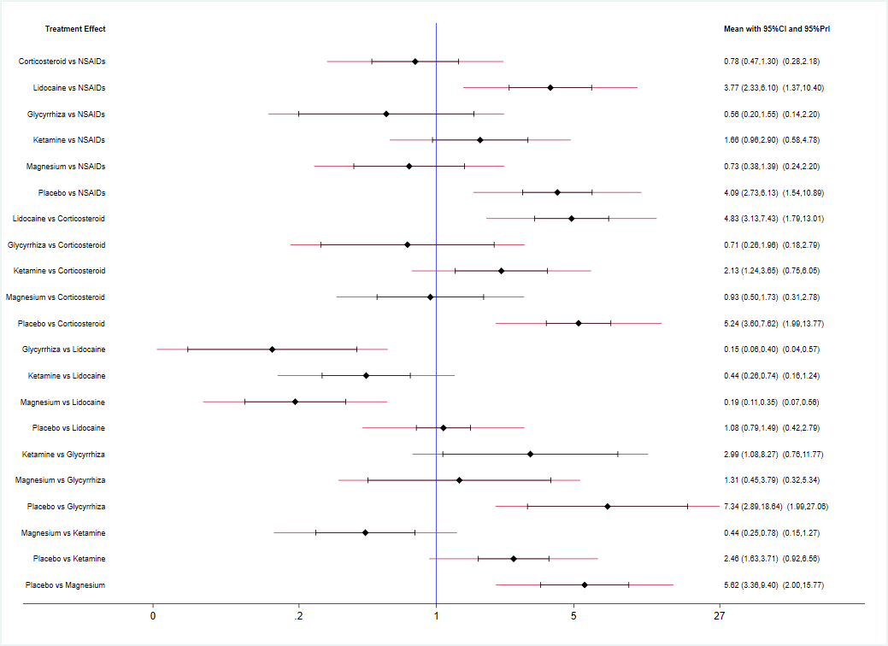
Note: The graph presents the network estimates for all pairwise comparisons. The length of the red lines represent the predictive intervals. Black lines terminating in vertical bars represent the credible intervals.

Appendix 12

Comparison-adjusted funnel plot for postoperative sore throat after tracheal intubation
（a）Comparison-adjusted funnel plot for 0-1h
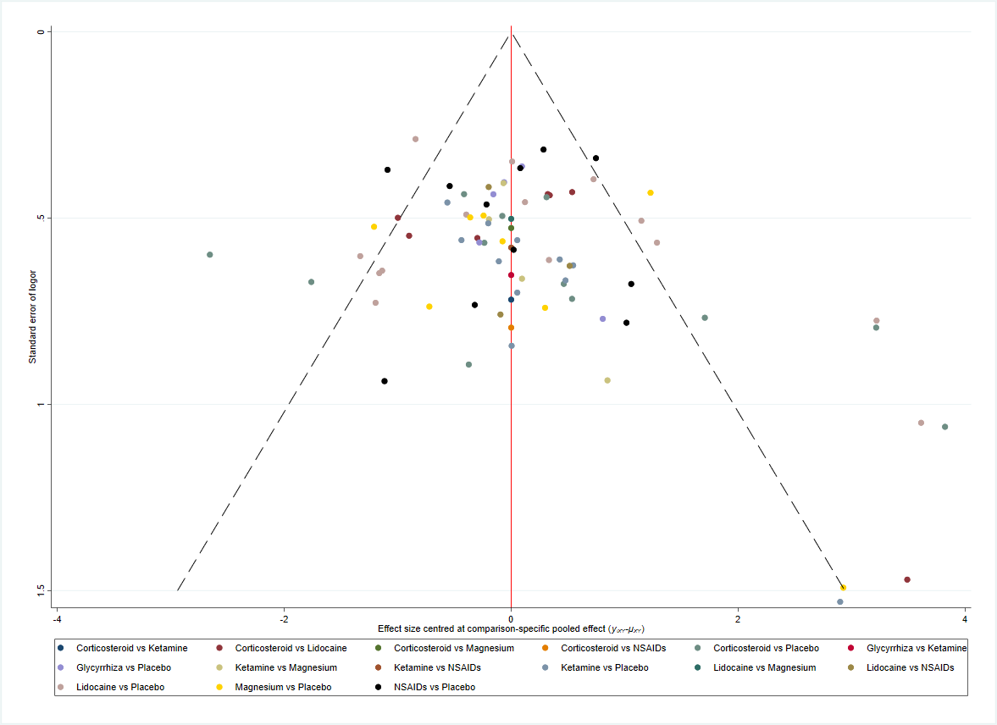

Note: Funnel plot for 0-1h was relatively symmetric, which didn’t show significant publication bias in our studies.

- 2-3h
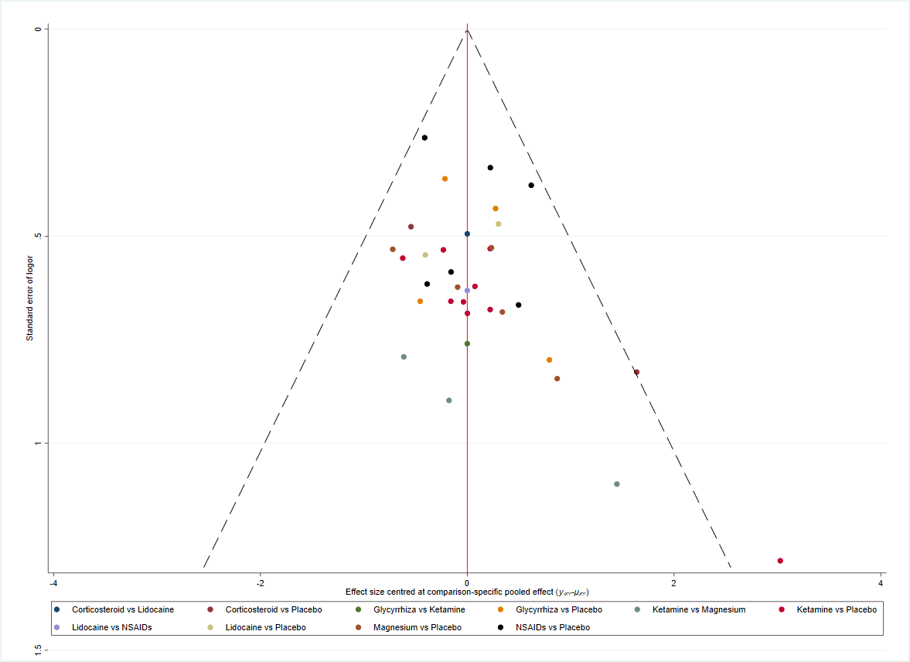

Note: Funnel plot for 2-3h was relatively symmetric, which didn’t show significant publication bias in our studies.

（c）4-6h
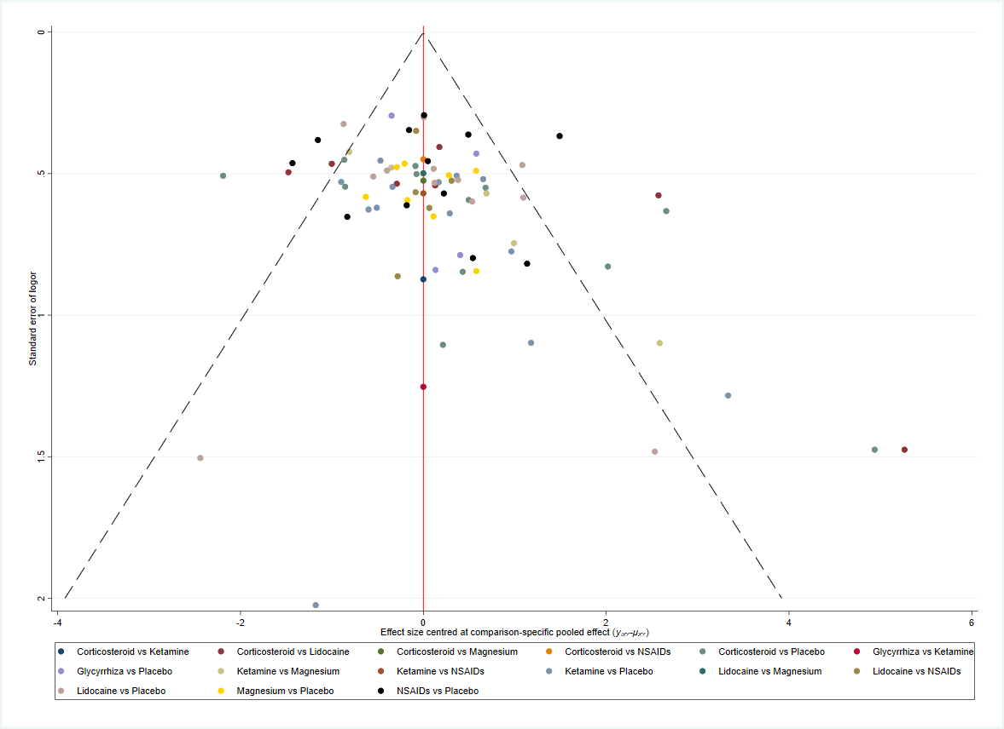

Note: Funnel plot for 4-6h was relatively symmetric, which didn’t show significant publication bias in our studies.

(d)24h
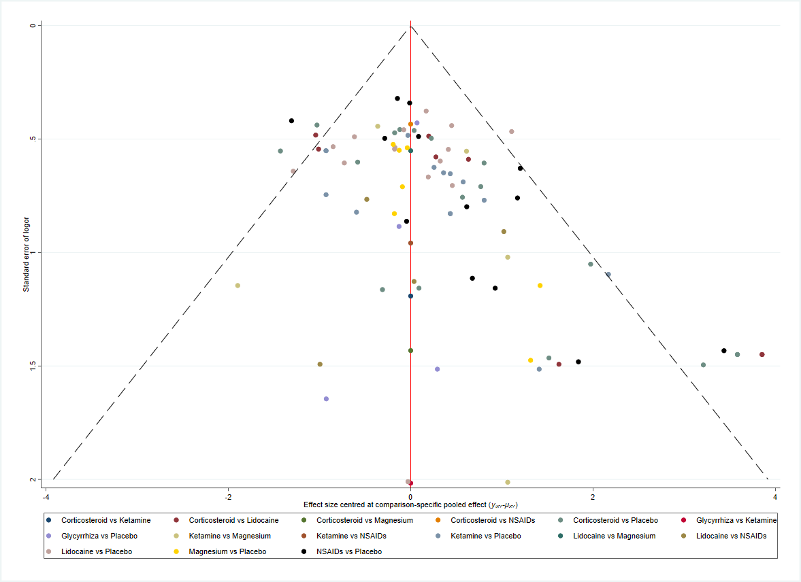

Note: Funnel plot for 24h was relatively symmetric, which didn’t show significant publication bias in our studies.

Appendix 13

Contribution summary of the risk of bias assessments

13.1 Summary of the risk of bias assessments for direct comparisons included in the meta-analysis on postoperative sore throat.
(a) 0-1h
Direct comparison | Risk of bias assessment
NSAIDs VS Corticosteroid | Moderate
NSAIDs VS Lidocaine | Moderate
NSAIDs VS Ketamine | Moderate
NSAIDs VS Placebo | High
Corticosteroid VS Lidocaine | High
Corticosteroid VS Ketamine | Moderate
Corticosteroid VS Magnesium | Moderate
Corticosteroid VS Placebo | High
Lidocaine VS Magnesium | Moderate
Lidocaine VS Placebo | High
Glycyrrhiza VS Ketamine | Low
Glycyrrhiza VS Placebo | Moderate
Ketamine VS Magnesium | Moderate
Ketamine VS Placebo | High
Magnesium VS Placebo | Moderate

Note: Summary of the risk of bias assessments for direct comparisons included in the meta-analysis on postoperative sore throat in 0-1h.
(b) 2-3h
Direct comparison | Risk of bias assessment
NSAIDs VS Lidocaine | Moderate
NSAIDs VS Placebo | High
Corticosteroid VS Lidocaine | Moderate
Corticosteroid VS Ketamine | Moderate
Corticosteroid VS Placebo | High
Lidocaine VS Placebo | Moderate
Glycyrrhiza VS Ketamine | Low
Glycyrrhiza VS Placebo | High
Ketamine VS Magnesium | Moderate
Ketamine VS Placebo | Moderate
Magnesium VS Placebo | Moderate

Note: Summary of the risk of bias assessments for direct comparisons included in the meta-analysis on postoperative sore throat in 2-3h.

(c) 4-6h
Direct comparison | Risk of bias assessment
NSAIDs VS Corticosteroid | Moderate
NSAIDs VS Lidocaine | Moderate
NSAIDs VS Ketamine | Moderate
NSAIDs VS Placebo | Moderate
Corticosteroid VS Lidocaine | High
Corticosteroid VS Ketamine | Moderate
Corticosteroid VS Magnesium | Moderate
Corticosteroid VS Placebo | High
Lidocaine VS Magnesium | Moderate
Lidocaine VS Placebo | High
Glycyrrhiza VS Ketamine | Low
Glycyrrhiza VS Placebo | High
Ketamine VS Magnesium | Moderate
Ketamine VS Placebo | Moderate
Magnesium VS Placebo | Moderate

Note: Summary of the risk of bias assessments for direct comparisons included in the meta-analysis on postoperative sore throat in 4-6h.

(d)24h
Direct comparison | Risk of bias assessment
NSAIDs VS Corticosteroid | Moderate
NSAIDs VS Lidocaine | Moderate
NSAIDs VS Ketamine | Moderate
NSAIDs VS Placebo | Moderate
Corticosteroid VS Lidocaine | High
Corticosteroid VS Ketamine | Moderate
Corticosteroid VS Magnesium | Moderate
Corticosteroid VS Placebo | Moderate
Lidocaine VS Magnesium | Moderate
Lidocaine VS Placebo | High
Glycyrrhiza VS Ketamine | Low
Glycyrrhiza VS Placebo | High
Ketamine VS Magnesium | High
Ketamine VS Placebo | Moderate
Magnesium VS Placebo | Moderate

Note: Summary of the risk of bias assessments for any direct comparisons included in the meta-analysis on postoperative sore throat at 24h.
13.2 The contribution of direct comparisons to mixed or indirect comparisons by the risk of bias classification on postoperative sore throat
(a) 0-1h
Comparisons | Risk of bias assessment
 | Low (%) | Moderate (%) | High (%)
NSAIDs VS Corticosteroid | 0 | 100% | 0
NSAIDs VS Lidocaine | 0 | 100% | 0
NSAIDs VS Ketamine | 0 | 100% | 0
NSAIDs VS Placebo | 9.1% | 72.7% | 18.2%
Corticosteroid VS Lidocaine | 14.3% | 57.1% | 28.6%
Corticosteroid VS Ketamine | 0 | 100% | 0
Corticosteroid VS Magnesium | 0 | 100% | 0
Corticosteroid VS Placebo | 0 | 84.6% | 15.4%
Lidocaine VS Magnesium | 0 | 100% | 0
Lidocaine VS Placebo | 6.7% | 60% | 33.3%
Glycyrrhiza VS Ketamine | 100% | 0 | 0
Glycyrrhiza VS Placebo | 40% | 40% | 20%
Ketamine VS Magnesium | 0 | 75% | 25%
Ketamine VS Placebo | 0 | 47.6% | 52.4%
Magnesium VS Placebo | 11.1% | 88.9% | 0

Note: Reference Contribution plot for postoperative sore throat after tracheal intubation (Appendix 7), the contribution of direct comparisons to mixed or indirect comparisons by the risk of bias classification on postoperative sore throat in 0-1h.

(b) 2-3h
Comparisons | Risk of bias assessment
 | Low (%) | Moderate (%) | High (%)
NSAIDs VS Lidocaine | 0 | 100% | 0
NSAIDs VS Placebo | 16.6% | 66.8% | 16.6%
Corticosteroid VS Lidocaine | 0 | 100% | 0
Corticosteroid VS Ketamine | 0 | 100% | 0
Corticosteroid VS Placebo | 0 | 66.7% | 33.3%
Lidocaine VS Placebo | 0 | 100% | 0
Glycyrrhiza VS Ketamine | 100% | 0 | 0
Glycyrrhiza VS Placebo | 33.3% | 33.3% | 33.3%
Ketamine VS Magnesium | 9.1% | 81.8% | 9.1%
Ketamine VS Placebo | 0 | 100% | 0
Magnesium VS Placebo | 0 | 100% | 0

Note: Reference Contribution plot for postoperative sore throat after tracheal intubation (Appendix 7), the contribution of direct comparisons to mixed or indirect comparisons by the risk of bias classification on postoperative sore throat in 2-3h.

(c) 4-6h
Comparisons | Risk of bias assessment
 | Low (%) | Moderate (%) | High (%)
NSAIDs VS Corticosteroid | 0 | 100% | 0
NSAIDs VS Lidocaine | 0 | 100% | 0
NSAIDs VS Ketamine | 0 | 100% | 0
NSAIDs VS Placebo | 18.2% | 72.7% | 9.1%
Corticosteroid VS Lidocaine | 14.3% | 57.1% | 28.6%
Corticosteroid VS Ketamine | 0 | 100% | 0
Corticosteroid VS Magnesium | 0 | 100% | 0
Corticosteroid VS Placebo | 0 | 75% | 25%
Lidocaine VS Magnesium | 0 | 100% | 0
Lidocaine VS Placebo | 8.3% | 75% | 16.7%
Glycyrrhiza VS Ketamine | 100% | 0 | 0
Glycyrrhiza VS Placebo | 50% | 25% | 25%
Ketamine VS Magnesium | 0 | 80% | 20%
Ketamine VS Placebo | 7.1% | 85.8% | 7.1%
Magnesium VS Placebo | 0 | 100% | 0

Note: Reference Contribution plot for postoperative sore throat after tracheal intubation (Appendix 7), the contribution of direct comparisons to mixed or indirect comparisons by the risk of bias classification on postoperative sore throat in 4-6h.

(d)24h
Comparisons | Risk of bias assessment
 | Low (%) | Moderate (%) | High (%)
NSAIDs VS Corticosteroid | 0 | 100% | 0
NSAIDs VS Lidocaine | 0 | 100% | 0
NSAIDs VS Ketamine | 0 | 100% | 0
NSAIDs VS Placebo | 7.7% | 76.9% | 15.4%
Corticosteroid VS Lidocaine | 12.5% | 62.5% | 25%
Corticosteroid VS Ketamine | 0 | 100% | 0
Corticosteroid VS Magnesium | 0 | 100% | 0
Corticosteroid VS Placebo | 0 | 88.2% | 11.8%
Lidocaine VS Magnesium | 0 | 100% | 0
Lidocaine VS Placebo | 5.9% | 64.7% | 29.4%
Glycyrrhiza VS Ketamine | 100% | 0 | 0
Glycyrrhiza VS Placebo | 25% | 50% | 25%
Ketamine VS Magnesium | 0 | 80% | 20%
Ketamine VS Placebo | 7.1% | 85.8% | 7.1%
Magnesium VS Placebo | 0 | 100% | 0

Note: Reference Contribution plot for postoperative sore throat after tracheal intubation (Appendix 7), the contribution of direct comparisons to mixed or indirect comparisons by the risk of bias classification on postoperative sore throat at 24h.

Appendix 14

Evaluation of the quality of the evidence using GRADE framework
for postoperative sore throat

Table of reasons for downgrading
(1) Study limitations: We downgraded by one level when the contributions from low RoB comparisons were less than 30% and contributiions from moderate RoB comparisons were greater than 70%.
(2) Imprecision: We considered a clinically meaningful threshold for OR to be 0.80 or 1.25 and downgraded the estimate if the OR point estimate is 1 or more and the lower limit of its CrI is below 0.80; or if the OR point estimate is less than 1 and the upper limit of its CrI is above 1.25.
(3) Inconsistency: We rated two concepts, heterogeneity and incoherence (inconsistency), in this domain. For the heterogeneity, we looked at the I². For the inconsistency, we looked at the results of node-splitting and we downgraded the comparisons with significant inconsistency (p<0.10)
(4) Indirectness: We have assured transitivity in our network by limiting the included studies to local applications. However, we downgraded singly-connected nodes for indirectness because that the evaluation of transitivity for such nodes is unclear.
(5) Publication bias: The comparison-adjusted funnel plot was not suggestive of funnel plot asymmetry. We managed to retrieve supplementary and unpublished information included in the available systematic reviews and network meta-analyses, and we are confident that we have collected all available information from clinical trial registries.

14-a. Evaluation of the quality of the evidence using GRADE framework for postoperative sore throat in 0-1h.
Comparison | Study limitation | Imprecision | Heterogeneity and inconsistency | Indirectness | Publication bias | GRADE
NSAIDs VS Corticosteroid | Downgrade  because >70%  contribution  from moderate  RoB comparisons | No downgrade | No downgrade | No downgrade | No downgrade | MODERATE
NSAIDs VS Lidocaine | Downgrade  because >70%  contribution  from moderate  RoB comparisons | No downgrade | No downgrade | No downgrade | No downgrade | MODERATE
NSAIDs VS Ketamine | Downgrade  because >70%  contribution  from moderate  RoB comparisons | No downgrade | No downgrade | No downgrade | No downgrade | MODERATE
NSAIDs VS Placebo | Downgrade  because >70%  contribution  from moderate  RoB comparisons | No downgrade | No downgrade | No downgrade | No downgrade | MODERATE
Corticosteroid VS Lidocaine | Downgrade  because ＜30%  contribution  from low RoB  comparisons | No downgrade | No downgrade | No downgrade | No downgrade | MODERATE
Corticosteroid VS Ketamine | Downgrade  because >70%  contribution  from moderate  RoB comparisons | No downgrade | No downgrade | No downgrade | No downgrade | MODERATE
Corticosteroid VS Magnesium | Downgrade  because >70%  contribution  from moderate  RoB comparisons | No downgrade | No downgrade | No downgrade | No downgrade | MODERATE
Corticosteroid VS Placebo | Downgrade  because >70%  contribution  from moderate  RoB comparisons | No downgrade | No downgrade | No downgrade | No downgrade | MODERATE
Lidocaine VS Magnesium | Downgrade  because >70%  contribution  from moderate  RoB comparisons | No downgrade | No downgrade | No downgrade | No downgrade | MODERATE
Lidocaine VS Placebo | Downgrade  because >70%  contribution  from moderate  RoB comparisons | No downgrade | No downgrade | No downgrade | No downgrade | MODERATE
Glycyrrhiza VS Ketamine | No downgrade | Downgrade  because point estimate <1.0 but upper limit >1.25 | No downgrade | Downgrade  Glycyrrhiza is a singly connected node and hence evaluation of  transitivity is unclear. | No downgrade | LOW
Glycyrrhiza VS Placebo | No downgrade | No downgrade | No downgrade | Downgrade  Glycyrrhiza is a singly connected node and hence evaluation of  transitivity is unclear. | No downgrade | MODERATE
Ketamine VS Magnesium | Downgrade  because >70%  contribution  from moderate  RoB comparisons | No downgrade | No downgrade | No downgrade | No downgrade | MODERATE
Ketamine VS Placebo | Downgrade  because ＜30%  contribution  from low RoB  Comparisons | No downgrade | No downgrade | No downgrade | No downgrade | MODERATE
Magnesium VS Placebo | Downgrade  because >70%  contribution  from moderate  RoB comparisons | No downgrade | No downgrade | No downgrade | No downgrade | MODERATE

- b. Evaluation of the quality of the evidence using GRADE framework for postoperative sore throat in 2-3h.
Comparison | Study limitation | Imprecision | Heterogeneity and inconsistency | Indirectness | Publication bias | GRADE
NSAIDs VS Lidocaine | Downgrade  because >70%  contribution  from moderate  RoB comparisons | No downgrade | No downgrade | No downgrade | No downgrade | MODERATE
NSAIDs VS Placebo | Downgrade  because ＜30%  contribution  from low RoB  comparisons | No downgrade | No downgrade | No downgrade | No downgrade | MODERATE
Corticosteroid VS Lidocaine | Downgrade  because >70%  contribution  from moderate  RoB comparisons | Downgrade  because point  estimate >1.0  but lower limit  <0.80 | No downgrade | No downgrade | Downgrade | LOW
Corticosteroid VS Ketamine | Downgrade  because >70%  contribution  from moderate  RoB comparisons | No downgrade | No downgrade | No downgrade | No downgrade | MODERATE
Corticosteroid VS Placebo | Downgrade  because >70%  contribution  from moderate  RoB comparisons | No downgrade | Downgrade  because node-splitting p=0.000 | No downgrade | No downgrade | LOW
Lidocaine VS Placebo | Downgrade  because >70%  contribution  from moderate  RoB comparisons | No downgrade | No downgrade | No downgrade | No downgrade | MODERATE
Glycyrrhiza VS Ketamine | No downgrade | Downgrade  because point estimate >1.0 but lower limit <0.80 | No downgrade | Downgrade  Glycyrrhiza is a singly connected node and hence evaluation of  transitivity is unclear. | No downgrade | LOW
Glycyrrhiza VS Placebo | No downgrade | No downgrade | Downgrade  because node-splitting p=0.002 | Downgrade  Glycyrrhiza is a singly connected node and hence evaluation of  transitivity is unclear. | No downgrade | LOW
Ketamine VS Magnesium | Downgrade  because >70%  contribution  from moderate  RoB comparisons | No downgrade | No downgrade | No downgrade | No downgrade | MODERATE
Ketamine VS Placebo | Downgrade  because >70%  contribution  from moderate  RoB comparisons | No downgrade | No downgrade | No downgrade | No downgrade | MODERATE
Magnesium VS Placebo | Downgrade  because >70%  contribution  from moderate  RoB comparisons | No downgrade | No downgrade | No downgrade | No downgrade | MODERATE

14-c. Evaluation of the quality of evidence using GRADE framework for Postoperative sore throat in 4-6h.
Comparison | Study limitation | Imprecision | Heterogeneity and inconsistency | Indirectness | Publication bias | GRADE
NSAIDs VS Corticosteroid | Downgrade  because >70%  contribution  from moderate  RoB comparisons | No downgrade | No downgrade | No downgrade | No downgrade | MODERATE
NSAIDs VS Lidocaine | Downgrade  because >70%  contribution  from moderate  RoB comparisons | No downgrade | No downgrade | No downgrade | No downgrade | MODERATE
NSAIDs VS Ketamine | Downgrade  because >70%  contribution  from moderate  RoB comparisons | Downgrade  because point estimate >1.0 but lower limit <0.80 | No downgrade | No downgrade | No downgrade | LOW
NSAIDs VS Placebo | Downgrade  because >70%  contribution  from moderate  RoB comparisons | No downgrade | No downgrade | No downgrade | No downgrade | MODERATE
Corticosteroid VS Lidocaine | Downgrade  because ＜30%  contribution  from low RoB  comparisons | No downgrade | No downgrade | No downgrade | No downgrade | MODERATE
Corticosteroid VS Ketamine | Downgrade  because >70%  contribution  from moderate  RoB comparisons | No downgrade | No downgrade | No downgrade | No downgrade | MODERATE
Corticosteroid VS Magnesium | Downgrade  because >70%  contribution  from moderate  RoB comparisons | No downgrade | No downgrade | No downgrade | No downgrade | MODERATE
Corticosteroid VS Placebo | Downgrade  because >70%  contribution  from moderate  RoB comparisons | No downgrade | No downgrade | No downgrade | No downgrade | MODERATE
Lidocaine VS Magnesium | Downgrade  because >70%  contribution  from moderate  RoB comparisons | No downgrade | No downgrade | No downgrade | No downgrade | MODERATE
Lidocaine VS Placebo | Downgrade  because >70%  contribution  from moderate  RoB comparisons | No downgrade | No downgrade | No downgrade | No downgrade | MODERATE
Glycyrrhiza VS Ketamine | No downgrade | Downgrade  because point estimate <1.0 but upper limit >1.25 | No downgrade | Downgrade  Glycyrrhiza is a singly connected node and hence evaluation of  transitivity is unclear. | No downgrade | LOW
Glycyrrhiza VS Placebo | No downgrade | No downgrade | No downgrade | Downgrade  Glycyrrhiza is a singly connected node and hence evaluation of  transitivity is unclear. | No downgrade | MODERATE
Ketamine VS Magnesium | Downgrade  because >70%  contribution  from moderate  RoB comparisons | Downgrade  because point  estimate >1.0 but lower limit <0.80 | No downgrade | No downgrade | No downgrade | LOW
Ketamine VS Placebo | Downgrade  because ＜30%  contribution  from low RoB  comparisons | No downgrade | No downgrade | No downgrade | No downgrade | MODERATE
Magnesium VS Placebo | Downgrade  because >70%  contribution  from moderate  RoB comparisons | No downgrade | No downgrade | No downgrade | No downgrade | MODERATE

14-d. Evaluation of the quality of the evidence using GRADE framework for postoperative sore throat 24h.
Comparison | Study limitation | Imprecision | Heterogeneity and inconsistency | Indirectness | Publication bias | GRADE
NSAIDs VS Corticosteroid | Downgrade  because >70%  contribution  from moderate  RoB comparisons | Downgrade  because point  estimate >1.0 but lower limit <0.80 | No downgrade | No downgrade | No downgrade | LOW
NSAIDs VS Lidocaine | Downgrade  because >70%  contribution  from moderate  RoB comparisons | No downgrade | No downgrade | No downgrade | No downgrade | MODERATE
NSAIDs VS Ketamine | Downgrade  because >70%  contribution  from moderate  RoB comparisons | No downgrade | No downgrade | No downgrade | No downgrade | MODERATE
NSAIDs VS Placebo | Downgrade  because >70%  contribution  from moderate  RoB comparisons | No downgrade | No downgrade | No downgrade | No downgrade | MODERATE
Corticosteroid VS Lidocaine | Downgrade  because ＜30%  contribution  from low RoB  comparisons | No downgrade | No downgrade | No downgrade | No downgrade | MODERATE
Corticosteroid VS Ketamine | Downgrade  because >70%  contribution  from moderate  RoB comparisons | No downgrade | No downgrade | No downgrade | No downgrade | MODERATE
Corticosteroid VS Magnesium | Downgrade  because >70%  contribution  from moderate  RoB comparisons | No downgrade | No downgrade | No downgrade | No downgrade | MODERATE
Corticosteroid VS Placebo | Downgrade  because >70%  contribution  from moderate  RoB comparisons | No downgrade | No downgrade | No downgrade | No downgrade | MODERATE
Lidocaine VS Magnesium | Downgrade  because >70%  contribution  from moderate  RoB comparisons | No downgrade | No downgrade | No downgrade | No downgrade | MODERATE
Lidocaine VS Placebo | Downgrade  because >70%  contribution  from moderate  RoB comparisons | No downgrade | No downgrade | No downgrade | No downgrade | MODERATE
Glycyrrhiza VS Ketamine | No downgrade | Downgrade  because point estimate <1.0 but upper limit >1.25 | No downgrade | Downgrade  Glycyrrhizais a singly connected node and hence evaluation of  transitivity is unclear. | No downgrade | LOW
Glycyrrhiza VS Placebo | Downgrade  because ＜30%  contribution  from low RoB  comparisons | No downgrade | Downgrade  because node-splitting p=0.011 | Downgrade  Glycyrrhiza is a singly connected node and hence evaluation of  transitivity is unclear. | No downgrade | VERY LOW
Ketamine VS Magnesium | Downgrade  because >70%  contribution  from moderate  RoB comparisons | No downgrade | No downgrade | No downgrade | No downgrade | MODERATE
Ketamine VS Placebo | Downgrade  because ＜30%  contribution  from low RoB  comparisons | No downgrade | No downgrade | No downgrade | No downgrade | MODERATE
Magnesium VS Placebo | Downgrade  because >70%  contribution  from moderate  RoB comparisons | No downgrade | No downgrade | No downgrade | No downgrade | MODERATE

