Appendix C: Funnel plots for all the primary outcomes represented in the meta-analysis, including sensory block onset time, sensory block duration, motor block onset time, and motor block duration.
Duration of Sensory Block
Duration of Motor Block
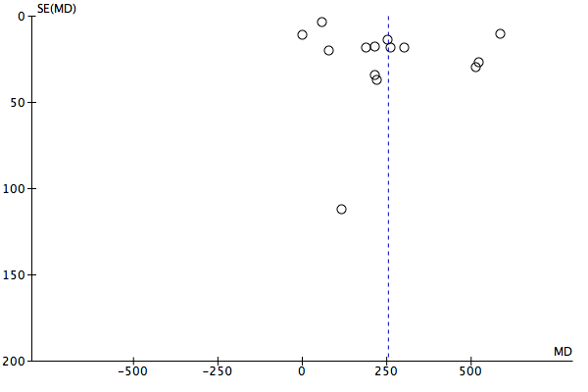

Onset of Motor Block
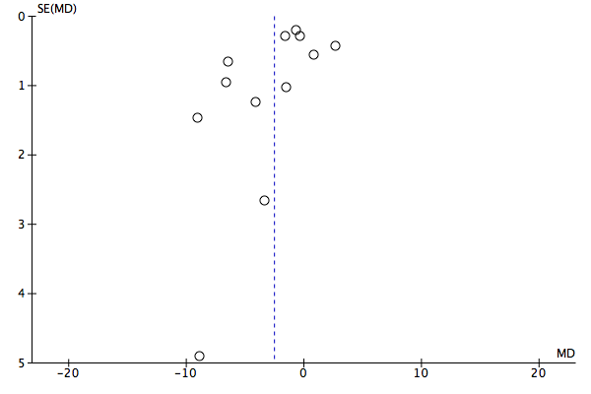
Onset of Sensory Block
