**Supplemental information**

**Supplemental materials and methods**

**Regents**

ARQ 092 and ARQ 087 were synthesized at ArQule, Incorperated. Annexin V FITC, apoptosis detection Kit (Cat#51-6710AK) was purchased from BD Biosciences (Franklin Lakes, NJ). Primary antibodies for Western blot analysis were purchased from Cell Signaling Technology (Danvers, MA): phospho-AKT1 (Ser473) (Cat# 9271), Pan AKT(Cat#2920), phospho-ERK (Thr202/Tyr204) (Cat# 9101), total ERK (Cat# 9107), total FGFR2 (Cat#11835). β-actin (Cat# A2228) is purchased from Sigma-Aldrich (St. Louis, MO). Precast Tris Glycine gels and PVDF were purchased from Life Technologies (Carlsbad, CA).

**Cell Culture**

Cancer cells were grown in cell culture media recommended by the vendors, and supplemented with 10% FBS maintained at 37°C in a humidified atmosphere at 5% CO2 (supplemental table 1). IGROV-1 cells were donated by Daiichi Sankyo (Chuo-ku, Tokyo, Japan).

**Cell proliferation MTS assays**

For single agent assays cells were seeded at an optimal number per well in 130 l of full growth media in 96-well tissue culture plates, incubated overnight, and then treated with 3-fold serial dilutions of ARQ 087 or ARQ 092 at a starting concentration of 33.3 or 100 M. Treated cells were incubated at 37°C for 72 hrs in 5% CO2.

For the combination study, cells were seeded in 96-well tissue-culture plates at optimal number of cells per well overnight and subsequently treated with serial dilutions of ARQ 087 at start concentration of 33.3 M in combination with serial dilutions of ARQ 092 at a starting concentration of 100 M. Treated cells were incubated at 37°C for 72 hrs in 5% CO2.

Thirty microliters of the mixture of MTS reagent (18.4 mg/ml) and PMS (0.92 mg/ml) at a ratio of 20:1 were added to each well, and the plates were incubated at 37°C for 4 hrs in 5% CO2. The absorbance was measured at 490nM using the Victor microplate reader. For single agent assay, IC50 was determined using Microsoft ExcelFit software in ArQule Activity Base. For the combination studies, a Combination Index (CI) of 50% effect was determined in Activity Base using the Chou-Talalay method [28]. Synergistic: CI<0.85; Additive: CI>0.85 and <1.2; and Antagonistic: CI>1.2.

**Annexin V FITC assay**

AN3CA and IGROV1 cells were treated with ARQ 092 or ARQ 087 at 0.1 or 1 M for 24 or 72 hrs. Apoptosis response was assessed using Annexin V FITC assay and analyzed using a flow cytometer (FACScalibur FLOW Cytometer)

**Western Blot Analysis**

Tumor samples were kept on dry ice at all the times and a tissue pulverizer was dipped in liquid nitrogen before use. Tumor tissues were first pulverized and then lysed in cell lysis buffer supplemented with Halt Protease Phosphatase inhibitor (ThermoFisher, Waltham, MA). Proteins were resolved in SDS-PAGE and transferred to PVDF membranes. After blockage with 5% BSA in TBX (1x) blocking buffer, the membranes were incubated with primary antibodies with 1%BSA in TBST overnight at 4 °C and then blotted with HRP conjugated secondary antibodies (Cell Signaling Technology). Immunoblotting detection was performed with GE ECL Prime reagent (GE Healthcare, Piscataway, NJ) and images were captured using FuJi LAS 3000 system.

**Pharmacokinetic analysis**

Male and Female (n=9/gender) Sprague Dawley rats were dosed orally with ARQ 092 at 15 mg/kg or ARQ 087 at 50 mg/kg, or combination of both agents. Plasma levels of ARQ 092 and ARQ 087 in day 1 and day 7 were determined by LC-MS/MS. Cmax and AUC were determined.

**Supplemental table and figure legends**

Supplemental Table 1. Cell lines and cultural media. Cell lines were purchased from various suppliers and maintained in cell cultural media accordingly.



Supplemental Table 2. Combination of ARQ 092 and ARQ 087 in 45 cancer cell lines. Cancer cells were treated with combination of ARQ 092 and ARQ 087 at various concentrations. CI values were calculated based on Chou-Talalay method. Mutation information for the cancer cell lines were obtained from COSMIC database. The number in the parentheses showed the repeats of the studies.

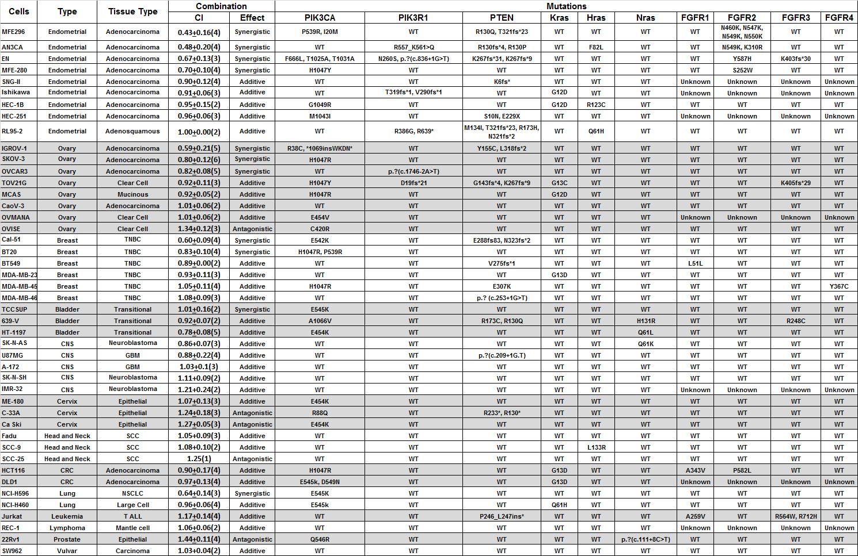

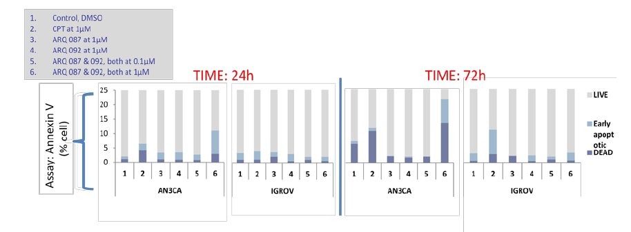Supplemental Figure 1. Combination of ARQ 092 and ARQ 087 induced apoptosis. AN3CA and IGROV1 cells were treated with ARQ 092 or ARQ 087 at 0.1 or 1 M for 24 or 72 hrs. Apoptosis response was assessed using Annexin V FITC assay and analyzed using a flow cytometer. The results were shown in % Annexin V positive cells. Camptothecin (CPT) was used as a positive control.

AN3CA cells but not IGROV-1 showed apoptotic response

Supplemental Figure 2. Combined effect of ARQ 092 and ARQ 087 on AKT and MAPK pathway. Tumor samples from AN3CA bearing mice treated with ARQ 092 at 100 mg/kg or ARQ 087 at 75 mg/kg or combined treatment were assessed for pAKT(S473), AKT, pERK(T202/Y204), and ERK using western blot analysis.

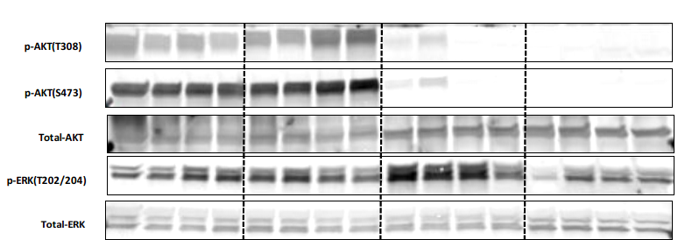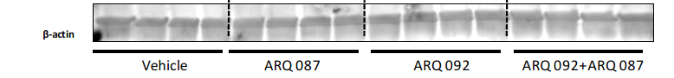

Supplemental Figure 3. ARQ 087 (50 mg/kg) and ARQ 092 (15 mg/kg) Cmax and AUC levels in rats on Days 1 and 7 of dosing. Mean values with standard deviation error bars.

