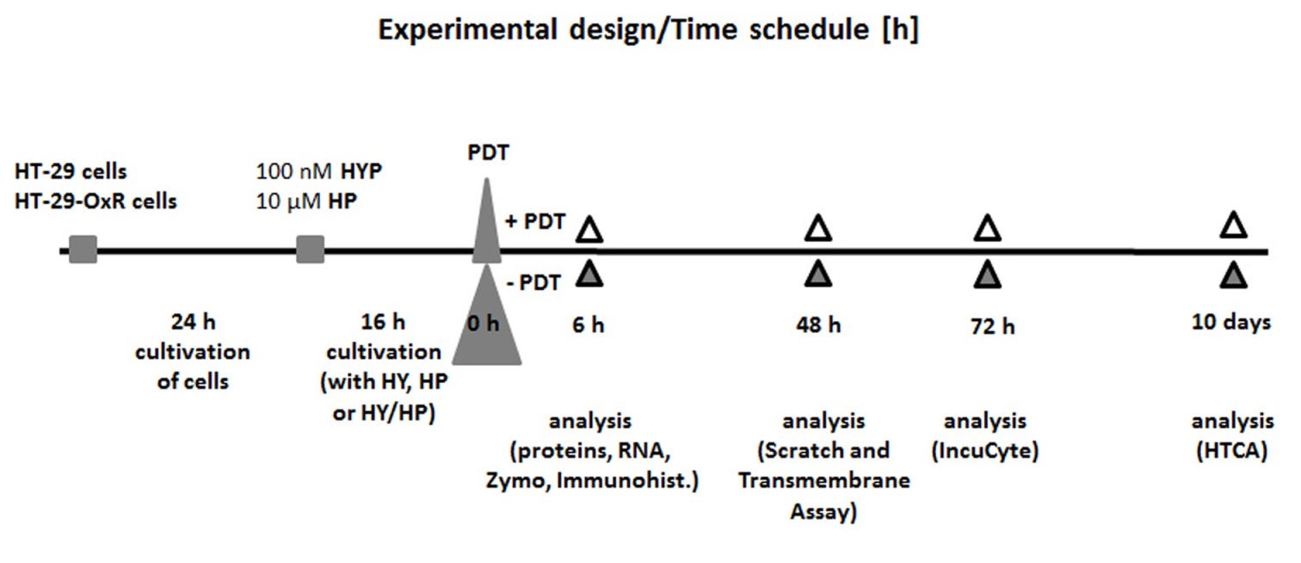

Fig.A. Experimental design. HT-29 or HT-29-OxR cells were incubated for 24 h before treatment with non-activated 100 nM HY, 10 µM HP or 100 nM HY/10 µM HP. Cells were treated with PDT (3.15 J/cm²) at 16 h after drugs treatment. Analyses (indicated in Figure) were performed at time: 6 h, 48 h or 72 h or 10 days (- without PDT, + after PDT).

