Supplemental for:
Effectiveness of modified dose dense paclitaxel in recurrent cervical cancer

Hiroko Machida, MD¹; Aida Moeini, MD, MPH¹; Marcia A. Ciccone, MD¹; Sayedamin Mostofizadeh, MD¹; Tsuyoshi Takiuchi, MD, PhD¹; Luarie L. Bruette, MD¹; Lynda D. Roman, MD^{1,2}; Koji Matsuo, MD, PhD^{1,2,*}

1. Division of Gynecologic Oncology, Department of Obstetrics and Gynecology, University of Southern California, Los Angeles, CA 90089, USA
2. Norris Comprehensive Cancer Center, University of Southern California, Los Angeles, CA 90089, USA.

* All corresponding to:
Koji Matsuo, MD, PhD
Division of Gynecologic Oncology
Department of Obstetrics and Gynecology
University of Southern California
2020 Zonal Avenue IRD520
Los Angeles, CA90089, USA.
Tel: +1-323-226-3416
Fax: +1-323-226-3427
Email: koji.matsuo@med.usc.edu

Keywords: cervical cancer; recurrence; paclitaxel; dose-dense chemotherapy.

Supplemental Table S1. Treatment regimens of cervical cancer patients (n=70).
Regimen | Number (%)
Paclitaxel doublet | 18 (100%)
Carboplatin + paclitaxel | 5 (27.8%)
Cisplatin + paclitaxel | 4 (22.2%)
Cisplatin + paclitaxel + bevacizumab | 4 (22.2%)
Paclitaxel + bevacizumab | 2 (11.1%)
Paclitaxel + 5-fluorouracil | 2 (11.1%)
Gemcitabine + docetaxel | 1 (5.6%)
Non-paclitaxel regimen | 52 (100%)
Cisplatin + gemcitabine | 25 (48.1%)
Cisplatin + topotecan | 4 (7.7%)
Cisplatin + pemetrexed | 4 (6.8%)
Cisplatin + vinorelbine | 4 (6.8%)
Topotecan alone | 3 (5.8%)
Cisplatin alone | 3 (5.8%)
Capecitabine only | 2 (3.8%)
Cisplatin + cetuximab | 2 (3.8%)
Pemetrexed alone | 1 (1.7%)
Carboplatin + gemcitabine | 1 (1.7%)
Others | 3 (5.8%)

Number (%) is shown.

Supplemental Table S2. Effects of dose-dense paclitaxel in gynecologic cancers: systematic review of literature
Author | Year | Type* | Design | No | Regimen | Cycle | Prior  chemo | RR (%) | PFS | OS
Chan JK  (GOG0262) | 2016 | OVCA  II-IV | Phase III | 55  57 | PTX (80 mg/m² weekly) + CBDCA (AUC 6 q21)  PTX (175 mg/m² q21) + CBDCA (AUC 6 q21) | 6 | ≤ 1 | na | 14.2  10.3 | na
Becker DA | 2016 | OVCA  III-IV | Retro  NAC | 21  40 | PTX (NA day 1, 8, and 15) + CBDCA (NA q21)  PTX (NA q21) + CBDCA (NA q21) | 3  3 | No | 85%  86% | na | na
Pignata S  (MITO7) | 2014 | OVCA  IC-IV | Phase III | 406  404 | PTX (60 mg/m² weekly) + CBDCA (AUC 2 weekly)  PTX (175 mg/m² q21) + CBDCA (AUC 6 q21) | 18  6 | No | 56%  59% | 18.3  17.3 | na
van der Burg ME | 2014 | OVCA  IIB-IV | Phase III | 133  134 | PTX (90mg/m²) + CDDP (70mg/m²) or CBDCA (AUC 4), weekly  PTX (175mg/m²) + CDDP (75mg/m²) or CBDCA (AUC 6), q21 | 6 | No | 86%  85% | 18.5  16.4 | 44.8  41.1
Katsumata  (JGOG-3016) | 2013 | OVCA  II-IV | Phase III | 312  319 | PTX (80 mg/m² day 1, 8, and 15) + CBDCA (AUC 6 q21)  PTX (180 mg/m² q21) + CBDCA (AUC 6 q21) | 6 | No | 56%  53% | 28.2  17.5 | 100.5  62.2
McCormack M | 2013 | OVCA  IB2-IV | Phase II  NAC | 46 | PTX (80 mg/m²) + CBDCA (AUC 2) weekly | 6 | No | 69% | na | na
Abaid LN | 2013 | OVCA  III-IV | Phase II | 88 | PTX (80 mg/m² day 1, 8, and 15) + CBDCA (AUC 6 q28) | 6 | No | 84% | na | na
Sharma R | 2009 | OVCA  Rec/M | Retro | 21 | PTX (70 mg/m²) + CBDCA (AUC 3), day 1,8, and 15 q28 | 6 | ≤ 2 | 60% | 7.9 | 13.3
Cadron et al | 2007 | OVCA  Rec/M | phase II | 33 | PTX (90mg/m²) + CBDCA (AUC 4), day 1,8 q21 | 6 | ≤ 2 | 66% | 9.0 | 18.0
Vandenput I | 2009 | EMCA  Rec/M | Retro | 42 | PTX (90 mg/m²) + CBDCA (AUC 4), day 1,8 q21 | 6 | ≤ 4 | 71% | 10.0 | na
Benedetti Panici P | 2015 | CXCA  IIA-IIIB | Phase II  NAC | 22 | PTX (60 mg/m²) + CDDP (60mg/m²) every 10 days | 5 | ≤ 1 | 53% | na | na
IVergote I | 2015 | CxCA  Rec/M | Retro | 34 | PTX (60mg/m² weekly) + CBDCA (AUC 2.7 weekly) + G-CSF | 18 | ≤ 1 | 51% | 7 | na
Singh RB | 2013 | CXCA  IIB-VIA | Pilot  NAC | 28 | PTX (60 mg/m²) + CBDCA (AUC 2) weekly | 6 | No | 68% | na | na
Torfs S | 2012 | CXCA  Rec/M | Retro | 43  22 | PTX (90mg/m²) + CBDCA (AUC 4), day1.8 q 21  PTX (60mg/m²) + CBDCA (AUC 2.7), weekly | 6 | No | 58%  36% | 5.0  na | 11.0  10.0

Abbreviation; Type*, type of cancer and stage; OVCA, ovarian cancer; EMCA, endometrial cancer; CXCA, cervical cancer; RR, response rate; PFS, progression-free survival (months); OS, overall survival (months); Rec, recurrent cervical cancer; M, metastasis cervical cancer; Retro, retrospective; Pilot, pilot study; NAC, neoadjuvant chemotherapy; PTX, paclitaxel; CBDCA, carboplatin; CDDP, cisplatin; AUC, area under the curve; and na, not available. References are listed in page 8.

Supplemental Table S3. Frequency of grade 3-4 toxicity in dose-dense paclitaxel with gynecologic cancers: systematic review of literature
Author | Hematologic* | Neutropenia | Thrombocytopenia | Neurotoxicity | hypersensitivity | Liver toxicity
Chan JK  (GOG0262) | 36%  16% | 72%  83% | 20%  16% | sensory 26%, motor 3%  sensory 2%, motor 1% | na | na
Becker DA | 42%  28% | 19%  13% | 19%  3% | 0  3% | na | na
Pignata S  (MITO7) | 6%  8% | 42%  50% | 1%  7% | 0  2% | 4%  4% | < 1%  < 1%
van der Burg ME | 11%  11% | 61%  66% | 40%  16% | 29%  9% | na | na
Katsumata (JGOG3016) | 69%  44% | 92%  88% | 44%  38% | sensory 21%, motor 15%  sensory 20%, motor 12% | na | na
McCormack M | 2% | 9% | 0% | 0% | 4% | na
Abaid LN | 1% | 23% | 8% | 1% | na | na
Cadron et al | 5% | 34% | 3% | 3% | 9% | na
Sharma R | 5% | 34% | 0 | 14% | na | na
Vandenput I | 14% | 81% | 26% | na | na | na
Benedetti Panici P | 4% | 14% | 0 | 4% | na | 9%
IVergote I | 81% | 38% | 19% | na | na | na
Singh RB | 14% | 32% | 3.5% | na | na | na
Torfs S | 42%  55% | 63%  50% | 42%  46% | 0  0 | 14%  10% | 42%  55%

*anemia, Abbreviation: na, not available. References are listed in page 8.
Supplemental Figure S1. Selection criteria for chemotherapy treatment in recurrent cervical cancer

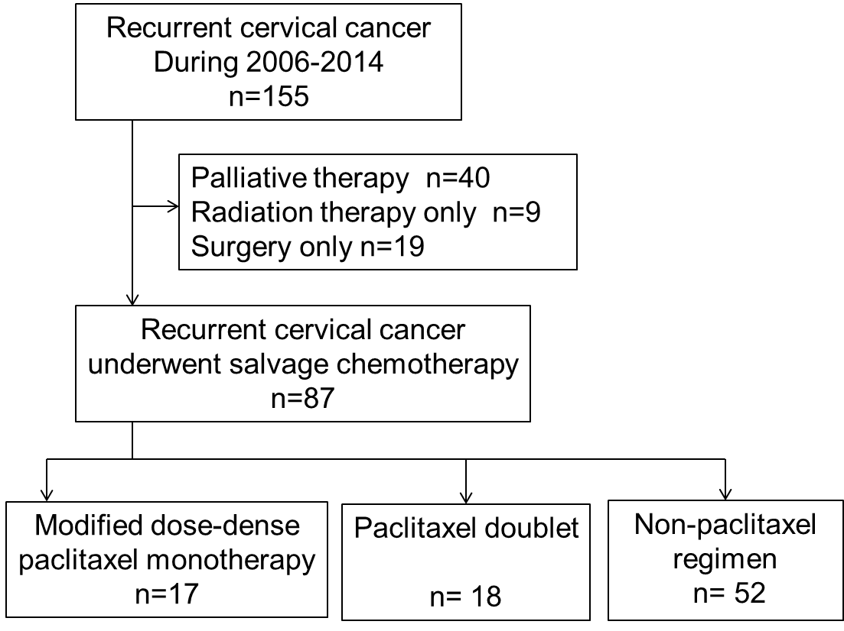

Supplemental Figure S2. Selection schema for systematic review: paclitaxel for recurrent cervical cancer.

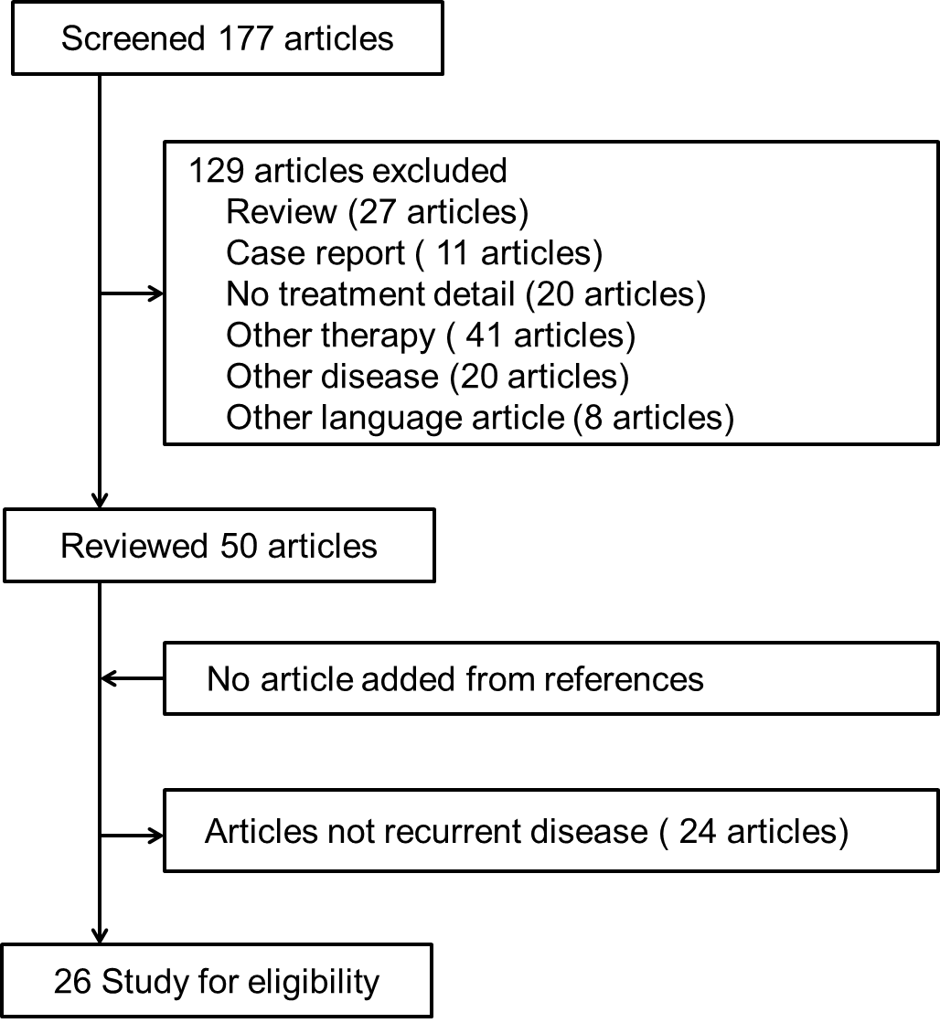
Abbreviations: PTX, paclitaxel

Supplemental Figure S3. Searching criteria for dose-dense paclitaxel chemotherapy with gynecologic cancers.
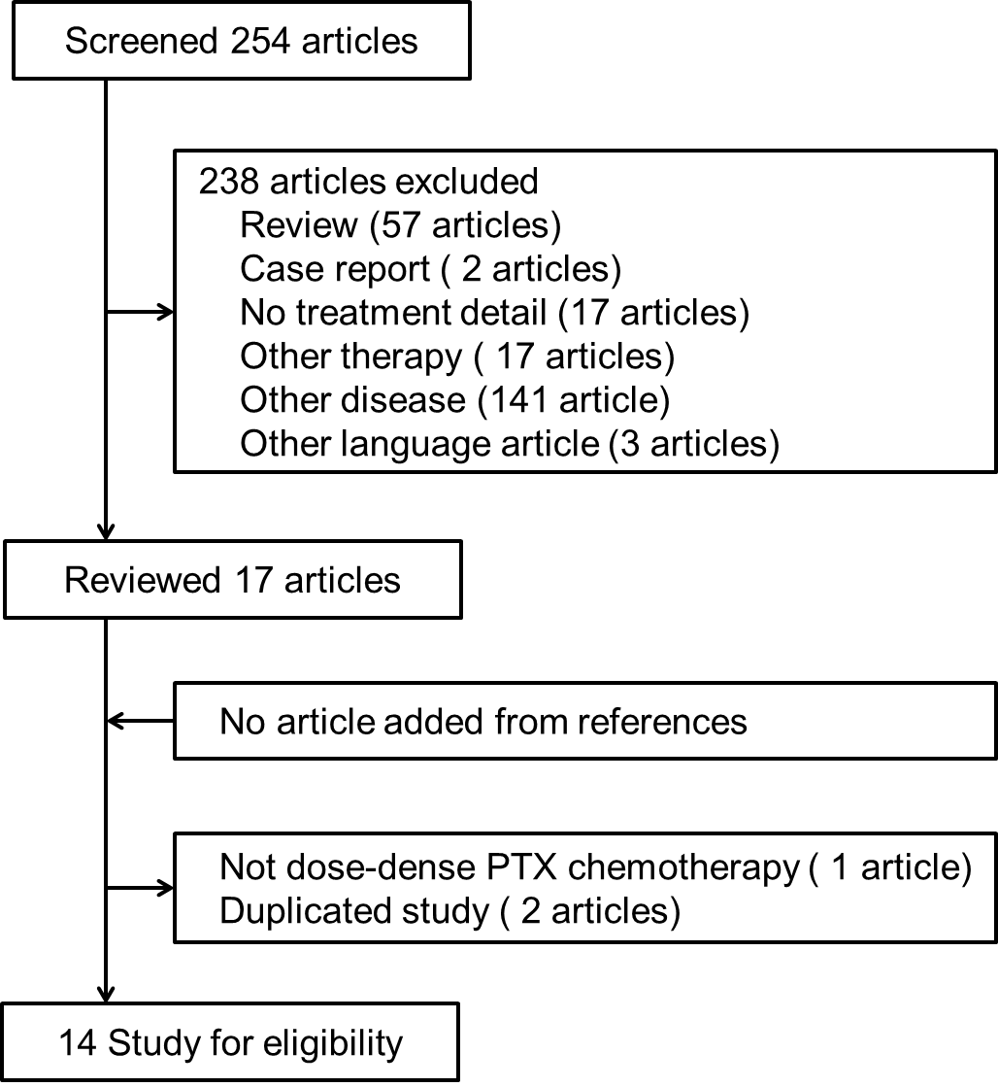
Abbreviation: PTX, paclitaxel.

REFERENCES
1. Chan JK, Brady MF, Penson RT, et al. Weekly vs. Every-3-Week Paclitaxel and Carboplatin for Ovarian Cancer. N Engl J Med. 2016;374:738-48.
2. Becker DA, Thomas ED, Gilbert AL, et al. Improved outcomes with dose-dense paclitaxel-based neoadjuvant chemotherapy in advanced epithelial ovarian carcinoma. Gynecol Oncol. 2016;142:25-9.
3. Benedetti Panici P, Palaia I, Marchetti C, Ruscito I, et al. Dose-Dense Neoadjuvant Chemotherapy plus Radical Surgery in Locally Advanced Cervical Cancer: A Phase II Study. Oncology. 2015;89:103-10.
4. Pignata S, Scambia G, Katsaros D, et al. Carboplatin plus paclitaxel once a week versus every 3 weeks in patients with advanced ovarian cancer (MITO-7): a randomised, multicentre, open-label, phase 3 trial. Lancet Oncol 2014;15:396-405.
5. van der Burg ME, Onstenk W, Boere IA, et al. Long-term results of a randomised phase III trial of weekly versus three-weekly paclitaxel/platinum induction therapy followed by standard or extended three-weekly paclitaxel/platinum in European patients with advanced epithelial ovarian cancer. Eur J Cancer. 2014;50:2592-601.
6. Katsumata N, Yasuda M, Isonishi S, et al. Long-term results of dose-dense paclitaxel and carboplatin versus conventional paclitaxel and carboplatin for treatment of advanced epithelial ovarian, fallopian tube, or primary peritoneal cancer (JGOG 3016): a randomised, controlled, open-label trial. Lancet Oncol. 2013;14:1020-6.
7. McCormack M, Kadalayil L, Hackshaw A, et al. A phase II study of weekly neoadjuvant chemotherapy followed by radical chemoradiation for locally advanced cervical cancer. Br J Cancer. 2013;108:2464-9.
8. Abaid LN, Micha JP, Rettenmaier MA, et al. A phase II study of modified dose-dense paclitaxel and every 4-week carboplatin for the treatment of advanced-stage primary epithelial ovarian, fallopian tube, or peritoneal carcinoma. Cancer Chemother Pharmacol. 2013;72:101-7.
9. Singh RB, Chander S, Mohanti BK, et al. Neoadjuvant chemotherapy with weekly paclitaxel and carboplatin followed by chemoradiation in locally advanced cervical carcinoma: a pilot study. Gynecol Oncol. 2013;129:124-8.
10. Cadron I, Leunen K, Amant F, et al. The "Leuven" dose-dense paclitaxel/carboplatin regimen in patients with recurrent ovarian cancer. Gynecol Oncol 2007;106:354-61.
11. Sharma R, Graham J, Mitchell H, et al. Extended weekly dose-dense paclitaxel/carboplatin is feasible and active in heavily pre-treated platinum-resistant recurrent ovarian cancer. Br J Cancer 2009;100:707-12.
12. Vandenput I, Vergote I, Leunen K, et al. Leuven dose-dense paclitaxel/carboplatin regimen in patients with primary advanced or recurrent endometrial carcinoma. Int J Gynecol Cancer 2009;19:1147-51.
13. Torfs S, Cadron I, Amant F, et al. Evaluation of paclitaxel/carboplatin in a dose dense or weekly regimen in 66 patients with recurrent or primary metastatic cervical cancer. Eur J Cancer 2012;48:1332-40.
14. Vergote I, Debruyne P, Kridelka F, et al. Phase II study of weekly paclitaxel/carboplatin in combination with prophylactic G-CSF in the treatment of gynecologic cancers: A study in 108 patients by the Belgian Gynaecological Oncology Group. Gynecol Oncol. 2015 ;138:278-84.

