Supplementary Appendix
Table S1: Baseline characteristics of participants who were followed during different types of periods. The subgroups are not mutually exclusive, as the same woman may undergo different types of periods.
 | Subgroup1  Untreated  Gestation  (N=149)* |  | Subgroup2  Untreated  Postpartum  (N=92) |  | Subgroup3  On treatment  Gestation  (N=49) |  | Subgroup4  On treatment  Postpartum  (N=36) |  | Subgroup5  After  withdrawal  (N=29)
 | N | % or  Median(range) | N | % or  Median(range) | N | % or  Median(range) | N | % or  Median(range) | N | % or  Median(range)
Age (years) | 149 | 32(18,49) | 92 | 33(22,51) | 49 | 31(23,40) | 36 | 31(23,40) | 29 | 31(24,40)
Race
White | 12 | 8% | 10 | 11% | 1 | 2% | 1 | 3% | 0 | 0%
Black | 27 | 18% | 19 | 21% | 3 | 6% | 2 | 6% | 1 | 3%
Asian | 109 | 73% | 62 | 67% | 43 | 88% | 31 | 86% | 28 | 97%
Other | 1 | 1% | 1 | 1% | 2 | 4% | 2 | 6% | 0 | 0%
Genotype
A | 22 | 17% | 17 | 22% | 1 | 2% | 0 | 0% | 0 | 0%
B | 49 | 38% | 32 | 41% | 16 | 33% | 12 | 34% | 11 | 38%
C | 45 | 35% | 20 | 25% | 27 | 56% | 20 | 57% | 16 | 55%
D | 6 | 5% | 7 | 9% | 2 | 4% | 1 | 3% | 1 | 3%
Other | 7 | 5% | 3 | 4% | 2 | 4% | 2 | 6% | 1 | 3%
Born in North America | 26 | 17% | 17 | 18% | 4 | 8% | 3 | 8% | 3 | 10%
HBeAg
Positive | 56 | 39% | 19 | 21% | 40 | 87% | 30 | 86% | 26 | 96%
Negative | 87 | 61% | 71 | 79% | 6 | 13% | 5 | 14% | 1 | 4%
ALT (U/L)
Overall | 144 | 22(5,513) | 88 | 21(6,69) | 49 | 25(9,513) | 36 | 25(9,513) | 29 | 20(12,135)
HBeAg+ | 55 | 25(12,513) | 18 | 25(12,44) | 40 | 25(9,513) | 30 | 25(9,513) | 26 | 20(12,135)
HBeAg- | 84 | 21(6,69) | 68 | 21(6,69) | 6 | 21(11,70) | 5 | 25(11,70) | 1 | 17
HBV DNA (IU/mL)
Overall | 147 | 1208(BLQ,ALQ) | 92 | 362(BLQ,4.1×10⁹) | 49 | 7.3×10⁶(BLQ,ALQ) | 36 | 9.5×10⁶(BLQ,ALQ) | 29 | 1.2×10⁸(BLQ,ALQ)
HBeAg+ | 56 | 1.3×10⁸(31,ALQ) | 19 | 4.1×10⁷(31, 4.1×10⁹) | 40 | 5.2×10⁷(BLQ,ALQ) | 30 | 4.3×10⁷(BLQ,ALQ) | 26 | 1.3×10⁸(BLQ,ALQ)
HBeAg- | 86 | 350(BLQ,1.3×10⁶) | 71 | 210(BLQ, 4.2×10⁵) | 6 | 465(BLQ,2.0×10⁵) | 5 | 258(BLQ,2.0×10⁵) | 1 | 672
APRI
Overall | 124 | 0.3(0.1,4.4) | 77 | 0.3(0.1,0.8) | 42 | 0.3(0.2,4.4 | 32 | 0.3(0.2,4.4) | 26 | 0.3(0.2,0.8)
HBeAg+ | 47 | 0.3(0.1,4.4) | 15 | 0.2(0.1,0.7) | 35 | 0.3(0.2,4.4) | 27 | 0.3(0.2,4.4) | 24 | 0.3(0.2,0.8)
HBeAg- | 74 | 0.3(0.1,0.8) | 61 | 0.3(0.1,0.8) | 5 | 0.5(0.2,0.6) | 4 | 0.5(0.2,0.6) | 1 | 0.4
Phenotype
IT, HBeAg+ | 15 | 11% | 3 | 3% | 15 | 33% | 11 | 31% | 13 | 48%
IA, HBeAg+ | 28 | 20% | 7 | 8% | 16 | 35% | 12 | 34% | 11 | 41%
IA, HBeAg- | 6 | 4% | 4 | 5% | 0 | 0% | 0 | 0% | 0 | 0%
IC, HBeAg- | 36 | 26% | 30 | 35% | 2 | 4% | 1 | 3% | 1 | 4%
Indeterminant | 53 | 38% | 42 | 49% | 13 | 28% | 11 | 31% | 2 | 7%

*All but one participant in subgroup 1 were untreated at enrollment. For that participant, antiviral therapy initiated 6 days before enrollment. As this participant was an adjudicated spontaneous flare based on clinical notes, we included her in the denominator for calculating spontaneous flare rates.
Table S2: Baseline characteristics among women who experienced a spontaneous flare (N=9) vs. women who did not experience any flare during the follow-up (N=136).
 | Spontaneous flare |  | No Flare* |  | p-value&
 | Number | Proportion or  median (range) | Number | Proportion or  median (range)
Age (years) | 9 | 31(27,37) | 136 | 32(18,51) | 0.649
Race |  |  |  |  | 0.377
White | 1 | 11% | 11 | 8%
Black | 0 | 0% | 27 | 20%
Asian | 8 | 89% | 97 | 71%
Other | 0 | 0% | 1 | 1%
Born in North America | 1 | 11% | 25 | 18% | >0.9
Genotype |  |  |  |  | 0.497
A | 0 | 0% | 22 | 19%
B | 4 | 44% | 45 | 39%
C | 4 | 44% | 37 | 32%
D | 1 | 11% | 6 | 5%
Other (E & F) | 0 | 0% | 6 | 5%
HBeAg
Positive | 6 | 67% | 45 | 35% | 0.074
Negative | 3 | 33% | 85 | 65%
HBV DNA (IU/mL)
overall | 9 | 7.3×10⁶(672,4.1×10⁹) | 134 | 750(BLQ,ALQ) | 0.005
among HBeAg+ | 6 | 9.4×10⁷(9.6×10⁴, 4.1×10⁹) | 45 | 1.2×10⁸(31,ALQ) | ─
among HBeAg- | 3 | 3.8×10³(672,2.0×10⁵) | 84 | 328(BLQ,1.3×10⁶) | ─
ALT (U/L)
overall | 9 | 38(15,513) | 131 | 21(5,69) | 0.113
among HBeAg+ | 6 | 87(15,513) | 44 | 25(12,52) | ─
among HBeAg- | 3 | 17(17,39) | 82 | 21(6,69) | ─
APRI
overall | 6 | 0.3(0.2,4.4) | 114 | 0.3(0.1,0.8) | 0.459
among HBeAg+ | 4 | 0.2(0.2,4.4) | 38 | 0.3(0.1,0.7) | ─
among HBeAg- | 2 | 0.4(0.4,0.4) | 73 | 0.3(0.1,0.8) | ─
Phenotype |  |  |  |  | 0.345
IT, HBeAg positive | 2 | 22 | 11 | 9
IA, HBeAg positive | 3 | 33 | 22 | 18
IA, HBeAg negative | 0 | 0 | 6 | 5
IC, HBeAg negative | 1 | 11 | 36 | 29
Indeterminant | 3 | 33 | 50 | 40

& P-value is not provided when n is too small.
*Women with non-viable outcomes or treatment-related flares were exclude.

Figure S1. ALT -Flares: Spontaneous reactivation
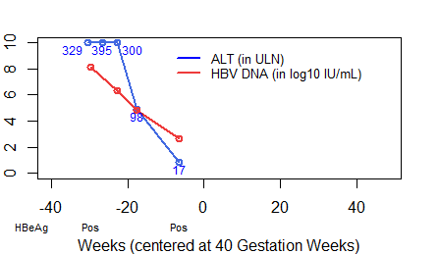 | Subject 1  Prior to conception: ALT 54 U/L and DNA of 1.97×10⁸ IU/ mL (8.3 log₁₀ IU/mL).  Flare:  Onset: First trimester (10 weeks)  Grade*: moderate  Duration: 24 weeks  Treatment initiated: no  HBeAg loss: no  HBV DNA: decrease (> 10 fold) with flare
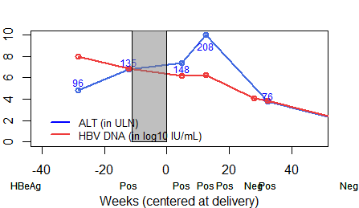 | Subject 2  Flare: 1st flare  Onset: Second trimester (27 weeks)  Grade: mild  Duration: unknown  Treatment: yes  HBeAg loss: no  HBV DNA: decrease (> 10 fold) with flare
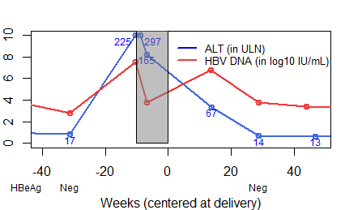 | Subject 3  Flare:  Onset: Third trimester (28 weeks)  Grade*: moderate  Duration: 39 weeks  Treatment initiated: yes  HBV DNA: increase (> 10 fold) with flare
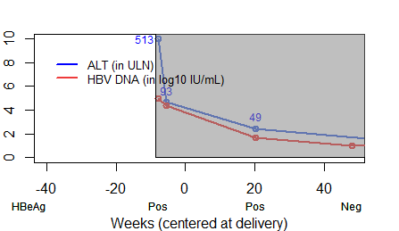 | Subject 4  Flare:  Onset: Third trimester (30 weeks)  Grade*: moderate  Duration: >48 weeks  Treatment initiated: yes  HBeAg loss: transient  HBV DNA change with flare: unknown
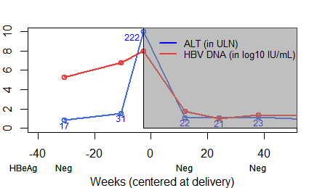 | Subject 5  Flare:  Onset: Third trimester (39 weeks)  Grade**: moderate  Duration: 15 weeks  Treatment initiated: yes  HBV DNA: increase (> 10 fold) with flare
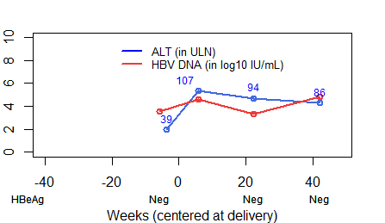 | Subject 6  Flare:  Onset: Post-partum (6 weeks)  Grade: mild  Duration: >36 weeks  Treatment initiated: no  HBV DNA: increase (> 10 fold) with flare
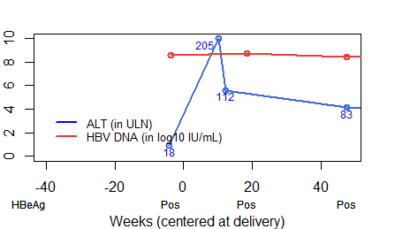 | Subject 7  Flare:  Onset: Post-partum (10 weeks)  Grade**: moderate  Duration: >37 weeks  Treatment initiated: no  HBeAg loss: no  HBV DNA: no change with flare (<10 fold)
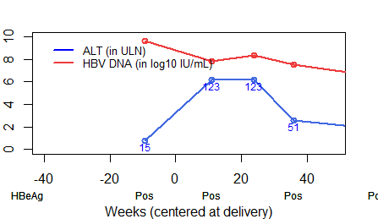 | Subject 8  Flare:  Onset: Post-partum (11 weeks)  Grade: mild  Duration: >25 weeks  Treatment initiated: no  HBeAg loss: no  HBV DNA: decrease (> 10 fold) with flare
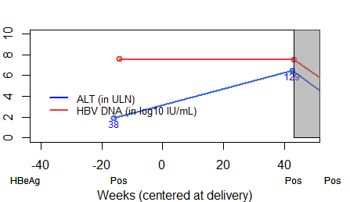 | Subject 9  Flare:  Onset: Post-partum (42 weeks)  Grade: mild  Duration: >5 weeks  Treatment initiated: yes  HBeAg loss: no  HBV DNA: no change with flare (<10 fold)
- The blue lines represent ALT (in ULN, such that each unit represents 20 U/L). ALT values above 10 ULN (i.e., 200 U/L) were plotted at 10 ULN, with actual values (in U/L) labeled on the figure in blue.
- The red lines represent HBV DNA (in log₁₀ IU/mL). For example, a value of 3 means 10³ IU/mL and a value of 7 means 10⁷ IU/mL. Each unit increase in log₁₀ IU/mL corresponds to 10-fold increase in the original scale (IU/mL).
- The grey area means the woman was receiving antiviral treatment.
- *confirmed by HBRN Adjudication Committee to be related to pregnancy
- **unknown or not yet confirmed by HBRN Adjudication Committee to be related to pregnancy
Figure S2. ALT Flares: on antiviral therapy
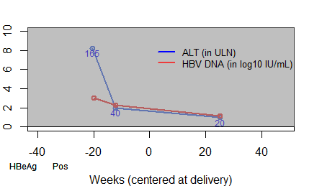 | Subject 1  Flare:  Onset: Second trimester (17 weeks)  Grade: mild  Duration: unknown  HBeAg loss: unknown  HBV DNA: unknown
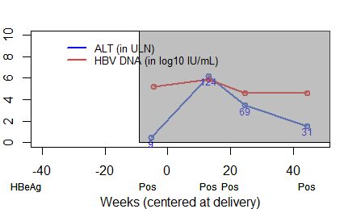 | Subject 2  Flare:  Onset: Post-partum (13 weeks)  Grade: mild  Duration: >31 weeks  HBeAg loss: no  HBV DNA: no change with flare (<10 fold)
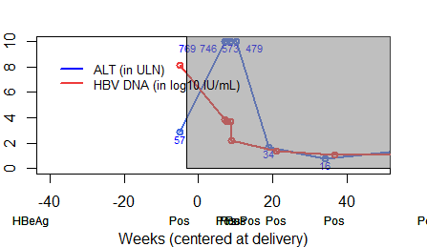 | Subject 3  Flare:  Onset: Post-partum (7 weeks)  Grade*: moderate  Duration: 12 weeks  HBeAg loss: no  HBV DNA: decrease (> 10 fold) with flare
- The blue lines represent ALT (in ULN, such that each unit represents 20 U/L). ALT values above 10 ULN (i.e., 200 U/L) were plotted at 10 ULN, with actual values (in U/L) labeled on the figure in blue.
- The red lines represent HBV DNA (in log₁₀ IU/mL). For example, a value of 3 means 10³ IU/mL and a value of 7 means 10⁷ IU/mL. Each unit increase in log₁₀ IU/mL corresponds to 10-fold increase in the original scale (IU/mL).
- The grey area means the woman was receiving antiviral treatment.
- *confirmed by HBRN Adjudication Committee to be related to pregnancy
Figure S3. ALT Flares: after withdrawal of therapy
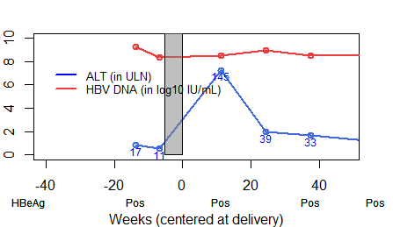 | Subject 1  Flare:  Onset: 11 weeks after discontinuation of therapy  Grade: mild  Duration: >26 weeks  Retreatment: no  HBeAg loss: no  HBV DNA: no change with flare (<10 fold)
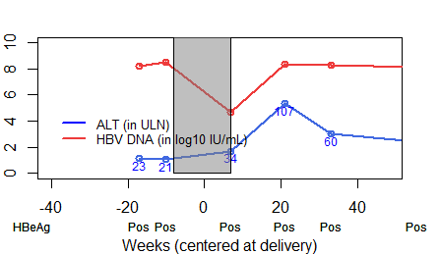 | Subject 2  Flare:  Onset: 14 weeks after discontinuation of therapy  Grade: mild  Duration: >12 weeks  Retreatment: no  HBeAg loss: no  HBV DNA: increase (>10 fold) with flare
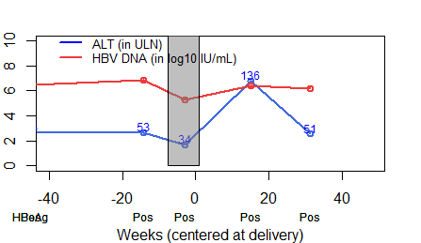 | Subject 3  Flare:  Onset: 14 weeks after discontinuation of therapy  Grade: mild  Duration: 16 weeks  Retreatment: no  HBeAg loss: no  HBV DNA: increase (>10 fold) with flare
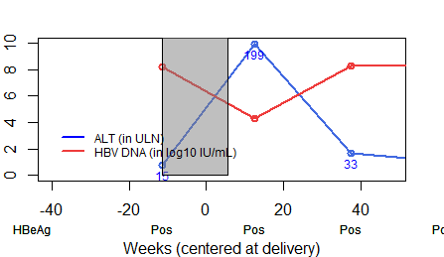 | Subject 4  Flare:  Onset: 7 weeks after discontinuation of therapy  Grade: mild  Duration: >25 weeks  Retreatment: no  HBeAg loss: no  HBV DNA: decrease (>10 fold) with flare
Subject 5

Flare: 2nd flare
Onset: 12 weeks after discontinuation of therapy
Grade*: moderate
Duration: >19 weeks
Retreatment: no
HBeAg loss: Yes
HBV DNA: no change with flare (<10 fold)

- The blue lines represent ALT (in ULN, such that each unit represents 20 U/L). ALT values above 10 ULN (i.e., 200 U/L) were plotted at 10 ULN, with actual values (in U/L) labeled on the figure in blue.
- The red lines represent HBV DNA (in log₁₀ IU/mL). For example, a value of 3 means 10³ IU/mL and a value of 7 means 10⁷ IU/mL. Each unit increase in log₁₀ IU/mL corresponds to 10-fold increase in the original scale (IU/mL).
- The grey area means the woman was receiving antiviral treatment.
- *confirmed by HBRN Adjudication Committee to be related to withdrawal of therapy

