SUPPLEMENT 2

Supplementary Table 1. Baseline characteristics and clinical outcome between CDS and HGSª
Variables | CDS (n = 32) | HGS (n = 32) | P Value
Age, mean (range), years | 67.63 (40, 90) | 62.03 (43, 88) | .06
Male sex, no. (%) | 19 (59.4) | 22 (68.8) | .43
Duodenal invasion, no. (%) | 9 (28.1) | 9 (28.1) | >.99
Surgically altered anatomy, no. (%)
Billroth-II | 0 (0) | 1 (25)
Roux-en-Y | 0 (0) | 3 (75)
Technical success, no. (%) | 29 (90.6) | 31 (96.9) | .61
Clinical success, no. (%) | 28 (87.5) | 26 (81.3) | .49
Procedure time, median (IQR), min | 5.8 (3.1, 19.2) | 4.8 (3.5, 7.2) | .13
Transmural fistula dilation, no. (%) |  |  | .89^{d}
1-step | 22 (75.9) | 24 (77.4)
2-step | 7 (24.1)^{b} | 7 (22.6)^{c}
Stent length (mm) | 6.2±0.6 | 8.9±0.8 | <.001
Adverse events, no. (%)
Early (procedure-related) | 2 (6.3) | 2 (6.3) | >.99
Late | 3 (9.4) | 0 (0) | .24
Procedure severity, no. (%)
Early Mild | 1 (50) | 1 (50)
Moderate | 1 (50) | 1 (50)
Late Mild | 2 (66.7) | 0 (0)
Moderate | 1 (33.3) | 0 (0)
Reintervention rate, no. (%) | 6 (18.8) | 4 (12.5) | .49
Reintervention method, no. |  |  | >.99
ERCP | 5 (83.3) | 4 (100)
PTBD | 1 (16.7) | 0 (0)
Hospital stay, median (range), days | 5 (2, 28) | 4 (3, 12) | .05
ªPlus-minus values are means±SD. CDS denotes choledochoduodenostomy, HGS hepaticogastrostomy, IQR interquartile range, ERCP endoscopic retrograde cholangiopancreatography, and PTBD percutaneous transhepatic biliary drainage.
^{b}Additional transmural fistula dilations were done with needle knife (n = 2), 4-mm balloon catheter without balloon dilation (n = 4), or bougie catheter (n = 1) in CDS group.
^{c}Additional transmural fistula dilations were done with needle knife (N=1) or 4-mm balloon catheter without balloon dilation (n = 6) in HGS group.
^{d}The rates of one-step transmural fistula dilation were calculated according to an intention-to-treat analysis.

Supplementary Table 2. Predictive factors of reintervention
Variables | No. | Reintervention (%) | Crude HR | 95% CI |  | P Value | Adjusted HRª | 95% CI |  | P Value
Age (years)
≤ 65 | 57 | 15 (26.3) | 1
> 65 | 68 | 21 (30.9) | 1.465 | 0.750 | 2.860 | .26
Sex
Male | 67 | 17 (25.4) | 0.658 | 0.340 | 1.273 | .21
Female | 58 | 19 (32.8) | 1
ASA class |  |  | 0.794 | 0.347 | 1.821 | .59
I | 10 | 4 (40.0)
II | 106 | 30 (28.3)
III | 9 | 2 (22.2)
Primary cancer
Pancreatic cancer | 78 | 23 (29.5) | 1.108 | 0.560 | 2.192 | .77
Other cancer | 47 | 13 (27.7) | 1
Initial total bilirubin level |  |  | 0.940 | 0.881 | 1.002 | .06 | 0.946 | 0.886 | 1.011 | .10
Common bile duct diameter (mm) |  |  | 0.927 | 0.844 | 1.017 | .11 | 0.951 | 0.864 | 1.048 | .31
Biliary drainage method
ERCP | 61 | 26 (42.6) | 3.339 | 1.607 | 6.940 | .001 | 3.142 | 1.511 | 6.534 | .002
EUS-BD | 64 | 10 (15.6) | 1 |  |  |  | 1
Duodenal invasion
Yes | 31 | 9 (29.0) | 1.460 | 0.685 | 3.111 | .33
No | 94 | 27 (28.7) | 1
Surgically altered anatomy
Yes | 5 | 2 (40.0) | 0.820 | 0.196 | 3.436 | .79
No | 120 | 34 (28.3) | 1
Systemic chemotherapy
Yes | 63 | 20 (31.8) | 0.863 | 0.444 | 1.680 | .67
No | 62 | 16 (25.8) | 1
ªAdjusted variables with P<0.2 on univariate analysis.

Supplementary Figures

Supplementary Figure 1. Schematics of EUS-guided transmural biliary drainage.
(A) Choledochoduodenostomy and (B) hepaticogastrostomy. (C) A preloaded partially covered metal stent and one-step dedicated stent introducer with tapered metal tip which functions as a push-type dilator.

(A)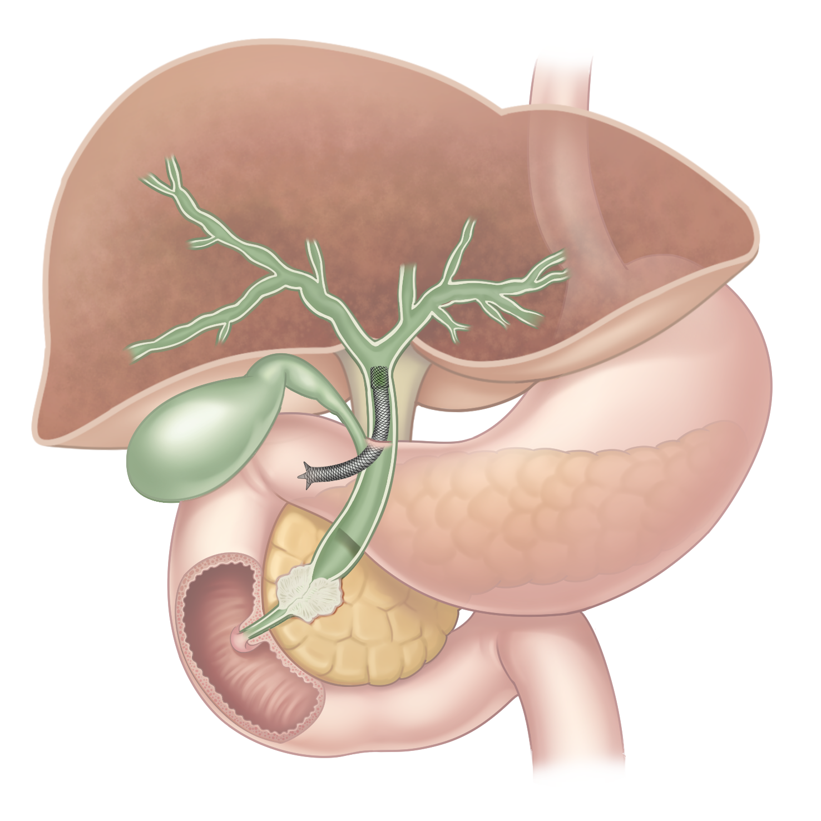
(B)
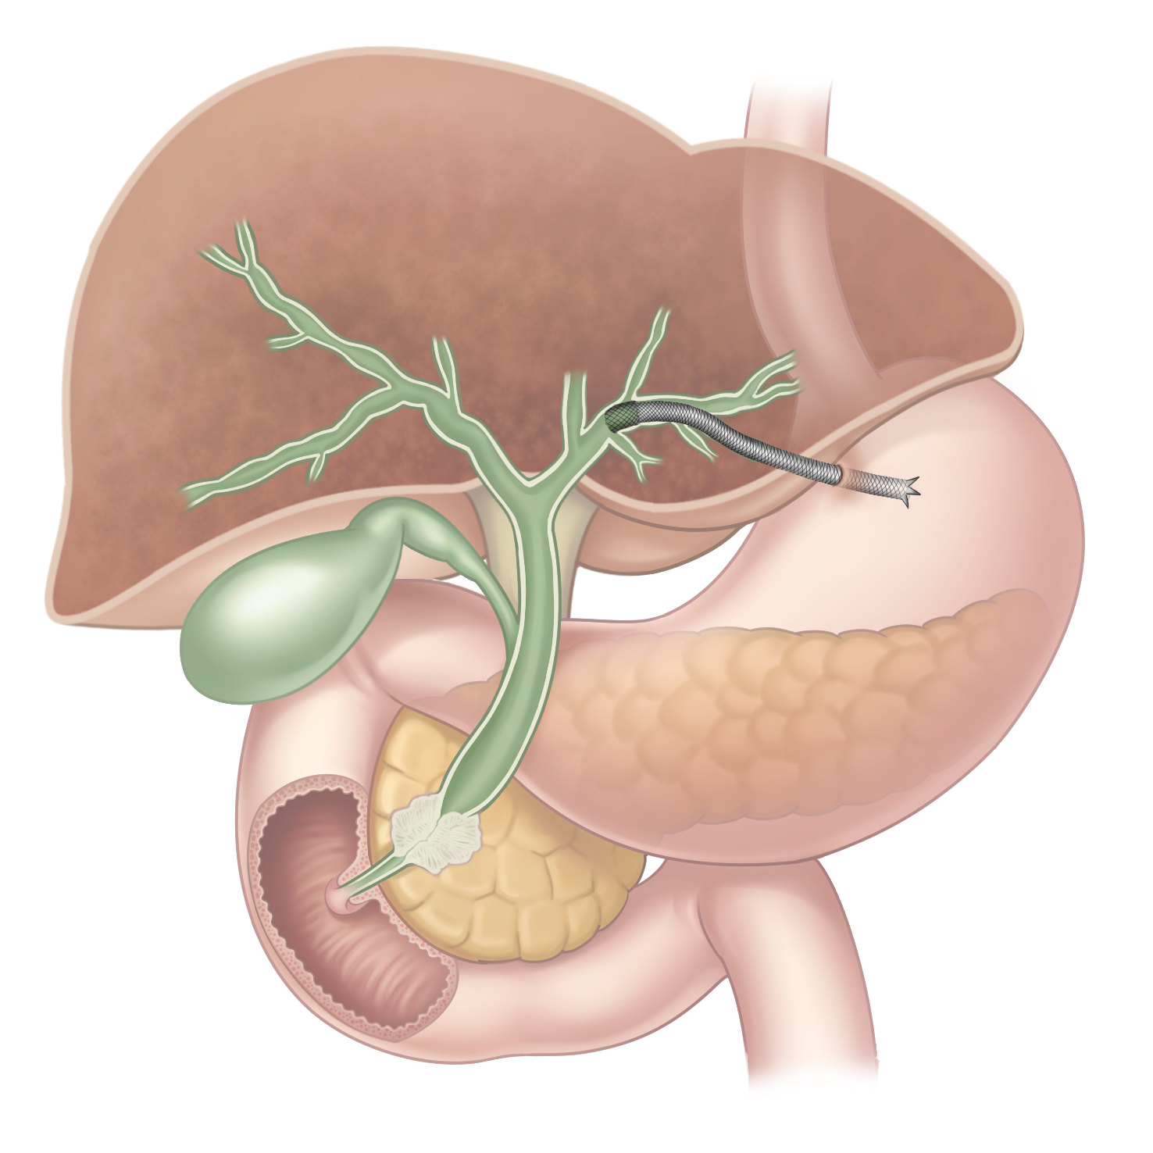

(C)

