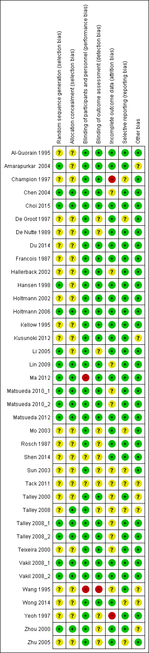
Supplementary Figure 1 Summary of results of consensus risk of bias assessments of the included studies (Red; risk of bias high, yellow; risk of bias unclear, green; risk of bias low)

Supplementary Figure 2 Forrest plot comparing prokinetic and placebo in patients with functional dyspepsia in term of not symptom-free or no symptom improvement, subgrouped by type of publication
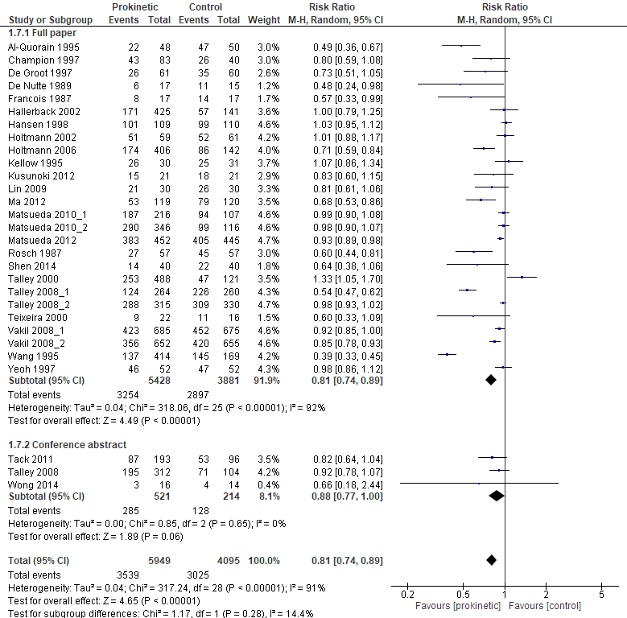

Supplementary Figure 3 Forrest plot comparing prokinetic and placebo in patients with functional dyspepsia in term of not symptom-free or no symptom improvement, subgrouped by assessment tool
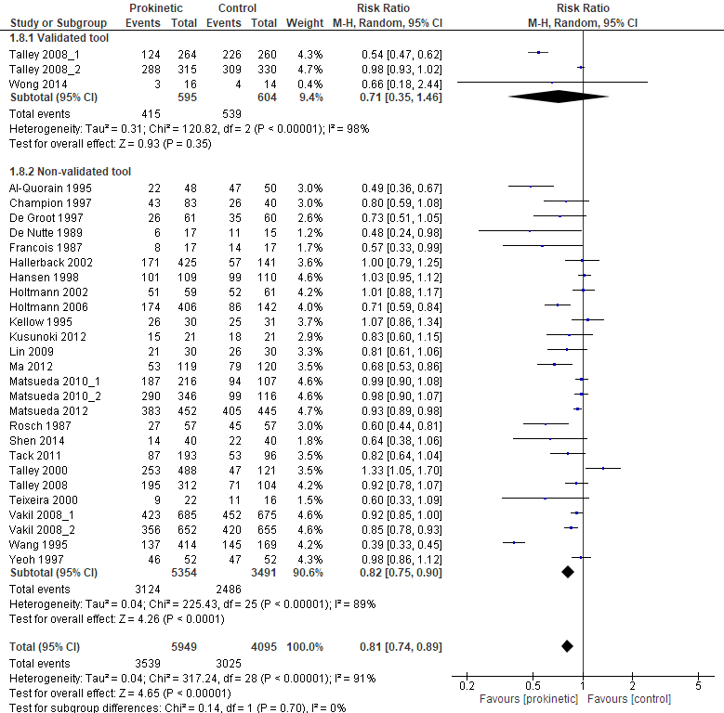

Supplementary Figure 4 Forrest plot comparing prokinetic and placebo in patients with functional dyspepsia in term of not symptom-free or no symptom improvement, subgrouped by duration of treatment and follow-up
