Supplementary Material.

Supplementary Results
Engraftment in germ-free mice
Mouse pellets at T₀, prior to gavage, as well as at any time point among the PBS control group returned significantly fewer high-quality sequence reads (3,130 ± 286) than did samples collected following gavage of fecal donor material (110,890 ± 18,286; p < 0.0001). Throughout the period of sample collection, no significant changes (p < 0.001) were observed in the bacterial compositions of the control group, and these samples clustered separately from samples taken after gavage of fecal preparations using AMOVA (Supplementary Figure 1). On the basis of these observations, The T₀ and control samples were not included in analyses following rarefaction to normalize sequence reads among samples.
Following gavage, engraftment proceeded with an early expansion of the Bacteroidetes, predominantly among the families Porphyromonadaceae and Bacteroidaceae, with a subsequent increase in the relative abundance of Firmicutes, primarily the families Lachnospiraceae and Ruminococcaceae (Supplementary Figure 2A). Engraftment was evident for both frozen and freeze-dried treatment groups at three days post-gavage (T₃; Supplementary Figure 2B), with donor OTUs accounting for >50% of the communities. The donor community appeared to establish more quickly using the freeze-dried preparation, but differences between preparation were not significant at T₃ (p = 0.101) or across all timepoints (p = 0.237). Community composition of both frozen and freeze-dried treatment groups varied from each other as well as from donor communities by ANOSIM (p < 0.001), and each group clustered independently (AMOVA p < 0.001, Supplementary Figure 1).

Ethics and FMT capsule protocol changes
Standardized donor screening and testing were done in accordance with our IND 015071 and University of Minnesota IRB protocol 1303M29781. The clinical use of microbiota-containing capsules was conducted under the principles of the FDA enforcement discretion policy governing FMT in treatment of C. difficile infection that fails resolution with standard antibiotic therapies. Throughout the study we emphasized the consent process. All patients were told the statistics from our extensive experience with colonoscopic FMT and all patients were offered colonoscopic FMT as an option. The patients were also informed about the up-to-date results from the capsule FMT cohort at the time of consent, including emerging changes in the protocol. In addition, we explained several uncertainties in the capsule FMT protocol, including the need for a colonic purgative prior to FMT, the potential for interaction with stomach acid blocking medications, and the dose of microbiota. The consent process included three steps: initial discussion during the clinic visit, review of informational handouts and the consent forms at home, and final review with signatures obtained by the research staff during the home visit.
The initial dose (~ 2.5 × 10¹² bacteria, 24-27 capsules) was based on our original colonoscopic FMT protocol, which itself was based on arbitrary dosing derived from average bacterial counts of individual donations (~ 50 g) of our first donor.⁷ The capsules were administered over 2-3 days, 2-3 times per day on an empty stomach. The first four patients were instructed to take a colon purgative, identical to the one they would have received prior to colonoscopic FMT, before taking the capsules.⁷ The colon purgative was not used in all subsequent patients and the period off vancomycin was lengthened to two days prior to FMT to ensure clearance of the antibiotic from the gut. The dose of microbiota was decreased in the course of this study due to the limited supply of prepared capsules. Initially, the dose was halved and 14 patients received 1.25 × 10¹² bacteria (14 capsules taken within one day). Subsequently, the original dose was decreased by an order of magnitude and the last 30 patients received a dose of 2.1-2.5 × 10¹¹ bacteria (2-3 capsules, single ingestion).

Changes in fecal microbiome following FMT
A mean sample coverage of 99.1 ± 0.1% was observed among all donor and patient samples, with a mean of 279 ± 29 OTUs observed in each sample. Total community alpha diversity was significantly lower in pre-FMT patient samples than donor and post-FMT samples, regardless of clinical outcome, based on the Shannon index (Supplementary Table 4, ANOVA p < 0.0001). While the abundance of Firmicutes did not differ significantly following capsule FMT, alpha diversity within the Firmicutes was significantly lower in pre-FMT samples and those from patients who experienced recurrence (Supplementary Figure 3, p < 0.0001), but differences in alpha diversity within the Bacteroidetes, which did show significant differences in abundance, did not differ significantly (p = 0.468).
Capsule dosage did not significantly affect alpha diversity as measured by the Shannon index, with no significant differences between patients who received the 10¹¹ bacteria dosages (3.42 ± 0.07) compared to 10¹² bacteria (3.72 ± 0.18, p = 0.187). Despite some variation in the relative abundances of the predominant phyla (Supplementary Figure 4), capsule dosage also did not significantly affect relative abundances of phyla within single timepoints (p > 0.05). Similarly, the extent of engraftment, measured by using SourceTracker software, was not dose-dependent, with no differences in the percent of donor similarity at any timepoint (p ≥ 0.920). Furthermore, following the two-month follow-up, patient communities and donor similarity were nearly identical regardless of dose. Similar to differences in dosage, Shannon diversity was not significantly affected by the use of proton pump inhibitors (PPI), with mean indices of 3.51 ± 0.08 versus 3.50 ± 0.10, for those on and off PPI, respectively (p = 0.824). Use of PPI also did not significantly affect the relative abundances of major phyla (Supplementary Figure 5, p > 0.05) or the extent of donor engraftment (p ≥ 0.977) within a single time point.
Patients who experienced recurrence showed similar taxonomic composition prior to FMT (Supplementary Figure 6), but the abundance of Proteobacteria in the days following FMT was observed to be greater than among patients who did not relapse (p = 0.013). While the microbiomes of several patients (i.e. P02, P03, and P05) returned to donor-like assemblages, primarily comprised of Firmicutes and Bacteroidetes, communities also showed decreases in alpha diversity within the first weeks following FMT, while other patients maintained a greater proportion of Proteobacteria. Notably, the microbiome of the patient who was placed on antibiotics for a UTI (P07) was primarily comprised of Proteobacteria. Thus, a clear trend in the shifts in microbial community composition that might indicate failure of FMT require further investigation.

Supplementary Table 1. Percent intact cell viability data from frozen (liquid) and lyophilized material obtained from a single sample at various timepoints after processing/lyophilization.
 | Raw material - 60.2% intact
 | Time (weeks)
Material | after lyoph | 1 | 2 | 3 | 4 | 6 | 8
Frozen - 10% glycerol | N/A | 55.1 | 58.1 | 53.4 | 57.2 | 56.2 | 55.3
10% Mannitol | 31.7 | 34.4 | 33.4 | 32.2 | 36.3 | 29.2 | 34.2
5% Mannitol | 29.5 | 32.1 | 27.6 | 30.1 | 28.6 | 31.3 | 28.4
10% Trehalose | 56.7 | 57.4 | 55.3 | 55.6 | 53.1 | 56.4 | 52.1
5% Trehalose | 59.4 | 55.4 | 58.9 | 57.2 | 56.2 | 52.2 | 55.8

Results in Supplementary Table 1 show that membrane integrity (synonymously used here for viability) was stable for up to 8 weeks post-lyophilization. Additionally, there was little difference in viability between preparations made with 5% trehalose compared to 10% trehalose. Lesser amount of trehalose allows dosing in fewer capsules.

Supplementary Table 2. Temperature stability of encapsulated freeze-dried microbiota.
 |  | Counts/square
 |  | 1 | 2 | 3 | 4 | 5 | Average | Cells/g | Membrane Integrity
Sample 1 | Initial | 69 | 67 | 64 | 57 | 58 | 63 | 7.9E+11 | 49%
 | - 20ºC | 56 | 52 | 50 | 49 | 48 | 51 | 6.4E+11 | 51%
 | + 4ºC | 40 | 44 | 49 | 52 | 37 | 44 | 5.6E+11 | 58%
 | Room Temperature | 66 | 56 | 57 | 55 | 49 | 57 | 7.1E+11 | 54%
Sample 2 | Initial | 57 | 55 | 53 | 60 | 57 | 56 | 7.1E+11 | 61%
 | - 20ºC | 57 | 68 | 60 | 56 | 60 | 60 | 7.5E+11 | 63%
 | + 4ºC | 55 | 64 | 50 | 49 | 58 | 55 | 6.9E+11 | 65%
 | Room Temperature | 67 | 62 | 74 | 56 | 55 | 63 | 7.9E+11 | 63%
Sample 3 | Initial | 89 | 83 | 85 | 82 | 83 | 84 | 1.1E+12 | 55%
 | - 20ºC | 90 | 87 | 88 | 82 | 92 | 88 | 1.1E+12 | 68%
 | + 4ºC | 72 | 68 | 73 | 66 | 70 | 70 | 8.7E+11 | 55%
 | Room Temperature | 95 | 78 | 81 | 91 | 83 | 86 | 1.1E+12 | 49%

Cell counts and membrane integrity were determined from triplicate samples of fresh microbiota prepared following filtration steps and held at room temperature, 4°C, and -20°C for 96 hours. Results of this experiment showed that there was no significant difference (p =) in cell integrity in samples held at room temperature (55.3±0.04%), 4ºC (59.3±0.03%), or -20ºC (60.6±0.05%), relative to that found in the initial preparation (55.0±0.03%).

Supplementary Table 3. Storage duration of encapsulated microbiota prior to dispensing to the patients.

Duration in -80ºC storage | Number of patients that underwent rescue capsule FMT following failure of colonoscopic FMT: failure/success | Patients that underwent their first FMT using capsule administration: failure/success
0-3 months | 1/6 | 3/15
3-6 months | 1/0 | 0/5
6-9 months | 0/1 | 0/3
9-12 months | 1/0 | 1/12

Supplementary Table 4. Alpha diversity indices (mean ± SE) for microbial communities in patient samples.
Clinical Outcome | Timepoint* | N (individuals) | n (sample) | Shannon
Donor | Donor | 3 | 5 | 3.95 ± 0.13
Cure | pre-FMT | 26 | 28 | 2.36 ± 0.17
 | Days | 25 | 25 | 3.40 ± 0.16
 | Weeks | 27 | 34 | 3.63 ± 0.11
 | Months | 11 | 14 | 3.48 ± 0.13
 | > 2 months | 7 | 7 | 3.37 ± 0.13
Recurrence | pre-FMT | 8 | 10 | 2.97 ± 0.44
 | Days | 8 | 9 | 3.36 ± 0.40
 | Weeks | 8 | 11 | 3.39 ± 0.38
 | Months | 4 | 4 | 3.27 ± 0.22
 | > 2 months | 2 | 2 | 2.94 ± 0.97
p-value |  |  |  | < 0.0001

*Samples were collected prior to FMT (pre-FMT), within the first 6 days post-FMT (days), between 7 and 21 days post-FMT (weeks), between 30 and 60 days post-FMT (months), or after 2 months post-FMT (>2 months). Samples were not collected in patients that suffered recurrence of CDI after initiation of antibiotics. Four patients suffered recurrence of CDI during week 2-3 following FMT, 2 patients after 1 month, and 2 patients after 2 months.

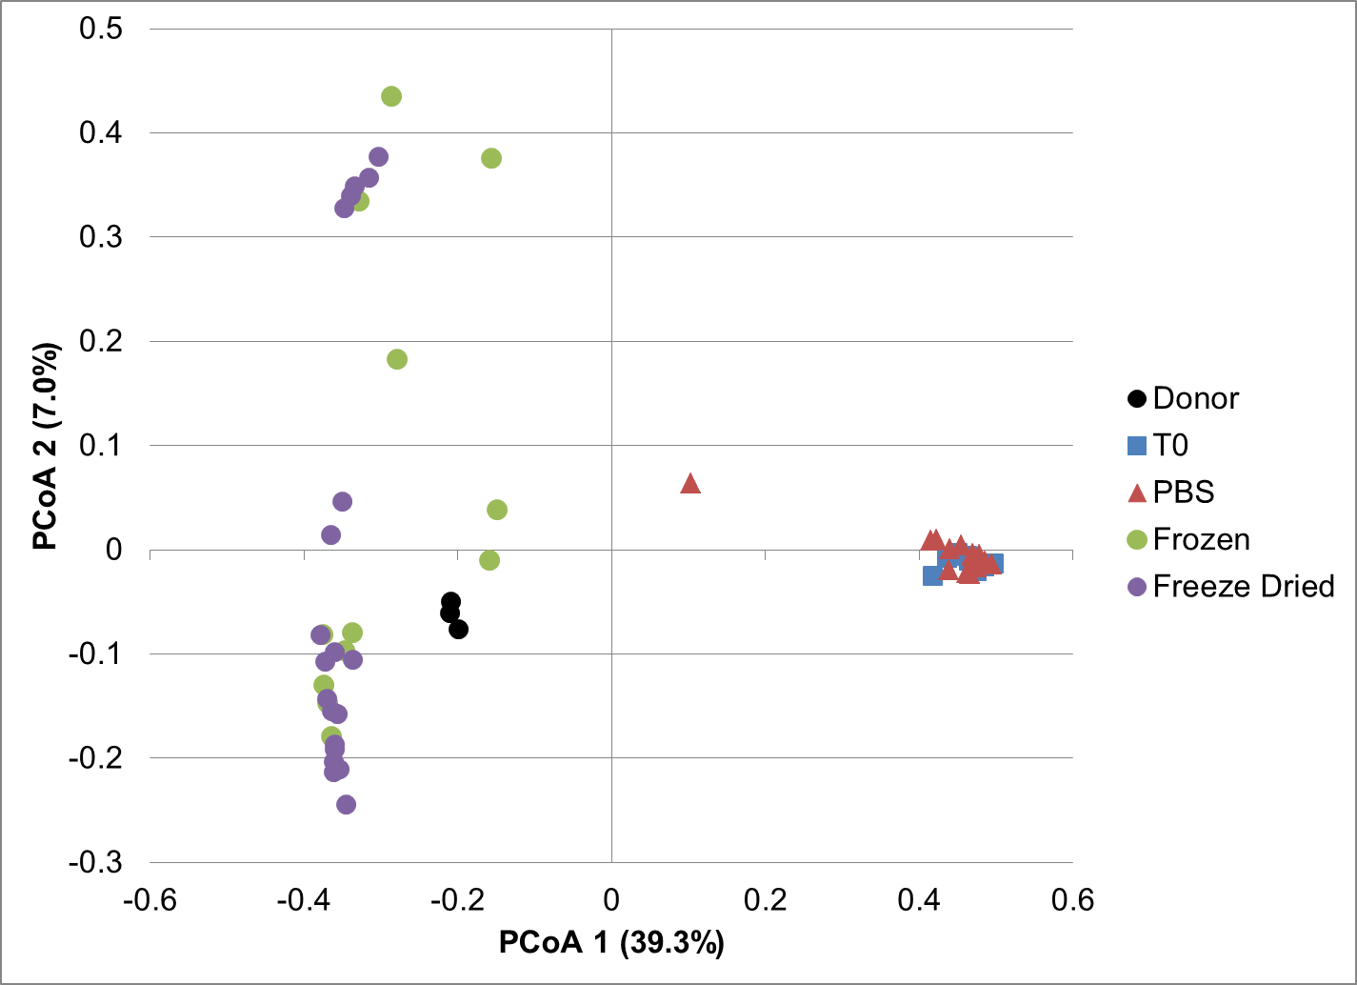
Supplementary Figure 1. Principal coordinate analysis of donor and germ-free mouse samples gavaged with PBS control, frozen, or freeze-dried fecal microbiota (r² = 0.73).
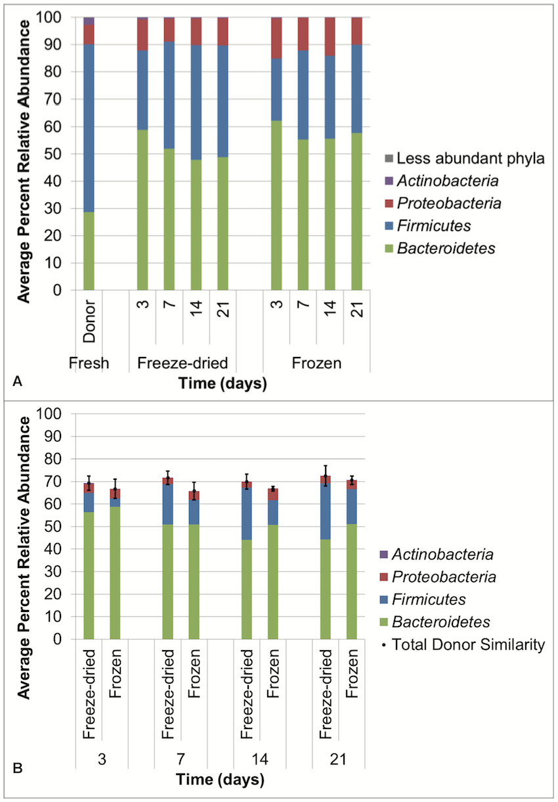
Supplementary Figure 2. A) Distribution of phyla among all mouse fecal pellets and donor samples, without rarefication. B) Phylum-level classification of OTUs that were associated with donor contribution as estimated by SourceTracker. Error bars reflect standard error of the mean.

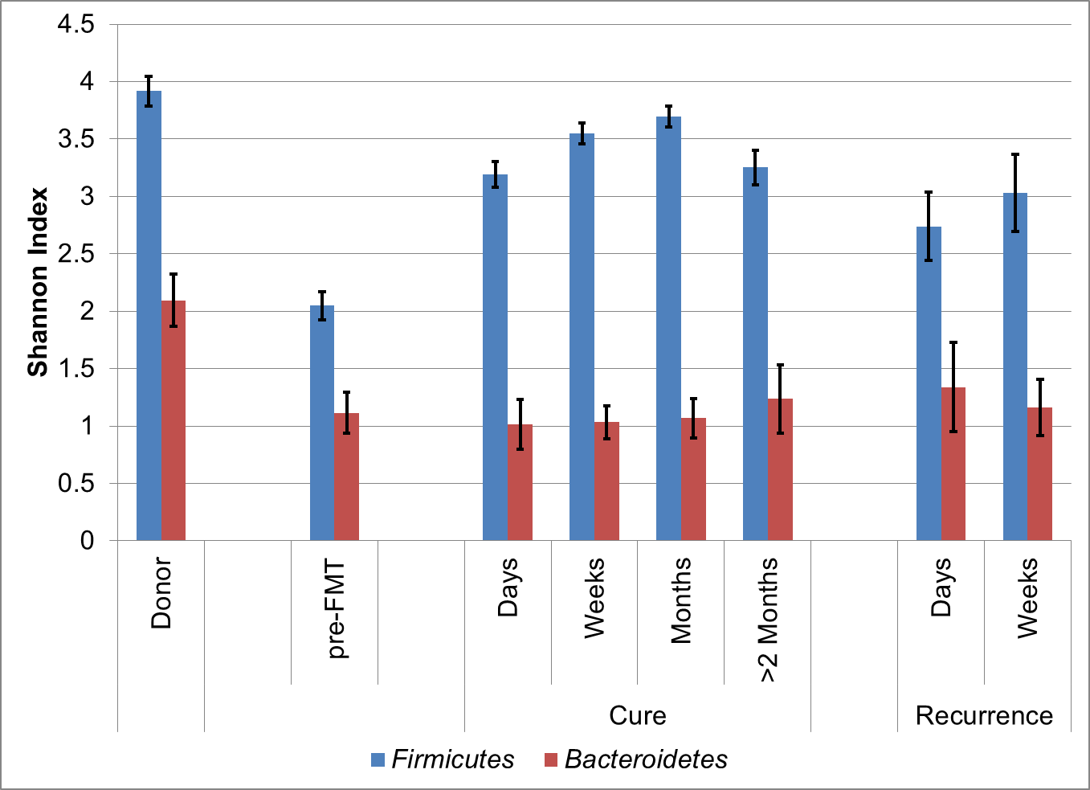
Supplementary Figure 3. Alpha diversity within the Bacteroidetes and Firmicutes phyla, individually, in patients pre- and post-FMT FMT, and the donor samples.
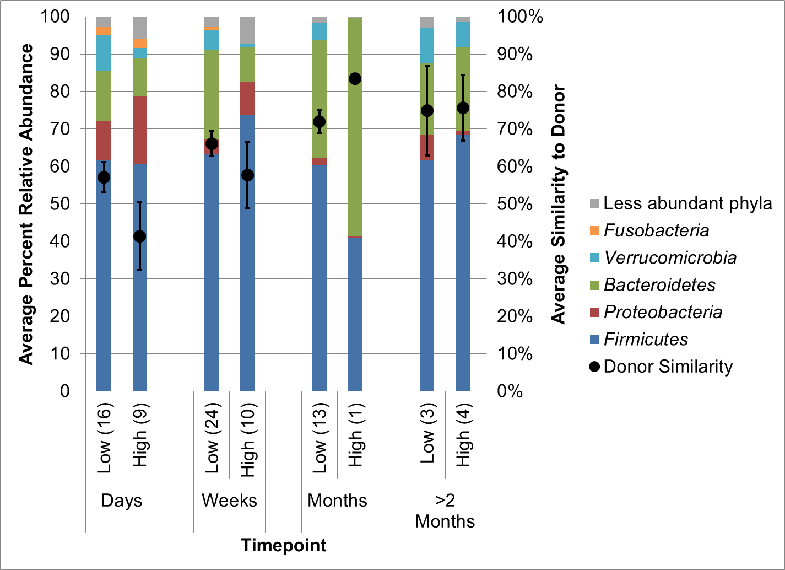
Supplementary Figure 4. Distribution of phyla and similarity to donor (i.e., attribution of DNA sequences to donor engraftment, as determined by using SourceTracker software) among samples from patients administered low (2.1-2.5 × 10¹¹ cells) and high (1.25-2.5 × 10¹² cells) doses of capsule FMT. Numbers in parentheses reflect sample size.
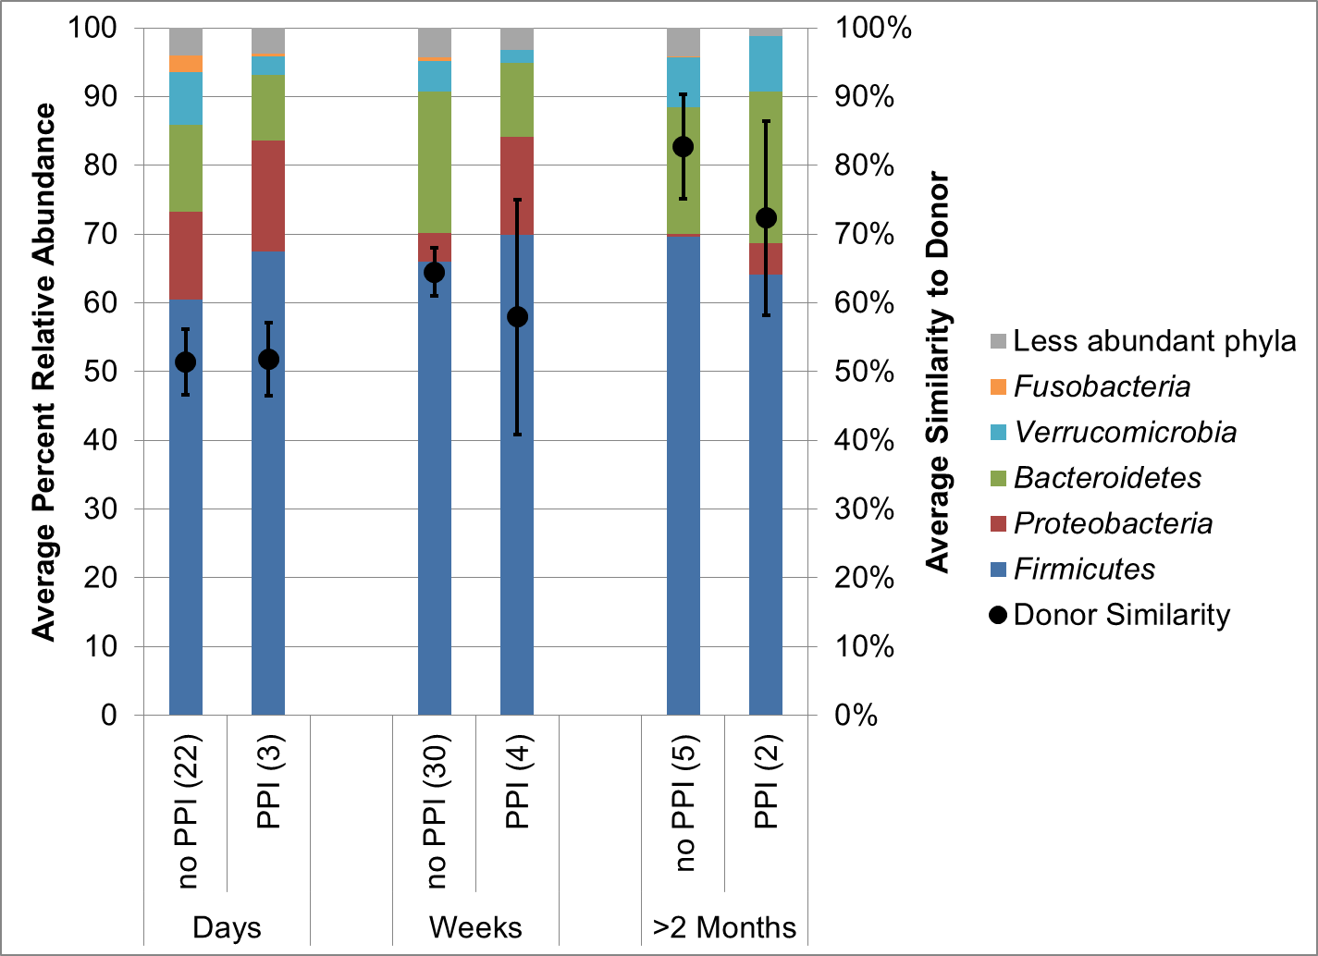
Supplementary Figure 5. Distribution of phyla and total donor similarity among samples from patients grouped by use of PPI. Numbers in parentheses reflect sample size.
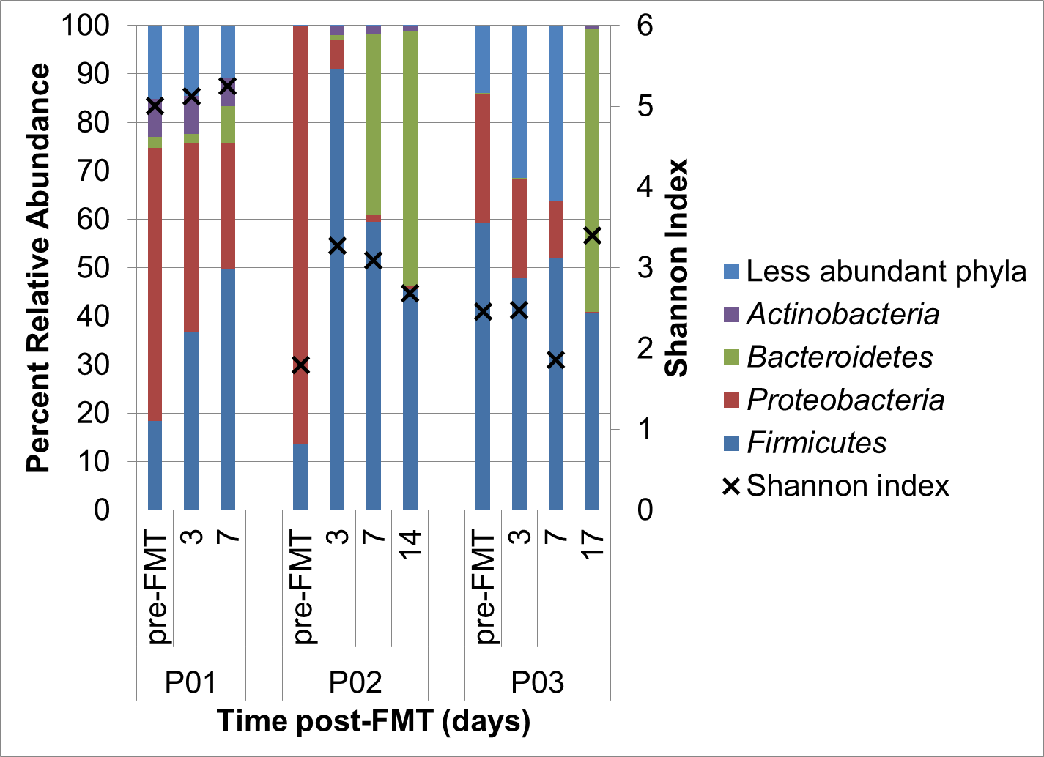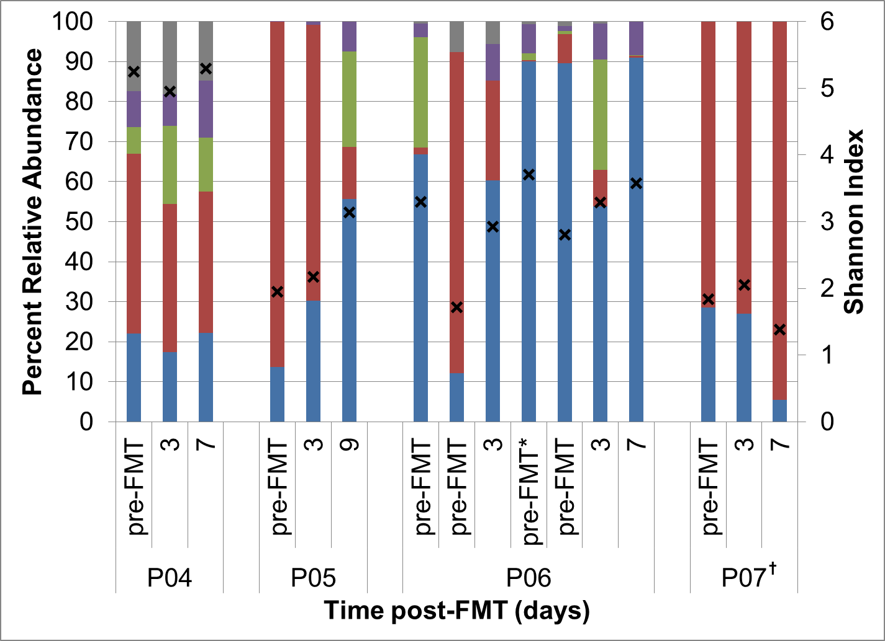
B
A
Supplementary Figure 6. Distribution of phyla and alpha diversity among patients who experienced recurrence of C. difficile infection following (A) initial capsule FMT or (B) capsule FMT following recurrence after colonoscopic FMT.
*Sample was collected prior to administration of fidaxomicin.
†Patient was administered antibiotics for a urinary tract infection.

