Supplementary Results
Contribution of additional variables to the predictive value of platelet count in the Jangouk, Levy, and Lindor criteria.

Primary Biliary Cholangitis (PBC)

Platelet count

C-statistic 0.785

Model

Coef S.E. Wald Z p-value
Intercept 0.9778 0.7182 1.36 0.1734
Platelet -0.0195 0.0051 -3.80 0.0001

Adding MELD to platelet count

C-statistic 0.798

Model
Coef S.E. Wald Z p-value
Intercept 0.6976 1.1078 0.63 0.5289
Platelet -0.0192 0.0052 -3.68 0.0002
MELD 0.0275 0.0831 0.33 0.7405

Adding Mayo (original) to platelet count

C-statistic 0.792

Model
Coef S.E. Wald Z p-value
Intercept 3.0626 1.8404 1.66 0.0961
Platelet -0.0225 0.0059 -3.85 0.0001
Mayo model -0.3324 0.2684 -1.24 0.2155

Primary Sclerosing Cholangitis (PSC)

Platelet count

C-statistic 0.845

Model

Coef S.E. Wald Z P-value
Intercept 1.1767 0.9274 1.27 0.2045
Platelet -0.0200 0.0067 -2.97 0.0030

Platelet + MELD

C-statistic 0.851

Model

Coef S.E. Wald Z P-value
Intercept 0.6959 1.4138 0.49 0.6226
Platelet -0.0195 0.0067 -2.93 0.0034
MELD 0.0411 0.0960 0.43 0.6687

Platelet + Bilirubin (mg/dl)

C-statistic 0.845

Coef S.E. Wald Z p-value
Intercept 1.1842 1.0086 1.17 0.2403
Platelet -0.0200 0.0067 -2.97 0.0030
bilirubin -0.0040 0.2079 -0.02 0.9847

Model with only platelet count (corrected with bootstrap):

Logit = 1.2655358-0.021495671*Plat300 (platelet introducted with a cap of 300).

A platelet count of 200 would be associated with a 5% risk of VNT (95% CI 1-14). 50% of patients with PBC had a platelet count of more than 200.

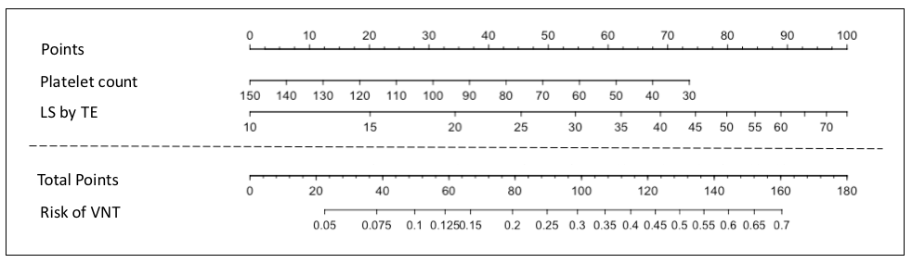

Supplementary Figure 1. Risk of VNT in patients with PBC: The ANTICIPATE-PBC model. This nomogram shows the risk of VNT treatment based on the results of LS by TE and platelet count in patients with PBC. VNT: Varices needing treatment; PBC: Primary biliary cholangitis; LS by TE: Liver stiffness measurement by transient elastography.

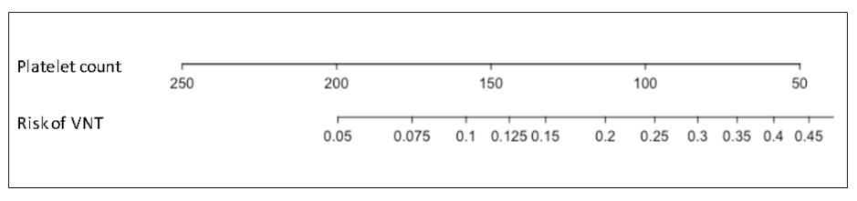

Supplementary Figure 2. Risk of VNT in patients with PSC: Platelet count alone. This nomogram shows the risk of VNT based solely on the results of platelet count in patients with PSC. VNT: Varices needing treatment; PSC: Primary sclerosing cholangitis.

