TITLE PAGE
Efficacy and Safety of Eluxadoline in Patients with IBS-D who Report Inadequate Symptom Control with Loperamide: RELIEF Phase 4 Study
-------------------------------------------------------------------------------------------------------------------------------
Darren M. Brenner, MD¹, Gregory S. Sayuk, MD², Catherine R. Gutman, PhD³, Esther Jo, MPH⁴, Steven J.R. Elmes, PhD³, Louis W.C. Liu, MD, PhD⁵, Brooks D. Cash, MD⁶
¹Feinberg School of Medicine, Northwestern University, Chicago, IL, USA
²Washington University School of Medicine, St. Louis, MO, USA and the St. Louis VA Medical Center, St Louis, MO, USA
³Allergan plc, Madison, NJ, USA
⁴Allergan plc, Irvine, CA, USA
⁵Toronto Western Hospital, University Health Network, Department of Medicine, University of Toronto, Toronto, ON, Canada
⁶McGovern Medical School, University of Texas Health Science Center at Houston, Houston, TX, USA
Corresponding Author:
Darren M. Brenner, MD
Northwestern University—Feinberg School of Medicine
NMH/Arkes Family Pavilion, Suite 1400
676 N Saint Clair
Chicago, IL 60611
Phone: 312-695-5620
Email: darren-brenner@northwestern.edu
Running Title: Eluxadoline for IBS-D – RELIEF Study
Keywords: Irritable bowel syndrome with diarrhea, IBS-D, eluxadoline, loperamide

SUPPLEMENTARY TABLES
Supplementary Table 1. Prior medication for IBS-D management
 | Placebo  (N=174)  n (%) | Eluxadoline  (N=172)  n (%)
Loperamide* | 172 (98.9) | 170 (98.8)
Antidiarrheals (other than loperamide) | 27 (15.5) | 23 (13.4)
Antidepressants | 15 (8.6) | 14 (8.1)
Anticholinergics/Antispasmodics | 15 (8.6) | 10 (5.8)
Patients who have tried at least one additional  management method in the past 12 months | 108 (62.1) | 103 (59.9)
Dietary changes | 71 (40.8) | 66 (38.4)
Probiotics | 48 (27.6) | 42 (24.4)
Exercise | 48 (27.6) | 49 (28.5)
Stress reduction techniques | 29 (16.7) | 22 (12.8)
Generic (sustained release peppermint oil) | 3 (1.7) | 3 (1.7)
Acupuncture | 2 (1.1) | 2 (1.2)
Gut-directed cognitive behavioral therapy | 1 (0.6) | 0
Other | 1 (0.6) | 5 (2.9)
None | 66 (37.9) | 69 (40.1)
Proportions based on number of patients who respond “Yes” on the questionnaire. P-values were not significant (p>0.05) for each parameter; p-values for continuous variables were based on Fisher’s Exact test or Chi-square test.
*A database entry error resulted in the erroneous notation that 2 patients in each group did not take loperamide prior to study enrollment. The affected sites were queried, and study questionnaires confirmed that all 4 patients took loperamide in the preceding 12 months as required by the inclusion criteria; however, the error was left as recorded since correction of this discrepancy would have required retroactive correction of source data.

Supplementary Table 2. Summary of key primary and secondary endpoints
 | Proportion of composite responders (WAP score improvement by ≥40%)ª |  | Proportion of composite responders (WAP score improvement by ≥30%)^{b} |  | Proportion of monthly pain responders (WAP score improvement by ≥40%) |  | Proportion of monthly stool consistency responders
 | Placebo  N=174 | Eluxadoline  N=172 | Placebo  N=174 | Eluxadoline  N=172 | Placebo  N=174 | Eluxadoline  N=172 | Placebo  N=174 | Eluxadoline  N=172
Weeks 1-12, n (%) | 18 (10.3) | 39 (22.7)** | 24 (13.8) | 45 (26.2)** | 54 (31.0) | 75 (43.6)* | 29 (16.7) | 48 (27.9)*
Weeks 1-4, n (%) | 12 (6.9) | 24 (14.0)* | 15 (8.6) | 33 (19.2)** | 45 (25.9) | 52 (30.2) | 22 (12.6) | 42 (24.4)**
Weeks 5-8, n (%) | 26 (14.9) | 46 (26.7)** | 32 (18.4) | 51 (29.7)* | 55 (31.6) | 79 (45.9)** | 35 (20.1) | 53 (30.8)*
Weeks 9-12, n (%) | 29 (16.7) | 53 (30.8)** | 35 (20.1) | 54 (31.4)* | 61 (35.1) | 77 (44.8) | 44 (25.3) | 51 (29.7)
*p<0.05; **p<0.01 compared to placebo.
ªPrimary endpoint: patients who met the daily composite response criteria (daily ≥40% improvement in WAP in the preceding 24 hours and daily stool consistency response [BSS score <5 or absence of bowel movement accompanied by ≥40% improvement in WAP]) for at least 50% of days with diary entry during the interval of Weeks 1-12. Any patient with fewer than 60 days of diary entries was considered a non-responder.
^{b}FDA-specified endpoint (post-hoc analysis): patients who met the daily composite response criteria (daily ≥30% improvement in WAP and daily stool consistency response [BSS score <5 or absence of a bowel movement if accompanied by ≥30% improvement in WAP]). BSS, Bristol Stool Scale; WAP, worst abdominal pain.
Supplementary Table 3. Summary of treatment-emergent serious adverse events
 | Placebo  (N=173)  n (%) | Eluxadoline  (N=171)  n (%)
Patients with at least one serious TEAE | 3 (1.7) | 1 (0.6)
Cardiac disorders | 1 (0.6) | 0
Cardiac failure, congestive | 1 (0.6) | 0
Gastrointestinal disorders | 0 | 1 (0.6)
Pancreatic mass | 0 | 1 (0.6)
Infections and infestations | 2 (1.2) | 0
Cellulitis | 1 (0.6) | 0
Pneumonia | 1 (0.6) | 0
Neoplasms benign, malignant and unspecified (including cysts and polyps) | 1 (0.6) | 0
Uterine leiomyoma | 1 (0.6) | 0
Reproductive system and breast disorders | 1 (0.6) | 0
Dysmenorrhoea | 1 (0.6) | 0
Endometriosis | 1 (0.6) | 0
Ovarian cyst | 1 (0.6) | 0
Pelvic pain | 1 (0.6) | 0
Treatment-emergent adverse event (TEAE) is defined as any AE with a start date that is on or after the start date of study medication, or any pre-existing AE worsened either in intensity or frequency after taking the first dose of the study medication. Patients were counted once under each system organ class and each preferred term. In the placebo group, one patient reported the congestive cardiac failure and pneumonia events; another patient reported the uterine leiomyoma, dysmenorrhea, endometriosis, ovarian cyst, and pelvic pain events; and the third patient reported the cellulitis event.

SUPPLEMENTARY FIGURES
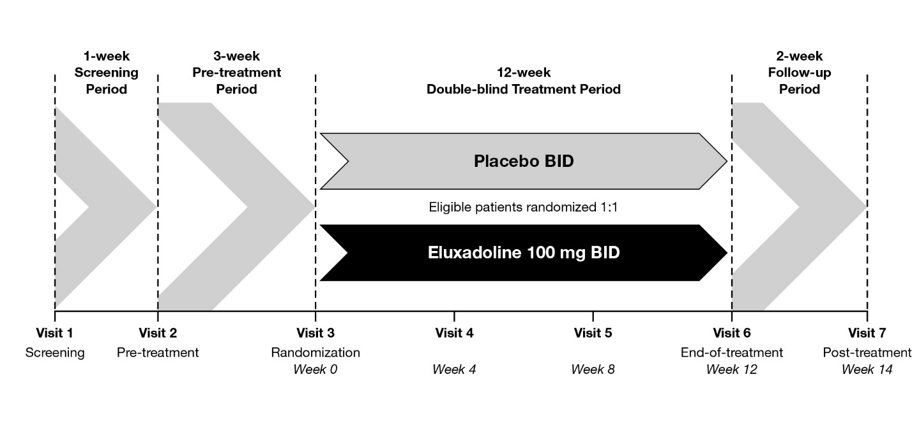Supplementary Figure 1. Study design. BID, bis in die (twice daily).

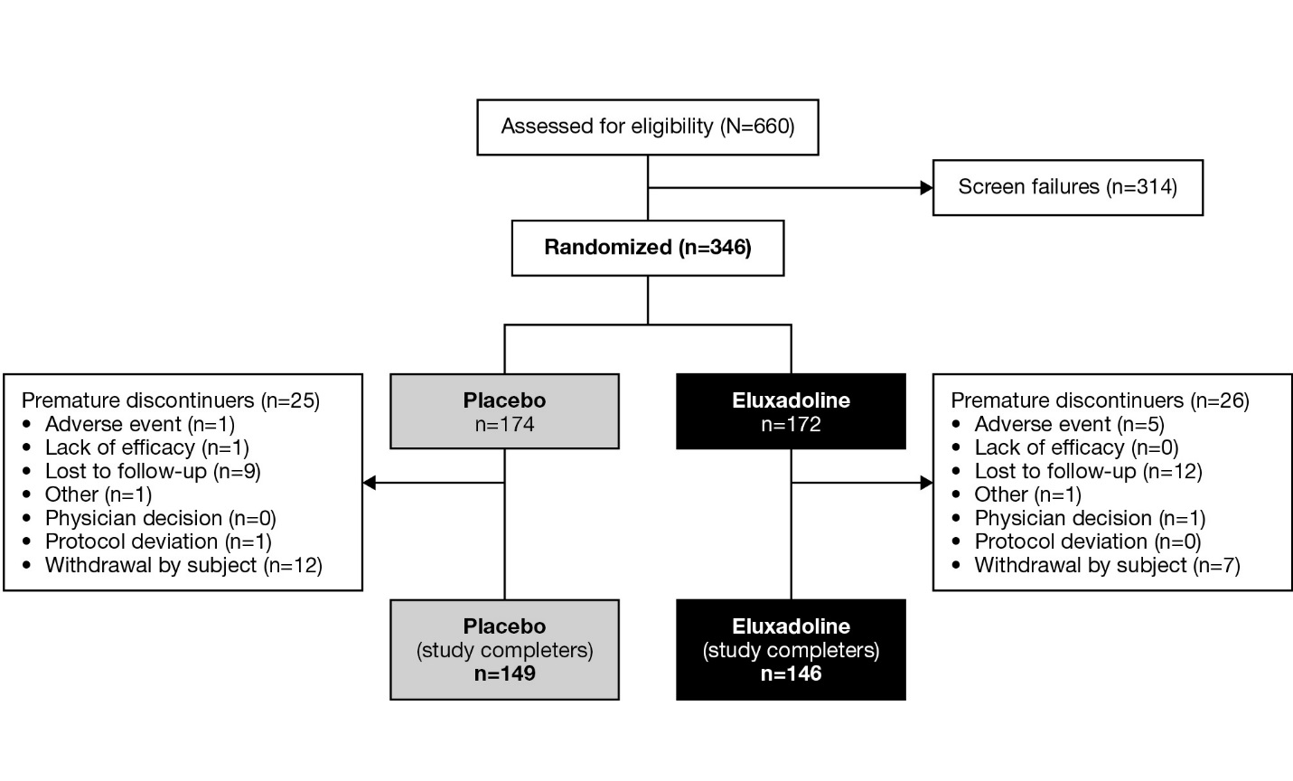Supplementary Figure 2. Patient disposition (CONSORT flow diagram).

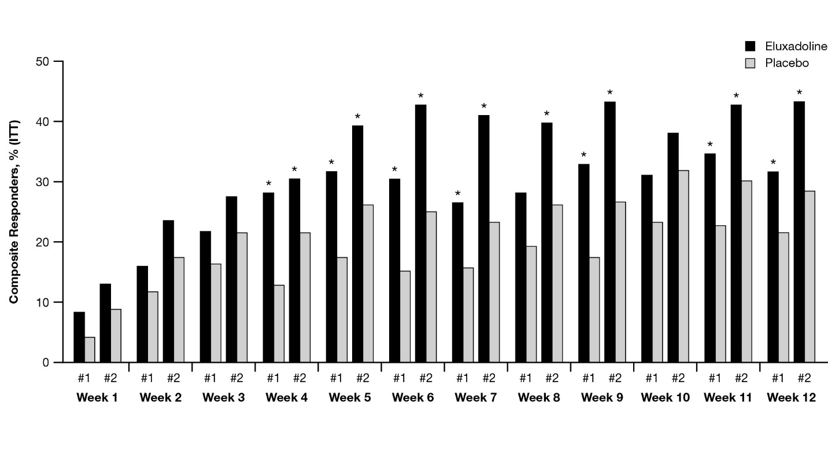Supplementary Figure 3. Weekly composite responder during the 12-week treatment period by two definitions.
Definition #1 = Weekly composite responder is defined as daily composite responder on ≥4 days for a week. Daily composite responder = WAP improvement by ≥40% compared with baseline and BSS <5 (or the absence of bowel movement if accompanied by ≥40% improvement in WAP) compared to baseline. Definition #2 = Weekly composite responder is defined as patients with weekly average WAP improvement of ≥40% from average WAP of the baseline week and with ≥50% reduction in the days of BSS 6/7 for a week comparing with days of BSS 6/7 during the baseline week. BSS, Bristol Stool Scale; WAP, worst abdominal pain. *p<0.05, based on Chi-square test.

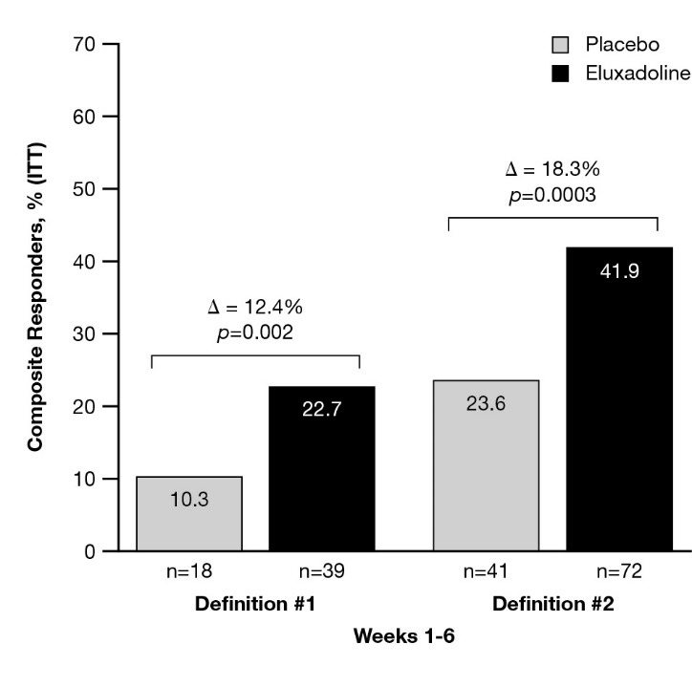
Supplementary Figure 4. Weekly composite responder during the 12-week treatment period, and for at least 6 weeks out of 12 weeks from weeks 1-6 by two definitions.
Definition #1 = Weekly composite responder is defined as daily composite responder on ≥4 days for a week. Daily composite responder = WAP improvement by ≥40% compared with baseline and BSS <5 (or the absence of bowel movement if accompanied by ≥40% improvement in WAP) compared to baseline. Definition #2 = Weekly composite responder is defined as patients with weekly average WAP improvement of ≥40% from average WAP of the baseline week and with ≥50% reduction in the days of BSS 6/7 for a week comparing with days of BSS 6/7 during the baseline week. BSS, Bristol Stool Scale; WAP, worst abdominal pain. P-values are based on Chi-square test.

ADDITIONAL SUPPORTING INFORMATION
Supplementary File 1: Study Protocol
Supplementary File 2: Statistical Analysis Plan
Supplementary File 3: CONSORT Checklist

