ONLINE SUPPLEMENTARY MATERIAL
A.1 Estimation of Model Inputs
Estimation of Transition Probabilities
Complications
Short run complications from aspiration therapy or bariatric surgery could occur after treatment in year 1. As the A-tube is regularly replaced and remains inside patient’s body, we assumed that patients faced a risk of long run complications from aspiration therapy every year they were on the treatment. We assumed that this risk was equal for each year on aspiration therapy. The risk of annual major and minor complications (3.7% and 9.8%, respectively) was based on Nystrom et al. (2018) (1). Meanwhile, risk of complications after bariatric surgery were obtained from the most recent, high quality randomized controlled trial comparing gastric bypass with sleeve gastrectomy (2) (results using data on complication risks from another recent, high-quality randomized controlled trial are shown in section A.3 below). As data on long-run complication risks from these randomized controlled trials was only available for the first 5 years, we assumed that the risk of long-run complications with bariatric surgery occurred in years 1 to 5.
Discontinuation of Treatment
In our model, the probability of discontinuation of aspiration therapy is based on Nystrom et al. (2018) (1)—0.09, 0.16, 0.16 and 0.17 in years 1 through 4, respectively. Given the lack of data beyond the fourth year, we assumed that patients who continued on the therapy for 4 years remained on it for the rest of their life. This is plausible as these patients would have both tolerated the therapy and responded to it. Gastric bypass is rarely reversed and sleeve gastrectomy is irreversible. Hence, reversal of these procedures was not modelled.
During the time that patients discontinue aspiration therapy, we assumed that they would experience BMI increase of a magnitude similar to that of an obese individual (BMI >=30 kg/m²) who does not undergo weight loss treatment, namely, a BMI increase of 0.175kg/m² each year (3).
Estimation of Transition Probabilities
To obtain transition probabilities across BMI health states, we simulated a hypothetical cohort of 1000 patients with BMI 35-55 kg/m² such that the proportion of patients in Obese 2 and Obese 3 categories mimicked the actual proportions among US obese adults, i.e., 56% and 44%, respectively(4). Next, for each procedure, we converted the weight loss effects measured in annual mean %EWL obtained from the literature into average annual change in BMI. The estimated change in BMI was then applied to the initial BMI for each individual to obtain the BMI at the end of each year. Finally, transition probabilities across BMI states were estimated as the proportion of patients in each BMI state who move to each of the other BMI states. Beyond the 4-5-year time period for which weight loss effect data are available, we assumed that the BMI remains unchanged for patients who continued treatment. Hence, probability of transition from one BMI state to another for these patients is zero. Among patients who discontinue treatment in years 1-4, we assumed an annual BMI increase of 0.175kg/m² (average increase for obese individuals who do not undergo treatment) and applied the similar calculation for transition probabilities described above.

Estimation of costs
Costs of Follow up, Maintenance and Discontinuation of Treatment
Patients who are treated with aspiration therapy require 8 follow-up visits in year 1 and 4 visits each year beyond year 1 (6). For patients undergoing bariatric surgery, follow up visits were based on recommendations by the American Society for Metabolic and Bariatric Surgery’s clinical practice guidelines (7). Gastric bypass patients require 5 visits in year 1, 3 visits in year 2 and 2 visits year 3 onwards. Sleeve gastrectomy patients require fewer follow-up visits: 5 visits in year 1, 2 visits in year 2 and 1 visit year 3 onwards. Patients on aspiration therapy also incur costs of replacement of A-tube and external connector. We accounted for a 40% probability of replacement of A-tube every 4 years (corresponding to an annual probability of 12%) as found by Nystrom et al. (2018)(1) and replacement of external connector every 6 weeks (8). We assumed the cost of replacement of A-tube was half the cost of the initial procedure as the A-tube is replaced at the same stoma site (8) and the cost of A-tube removal was 1/4th that of the initial procedure; these costs were varied in the sensitivity analyses.
Estimation of Effectiveness
Disutility from Treatment
Following other published studies, we assumed that disutility associated with bariatric surgery and its major complications lasted for 6 weeks while disutility from any minor complications lasted for 4 weeks (9). No data were available on disutility associated with aspiration therapy. However, as aspiration therapy is less invasive and recovery after the procedure is faster (10), we assumed disutility due to the initial procedure and its complications was half of the respective utility decrements for bariatric surgery and only lasted for 4 weeks.

A.2 Results for alternative scenarios of discontinuation of Aspiration therapy
We varied the proportion of patients who discontinue aspiration therapy after 4 years (25%, 75% and 100% versus 47% in base case). In all scenarios, aspiration therapy remained dominated by bariatric surgery and was cost-effective relative to no treatment.

Table A.2.1: Incremental Cost-Effectiveness Results, alternative discontinuation rates of aspiration therapy
Scenario | Aspiration therapy compared with bariatric surgery | Aspiration therapy compared with no treatment
25% discontinue after year 4 | Dominated | $16,574/QALY
47% discontinue after year 4 (base case) | Dominated | $17,549/QALY
75% discontinue after year 4 | Dominated | $20,077/QALY
100% discontinue after year 4 | Dominated | $27,560/QALY
All costs are in 2017 US dollars (US$). ICER = incremental cost-effectiveness ratio.

A.3 Results using alternate source of data on bariatric surgery-related complication risks
We first used data on complication risks from a second, recent, high-quality randomized controlled trial comparing gastric bypass and sleeve gastrectomy (11) (Table A.3.1). This study only reported short and long-run reoperative events; minor complications not requiring surgical or endoscopic intervention were not reported. Consequently, for this analysis, it was assumed that there were no minor complications. Next, we used meta-analytic estimates for short-run complications from Osland et al. 2016 (12) (Table A.3.2). These short-run estimates were complemented with meta-analytic estimates for long-run complication risks from Osland et al. 2016 (13). In both these analyses, our base case results continued to hold, namely, aspiration therapy was dominated by bariatric surgery and gastric bypass was the most cost-effective treatment.
Table A.3.1: Incremental Cost-Effectiveness Results, data on bariatric surgery-related complication risks from second randomized controlled trial
Strategy | Cost (US$) | Incremental Costs (US$) | Effectiveness | Incremental Effectiveness | ICER (US$/QALY)
No treatment | 117,357 | - | 12.96 | - | -
Sleeve Gastrectomy | 122,530 | 5,173 | 15.11 | 2.15 | 2,405
Gastric Bypass | 129,271 | 6,741 | 15.35 | 0.24 | 28,531
Aspiration Therapy | 136,231 | 6,961 | 14.04 | -1.31 | Dominated
All costs are in 2017 US dollars (US$). ICER = incremental cost-effectiveness ratio.

Table A.3.2: Incremental Cost-Effectiveness Results, meta-analytic estimates for bariatric surgery-related complication risks
Strategy | Cost (US$) | Incremental Costs (US$) | Effectiveness | Incremental Effectiveness | ICER (US$/QALY)
I. All strategies
No treatment | 117,357 | - | 12.96 | - | -
Sleeve Gastrectomy | 119,953 | 2,597 | 15.11 | 2.15 | 1,207
Gastric Bypass | 129,649 | 9,696 | 15.35 | 0.23 | 41,777
Aspiration Therapy | 136,231 | 6,582 | 14.04 | -1.31 | Dominated
All costs are in 2017 US dollars (US$). ICER = incremental cost-effectiveness ratio.

A.4 Results using Monte Carlo Microsimulation
Results from 1000 Monte Carlo microsimulations were similar to those obtained in the base case (Table A.4.1). Aspiration therapy remained dominated by bariatric surgery and gastric bypass was the most cost-effective treatment strategy with an ICER of US$24,633 per QALY gained. Aspiration therapy also remained cost-effective compared with no treatment with an ICER of US$19,396 per QALY gained. Cost-effectiveness acceptability curve using microsimulation shown in Figure A.4.1 indicates that, at the willingness to pay threshold of US$100,000/QALY), gastric bypass was the optimal treatment option in maximum number of iterations (40%).
Table A.4.1: Incremental Cost-Effectiveness Results, microsimulation
Strategy | Cost (US$) | Incremental Costs (US$) | Effectiveness | Incremental Effectiveness | ICER (US$/QALY)
Panel A: All strategies
No treatment | 118,360 | - | 13.08 | - | -
Sleeve Gastrectomy | 122,771 | 4,411 | 15.28 | 2.20 | 2002
Gastric Bypass | 132,649 | 9,878 | 15.68 | 0.40 | 24,633
Aspiration Therapy | 136,072 | 3,423 | 13.99 | -1.69 | Dominated
Panel B: Aspiration therapy vs. No treatment
No treatment | 118,360 | - | 13.08 | - | -
Aspiration Therapy | 136,072 | 17,712 | 13.99 | 0.91 | 19,396
All costs are in 2017 US dollars (US$). ICER = incremental cost-effectiveness ratio

Figure A.4.1: Cost-Effectiveness Acceptability Curve with microsimulation
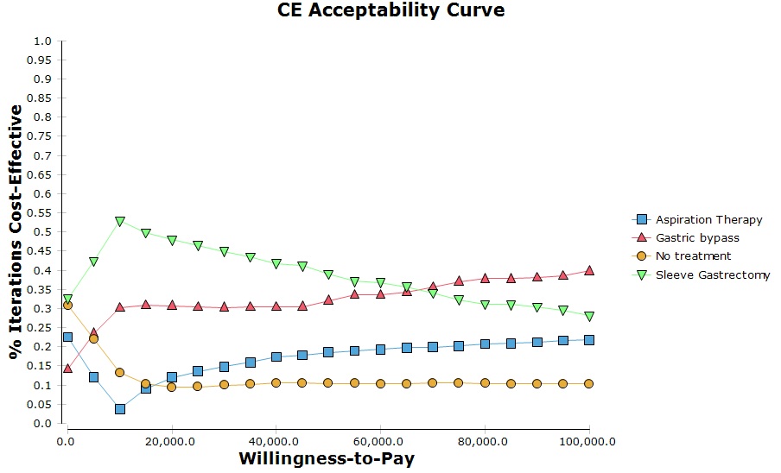

A.5 Results using life years as outcome
Aspiration therapy remained dominated by bariatric surgery. Gastric bypass cost US$9,454 more than sleeve gastrectomy (the next most costly alternative) but also yielded 0.05 additional life years for an ICER of US$183,224 per life year gained. Compared with no treatment, aspiration therapy yielded 0.53 additional life years at an additional cost of US$18,875 giving an ICER of US$35,803 per life year gained.
Table A.5.1: Incremental Cost-Effectiveness Results, life years outcome
Strategy | Cost (US$) | Incremental Costs (US$) | Effectiveness | Incremental Effectiveness | ICER (US$/LYG)
Panel A: All strategies
No treatment | 117,357 | - | 17.98 | - | -
Sleeve Gastrectomy | 121,459 | 4,103 | 19.10 | 1.12 | 3,675
Gastric Bypass | 130,914 | 9,454 | 19.15 | 0.05 | 183,224
Aspiration Therapy | 136,231 | 5,318 | 18.51 | -0.64 | Dominated
Panel B: Aspiration therapy vs. No treatment
No treatment | 117,357 | 0 | 17.98 | 0
Aspiration Therapy | 136,231 | 18,875 | 18.51 | 0.53 | 35,803
All costs are in 2017 US dollars (US$). ICER = incremental cost-effectiveness ratio; LYG = life year gained

Figure F1: Cost Effectiveness Model
(a) Aspiration Therapy
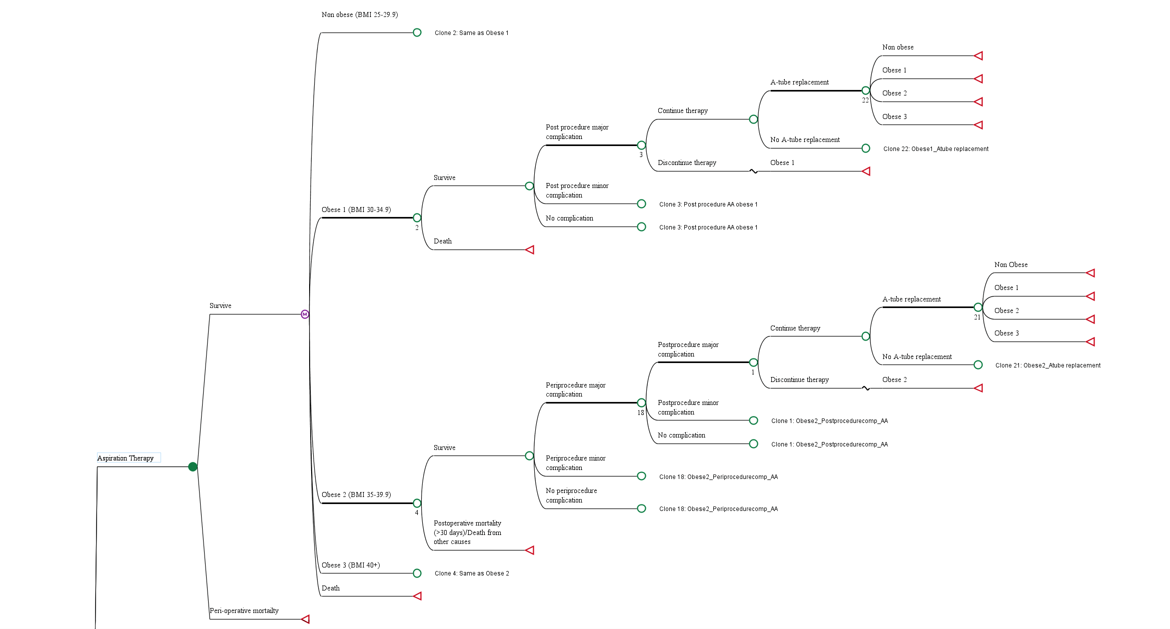
(b) Gastric Bypass
(c) Sleeve Gastrectomy
(d) No Treatment

REFERENCES
1. Nyström M, Machytka E, Norén E, et al. Aspiration therapy as a tool to treat obesity: 1-to 4-year results in a 201-patient multi-center post-market European Registry Study. Obesity surgery 2018;1–9.
2. Salminen P, Helmiö M, Ovaska J, et al. Effect of laparoscopic sleeve gastrectomy vs laparoscopic Roux-en-Y gastric bypass on weight loss at 5 years among patients with morbid obesity: the SLEEVEPASS randomized clinical trial. Jama 2018;319:241–254.
3. Lyratzopoulos G, McElduff P, Heller RF, et al. Mid-term Body Mass Index increase among obese and non-obese individuals in middle life and deprivation status: a cohort study. BMC Public Health 2005;5:32.
4. CDC. Health, United States: Table 058: Normal weight, overweight, and obesity among adults aged 20 and over, by selected characteristics: United States, selected years 1988–1994 through 2013–2016 [Internet]. 2018;[cited 2018 Oct 20] Available from: https://www.cdc.gov/nchs/hus/contents2017.htm
5. Hatoum IJ, Kaplan LM. Advantages of percent weight loss as a method of reporting weight loss after Roux‐en‐Y gastric bypass. Obesity 2013;21:1519–1525.
6. Aspire Bariatrics. AspireAssist-Clinician Guide [Internet]. 2015;[cited 2018 Oct 20] Available from: https://www.accessdata.fda.gov/cdrh_docs/pdf15/p150024d.pdf
7. Clinical Practice Guidelines for the Support of the Bariatric Surgery Patient | ASMBS [Internet]. American Society for Metabolic and Bariatric Surgery 2013;[cited 2019 Mar 27] Available from: https://asmbs.org/resources/clinical-practice-guidelines-for-the-perioperative-nutritional-metabolic-and-nonsurgical-support-of-the-bariatric-surgery-patient
8. Aspire Bariatrics. AspireAssist-Patient Guide [Internet]. 2015;[cited 2018 Oct 20] Available from: https://www.accessdata.fda.gov/cdrh_docs/pdf15/p150024c.pdf
9. Campbell J, McGarry LA, Shikora SA, et al. Cost-effectiveness of laparoscopic gastric banding and bypass for morbid obesity. The American journal of managed care 2010;16:e174-87.
10. Aspire Bariatrics. The AspireAssist [Internet]. AspireAssist Non-Surgical Weight Loss Procedure 2017;[cited 2018 Oct 21] Available from: https://www.aspirebariatrics.com/about-the-aspireassist/
11. Peterli R, Wölnerhanssen BK, Peters T, et al. Effect of laparoscopic sleeve gastrectomy vs laparoscopic Roux-en-Y gastric bypass on weight loss in patients with morbid obesity: the SM-BOSS randomized clinical trial. Jama 2018;319:255–265.
12. Osland E, Yunus RM, Khan S, et al. Postoperative early major and minor complications in laparoscopic vertical sleeve gastrectomy (LVSG) versus laparoscopic Roux-en-Y gastric bypass (LRYGB) procedures: a meta-analysis and systematic review. Obesity surgery 2016;26:2273–2284.
13. Osland E, Yunus RM, Khan S, et al. Late postoperative complications in laparoscopic sleeve gastrectomy (LVSG) versus laparoscopic Roux-en-Y gastric bypass (LRYGB): meta-analysis and systematic review. Surgical Laparoscopy Endoscopy & Percutaneous Techniques 2016;26:193–201.

%EWL was converted into change in BMI using the formula: $\%EWL=\frac{Initial BMI - Final BMI}{Initial BMI - Target BMI}$ . As is frequently done in the literature, BMI of 25 kg/ m², the upper bound normal BMI, was used as the target BMI)(5).

