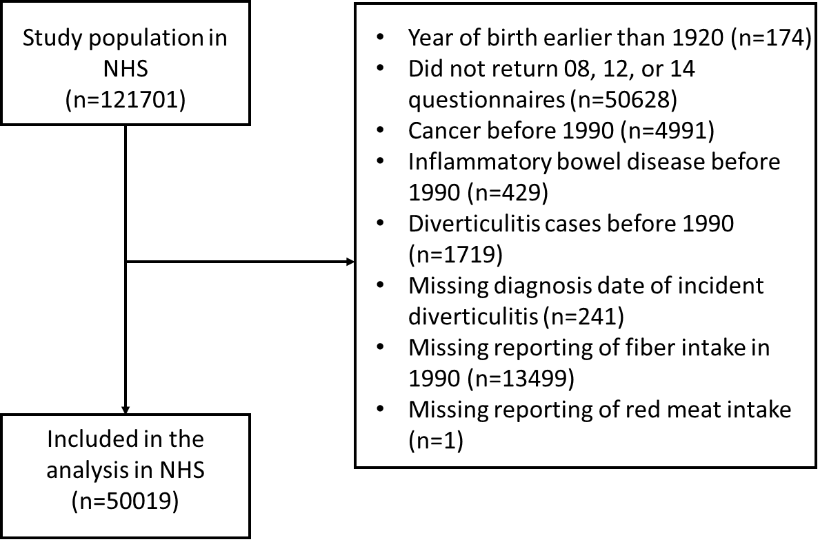

Supplemental Figure 1. Flowchart of study population for analysis of dietary fiber intake and risk of diverticulitis in Nurses’ Health Study (1990-2014).

Supplemental Table 1. Energy-adjusted soluble and insoluble fiber intake and risk of diverticulitis in Nurses' Health Study (1990-2014)
 | Quintiles of dietary intake
 | 1 | 2 | 3 | 4 | 5 | P for trend
Soluble fiber
Median (range), g/d | 3.7 (0-4.2) | 4.6 (4.3-4.9) | 5.3 (5.0-5.7) | 6.2 (5.8-6.8) | 7.9 (6.9-34.1)
Incidence per 100,000 person-years | 405 | 384 | 379 | 400 | 394
Age | 1 (ref) | 0.94 (0.86, 1.04) | 0.93 (0.84, 1.02) | 0.96 (0.88, 1.06) | 0.92 (0.84, 1.01) | 0.17
Multivariable* | 1 (ref) | 0.95 (0.86, 1.04) | 0.93 (0.85, 1.03) | 0.97 (0.89, 1.07) | 0.95 (0.86, 1.04) | 0.49
Multivariable+red meat | 1 (ref) | 0.95 (0.86, 1.04) | 0.94 (0.85, 1.03) | 0.98 (0.89, 1.07) | 0.95 (0.86, 1.05) | 0.57
Insoluble fiber
Median (range), g/d | 9.5 (0-10.8) | 11.8 (10.9-12.7) | 13.7 (12.8-14.6) | 15.8 (14.7-17.2) | 19.6 (17.3-131.2)
Incidence per 100,000 person-years | 400 | 395 | 393 | 406 | 368
Age | 1 (ref) | 0.95 (0.87, 1.04) | 0.92 (0.84, 1.01) | 0.93 (0.85, 1.02) | 0.83 (0.75, 0.91) | <0.001
Multivariable* | 1 (ref) | 0.95 (0.87, 1.05) | 0.93 (0.84, 1.02) | 0.94 (0.86, 1.04) | 0.86 (0.78, 0.95) | 0.004
Multivariable+red meat | 1 (ref) | 0.95 (0.87, 1.05) | 0.93 (0.84, 1.02) | 0.94 (0.86, 1.04) | 0.86 (0.78, 0.95) | 0.004
* Soluble and insoluble fiber were estimated for 1990 and 1994 questionnaires in the NHS.
* Further adjusted for body mass index (<22.5, 22.5-24.9, 25.0-27.4, 27.5-29.9, 30.0-34.9, ≥35 kg/m²), menopausal status and menopausal hormone use (premenopausal and postmenopausal hormone use (never, past, current), vigorous activity (0, 0.1-3.4, 3.5-10.4, 10.5-28.4, ≥28.5 MET-h/week), alcohol intake (0, 0-4.9, 5.0-9.9, 10.0-14.9, ≥15.0 g/d), smoking (never smoker, past smoker, current smoker (1-14, 15-24, ≥25 cigarettes/d)), aspirin use (yes/no), other nonsteroidal anti-inflammatory drug use (yes/no), multivitamin use (yes/no), acetaminophen use (yes/no), physical examination (yes/no), hypertension (yes/no), hypercholesterolemia (yes/no), and calorie intake (quintile).

