Supplementary Figure 1: Individual excursions of a) HBV DNA >10,000 IU/mL and b) ALT ratio >2* by category of HBV DNA level over duration of follow-up
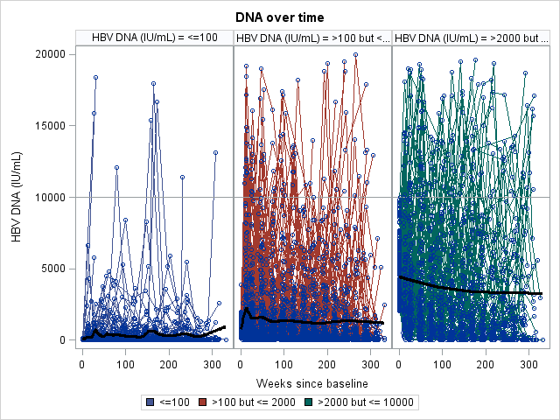
HBV DNA over time
A
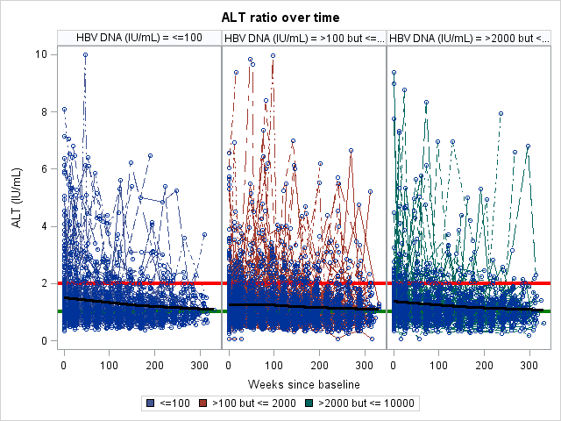
B
*ALT ratio calculated as ALT/ALT [ULN]; ULN = 20 U/L in males and 30 U/L in females.
Red line represents a) HBV DNA level of 10,000 IU/mL and b) ALT ratio of 2. Black line represents overall trend for all participants over 300 weeks of follow-up time.

Supplementary Figure 2. Cumulative incidence for participants with HBV DNA≤2000 IU/mL with A) phase transition with treatment initiation and B) phase transition with censoring of treatment initiation over 5 years of follow-up

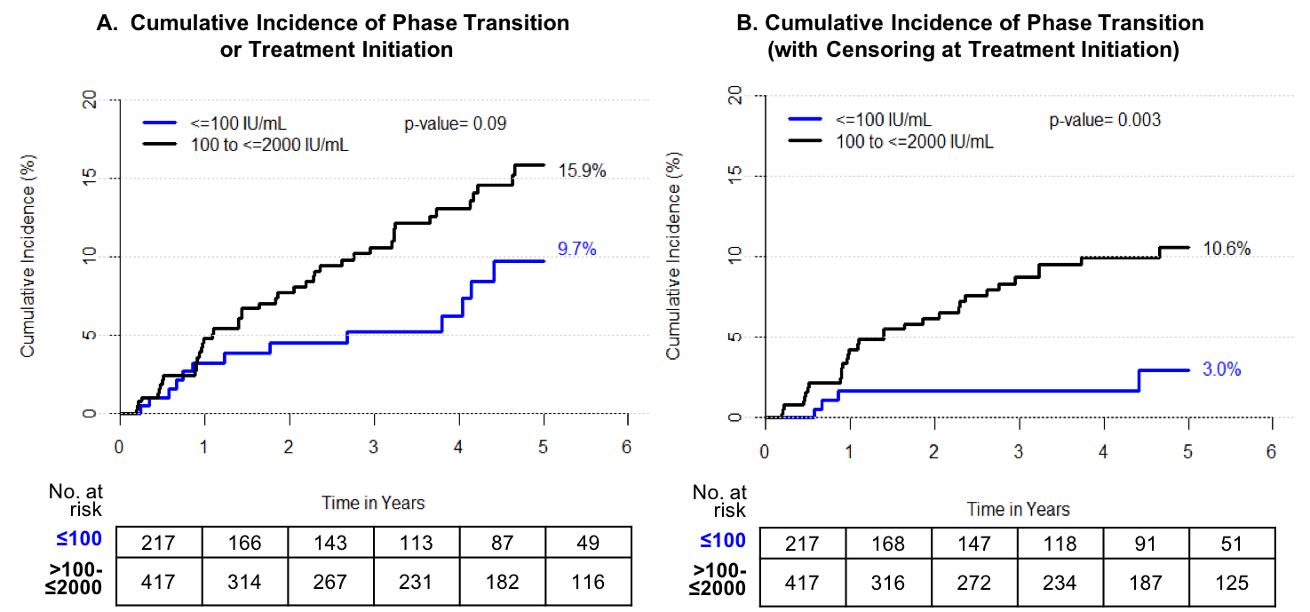

The Kaplan-Meier plots show up to five-years of follow-up, when a reasonable number of participants were still at risk of outcome (n=165 in Panel A and n=176 in Panel B).

Supplementary Figure 3: Sensitivity analysis of A) phase transition or treatment initiation and B) phase transition with censoring of treatment initiation over 5 years of follow-up using higher normal ALT (<25 for females, <35 for males)

Supplementary Table 1: Results of univariate Cox regression analysis with primary outcome of phase transition or treatment initiation among HBV DNA≤10,000 IU/mL
Covariate | Hazard Ratio | Lower 95% | Upper 95% | p-value
Gender
Male | 1.05 | 0.705 | 1.564 | 0.812
Race |  |  |  | 0.474
Asian | 1.362 | 0.722 | 2.57 | 0.340
Black | 0.885 | 0.39 | 2.006 | 0.769
Other | 1.213 | 0.269 | 5.478 | 0.802
Genotype |  |  |  | 0.066
B | 2.092 | 1.101 | 3.978 | 0.024
C | 1.654 | 0.84 | 3.256 | 0.146
D | 0.703 | 0.227 | 2.183 | 0.542
Others | 0.985 | 0.22 | 4.402 | 0.984
G1896 Mutation
Yes | 1.055 | 0.565 | 1.968 | 0.867
Any BCP mutation
Yes | 1.867 | 1.004 | 3.472 | 0.048
Marital Status
In a Marriage or Marriage-Like Relationship | 0.807 | 0.528 | 1.234 | 0.322
Education |  |  |  | 0.005
High school or equivalent (GED) | 0.8 | 0.449 | 1.427 | 0.450
Some college or equivalent | 0.618 | 0.322 | 1.185 | 0.148
Bachelors or above | 0.409 | 0.242 | 0.693 | 0.001
Employment |  |  |  | 0.312
Homemaker, not currently working for pay | 0.4 | 0.098 | 1.628 | 0.201
Not currently employed | 0.783 | 0.463 | 1.323 | 0.361
Med Hx: Diabetes
Yes | 2.141 | 1.143 | 4.011 | 0.018
Source of Infection
Horizontal | 0.819 | 0.506 | 1.324 | 0.415
Med Hx: Hyperlipidemia
Yes | 1.91 | 1.188 | 3.073 | 0.008
Metabolic Syndrome
Yes | 1.5 | 0.858 | 2.625 | 0.155
Prior Treatment
Non-IFN-based | 0.742 | 0.374 | 1.475 | 0.395
HDV
Positive | 2.249 | 0.91 | 5.557 | 0.079
ALT |  |  |  | <0.001
ALT (IU/L) > ULN but <=1.5XULN | 2.078 | 1.303 | 3.315 | 0.002
ALT (IU/L) >1.5XULN but <= 2 X ULN | 2.941 | 1.701 | 5.084 | <0.001
HBV DNA |  |  |  | <0.001
HBV DNA (IU/mL) <=2000 | 1.529 | 0.819 | 2.857 | 0.183
HBV DNA (IU/mL) >2000 but <= 10,000 | 3.419 | 1.838 | 6.362 | <0.001
HBsAg Categories
> 1000 IU/mL | 1.246 | 0.82 | 1.893 | 0.303
APRI
>0.50 | 3.646 | 2.184 | 6.084 | <0.001
Fib4 |  |  |  | 0.041
FIB-4, categorized 1.45-3.25 | 1.837 | 1.143 | 2.954 | 0.012
FIB-4, categorized >3.25 | 1.54 | 0.212 | 11.161 | 0.670
Age at baseline (per year) | 1.017 | 1.001 | 1.033 | 0.036
Body Mass Index (per kg/m2) | 0.976 | 0.933 | 1.022 | 0.301
HOMA-IR (per 1) | 0.942 | 0.781 | 1.136 | 0.530
log10 HBsAg Quant (Central Lab) per 1 log | 1.25 | 1.022 | 1.527 | 0.029
Time (in years) since HBV diagnosis per year | 0.99 | 0.968 | 1.012 | 0.364
ALT (IU/mL) per 1 IU/mL | 1.042 | 1.024 | 1.061 | <0.001
ALT Ratio per 1 unit | 3.648 | 2.186 | 6.088 | <0.001
HBV DNA per 1 log | 2.139 | 1.597 | 2.865 | <0.001
AST (IU/mL) per 1 IU/mL | 1.031 | 1.013 | 1.051 | 0.001
Platelet (per 10^3 mm^3) | 0.996 | 0.992 | 1.000 | 0.040
APRI per 1 unit | 3.688 | 1.995 | 6.816 | <0.001
FIB-4 per 1 unit | 1.228 | 1.044 | 1.445 | 0.013

Supplementary Table 2: Key baseline differences in participants with and without clinical diagnosis of hyperlipidemia (HBV DNA ≤10,000 IU/mL)
Characteristic | No hyperlipidemia  N=832 | Hyperlipidemia  N=132 | p-value
Age at baseline | 41.0 (34.0-51.0) | 54.5 (46.0-63.0) | <0.001
Male | 381 (45.8%) | 82 (62.1%) | 0.001
Estimated Duration of HBV Infection | 33.0 (21.0-42.0) | 43.0 (22.0-56.0) | <0.001
HBV DNA (IU/mL) |  |  | 0.99
<=100 | 234 (28.1%) | 36 (27.3%)
>100 but <= 2000 | 403 (48.4%) | 65 (49.2%)
>2000 but <= 10,000 | 195 (23.4%) | 31 (23.5%)
ALT (IU/L) |  |  | 0.17
<=ULN | 349 (42.7%) | 55 (43.0%)
>ULN but <= 1.5 X ULN | 274 (33.5%) | 33 (25.8%)
>1.5XULN but <= 2 X ULN | 97 (11.9%) | 22 (17.2%)
>2 X ULN | 97 (11.9%) | 18 (14.1%)
Metabolic Syndrome | N=357 | N=81 | <0.001
No | 302 (84.6%) | 17 (21.0%)
Yes | 55 (15.4%) | 64 (79.0%)

Supplementary Table 3: Results of multivariable Cox regression analysis with secondary outcome of phase transition (with censoring of treatment initiation) among HBV DNA≤10,000 IU/mL
Covariates | Adjusted HR (95% CI)
ALT
<= ULN | Ref
>ULN but <= 1.5 X ULN | 2.1 (1.0-4.4)
>1.5XULN but <= 2 X ULN | 4.3 (2.0-9.2)
HBV DNA
<=100 IU/mL | Ref
>100 but <= 2000 IU/mL | 3.9 (1.2-12.8)
>2000 but <= 10,000 IU/mL | 7.1 (2.1-23.9)
Platelet count (per 20000 mm3 decline) | 1.2 (1.1-1.4)

Supplementary Table 4: Results of multivariable Cox regression analysis with primary outcome of phase transition or treatment initiation among participants with baseline HBV DNA ≤2000 IU/mL
Covariates | Adjusted HR (95% CI)
History of diabetes | 4.0 (2.0-7.8)
ALT (U/L) ≤ULN | Ref
>ULN to ≤1.5x ULN | 1.8 (1.0-3.2)
1.5x ULN to ≤2x ULN | 3.3 (1.7-6.4)
HBV DNA (IU/mL) ≤100 | Ref
100 to ≤2000 | 1.5 (0.9-2.8)

Supplemental Table 5: Sensitivity analysis of predictors of primary outcome of phase transition or treatment initiation using higher normal ALT (<25 for females, <35 for males) among HBV DNA≤10,000 IU/mL

Covariates | Adjusted HR (95% CI)
Genotype A | Ref
B | 3.6 (1.6-8.1)
C | 3.0 (1.4-6.4)
D | 1.5 (0.4-4.8)
Other | 1.1 (0.2-5.2)
No history of hyperlipidemia | Ref
History of hyperlipidemia | 2.7 (1.6-4.6)
ALT (U/L) ≤ULN | Ref
>ULN to ≤1.5x ULN | 3.0 (1.8-5.1)
1.5x ULN to ≤2x ULN | 3.9 (2.0-7.9)
HBV DNA (IU/mL) ≤100 | Ref
100 to ≤2000 | 2.7 (0.9-7.6)
2000 to ≤10,000 | 4.1 (1.4-11.6)
Platelet count (per 20000 mm³ decline) | 1.1 (1.0-1.3)
HBsAg (IU/mL) ≤1000 | Ref
HBsAg >1000 | 1.5 (0.9-2.5)

