Supplemental Figure 1: Change in Excess Inpatient Hospitalizations Attributable to IBD Between 2005-2015
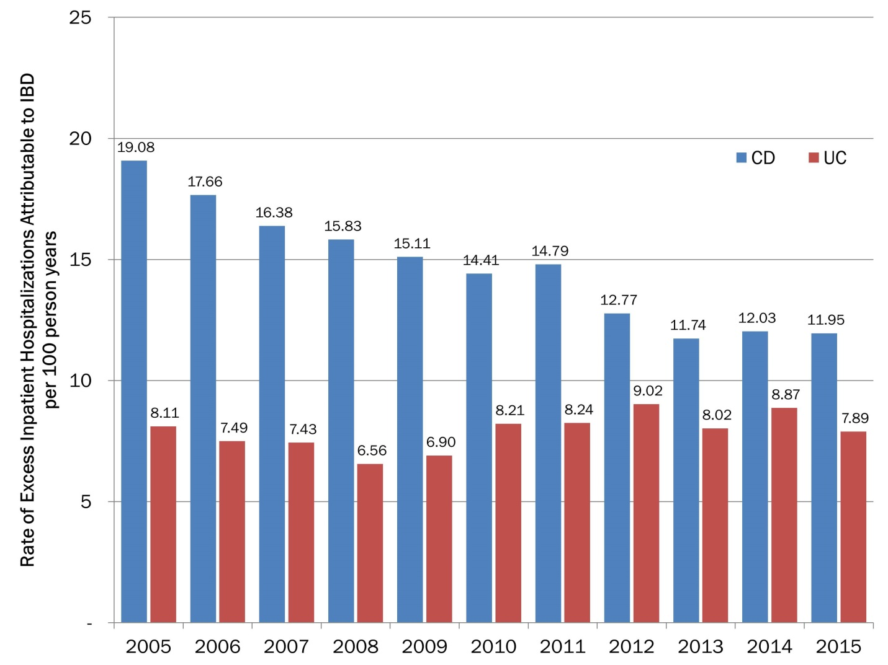
Supplemental Figure 2: Change in Excess Outpatient Visits Attributable to IBD Between 2005-2015
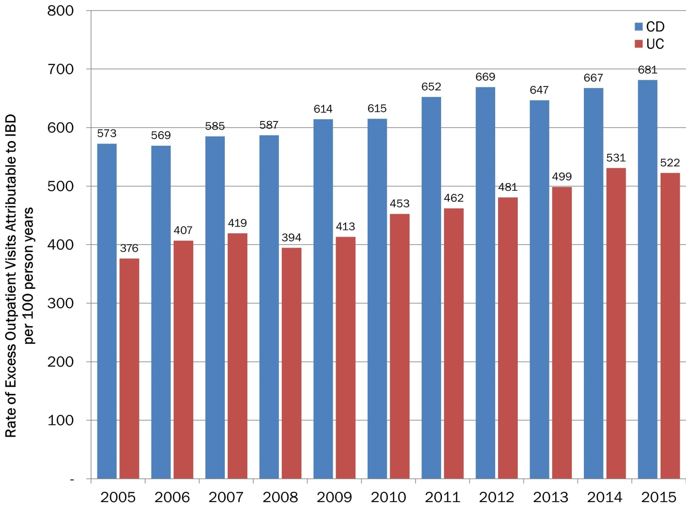

Supplemental Figure 3: Change in IBD-Specific Urgent Hospitalizations Between 2005-2015
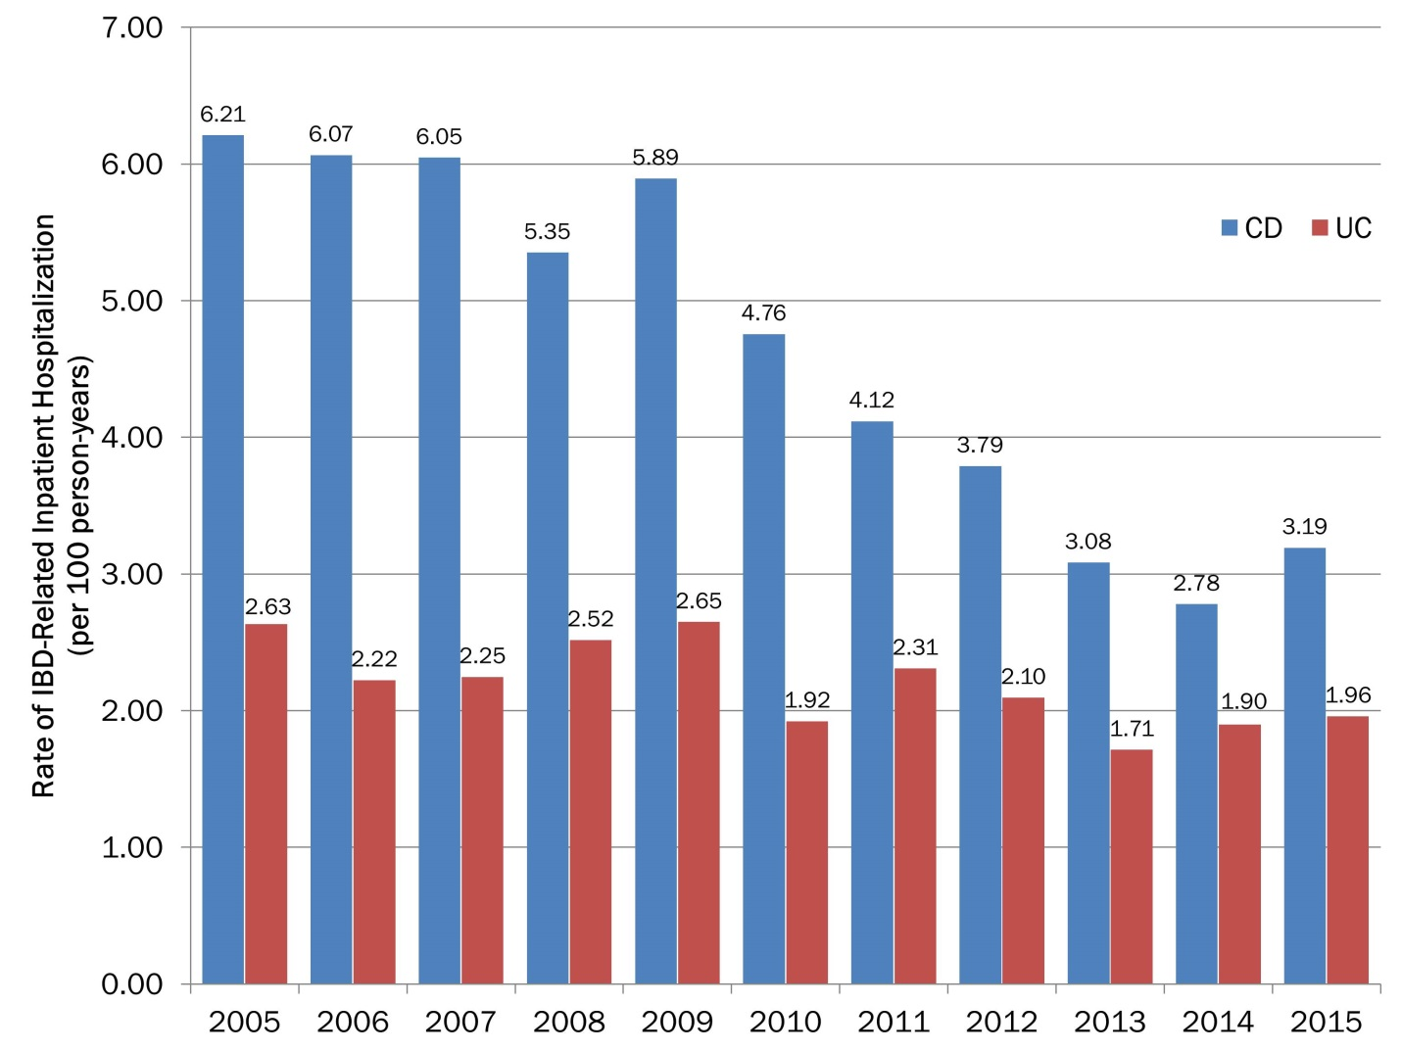

Supplemental Figure 4: Change in Incidence IBD-Related Resective Surgeries Between 2005-2015

