**Supplementary Material:**

**Figure 1:** Forest plot of case control studies showing prevalence of SIBO in patients with IBS, when only high-quality studies are included (OR=4.1 (95%CI 3.0-5.6), p<0.001), (I2=27.7, p<0.15).

**Figure 2:** Funnel plot of SIBO in patients with IBS and controls, when only low risk bias studies are included.

**Figure 3:** Forest plot of case control studies showing prevalence of SIBO in patients with IBS, and healthy asymptomatic controls (OR=4.9 (95%CI 2.8-8.6), p<0.001), (I2=74.3, p<0.001).

**Figure 4:** Funnel plot of SIBO in patients with IBS and healthy asymptomatic controls.

**Figure 5:** Forest plot of case control studies showing prevalence of SIBO in patients with IBS, utilizing breath tests (OR=4.4 (95%CI 2.5-7.7), p<0.001), (I2=80.2, p<0.001).

**Figure 6:** Funnel plot of SIBO in patients with IBS and controls, utilizing breath tests.

**Figure 7:** Forest plot of case control studies showing SIBO in patients with IBS and controls, utilizing lactulose breath test (OR=3.5(95%CI 1.0-12.9), p<0.06) (I2=89.1, p<0.001).

**Figure 8:** Forest plot of case control studies of SIBO in patients with IBS and controls, utilizing glucose breath test (OR=6.0(95%CI 4.1-8.8), p<0.001) (I2=0, p=0.9).

**Figure 9:** Forest plot of case control studies showing SIBO in patients with IBS and controls, utilizing small bowel culture and aspirate with cut off value of was 105 cfu/ml (OR=1.9(95%CI 0.6-6.3), p=0.271), (I2=83.7, p<0.001).

**Figure 10:** Forest plot of case control studies showing SIBO in patients with IBS and controls, utilizing small bowel culture and aspirate with cut off value of was 103cfu/ml (OR=3.7(95%CI 1.5-9.2), p<0.005), (I2=85.7, p<0.001).

**Figure 11:** Forest plot of case control studies of SIBO in IBS subtypes (IBS D versus IBS C), (OR=1.8(95%CI 1.8-2.8), p<0.00), (I2=26.6, p=0.17).

**Figure 12:** Forest plot of case control studies of SIBO in IBS subtypes (IBS D versus Non-diarrhoeal IBS (IBS M and IBS C)), (OR=1.6(95%CI 1.2-2.3), p<0.004), (I2=45.2, p<0.03).

**Figure 13:** Forest plot of case control studies showing of SIBO in IBS patients on PPI as compared to those not on PPI therapy. (OR=0.8(95% CI, 0.5–1.5, p=0.55), (I2=0, p=0.87).

**Figure 14:** Forest plot of case control studies showing Methane positive SIBO in patients with IBS and controls, (OR=1.2(95% CI, 0.8–1.9, p=0.38), (I2=0, p=0.43).

**Figure 15:** Forest plot of case control studies showing Methane positive SIBO in patients with IBS subtypes (IBS D versus IBS C), (OR=2.3(95% CI, 1.2–4.2, p<0.01), (I2=15.7, p=0.31).

**Table 1:** Assessment of risk factors for SIBO in case control studies included in the systematic review and meta-analysis.

**Table 2:** Assessment of cut off criteria for diagnosing SIBO in IBS patients and controls.

**Table 3:** Studies evaluating the effect of antibiotic treatment in IBS patients with SIBO.

**Table 4:** Case-control studies of methane-positive SIBO in IBS patients and control.

**Table 5:** Newcastle-Ottawa scale for assessment of quality of Case control studies included in the Systematic review and meta-analysis.



**Figure 1:** Forest plot of case control studies showing prevalence of SIBO in patients with IBS, when only high-quality studies are included (OR=4.1 (95%CI 3.0-5.6), p<0.001), (I2=27.7, p<0.15).



**Figure 2:** Funnel plot of SIBO in patients with IBS and controls, when only high-quality studies are included.

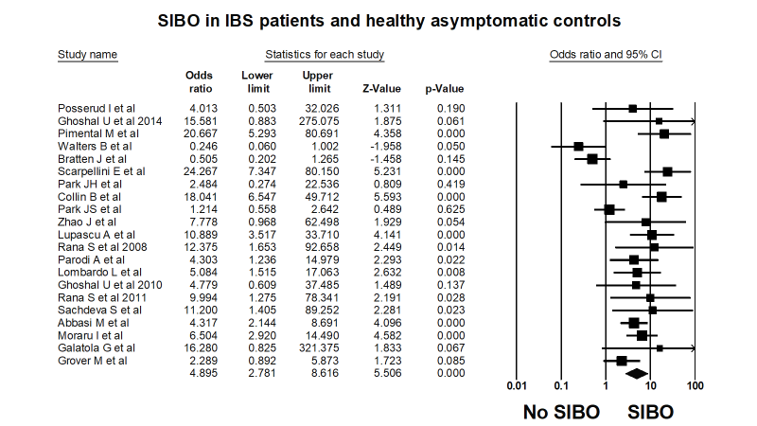

**Figure 3:** Forest plot of case control studies showing prevalence of SIBO in patients with IBS, and healthy asymptomatic controls (OR=4.9 (95%CI 2.8-8.6), p<0.001), (I2=74.3, p<0.001).



**Figure 4:** Funnel plot of SIBO in patients with IBS and healthy asymptomatic controls.

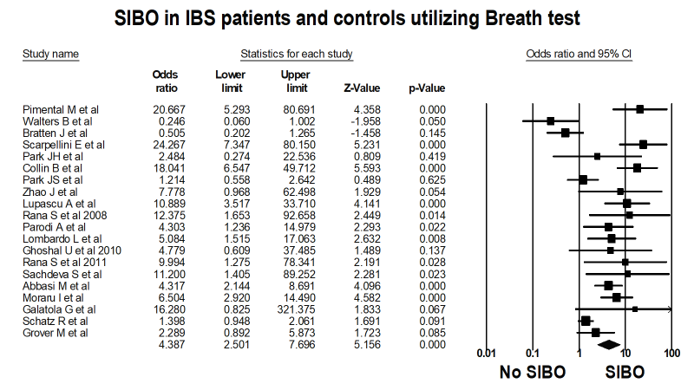

**Figure 5:** Forest plot of case control studies showing prevalence of SIBO in patients with IBS, utilizing breath tests (OR=4.4 (95%CI 2.5-7.7), p<0.001), (I2=80.2, p<0.001).

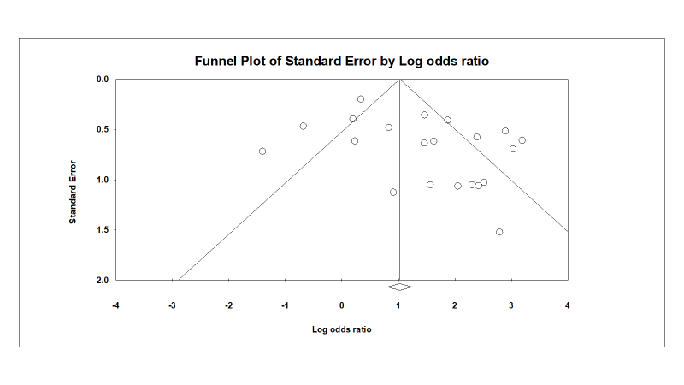

**Figure 6:** Funnel plot of SIBO in patients with IBS and controls, utilizing breath tests.

.



**SIBO in IBS patients and controls utilizing LBT**

**Figure 7:** Forest plot of case control studies showing SIBO in patients with IBS and controls, utilizing lactulose breath test (OR=3.5(95%CI 1.0-12.9), p<0.06) (I2=89.1, p<0.001).

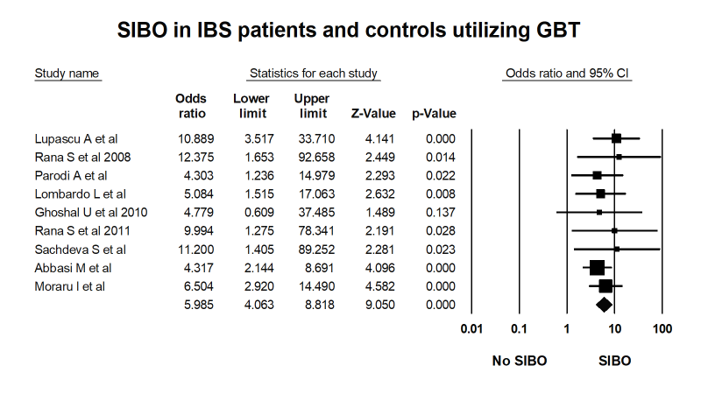

**Figure 8:** Forest plot of case control studies of SIBO in patients with IBS and controls, utilizing glucose breath test (OR=6.0(95%CI 4.1-8.8), p<0.001) (I2=0, p=0.91).

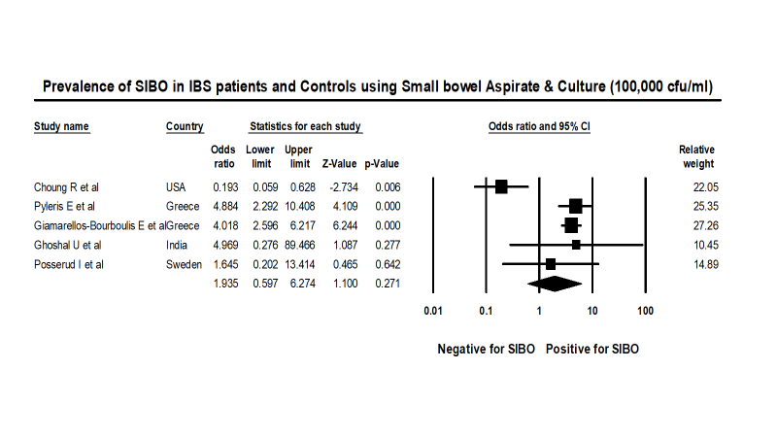

**Figure 9:** Forest plot of case control studies showing SIBO in patients with IBS and controls, utilizing small bowel culture and aspirate with cut off value of was 105 cfu/ml (OR=1.9(95%CI 0.6-6.3), p=0.271), (I2=83.7, p<0.001).

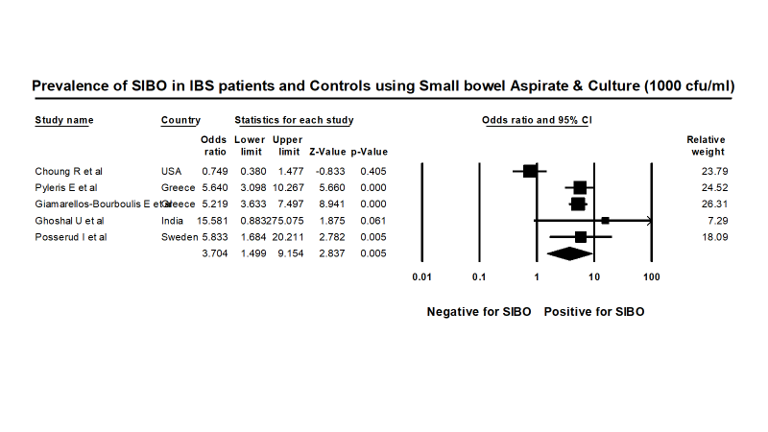

**Figure 10:** Forest plot of case control studies showing SIBO in patients with IBS and controls, utilizing small bowel culture and aspirate with cut off value of was 103cfu/ml (OR=3.7(95%CI 1.5-9.2), p<0.005), (I2=85.7, p<0.001).

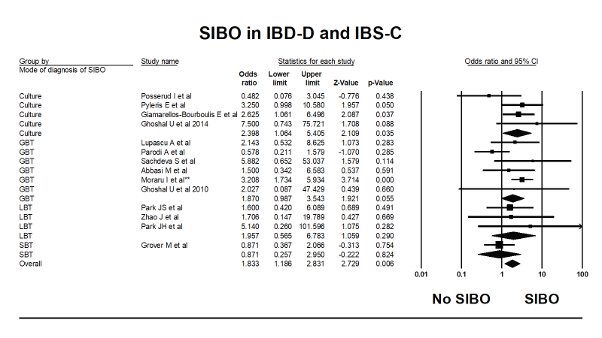

**Figure 11:** Forest plot of case control studies of SIBO in IBS subtypes (IBS D versus IBS C), (OR=1.8(95%CI 1.2-2.8), p<0.006), (I2=26.6, p=0.17).

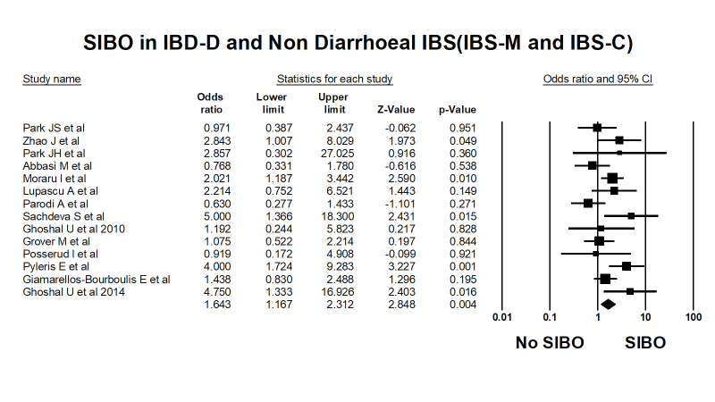

**Figure 12:** Forest plot of case control studies of SIBO in IBS subtypes (IBS D versus Non-diarrhoeal IBS (IBS M and IBS C)), (OR=1.6(95%CI 1.2-2.3), p<0.004), (I2=45.2, p<0.03).

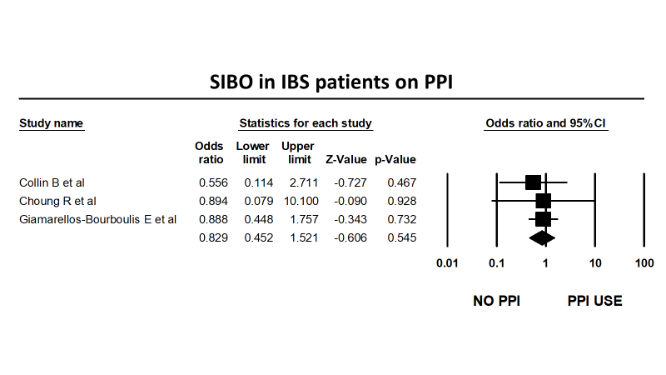

**Figure 13:** Forest plot of case control studies showing of SIBO in IBS patients on PPI as compared to those not on PPI therapy, (OR=0.8(95% CI, 0.5–1.5, p=0.55), (I2=0, p=0.87).

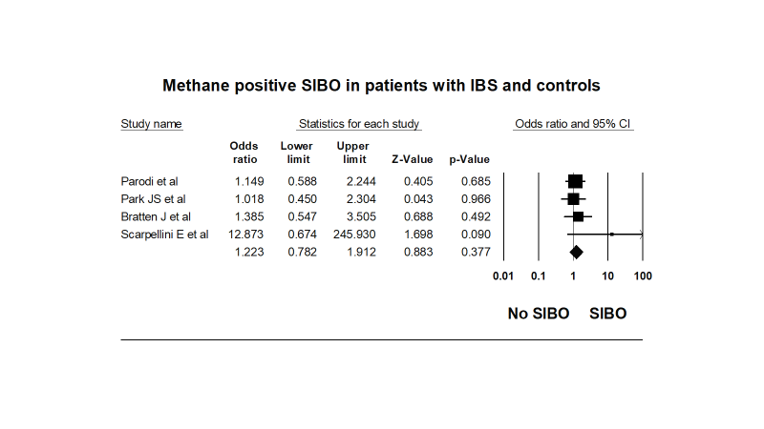

**Figure 14:** Forest plot of case control studies showing Methane positive SIBO in patients with IBS and controls, (OR=1.2(95% CI, 0.8–1.9, p=0.38), (I2=0, p=0.43).

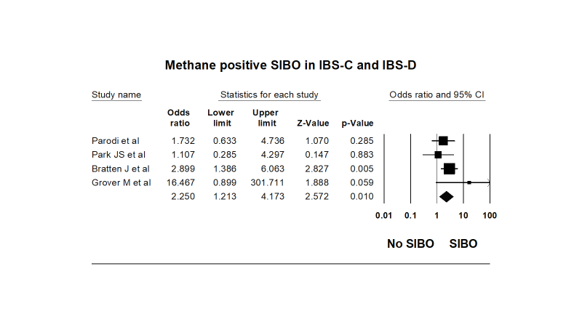

**Figure 15:** Forest plot of case control studies showing Methane positive SIBO in patients with IBS subtypes (IBS C versus IBS D), (OR=2.3(95% CI, 1.2–4.2, p<0.01), (I2=15.7, p=0.31).

**Table 1: Assessment of risk factors for SIBO in case control studies included in the systematic review and meta-analysis**

|  |  |  |  |  |  |  |  |  |
| --- | --- | --- | --- | --- | --- | --- | --- | --- |
| **Study No** | **Author** | **Prior antibiotic use** | **Concurrent PPI** | **Treatment with antibiotic** | **Duration of treatment** | **Treatment efficacy** | **Prior Surgery** | **Additional Comments** |
| 1 | Pimentel M *et al*1 | None within prior 3 months | NA | NA | NA | NA | None (except appendisectomy, cholecystectomy or hernia repair) | NA |
| 2 | Walters B *et* *al*2 | None within prior 2 weeks | NA | NA | NA | NA | NA | NA |
| 3 | Bratten J *et al*3 | None within prior 1 month | NA | NA | NA | NA | None (except appendisectomy, cholecystectomy or hernia repair) | IBS CH4 producers are more likely to have IBS C than IBS D |
| 4 | Scarpellini E *et al*4 | None within prior 2 months | NA | NA | NA | NA | No gastrointestinal Surgeries | NA |
| 5 | Park JH *et al*5 | None within prior 2 weeks | NA | NA | NA | NA | NA | Intestinal permeability measured using polyethylene glycol (PEG) 3350/400 retrieval ratio was significantly increased in IBS patients as compared to controls, but this did not correlate with the occurrence of SIBO |
| 6 | Collin B *et al*6 | None within prior 2 months | 23(31) on PPI or H2RB | NA | NA | NA | bowel resection | 20/68(30%) children with FGIDs & positive LBT were concomitantly taking H2RB or PPI as compared to 3/7(43%) with FGIDs and negative LBT, suggesting acid suppression did not increase prevalence of SIBO |
| 7 | Park JS *et al*7 | None within prior 2 weeks | NA | NA | NA | NA | NA |  |
| 8 | Zhao J *et al*8 | None within prior 4 weeks | NA | Rifaximin 600mg BD | 10 days | SIBO Positive IBS patients, particularly those with IBS D showed significant improvement in overall severity(p=0.002). IBS-D patients without SIBO did not benefit | NA | NA |
| 9 | Lupascu A *et al*9 | None within prior 2 months | NA | NA | NA | NA | None (except appendisectomy, cholecystectomy or hernia repair) | NA |
| 10 | Rana S *et al*10 2008 | None within prior 1 month | None within prior 8 weeks | NA | NA | NA | prior gastric surgery/ vagotomy | NA |
| 11 | Parodi A *et* *al**11* | NA | 1 SIBO positive IBS patient was on PPI | Rifaximin 400mg TDS | 10 days | GBT normalization was seen in 70%(17/24) of SIBO positive IBS patients, with significant symptom improvement in eradicated vs nor eradicated patients(p<0.001) | 7/21 IBS patients who were SIBO positive had abdominal surgeries (5 appendisectomy and 2 cholecystectomy) | 26% of GBT positive IBS patients were CH4 producers, not associated with any bowel pattern |
| 12 | Lombardo L *et al*12 | None within prior 6 months | None within prior 3 years | Rifaximin 400mg TDS | 2 weeks | The eradication rate (GBT 2 months after completion of treatment and improvement in75% symptom severity and frequency) of SIBO was 87% in PPI group and 91% in IBS group | No gastrointestinal Surgeries | SIBO was detected in 50% of current PPI users (patients with GERD),24.5% in IBS patients and 6% in controls, with the increase in symptom severity being directly proportional to therapy duration. |
| 13 | Ghoshal U *et* *al*13 2010 | None within prior 4 weeks | None within prior 4 weeks | NA | NA | NA | NA |  |
| 14 | Rana S *et al*14 2012 | None within prior 4 weeks | NA | SIBO positive patients were treated with antibiotics | 4 weeks | Normalization of GBT in 9/9 patients who came back for follow up GBT with symptom improvement | None | Patients & controls underwent GBT & LB. Using GBT as a gold standard for SIBO the sensitivity, specificity, PPV and NPV for SIBO in IBS was 63.6%,67.7%,11.7% & 96.6% respectively. |
| 15 | Sachdeva S *et al*15 | None within prior 6 weeks | None within prior 6 weeks | NA | NA | NA | No gastrointestinal Surgeries | NA |
| 16 | Abbasi M *et al*16 | None within prior 8 weeks | None within prior 8 weeks | NA | NA | NA | None (except appendisectomy) |  |
| 17 | Moraru I *et al*17 | None within prior 4 weeks | NA | Rifaximin 1200mg/day | 2 weeks | 76 SIBO positive IBS patients and 5 SIBO positive healthy controls had normalization of GBT | NA | 65/76(85.5%) and all controls had normalization of LBT 1 week after treatment with Rifaximin and the remaining after an additional 1 week of Rifaximin therapy. |
| 18 | Galatola G *et al*18 | NA | NA | NA | NA | NA |  | NA |
| 19 | Schatz R *et al*19 | None within prior 4 weeks | None within prior 2 weeks | NA | NA | NA | Patients included in the study had following surgery (besides appendisectomy, cholecystectomy, hernia repair) gastric bypass: 23, Fundoplication: 17, Bilroths procedure: 4 | IBS (1.40 95% CI 0.95-2.06, p=0.09), PPI Use (OR: 0.76, 95% CI 0.57-0.96, p=0.02) or previous abdominal surgery was not associated with SIBO. |
| 20 | Grover M *et* *al*20 | NA | NA | NA | NA | NA | None (except appendisectomy, cholecystectomy or hernia repair) | CH4 production is associated with constipation |
| 21 | Posserud I *et al*21 | None within prior 2 weeks | NA | ciprofloxacin 500mg BD | 10 days | 3/7 patients reported >25% symptom improvement.5/7 treated patients had decreased level of bacteria in cultures but 4 still fulfilled the standard definition for SIBO. | NA | Signs of enteric dysmotility (fewer phase III activities) were seen in 86% patients with SIBO and 39% without SIBO(p=0.02). |
| 22 | Choung R *et al*22 | 83(13%) were on antibiotics in the 3 months prior to duodenal aspirate | 53(36%) were on PPI | NA | NA | NA | 341(51%) patients had history of abdominal surgery, 65(10%) had gastric surgery and 94(14%) had intestinal surgery | No clear association was seen between SIBO and PPI use (OR 1.8, 95%CI 0.9-33, p=0.07) or IBS 0.2(95%CI 0.1-0.7) |
| 23 | Pyleris E *et al*23 | None within prior 1 month | 22(35.5%) with SIBO were on PPI as compared to 56(21.7%) without SIBO(p=0.014) | NA | NA | NA | NA | Risk factors for SIBO: PPI use (OR=1.95, 95% CI 1.00-3.78, p=0.049), history of T2DM (OR=2.69, 95% CI 1.34-5.40, p=0.005). Presence of gastritis was found to be protective (OR=0.50, 95% CI 0.27-0.93, p=0.028) |
| 24 | Giamarellos-Bourboulis E *et al*24 | None within prior 1 month | 184(20.50%) were on PPI | NA | NA | NA | NA | Factors associated with SIBO: IBS (OR: 6.28,95%Cl 4.26-9.25  P<0.0001), age > 60 years (OR: 2.36, 95%Cl 1.45-3.84 p<0.001), T2DM (OR:1.59,95%Cl 1.04-2.45, p<0.032), gastritis (OR:0.47, 95%Cl 0.32-0.69, p<0.0001), PPI use did not increase risk of SIBO (OR: 0.76, 95%Cl 0.45-1.42, p 0.765). |
| 25 | Ghoshal U *et al*252014 | None within prior 8 weeks | None within prior 8 weeks | NA | NA | NA | NA | 4/15(27%) with and 0/65 without SIBO had a positive GBT (sensitivity 27%, specificity 100%), 0/15 with and 1/65 without SIBO had double peak on LBT (sensitivity 0%, specificity 98%), 5/15(33%) and 23/65(35%) with SIBO had an early peak on LBT (sensitivity 33%, specificity 65%) |

IBS: irritable bowel syndrome; IBS D: IBS diarrhoea; IBS C: IBS constipation; IBS M: IBS mixed; SIBO: small intestinal bacterial overgrowth; PPI: proton pump inhibitor; H2RB: H2 receptor blocker; GBT: glucose breath test; LBT; lactulose breath test; T2DM: diabetes mellitus; FGIDs: functional gastrointestinal disorders; H2: hydrogen; CH4: methane; GERD: gastroesophageal reflux disease; NA: not applicable; PPV: positive predictor value: NPV: Negative predictor value.

**Table 2: Assessment of cut off criteria for diagnosing SIBO in IBS patients and controls**

|  |  |  |  |  |
| --- | --- | --- | --- | --- |
| **Study No** | **Author** | **Mode of diagnosis of SIBO** | **Dose of substrate** | **Cut off criteria for SIBO diagnosis** |
| 1 | Pimental M *et al*1 | LBT | 10g | All abnormal, except no rise H2 or Ch4 within 90mins with a definitive rise <20 ppm during 180mins of test duration. |
| 2 | Walters B *et al*2 | LBT | 10g | >20 ppm H2 rise over baseline within 90mins & 2 distinct peaks |
| 3 | Bratten J *et* *al*3 | LBT | 10g | No rise H2 within 90mins with a definitive rise <20 ppm during 180mins of test duration  >20 ppm H2 rise over baseline within 90mins & 2 distinct peaks of hydrogen production >12 ppm above basal value with decrease of ≥5 ppm before second peak or breath CH4 of >1ppm. |
| 4 | Scarpellini E *et al*4 | LBT | 10g | >20 ppm H2/CH4 rise over baseline within 90mins |
| 5 | Park JH *et al*5 | LBT | 10g | >20 ppm H2 or CH4 rise over baseline that occurred 15 min before the colonic peak or an elevated fasting H2 and/or CH4 level (＞12-15 ppm). |
| 6 | Collin B *et al*6 | LBT | 10g | Normal test: H2 peak > 90mins after lactulose ingestion with a H2 peak <20pp over 180mins, anything beyond these criteria was abnormal. |
| 7 | Park JS *et al*7 | LBT | NA | (1) baseline H2 ＞20 ppm or rise of H2 ＞20 ppm above the baseline in ＜90 mins, or (2) baseline CH4 10 ppm or rise of breath CH4 ＞10 ppm above the baseline in ＜90 mins. |
| 8 | Zhao J *et al*8 | LBT | 10g | **Criteria 1/2**: ≥20 ppm H2 rise over baseline within 90 or 180mins,  **Criteria 3:** dual breath H2 peaks, 12-ppm H2 rise over baseline with a decrease in ≥5 ppm before the second peak,  **Criteria 4:** initial H2 rise, involving at least two consecutive values ≥5 ppm above baseline, commenced at least 15mins before an increase in radioactivity (≥5% of administered dose) in the cecal region,  **Criteria 5:**  initial H2 rise, involving at least two consecutive values ≥10 ppm above baseline, commenced at least 15mins before an increase in radioactivity (≥5% of administered dose) in the cecal region and  **Criteria 6:** initial H2 rise, involving at least two consecutive values ≥20 ppm above baseline, commenced at least 15mins before an increase in radioactivity (≥5% of administered dose) in the cecal region. |
| 9 | Lupascu A *et* *al*9 | GBT | 50g | >10 ppm H2 rise over baseline. |
| 10 | Rana S *et al*10 2008 | GBT | 50g | >12 ppm H2 rise over baseline. |
| 11 | Parodi A *et* *al**11* | GBT | 50g | >12 ppm H2 rise over baseline. |
| 12 | Lombardo L *et al*12 | GBT | 50g | >10 ppm H2 rise over baseline. |
| 13 | Ghoshal U *et al*13 2010 | GBT | 100g | Persistent rise in breath hydrogen > 12 ppm above basal (at least two readings). |
| 14 | Rana S *et al*14 2012* | GBT | 80g | ≥10 ppm H2 orCH4 rise over baseline within 120 min after glucose ingestion. |
| 15 | Sachdeva S *et* *al*15 | GBT | 100g | > 12 ppm persistent rise in H2 or CH4 over baseline. |
| 16 | Abbasi M *et al*16 | GBT | 1g/Kg | >20 ppm H2 rise over baseline, when the baseline was <10ppm or rise by >12ppm when the baseline was ≥10 ppm. |
| 17 | Moraru I *et al*17 | GBT | 50g | >20 ppm H2 peak over baseline within 120 min after glucose ingestion. |
| 18 | Galatola G *et* *al*18 | XBT | 1g | A rise of greater than 2 standard deviations above mean of healthy subjects on any timepoint in 30-60 min after xylose. |
| 19 | Schatz R *et al**19* | XBT | 10 µCi | A positive test is defined as a greater than 2 standard deviation rise in CO2 (14C) value above the normal range at any one or more of the following points: 30 min (≥ 0.0014), 60 min (≥ 0.0029). |
| 20 | Grover M *et al*20 | SBT | 50g | Baseline H2 > 20ppm or > 12ppm rise H2 or CH4 over baseline in 60 min or a peak of ≥12 ppm above baseline >60 min after ingestion followed by a second peak of ≥20 ppm above baseline after a gap of ≥15 min from the first peak. |
| 21 | Posserud I *et al*21 | Jejunal Culture |  | 105 cfu/ml |
| 22 | Choung R *et* *al*22 | DU Culture |  | 105 cfu/ml |
| 23 | Pyleris E *et al*23 | DU Culture |  | 105 cfu/ml |
| 24 | Giamarellos-Bourboulis E *et al*24 | DU Culture |  | 105 cfu/ml |
| 25 | Ghoshal U *et al*252014 | Proximal small bowel culture |  | 105 cfu/ml |

ppm: parts per million;LBT: lactulose breath test; GBT: glucose breath test; XBT: xylose breath test; SBT: sucrose breath test; DU: duodenum; H2: hydrogen; CH4: methane; cfu/ml: colony forming unit/ml, NA: not applicable *All patients and controls underwent both GBT and LBT, GBT was however considered as gold standard.

**Table 3:** Studies evaluating the effect of antibiotic treatment in IBS patients with SIBO.

|  |  |  |  |  |  |  |  |
| --- | --- | --- | --- | --- | --- | --- | --- |
| **Author** | **Mode of diagnosis of SIBO** | **SIBO positive who underwent antibiotic treatment**  **n** | **Antibiotic type** | **Duration of therapy** | **Post treatment symptom improvement**  **n** | **Post treatment normalization of BT or reduction in bacterial counts**  **n** | **Adverse effects**  **N** |
| Zhao J *et al*8 | LBT | 34 | Rifaximin 600mg BD | 10 days | 34 | NA | NA |
| Parodi A *et al**11* | GBT | 24 | Rifaximin 400mg TDS | 10 days | 15 | 17 | NA |
| Lombardo L *et al*12 | GBT | 49 | Rifaximin 400mg TDS | 2 weeks | 45 | 45 | 4(mild headache/ nausea) |
| Posserud I *et al*21 | Culture, 105cfu/ml | 7 | ciprofloxacin 500mg BD | 10 days | 3 | 5 | NA |
| Ghoshal U *et al*26 2014 | Culture, 105cfu/ml | 8 | Norfloxacin 400mg BD | 10 days | 7 | proportion of patients did not consent to repeat test | 0 |
| Rana S *et al*142012 | GBT | 12 | Antibiotic type not specified | 4 weeks | 9* | 9 | NA |
| Moraru I *et al*17 | GBT | 105** | Rifaximin 1200mg OD | 14 days | 82*** | 76 | NA |

BT: breath test; LBT: lactulose breath test; GBT: glucose breath test; cfu/ml: colony forming unit/ml, NA: not applicable. * only 9/12 SIBO positive patients attended follow up GBT after cesssation of antibiotic therapy. ** dropout rate was 29/105, 76 patients returned to have a GBT after completion of antibiotic therapy. ***49(46.6%) and 33(31.4%) had complete and partial symptomatic improvement following antibiotic therapy. 7 SIBO positive controls underwent antibiotic treatment with normalization of BT in all 5/7 who had a post treatment repeat BT.

**Table 4:** Case-control studies of methane-positive SIBO in IBS patients and control.

|  |  |  |  |  |  |  |  |  |  |  |
| --- | --- | --- | --- | --- | --- | --- | --- | --- | --- | --- |
| **Study no** | **Author** | **Mode of diagnosis** | **IBS n** | **CH4 Positive in IBS n** | **Total control n** | **CH4 positive in controls n** | **IBS-D n** | **CH4 Positive in IBS-D n** | **IBS-C n** | **CH4 Positive in IBS-C n** |
| 1 | Parodi *et al**11* | GBT | 130 | 35 | 70 | 17 | 51 | **11** | 31 | 10 |
| 2 | Rana S *et al*14 2012 | GBT | 175 | 0 | 150 | 0 | 175 | 0 | 0 | 0 |
| 3 | Park JS *et al*7 | LBT | 76 | 25 | 40 | 13 | 45 | 14 | 12 | 4 |
| 4 | Bratten J *et al*3 | LBT | 224 | 44 | 40 | 6 | 114 | 13 | 92 | 25 |
| 5 | Grover M *et al*20* | SBT | 158 | 52 | 34 | NA | 47 | 0 | 43 | 6 |
| 6 | Scarpellini E *et al*4** | LBT | 43 | 4 | 56 | 0 | NA | NA | NA | NA |

LBT: lactulose breath test; GBT: glucose breath test; SBT: sucrose breath test; NA: not applicable; IBS: irritable bowel syndrome; IBS D: IBS diarrhoea; IBS C: IBS constipation; *Study not included in analysing the prevalence of methane positive SIBO in IBS patients and controls

** Study not included in analysing the prevalence of methane-positive SIBO in IBS-C and IBS-D

**Table 5:** Newcastle-Ottawa scale for assessment of quality of Case control studies included in the Systematic review & meta-analysis

|  |  |  |  |  |  |  |  |  |  |  |  |  |  |  |  |  |  |  |  |  |  |  |  |  |  |
| --- | --- | --- | --- | --- | --- | --- | --- | --- | --- | --- | --- | --- | --- | --- | --- | --- | --- | --- | --- | --- | --- | --- | --- | --- | --- |
|  | 11 | 22 | 33 | 44 | 55 | 66 | 77 | 88 | 99 | 1010 | 1111 | 1212 | 1313 | 1414 | 1515 | 1616 | 1717 | 1818 | 1919 | 2020 | 2121 | 2222 | 2323 | 2424 | 2525 |
| **SELECTION** |  |  |  |  |  |  |  |  |  |  |  |  |  |  |  |  |  |  |  |  |  |  |  |  |  |
| Is the case definition adequate? | * | * | * | * | * | - | * | * | * | * | * | * | * | * | * | * | * | - | - | * | * | - | - | - | * |
| Representativeness of the cases | - | * | * | * | * | * | * | * | * | * | * | * | * | * | * | * | * | * | * | - | * | * | * | * | * |
| Selection of Controls | * | - | * | * | * | - | * | * | * | * | * | * | * | * | * | * | * | * | - | * | * | - | - | - | * |
| Definition of Controls | - | * | * | - | * | - | - | * | - | - | - | - | - | - | - | - | - | - | - | * | - | - | - | - | - |
| **COMPARIBILITY** |  |  |  |  |  |  |  |  |  |  |  |  |  |  |  |  |  |  |  |  |  |  |  |  |  |
| Study controls for single factor | * | * | * | * | * | - | * | * | * | * | * | * | * | * | * | * | * | * | - | * | * | - | - | - | * |
| Study controls for additional factors | - | * | - | * | * | - | * | * | * | * | * | * | * | * | * | * | * | - | - | * | * | - | - | - | * |
| **EXPOSURE** |  |  |  |  |  |  |  |  |  |  |  |  |  |  |  |  |  |  |  |  |  |  |  |  |  |
| Ascertainment of exposure (presence of SIBO) | * | * | * | * | * | * | * | * | * | * | * | * | * | * | * | * | * | * | * | * | * | * | * | * | * |
| Same method of ascertainment for cases and controls | * | * | * | * | * | * | * | * | * | * | * | * | * | * | * | * | * | * | * | * | * | * | * | * | * |
| Non-Response rate | - | * | - | - | - | - | - | * | - | - | - | - | - | - | - | - | - | - | - | - | * | * | * | * | - |
| **Overall Quality Score**  **(Maximum = 9)** | 5 | 8 | 7 | 7 | 8 | 3 | 7 | 9 | 7 | 7 | 7 | 7 | 7 | 7 | 7 | 7 | 7 | 5 | 3 | 7 | 8 | 4 | 4 | 4 | 7 |
| **Reason for exclusion** | a | b | c | d |  | e |  |  |  |  |  |  |  |  |  |  |  | d | b |  |  | b | e | e |  |

* each asterisk represents if individual criterion within the subsection was fulfilled.

1. Control group (fibromyalgia) inappropriate since it has increased prevalence of IBS
2. Criteria for cases or controls insufficiently defined.
3. Control groups significantly younger as compared to patients
4. Control group heterogenous paediatric patients referred for routine medical care. Risk of concomitant conditions interfering with determining true SIBO prevalence in control group.
5. Controls include a variety of functional conditions. Thus, the study lacks appropriate control group.

**Detailed assessment of quality of Case control studies included in the Systematic review & meta-analysis:**

**1. Pimentel et al 2004:** Case definition based upon Rome I. However, IBS patients were recruited by advertisement. Controls were defined as ‘normal subjects’ and GI symptoms were not appropriately captured in this cohort. Key information was lacking for controls. Presence or absence of GI symptoms could have influenced the likelihood of participation.

**2. Walters et al 2005:** Adequate definition of cases (Rome II). However, unclear how many patients were consecutive patients seen in outpatients and how many were recruited from a cohort of study patients enrolled in a clinical trial on acupuncture. Control patients without GI symptoms as measured by standardised questionnaire). Control group not matched for gender (all controls female) and age of controls and patients different (median of controls 46 vs. patients 51.4 + 12.8 yrs). Variable criteria applied for the diagnosis of SIBO.

**3. Bratten et al 2008:** Patients and controls are well defined, and gender matched. There is a significant difference in relation to age between controls and patients, which increases the risk on bias.

**4.** **Scarpelli et al 2009:** Cases were appropriately defined and controls patients without history of IBS (‘admitted for routine medical care’). Well controlled for age, gender and other parameters. Symptoms in controls were not assessed by a VAS.

**5. Park et al 2009:** Patients and controls are well defined, and symptoms were assessed with standardised questionnaire. However, it is unknown if patients or controls with specific symptoms or clinical features were more likely to be included into the study.

**6. Collins et al. 2011:** Patients with abdominal symptoms were recruited and classified as IBS (patient cohort) and compared with those with functional dyspepsia, functional abdominal pain, or abdominal migraine (patient controls). The lack of proper asymptomatic healthy controls exposes this study to an extreme risk of false negative findings.

**7. Park et al 2010:** included were patients with IBS, functional bowel disorders and healthy controls, recruited by advertisement. No standardized assessment of GI symptoms in the control group.

**8. Zhao et al 2014:** 94 consecutive patients with IBS (Rome III) and 13 asymptomatic controls were recruited in this study. Structural lesions excluded in patients. Symptoms were assessed with a standardised 5-point scale.

**9. Lupascu et al 2005:** This study included 65 patients with IBS (Rome II) and 102 (first degree relatives) as controls, clinical assessment, but no standardised questionnaires were used to assess symptoms in controls. It is also unclear how many were excluded because of underlying disease.

**10. Rana at al 2009:** Consecutive IBS patients, predominantly male, no precise case definition (i.e. Rome I). Healthy controls, but no symptom assessment was done.

**11. Parodi et al 2009:** Well defined and characterised IBS patients (Rome III). No standardized symptom assessment of the control population (healthy subjects). Matched for age and gender.

**12. Lombardo et al 2010:** Consecutive patients with defined disease condition (GERD, IBS (Rome III)) and healthy controls. Controls did not undergo standardised symptom assessment.

**13. Ghoshal et al 2010:** Retrospective study of appropriately defined patients and controls. Unclear how symptoms assessed in control population.

**14. Rana et al 2012**: Prospectively enrolled patients with IBS-D and age and gender matched health controls. Controls matched for age and gender, but symptoms not properly assessed. Tests were interpreted by an experienced faculty member blinded to conditions and symptoms.

**15. Sachdeva et al. 2011:**  Prospectively enrolled IBS (Rome III) patients and controls. Controls did not undergo standardised symptom assessment**.**

**16. Abbasi et al 2014:** IBS patients according to Rome III, age and gender matched controls (healthy blood donors). However, no standardized symptom assessment was done in controls.

**17. Moraru et al. 2014:** Consecutive IBS patients (Rome III). Controls age and gender matched healthy subjects. However, no standardized symptom assessment was done in controls.

**18. Galatola et al 1991:** This study included acohort of patients with a variety of GI diseases. The cases and control groups are not well defined.

**19. Schatz et al 2015:** Retrospective study (audit). Criteria for cases and controls insufficiently defined.

**20. Grover et al 2008:** This study included **c**linically diagnosed IBS patients (Rome II) and controls without significant GI conditions. It is unclear if subjects are representative for IBS patients, (recruited by advertisement). Standardised symptom assessment questionnaires were used for cases and control groups.

**21. Posserud et al 2007:** This study includedIBS patients according to Rome II and control group were healthy subjects without any GI symptoms. However, there was no standardised assessment of GI symptoms.

**22. Choung et al 2011:** This is a retrospective study of all patients who underwent duodenal aspirate and culture for a variety of clinical indications or symptoms and did not included any healthy asymptomatic controls. No standardised assessment of symptoms (‘diagnosis was obtained from physician notes’) for cases or control group.

**23. Pyleris et al 2012:** This is a prospective study of patients undergoing outpatient endoscopy. Diagnosis of IBS based upon clinical assessment and Rome II criteria. The study used a questionnaire, assessing abdominal pain or discomfort and the relationship with bowel habits to classify patients with IBS and without IBS (who were used as a control group).

**24. Giamarellos-Bourboulis et al 2016:** This study included a large cohort of patients undergoing upper GI endoscopy. IBS was diagnosed based upon clinical assessment and Rome criteria. Controls were poorly defined (most likely patients undergoing endoscopy who did not have IBS).

**25.Ghoshal et al 2014:** This study included a cohort of patients with IBS (Rome III) and Historic controls, which were not well defined.

**References:**

1. Pimentel M, Wallace D, Hallegua D, et al. A link between irritable bowel syndrome and fibromyalgia may be related to findings on lactulose breath testing. Ann Rheum Dis 2004;63:450-2.

2. Walters B, Vanner SJ. Detection of bacterial overgrowth in IBS using the lactulose H2 breath test: comparison with 14C-D-xylose and healthy controls. Am J Gastroenterol 2005;100:1566-70.

3. Bratten JR, Spanier J, Jones MP. Lactulose breath testing does not discriminate patients with irritable bowel syndrome from healthy controls. Am J Gastroenterol 2008;103:958-63.

4. Scarpellini E, Giorgio V, Gabrielli M, et al. Prevalence of small intestinal bacterial overgrowth in children with irritable bowel syndrome: a case-control study. J Pediatr 2009;155:416-20.

5. Park JH, Park DI, Kim HJ, et al. The Relationship between Small-Intestinal Bacterial Overgrowth and Intestinal Permeability in Patients with Irritable Bowel Syndrome. Gut Liver 2009;3:174-9.

6. Collins BS, Lin HC. Double-blind, placebo-controlled antibiotic treatment study of small intestinal bacterial overgrowth in children with chronic abdominal pain. J Pediatr Gastroenterol Nutr 2011;52:382-6.

7. Park JS, Yu JH, Lim HC, et al. [Usefulness of lactulose breath test for the prediction of small intestinal bacterial overgrowth in irritable bowel syndrome]. Korean J Gastroenterol 2010;56:242-8.

8. Zhao J, Zheng X, Chu H, et al. A study of the methodological and clinical validity of the combined lactulose hydrogen breath test with scintigraphic oro-cecal transit test for diagnosing small intestinal bacterial overgrowth in IBS patients. Neurogastroenterol Motil 2014;26:794-802.

9. Lupascu A, Gabrielli M, Lauritano EC, et al. Hydrogen glucose breath test to detect small intestinal bacterial overgrowth: a prevalence case-control study in irritable bowel syndrome. Aliment Pharmacol Ther 2005;22:1157-60.

10. Rana SV, Sinha SK, Sikander A, et al. Study of small intestinal bacterial overgrowth in North Indian patients with irritable bowel syndrome: a case control study. Trop Gastroenterol 2008;29:23-5.

11. Parodi A, Dulbecco P, Savarino E, et al. Positive glucose breath testing is more prevalent in patients with IBS-like symptoms compared with controls of similar age and gender distribution. J Clin Gastroenterol 2009;43:962-6.

12. Lombardo L, Foti M, Ruggia O, et al. Increased incidence of small intestinal bacterial overgrowth during proton pump inhibitor therapy. Clin Gastroenterol Hepatol 2010;8:504-8.

13. Ghoshal UC, Kumar S, Mehrotra M, et al. Frequency of small intestinal bacterial overgrowth in patients with irritable bowel syndrome and chronic non-specific diarrhea. J Neurogastroenterol Motil 2010;16:40-6.

14. Rana SV, Sharma S, Kaur J, et al. Comparison of lactulose and glucose breath test for diagnosis of small intestinal bacterial overgrowth in patients with irritable bowel syndrome. Digestion 2012;85:243-7.

15. Sachdeva S, Rawat AK, Reddy RS, et al. Small intestinal bacterial overgrowth (SIBO) in irritable bowel syndrome: frequency and predictors. J Gastroenterol Hepatol 2011;26 Suppl 3:135-8.

16. Abbasi MH, Zahedi M, Darvish Moghadam S, et al. Small bowel bacterial overgrowth in patients with irritable bowel syndrome: the first study in iran. Middle East J Dig Dis 2015;7:36-40.

17. Moraru IG, Moraru AG, Andrei M, et al. Small intestinal bacterial overgrowth is associated to symptoms in irritable bowel syndrome. Evidence from a multicentre study in Romania. Rom J Intern Med 2014;52:143-50.

18. Galatola G, Grosso M, Barlotta A, et al. [Diagnosis of bacterial contamination of the small intestine using the 1 g [14C] xylose breath test in various gastrointestinal diseases]. Minerva Gastroenterol Dietol 1991;37:169-75.

19. Schatz RA, Zhang Q, Lodhia N, et al. Predisposing factors for positive D-Xylose breath test for evaluation of small intestinal bacterial overgrowth: A retrospective study of 932 patients. World Journal of Gastroenterology : WJG 2015;21:4574-4582.

20. Grover M, Kanazawa M, Palsson OS, et al. Small intestinal bacterial overgrowth in irritable bowel syndrome: association with colon motility, bowel symptoms, and psychological distress. Neurogastroenterol Motil 2008;20:998-1008.

21. Posserud I, Stotzer PO, Bjornsson ES, et al. Small intestinal bacterial overgrowth in patients with irritable bowel syndrome. Gut 2007;56:802-8.

22. Choung RS, Ruff KC, Malhotra A, et al. Clinical predictors of small intestinal bacterial overgrowth by duodenal aspirate culture. Aliment Pharmacol Ther 2011;33:1059-67.

23. Pyleris E, Giamarellos-Bourboulis EJ, Tzivras D, et al. The prevalence of overgrowth by aerobic bacteria in the small intestine by small bowel culture: relationship with irritable bowel syndrome. Dig Dis Sci 2012;57:1321-9.

24. Giamarellos-Bourboulis EJ, Pyleris E, Barbatzas C, et al. Small intestinal bacterial overgrowth is associated with irritable bowel syndrome and is independent of proton pump inhibitor usage. BMC Gastroenterol 2016;16:67.

25. Ghoshal UC, Srivastava D, Ghoshal U, et al. Breath tests in the diagnosis of small intestinal bacterial overgrowth in patients with irritable bowel syndrome in comparison with quantitative upper gut aspirate culture. Eur J Gastroenterol Hepatol 2014;26:753-60.

26. Ghoshal UC, Srivastava D, Misra A, et al. A proof-of-concept study showing antibiotics to be more effective in irritable bowel syndrome with than without small-intestinal bacterial overgrowth: a randomized, double-blind, placebo-controlled trial. European Journal of Gastroenterology & Hepatology 2016;28:281-289.