Supplementary Figure S1: Female-to-male incidence rate ratio of celiac disease in the 21st century
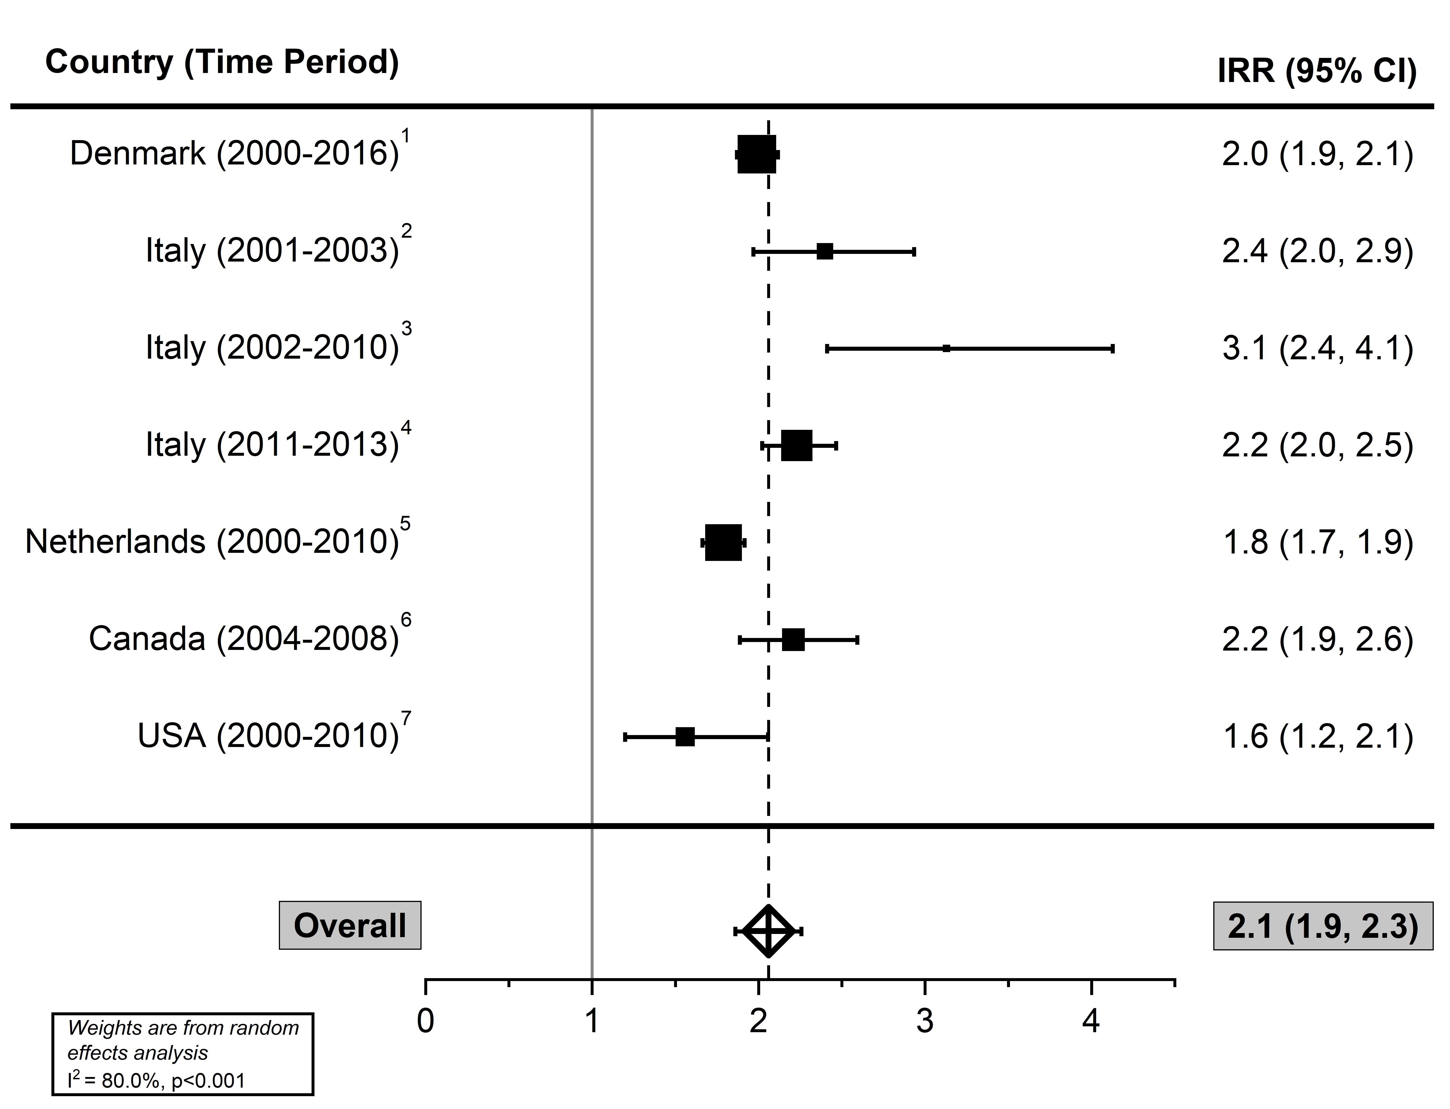

References
- Grode L, Bech BH, Jensen TM, et al. Prevalence, incidence, and autoimmune comorbidities of celiac disease: a nation-wide, population-based study in Denmark from 1977 to 2016. Eur J Gastroenterol Hepatol. 2018;30(1):83-91.
- Lanzarotto F, Crimi F, Amato M, Villanacci V, Pillan NM, Lanzini A. Is under diagnosis of celiac disease compounded by mismanagement in the primary care setting? A survey in the Italian Province of Brescia. Minerva Gastroenterol Dietol. 2004;50(4):283-288.
- Angeli G, Pasquini R, Panella V, Pelli MA. An epidemiologic survey of celiac disease in the Terni area (Umbria, Italy) in 2002-2010. J Prev Med Hyg. 2012;53(1):20-23.
- Zingone F, West J, Auricchio R, et al. Incidence and distribution of coeliac disease in Campania (Italy): 2011-2013. United European Gastroenterol J. 2015;3(2):182-189.
- Burger JP, Roovers EA, Drenth JP, Meijer JW, Wahab PJ. Rising incidence of celiac disease in the Netherlands; an analysis of temporal trends from 1995 to 2010. Scand J Gastroenterol. 2014;49(8):933-941.
- Stewart M, Andrews CN, Urbanski S, Beck PL, Storr M. The association of coeliac disease and microscopic colitis: a large population-based study. Aliment Pharmacol Ther. 2011;33(12):1340-1349.
- Ludvigsson JF, Rubio-Tapia A, van Dyke CT, et al. Increasing incidence of celiac disease in a North American population. Am J Gastroenterol. 2013;108(5):818-824.

Supplementary Figure S2: Female-to-male incidence rate ratio of celiac disease among children (A) and adults (B) in the 21st century
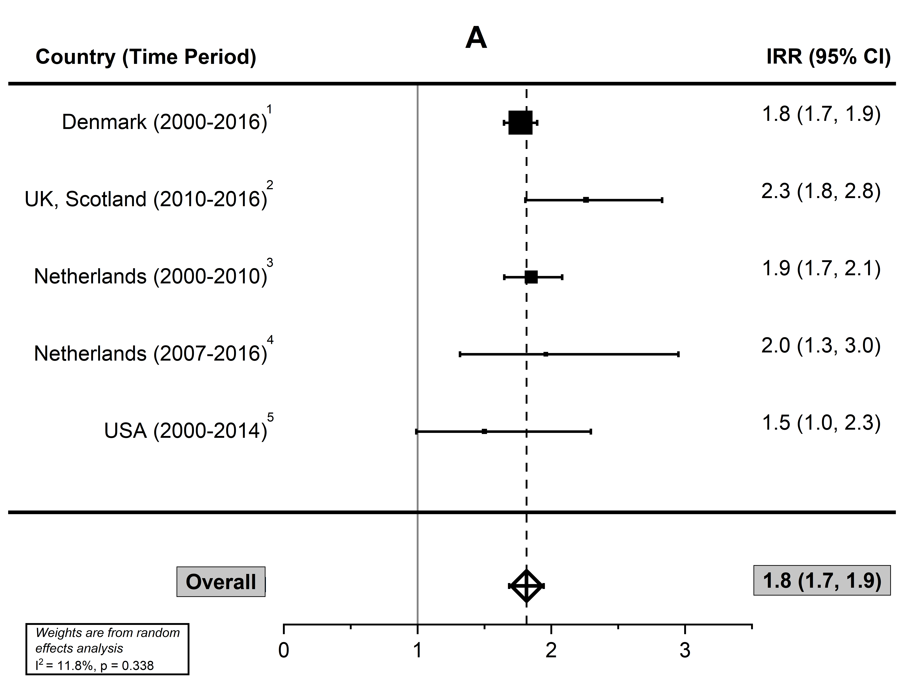

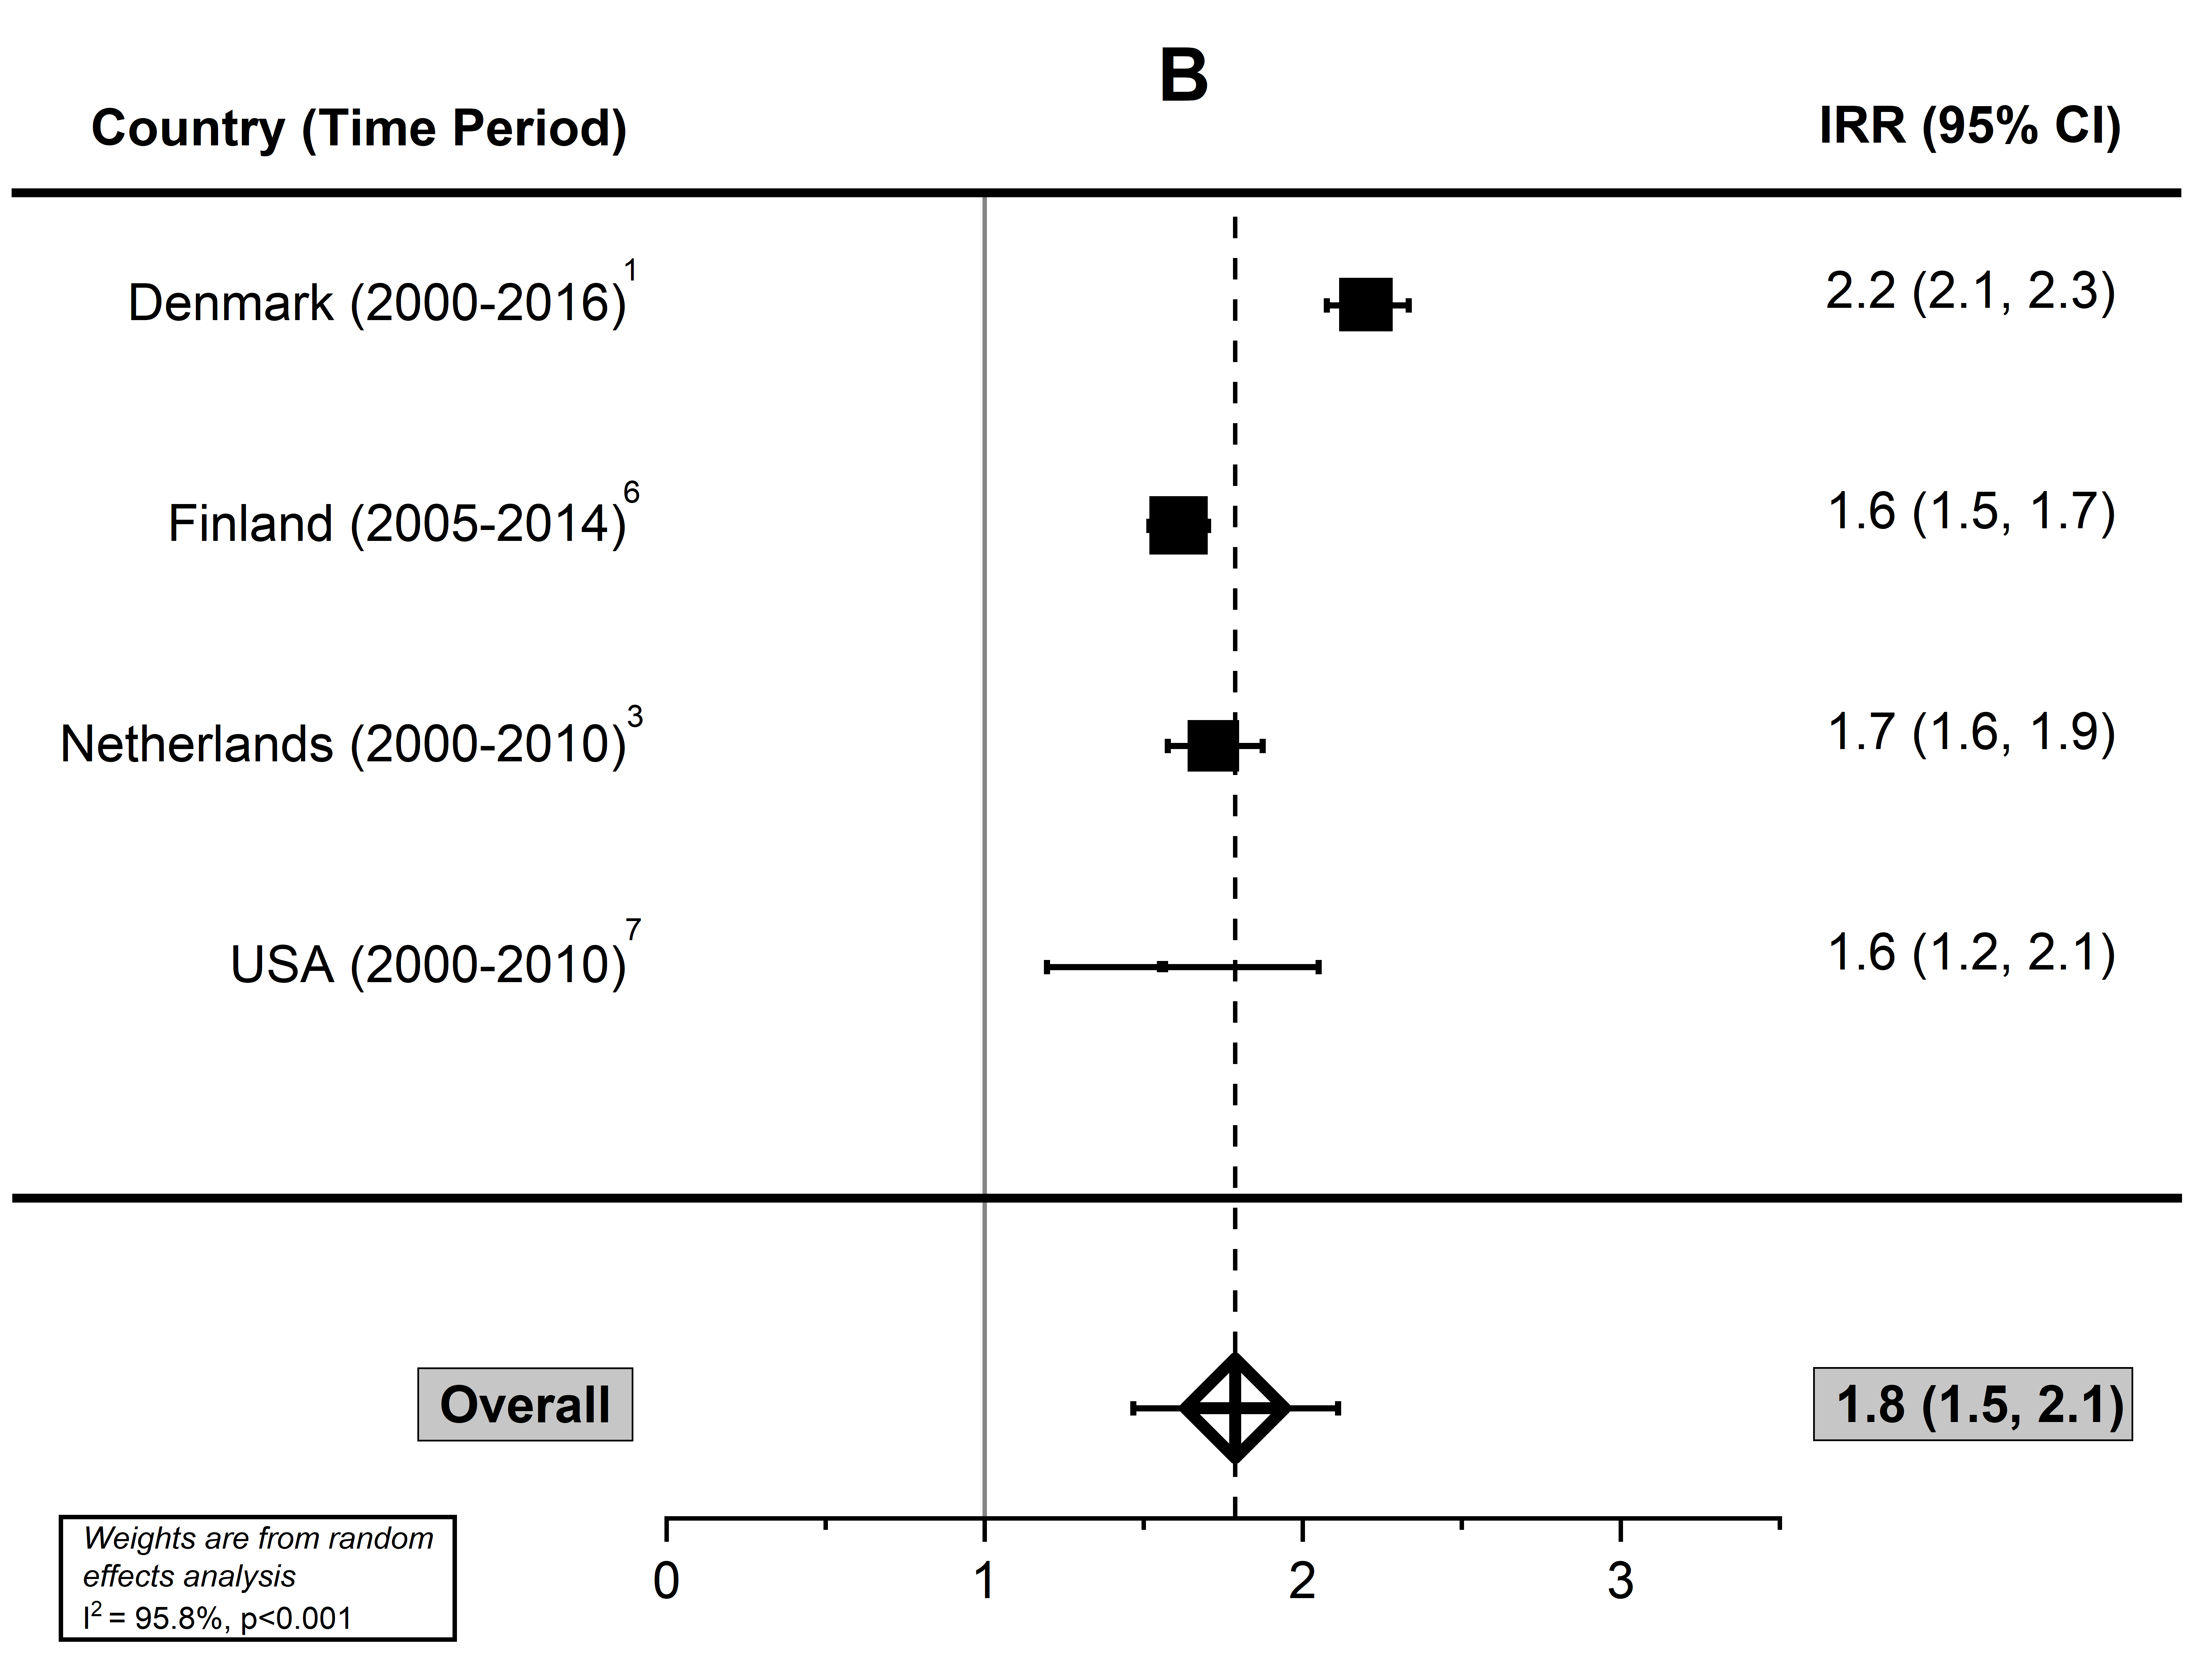

References
- Grode L, Bech BH, Jensen TM, et al. Prevalence, incidence, and autoimmune comorbidities of celiac disease: a nation-wide, population-based study in Denmark from 1977 to 2016. Eur J Gastroenterol Hepatol. 2018;30(1):83-91.
- Lister M, Wood P, Henderson P, Gillett P. The rising incidence of childhood coeliac disease: A 7-year regional cohort study. Paper presented at: Coeliac UK’s Research Conference 2018, 2018; London, UK.
- Burger JP, Roovers EA, Drenth JP, Meijer JW, Wahab PJ. Rising incidence of celiac disease in the Netherlands; an analysis of temporal trends from 1995 to 2010. Scand J Gastroenterol. 2014;49(8):933-941.
- Van Kalleveen MW, de Meij T, Plotz FB. Clinical spectrum of paediatric coeliac disease: a 10-year single-centre experience. Eur J Pediatr. 2018;177(4):593-602.
- Almallouhi E, King KS, Patel B, et al. Increasing incidence and altered presentation in a population-based study of pediatric celiac disease in North America. J Pediatr Gastroenterol Nutr. 2017;65(4):432-437.
- Virta LJ, Saarinen MM, Kolho KL. Declining trend in the incidence of biopsy-verified coeliac disease in the adult population of Finland, 2005-2014. Aliment Pharmacol Ther. 2017;46(11-12):1085-1093.
- Ludvigsson JF, Rubio-Tapia A, van Dyke CT, et al. Increasing incidence of celiac disease in a North American population. Am J Gastroenterol. 2013;108(5):818-824.

