SUPPLEMENTARY APPENDIX

Mortality risk in irritable bowel syndrome: results from a nationwide, prospective cohort study
Kyle Staller et al.

Table of Contents
Page 4 Table S1 Disease definitions using ICD and SNOMED codes
Page 5 Table S2 Definitions of baseline comorbidities within 5 years before start of follow-up

IBS patients without colorectal biopsy
Page 6 Figure S1 Flow chart of identified patients with IBS but no colorectal biopsy vs. matched comparators
Page 7 Table S3 IBS but no colorectal biopsy vs. matched comparators. Baseline characteristics of study cohort
Page 9 Table S4 IBS but no colorectal biopsy vs. matched comparators. Risk of all-cause and cause specific mortality in patients with IBS and matched general population comparators
Page 10 Figure S2 Kaplan-Meier survival curves of time to all-cause mortality (follow-up until Dec 31, 2017) in patients with IBS but no colorectal biopsy and matched comparators
Page 12 Table S5 IBS but no colorectal biopsy. Risk of all-cause mortality overall and by subgroups in patients with IBS and matched general population comparators
IBS patients with normal colorectal mucosa and reference individuals with normal colorectal
mucosa (i.e. all study participants had undergone biopsy with normal mucosa)
Page 13 Figure S3 Individuals with normal colorectal mucosa: Impact of IBS on mortality. Flow chart of identified patients and their comparators
Page 14 Table S6 Individuals with normal colorectal mucosa: Impact of IBS on mortality. Baseline characteristics of study cohort
Page 16 Figure S4 IBS but no colorectal biopsy vs. matched comparators. Risk of all-cause and cause specific mortality in patients with IBS and matched general population comparators
Page 17 Table S7 Individuals with normal colorectal mucosa: Impact of IBS on mortality. Risk of all-cause mortality overall and by subgroups.
IBS patients compared to siblings
Page 18 Figure S5 Flow chart of identified IBS patients and their siblings
Page 19 Table S8 IBS and siblings. Baseline characteristics of study cohort
Page 20 Figure S6 Kaplan-Meier survival curves of time to all-cause mortality (follow-up until Dec 31, 2017) in patients with IBS and their siblings (comparators)
Page 22 Table S9 Sibling analyses. Risk of all-cause mortality overall and by subgroups in patients with IBS and siblings (comparators)
IBS patients by subtype
Page 24 Figure S7 Flow chart of identified patients with IBS subtype (IBS-D and IBS non-D) and their matched comparators
Page 25 Table S10 IBS subtype (IBS-D and IBS non-D). Baseline characteristics of study cohort
Page 27 Figure S8 Kaplan-Meier survival curves of time to all-cause mortality (follow-up until Dec 31, 2017) in patients with IBS and diarrhea (left panel) and IBS without diarrhea (right panel)
Page 28 Table S11 Risk of all-cause mortality overall and by subgroups in patients with IBS with diarrhea (IBS-D) and matched general population comparators
Page 29 Table S12 Risk of all-cause mortality overall and by subgroups in patients with IBS without diarrhea (IBS non-D) and matched general population comparator
IBS patients by histopathology (inflammation vs. none) compared to all reference individuals
Page 30 Figure S9 IBS and underlying histopathology (normal mucosa vs. inflammation). Flow chart of identified patients and their matched comparators
Page 31 Table S13 IBS and underlying histopathology (normal mucosa vs. inflammation). Baseline characteristics of study cohort
Page 33 Figure S10 IBS and underlying histopathology (normal mucosa vs. inflammation). Kaplan-Meier survival curves of time to all-cause mortality (follow-up until Dec 31, 2017) in patients with IBS and normal mucosa (left panel) and IBS with inflammation in mucosa (right panel)
Page 34 Table S14 Risk of all-cause mortality overall and by subgroups in patients with IBS and normal mucosa and matched general population comparator
Page 35 Table S15 Risk of all-cause mortality overall and by subgroups in patients with IBS and inflammation in mucosa and matched general population comparator

Table S1 Disease definitions using ICD and SNOMED codes
 | ICD-codes |  |  |  | SNOMED codes
 | ICD-10 | ICD-9 | ICD-8 | ICD-7
Diagnoses
Irritable Bowel Syndrome (IBS) | K58 | 564B |  |  | M + topographic code T67 or T68
IBS with diarrhea-predominance (IBS-D) | K58.0
IBS without diarrhea (IBS non-D) | K58.9
IBS with inflammation in mucosa* | K58 | 564B |  |  | M43000, M44000, M45020, M41000, M41700, M42000, M42100, M40000, M40460
Normal mucosa |  |  |  |  | M00100, M00110
Celiac disease | K900 | 579A | 269,00 | 286
Inflammatory bowel disease | K50-K51 | 555-556 | 563 | 572
Colorectal cancer | C18-C21 | 153-154 | 153-154 | 153-154
Giardiasis | A07.1
Exocrine pancreatic insufficiency | K86.8
Porphyria | E80
Sucrase-isolmaltase deficiency | E74.3
Small intestinal bacterial overgrowth | A04.9
Eosinophilic gastroenteritis | K52.8
Pelvic floor dysfunction | N81
Microscopic colitis |  |  |  |  | M40600, M47170 + topographic code T67 or T68

M43000 (chronic inflammation), M44000 (granulomatous inflammation), M45020 (inflammation with granulation), M41000 (acute inflammation), M41700 (inflammation with necrosis), M42000 (subacute inflammation), M42100 (acute and chronic inflammation), M40000 (unspecified inflammation), M40460 (unspecified inflammation with pus)

Table S2 Definitions of baseline comorbidities within 5 years before start of follow-up
Comorbidity | ICD-10 codes
Cardiovascular disease (CVD) | I00-I99
Myocardial infarction | I21-I22
Cancer | C00-D48
Diabetes | E10-E14
Neurologic disease | G10-G99

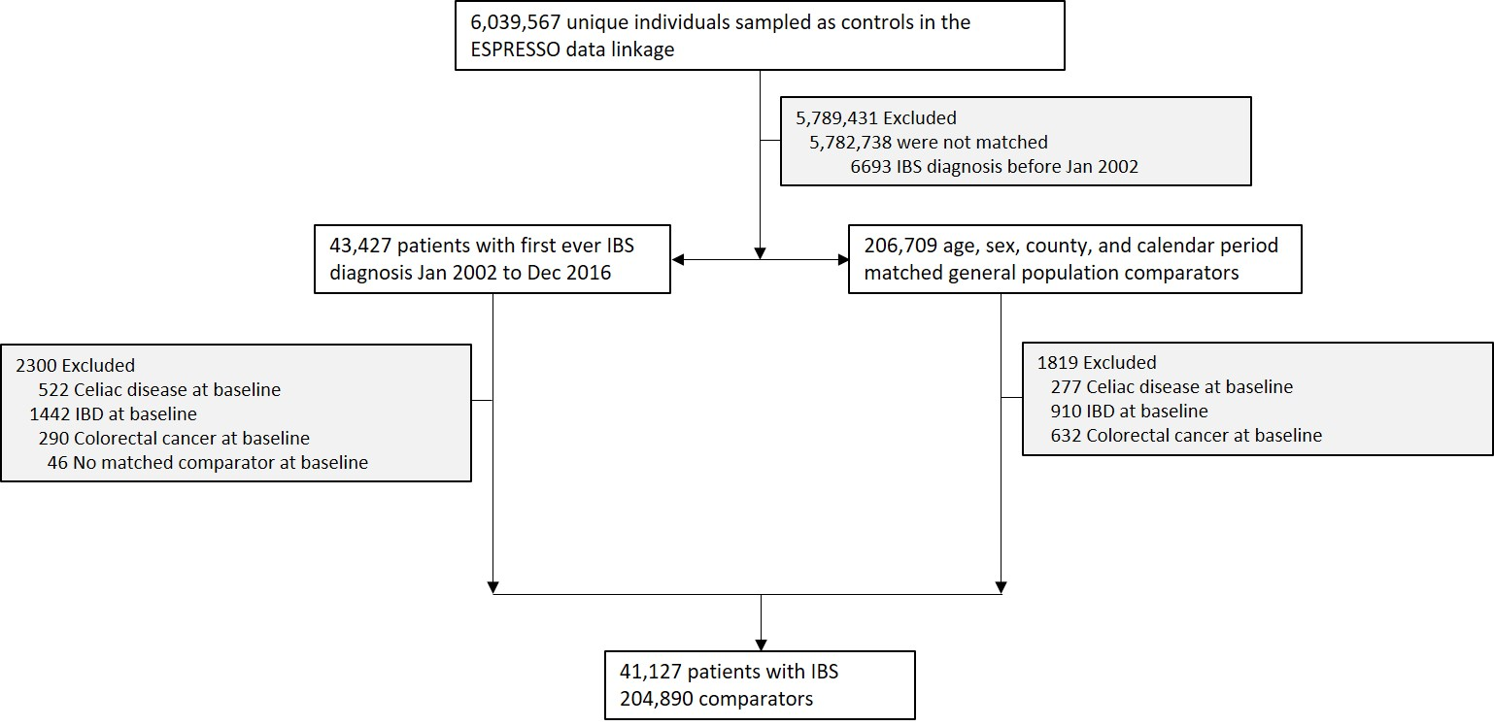
Figure S1 Flow chart of identified patients with IBS but no colorectal biopsy vs. matched comparators

IBS, irritable bowel syndrome; IBD, inflammatory bowel disease

Table S3 IBS but no colorectal biopsy vs. matched comparators. Baseline characteristics of study cohort
Characteristic | Irritable bowel syndrome  (n=41,127) | Matched comparators  (n=204,890) | IBS - Main analysis  (n=45,254) | Comparators - Main analysis  (n=217,316)
Female, no. (%) | 30 805 (74.9%) | 151 821 (74.1%) | 32 029 (70.8%) | 153 817 (70.8%)
Male, no (%) | 10 322 (25.1%) | 53 069 (25.9%) | 13 225 (29.2%) | 63 499 (29.2%)
Age
Mean (SD) | 49.3 (19.3) | 48.6 (19.0) | 46.0 (18.3) | 45.3 (17.9)
Median (IQR) | 49.5 (33.1-64.5) | 48.8 (32.6-63.5) | 44.9 (30.3-60.5) | 44.2 (29.9-59.5)
Range, min-max | 1.1-100.8 | 0.8-101.3 | 0.2-99.8 | 0.0-99.9
Categories, no. (%)
<18y | 1335 (3.2%) | 6849 (3.3%) | 1062 (2.3%) | 5386 (2.5%)
18y - <30y | 7105 (17.3%) | 36 441 (17.8%) | 10 012 (22.1%) | 49 349 (22.7%)
30y - <40y | 6118 (14.9%) | 31 103 (15.2%) | 7754 (17.1%) | 38 032 (17.5%)
40y - <50y | 6354 (15.4%) | 32 091 (15.7%) | 7614 (16.8%) | 37 157 (17.1%)
50y - <60y | 6789 (16.5%) | 34 408 (16.8%) | 7173 (15.9%) | 34 877 (16.0%)
60y - <70y | 6722 (16.3%) | 33 495 (16.3%) | 6495 (14.4%) | 30 692 (14.1%)
≥70y | 6704 (16.3%) | 30 503 (14.9%) | 5144 (11.4%) | 21 823 (10.0%)
Country of birth, no (%)
Nordic country | 36 976 (89.9%) | 182 946 (89.3%) | 40 805 (90.2%) | 187 422 (86.2%)
Other | 4151 (10.1%) | 21 940 (10.7%) | 4449 (9.8%) | 29 889 (13.8%)
Missing | 0 (0.0%) | 4 (0.0%) | 0 (0.0%) | 5 (0.0%)
Level of education, no (%)
≤9 years | 8577 (20.9%) | 45 085 (22.0%) | 8743 (19.3%) | 43 291 (19.9%)
10-12 years | 18 293 (44.5%) | 88 201 (43.0%) | 21 067 (46.6%) | 95 852 (44.1%)
>12 years | 13 555 (33.0%) | 67 374 (32.9%) | 14 934 (33.0%) | 73 791 (34.0%)
Missing | 702 (1.7%) | 4230 (2.1%) | 510 (1.1%) | 4382 (2.0%)
Start year of follow-up
2002-2005 | 8343 (20.3%) | 42 378 (20.7%) | 9708 (21.5%) | 47 036 (21.6%)
2006-2010 | 14 061 (34.2%) | 70 062 (34.2%) | 15 963 (35.3%) | 76 779 (35.3%)
2011-2016 | 18 723 (45.5%) | 92 450 (45.1%) | 19 583 (43.3%) | 93 501 (43.0%)
Disease history within 5 years before start of follow-up,
no. (%)
Cardiovascular disease (CVD) | 6683 (16.2%) | 19 173 (9.4%) | 6826 (15.1%) | 16 453 (7.6%)
Myocardial infarction (MI) | 512 (1.2%) | 1658 (0.8%) | 387 (0.9%) | 1216 (0.6%)
Cardiovascular disease in inpatient care | 3013 (7.3%) | 9607 (4.7%) | 2769 (6.1%) | 7605 (3.5%)
Cancer | 6993 (17.0%) | 20 974 (10.2%) | 8121 (17.9%) | 19 090 (8.8%)
Diabetes | 984 (2.4%) | 3668 (1.8%) | 1132 (2.5%) | 3357 (1.5%)
Neurologic disease | 4157 (10.1%) | 10 842 (5.3%) | 4711 (10.4%) | 10 679 (4.9%)

SD, standard deviation; IQR, interquartile range

Table S4 IBS but no colorectal biopsy vs. matched comparators. Risk of all-cause and cause specific mortality in patients with IBS and matched general population comparators
 | All-cause mortality |  | CVD |  | Cancer |  | Psychiatric disease
 | IBS | Comparators | IBS | Comparators | IBS | Comparators | IBS | Comparators
N | 41 127 | 204 890 | 41 104 | 204 780 | 41 104 | 204 780 | 41 104 | 204 780
Deaths, no (%) | 3943 (9.6%) | 17196 (8.4%) | 1962 (4.8%) | 8538 (4.2%) | 1250 (3.0%) | 4958 (2.4%) | 474 (1.2%) | 2519 (1.2%)
Follow-up years
Mean (SD) | 7.4 (4.2) | 7.4 (4.1) | 6.5 (4.1) | 6.5 (4.1) | 6.5 (4.1) | 6.5 (4.1) | 6.5 (4.1) | 6.5 (4.1)
Median (IQR) | 6.9 (3.9-10.6) | 7.0 (3.9-10.6) | 6.0 (3.0-9.6) | 6.1 (3.1-9.7) | 6.0 (3.0-9.6) | 6.1 (3.1-9.7) | 6.0 (3.0-9.6) | 6.1 (3.1-9.7)
Incidence rate  per 1000 PY (95% CI) | 13.0 (12.6-13.4) | 11.3 (11.1-11.4) | 7.4 (7.0-7.7) | 6.4 (6.2-6.5) | 4.7 (4.4-5.0) | 3.7 (3.6-3.8) | 1.8 (1.6-1.9) | 1.9 (1.8-2.0)
Hazard ratio (95% CI)
Unadjusted | 1.15 (1.11-1.19) |  | 1.16 (1.10-1.21) |  | 1.27 (1.19-1.35) |  | 0.95 (0.86-1.04)
Conditioned | 1.12 (1.08-1.16) |  | 1.12 (1.06-1.18) |  | 1.27 (1.19-1.35) |  | 0.92 (0.82-1.02)
Adjusted I | 1.15 (1.10-1.19) |  | 1.14 (1.08-1.21) |  | 1.29 (1.21-1.38) |  | 0.94 (0.84-1.04)
Adjusted II | 1.02 (0.99-1.06) |  | 1.00 (0.95-1.06) |  | 1.12 (1.04-1.19) |  | 0.89 (0.80-0.99)
Conditioned: Conditioned on age, sex, county, and calendar period;
Adjusted I: Conditioned and further adjusted for level of education;
Adjusted II: Adjusted I and further adjusted for baseline medical comorbidities (cancer, diabetes, CVD, and neurologic disease)

IBS, irritable bowel syndrome; CVD, cardiovascular disease; SD, standard deviation; IQR, interquartile range

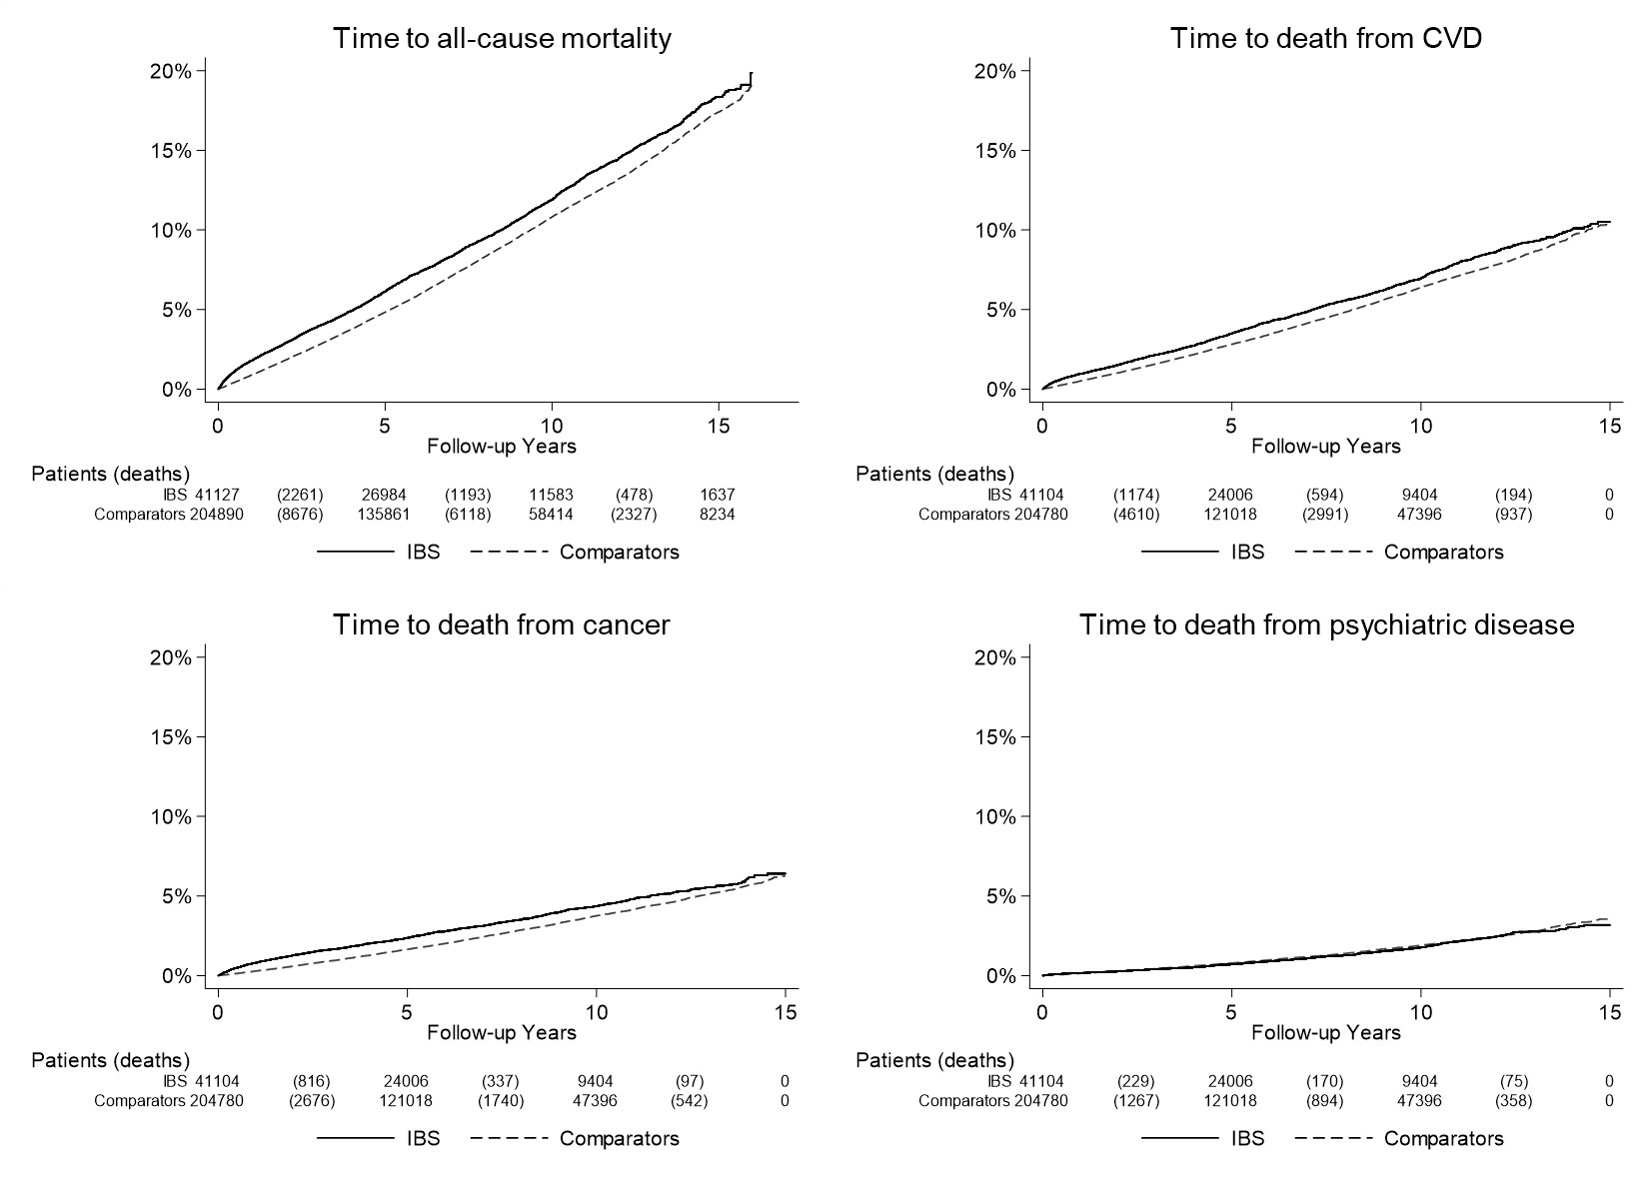
Figure S2 Kaplan-Meier survival curves of time to all-cause mortality (follow-up until Dec 31, 2017) and cause-specific mortality (follow-up until Dec 31, 2016) in patients with IBS but no colorectal biopsy and matched comparators

IBS, irritable bowel syndrome; CVD, cardiovascular disease

Table S5 IBS but no colorectal biopsy. Risk of all-cause mortality overall and by subgroups in patients with IBS and matched general population comparators
Group | N (%) |  | Time at risk (years) |  | N events |  | Incidence rate (95% CI) |  | HR*  (95%CI) | HR**  (95%CI)
 | IBS | Comparators | IBS | Comparators | IBS | Comparators | IBS | Comparators
Overall | 41 127 (100.0%) | 204 890 (100.0%) | 303 361 | 1 525 458 | 3943 (9.6%) | 17196 (8.4%) | 13.0 (12.6-13.4) | 11.3 (11.1-11.4) | 1.12 (1.08-1.16) | 1.02 (0.99-1.06)
Follow-up
0-<1y | 41 127 (100.0%) | 204 890 (100.0%) | 40 645 | 203 629 | 736 (1.8%) | 1804 (0.9%) | 18.1 (16.8-19.4) | 8.9 (8.5-9.3) | 1.86 (1.71-2.04) | 1.64 (1.49-1.80)
1-5y | 40 288 (98.0%) | 202 266 (98.7%) | 160 705 | 807 834 | 1844 (4.6%) | 8314 (4.1%) | 11.5 (11.0-12.0) | 10.3 (10.1-10.5) | 1.06 (1.01-1.12) | 0.96 (0.91-1.01)
>5y | 26 984 (65.6%) | 135 861 (66.3%) | 127 341 | 641 672 | 1682 (6.2%) | 8520 (6.3%) | 13.2 (12.6-13.8) | 13.3 (13.0-13.6) | 0.99 (0.93-1.04) | 0.93 (0.88-0.98)
Sex
Women | 30 805 (74.9%) | 151 821 (74.1%) | 230 625 | 1 147 610 | 2605 (8.5%) | 11022 (7.3%) | 11.3 (10.9-11.7) | 9.6 (9.4-9.8) | 1.08 (1.03-1.13) | 0.99 (0.94-1.04)
Men | 10 322 (25.1%) | 53 069 (25.9%) | 72 736 | 377 848 | 1338 (13.0%) | 6174 (11.6%) | 18.4 (17.4-19.4) | 16.3 (15.9-16.7) | 1.20 (1.13-1.28) | 1.09 (1.03-1.17)
Age
<18y | 1335 (3.2%) | 6849 (3.3%) | 8 607 | 44 131 | 1 (0.1%) | 7 (0.1%) | 0.1 (0.0-0.3) | 0.2 (0.0-0.3) | 0.78 (0.09-6.48) | 2.07 (0.17-24.60)
18y -<30y | 7105 (17.3%) | 36 441 (17.8%) | 51 757 | 262 450 | 26 (0.4%) | 114 (0.3%) | 0.5 (0.3-0.7) | 0.4 (0.4-0.5) | 1.14 (0.74-1.76) | 1.04 (0.65-1.67)
30y - <40y | 6118 (14.9%) | 31 103 (15.2%) | 47 467 | 240 619 | 50 (0.8%) | 191 (0.6%) | 1.1 (0.8-1.3) | 0.8 (0.7-0.9) | 1.38 (1.00-1.89) | 1.15 (0.82-1.63)
40y - <50y | 6354 (15.4%) | 32 091 (15.7%) | 50 259 | 253 123 | 105 (1.7%) | 491 (1.5%) | 2.1 (1.7-2.5) | 1.9 (1.8-2.1) | 1.07 (0.86-1.33) | 0.89 (0.71-1.12)
50y - <60y | 6789 (16.5%) | 34 408 (16.8%) | 56 225 | 285 888 | 307 (4.5%) | 1558 (4.5%) | 5.5 (4.8-6.1) | 5.4 (5.2-5.7) | 0.99 (0.87-1.12) | 0.87 (0.77-1.00)
60y - <70y | 6722 (16.3%) | 33 495 (16.3%) | 51 087 | 255 706 | 739 (11.0%) | 3578 (10.7%) | 14.5 (13.4-15.5) | 14.0 (13.5-14.5) | 1.03 (0.95-1.11) | 0.91 (0.84-0.99)
≥70y | 6704 (16.3%) | 30 503 (14.9%) | 37 960 | 183 540 | 2715 (40.5%) | 11 257 (36.9%) | 71.5 (68.8-74.2) | 61.3 (60.2-62.5) | 1.17 (1.12-1.23) | 1.08 (1.03-1.13)
Year
2002-2005 | 8343 (20.3%) | 42 378 (20.7%) | 105 678 | 536 539 | 1404 (16.8%) | 6934 (16.4%) | 13.3 (12.6-14.0) | 12.9 (12.6-13.2) | 1.04 (0.98-1.10) | 0.95 (0.90-1.02)
2006-2010 | 14 061 (34.2%) | 70 062 (34.2%) | 123 431 | 618 146 | 1536 (10.9%) | 6888 (9.8%) | 12.4 (11.8-13.1) | 11.1 (10.9-11.4) | 1.06 (1.00-1.12) | 0.96 (0.90-1.02)
2011-2016 | 18 723 (45.5%) | 92 450 (45.1%) | 74 252 | 370 773 | 1003 (5.4%) | 3374 (3.6%) | 13.5 (12.7-14.3) | 9.1 (8.8-9.4) | 1.40 (1.30-1.51) | 1.29 (1.19-1.39)
Country of birth
Nordic | 36 976 (89.9%) | 182 946 (89.3%) | 273 171 | 1 371 185 | 3717 (10.1%) | 16169 (8.8%) | 13.6 (13.2-14.0) | 11.8 (11.6-12.0) | 1.12 (1.08-1.17) | 1.03 (0.99-1.07)
Other | 4151 (10.1%) | 21 940 (10.7%) | 30 190 | 154 252 | 226 (5.4%) | 1027 (4.7%) | 7.5 (6.5-8.5) | 6.7 (6.3-7.1) | 0.81 (0.59-1.12) | 0.74 (0.53-1.05)
Level of education
≤9 years | 8577 (20.9%) | 45 085 (22.0%) | 61 579 | 335 025 | 1735 (20.2%) | 8403 (18.6%) | 28.2 (26.8-29.5) | 25.1 (24.5-25.6) | 1.17 (1.09-1.25) | 1.05 (0.98-1.13)
10-12 years | 18 293 (44.5%) | 88 201 (43.0%) | 138 128 | 672 290 | 1462 (8.0%) | 5936 (6.7%) | 10.6 (10.0-11.1) | 8.8 (8.6-9.1) | 1.19 (1.10-1.28) | 1.04 (0.96-1.13)
>12 years | 13 555 (33.0%) | 67 374 (32.9%) | 100 322 | 496 972 | 671 (5.0%) | 2466 (3.7%) | 6.7 (6.2-7.2) | 5.0 (4.8-5.2) | 1.14 (1.00-1.30) | 0.99 (0.87-1.14)
Missing | 702 (1.7%) | 4230 (2.1%) | 3 332 | 21 172 | 75 (10.7%) | 391 (9.2%) | 22.5 (17.4-27.6) | 18.5 (16.6-20.3) | 1.42 (0.75-2.67) | 1.30 (0.67-2.51)
Comorbidity
CVD | 6683 (16.2%) | 19173 (9.4%) | 43 292 | 123 432 | 1637 (24.5%) | 4982 (26.0%) | 37.8 (36.0-39.6) | 40.4 (39.2-41.5) | 1.05 (0.96-1.14) | 1.03 (0.94-1.13)
MI | 512 (1.2%) | 1658 (0.8%) | 2 916 | 10 028 | 230 (44.9%) | 655 (39.5%) | 78.9 (68.7-89.1) | 65.3 (60.3-70.3) | 1.76 (0.96-3.22) | 2.12 (1.08-4.15)
CVD inpatient | 3013 (7.3%) | 9607 (4.7%) | 18 344 | 59 423 | 1157 (38.4%) | 3591 (37.4%) | 63.1 (59.4-66.7) | 60.4 (58.5-62.4) | 1.01 (0.89-1.14) | 0.99 (0.88-1.13)
Cancer | 6993 (17.0%) | 20 974 (10.2%) | 45 923 | 139 650 | 1206 (17.2%) | 3238 (15.4%) | 26.3 (24.8-27.7) | 23.2 (22.4-24.0) | 1.22 (1.09-1.38) | 1.18 (1.04-1.33)
*Conditioned on matching set
**Conditioned on matching set and adjusted for education and baseline medical comorbidities (cancer, diabetes, CVD, and neurologic disease)
IBS, irritable bowel syndrome; CVD, cardiovascular disease; MI, myocardial infarction; SD, standard deviation; IQR, interquartile range

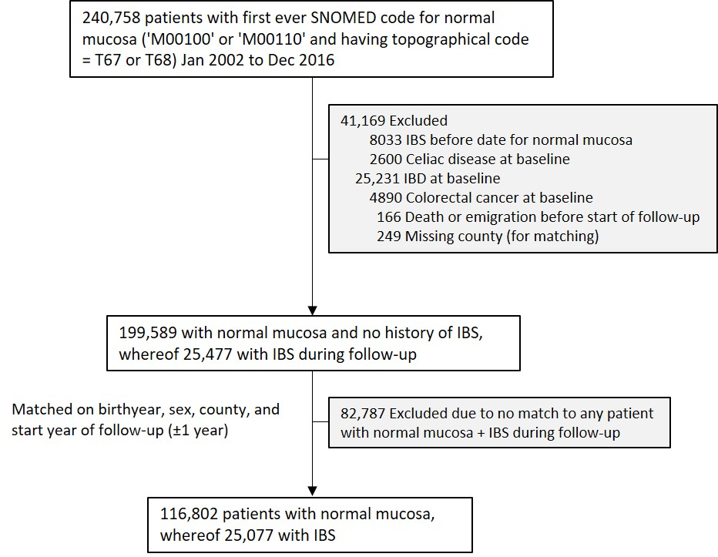
Figure S3 Individuals with normal colorectal mucosa: Impact of IBS on mortality. Flow chart of identified patients and their comparators
IBS, irritable bowel syndrome; IBD, inflammatory bowel disease; SNOMED, Systematized Nomenclature of Medicine

Table S6 Individuals with normal colorectal mucosa: Impact of IBS on mortality. Baseline characteristics of study cohort
Characteristic | Irritable bowel syndrome  (n=25,077) | Comparators  (n=116,802)
Female, no. (%) | 17 481 (69.7%) | 82 550 (70.7%)
Male, no (%) | 7596 (30.3%) | 34 252 (29.3%)
Age
Mean (SD) | 42.1 (17.1) | 42.2 (16.9)
Median (IQR) | 39.7 (27.5-54.9) | 39.9 (27.6-55.0)
Range, min-max | 0.6-93.8 | 0.0-94.5
Categories, no. (%)
<18y | 645 (2.6%) | 2604 (2.2%)
18y - <30y | 7054 (28.1%) | 32735 (28.0%)
30y - <40y | 4952 (19.7%) | 23197 (19.9%)
40y - <50y | 4348 (17.3%) | 20318 (17.4%)
50y - <60y | 3557 (14.2%) | 16849 (14.4%)
60y - <70y | 2771 (11.0%) | 13254 (11.3%)
≥70y | 1750 (7.0%) | 7845 (6.7%)
Country of birth, no (%)
Nordic country | 22 478 (89.6%) | 101 644 (87.0%)
Other | 2599 (10.4%) | 15 158 (13.0%)
Missing | 0 (0.0%) | 0 (0.0%)
Level of education, no (%)
≤9 years | 4364 (17.4%) | 20 683 (17.7%)
10-12 years | 11 800 (47.1%) | 53 121 (45.5%)
>12 years | 8646 (34.5%) | 41 535 (35.6%)
Missing | 267 (1.1%) | 1463 (1.3%)
Start year of follow-up
2002-2005 | 4579 (18.3%) | 20 729 (17.7%)
2006-2010 | 8980 (35.8%) | 42 141 (36.1%)
2011-2016 | 11 518 (45.9%) | 53 932 (46.2%)
Time to register-based definition of IBS onset*
(time in years between first IBS diagnosis and biopsy)
Mean (SD) | 1.1 (2.3)
Median (IQR) | 0.1 (0.0-1.0)
Range, min-max | 0.0-14.6
Disease history within 5 years before start of follow-up,
no. (%)
Cardiovascular disease (CVD) | 2967 (11.8%) | 13 679 (11.7%)
Myocardial infarction (MI) | 142 (0.6%) | 684 (0.6%)
Cardiovascular disease in inpatient care | 1087 (4.3%) | 5258 (4.5%)
Cancer | 3553 (14.2%) | 17 533 (15.0%)
Diabetes | 550 (2.2%) | 2636 (2.3%)
Neurologic disease | 2382 (9.5%) | 9164 (7.8%)

SD, standard deviation; IQR, interquartile range. *Or time between biopsy and first IBS diagnosis (biopsy could occur before or after IBS diagnosis).
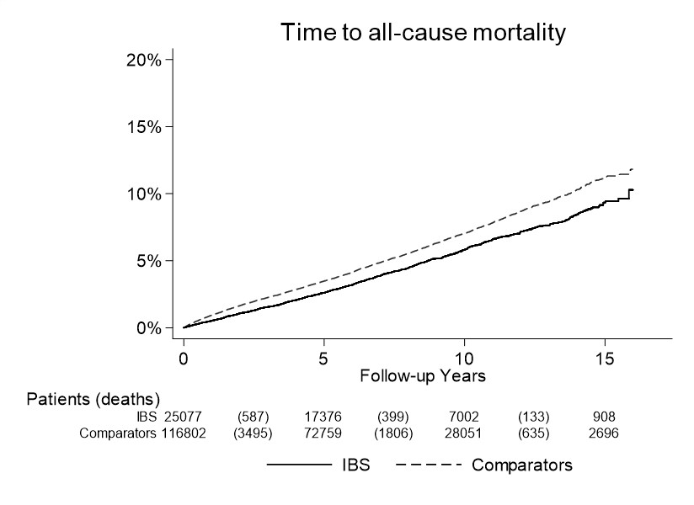
Figure S4 Kaplan-Meier survival curves of time to all-cause mortality (follow-up until Dec 31, 2017) in patients with
normal mucosa. Impact of IBS on mortality.

IBS, irritable bowel syndrome

Table S7 Individuals with normal colorectal mucosa: Impact of IBS on mortality. Risk of all-cause mortality overall and by subgroups.
Group | N (%) |  | Time at risk (years) |  | N events |  | Incidence rate (95% CI) |  | HR*  (95%CI) | HR**  (95%CI)
 | IBS | Comparators | IBS | Comparators | IBS | Comparators | IBS | Comparators
Overall | 25 077 (100.0%) | 116 802 (100.0%) | 189 940 | 800 986 | 1122 (4.5%) | 5944 (5.1%) | 5.9 (5.6-6.3) | 7.4 (7.2-7.6) | 0.78 (0.73-0.83) | 0.80 (0.74-0.85)
Follow-up
0-<1y | 25 077 (100.0%) | 116 802 (100.0%) | 24 983 | 112 419 | 133 (0.5%) | 1055 (0.9%) | 5.3 (4.4-6.2) | 9.4 (8.8-10.0) | 0.55 (0.46-0.65) | 0.56 (0.47-0.68)
1-5y | 24 892 (99.3%) | 109 948 (94.1%) | 102 448 | 439 651 | 553 (2.2%) | 2893 (2.6%) | 5.4 (4.9-5.8) | 6.6 (6.3-6.8) | 0.80 (0.73-0.88) | 0.81 (0.74-0.89)
>5y | 17 376 (69.3%) | 72 759 (62.3%) | 78 787 | 316 364 | 535 (3.1%) | 2449 (3.4%) | 6.8 (6.2-7.4) | 7.7 (7.4-8.0) | 0.88 (0.79-0.97) | 0.89 (0.80-0.99)
Sex
Women | 17 481 (69.7%) | 82 550 (70.7%) | 132 384 | 561 525 | 728 (4.2%) | 3850 (4.7%) | 5.5 (5.1-5.9) | 6.9 (6.6-7.1) | 0.79 (0.73-0.86) | 0.80 (0.74-0.88)
Men | 7596 (30.3%) | 34 252 (29.3%) | 57 555 | 239 461 | 394 (5.2%) | 2094 (6.1%) | 6.8 (6.2-7.5) | 8.7 (8.4-9.1) | 0.76 (0.68-0.85) | 0.78 (0.69-0.87)
Age
<18y | 645 (2.6%) | 2604 (2.2%) | 4 923 | 17 712 | 1 (0.2%) | 11 (0.4%) | 0.2 (0.0-0.6) | 0.6 (0.3-1.0) | 0.52 (0.06-4.15) | 1.73 (0.10-30.76)
18y -<30y | 7054 (28.1%) | 32 735 (28.0%) | 52 432 | 210 699 | 40 (0.6%) | 161 (0.5%) | 0.8 (0.5-1.0) | 0.8 (0.6-0.9) | 0.98 (0.69-1.40) | 1.32 (0.88-1.98)
30y - <40y | 4952 (19.7%) | 23 197 (19.9%) | 38 920 | 165 284 | 46 (0.9%) | 243 (1.0%) | 1.2 (0.8-1.5) | 1.5 (1.3-1.7) | 0.78 (0.56-1.07) | 0.89 (0.63-1.26)
40y - <50y | 4348 (17.3%) | 20 318 (17.4%) | 34 442 | 147 233 | 73 (1.7%) | 482 (2.4%) | 2.1 (1.6-2.6) | 3.3 (3.0-3.6) | 0.63 (0.49-0.81) | 0.64 (0.49-0.83)
50y - <60y | 3557 (14.2%) | 16 849 (14.4%) | 28 755 | 125 988 | 138 (3.9%) | 985 (5.8%) | 4.8 (4.0-5.6) | 7.8 (7.3-8.3) | 0.59 (0.49-0.71) | 0.62 (0.51-0.75)
60y - <70y | 2771 (11.0%) | 13 254 (11.3%) | 20 255 | 90 502 | 281 (10.1%) | 1603 (12.1%) | 13.9 (12.3-15.5) | 17.7 (16.8-18.6) | 0.78 (0.69-0.89) | 0.80 (0.70-0.91)
≥70y | 1750 (7.0%) | 7845 (6.7%) | 10 213 | 43 568 | 543 (31.0%) | 2459 (31.3%) | 53.2 (48.7-57.6) | 56.4 (54.2-58.7) | 0.87 (0.78-0.96) | 0.86 (0.78-0.96)
Year
2002-2005 | 4579 (18.3%) | 20 729 (17.7%) | 60 133 | 242 083 | 376 (8.2%) | 1886 (9.1%) | 6.3 (5.6-6.9) | 7.8 (7.4-8.1) | 0.77 (0.68-0.87) | 0.79 (0.70-0.90)
2006-2010 | 8980 (35.8%) | 42 141 (36.1%) | 80 722 | 343 008 | 485 (5.4%) | 2600 (6.2%) | 6.0 (5.5-6.5) | 7.6 (7.3-7.9) | 0.79 (0.71-0.88) | 0.80 (0.72-0.89)
2011-2016 | 11 518 (45.9%) | 53 932 (46.2%) | 49 085 | 215 895 | 261 (2.3%) | 1458 (2.7%) | 5.3 (4.7-6.0) | 6.8 (6.4-7.1) | 0.79 (0.69-0.91) | 0.81 (0.70-0.93)
Country of birth
Nordic | 22 478 (89.6%) | 101 644 (87.0%) | 170 515 | 698 219 | 1060 (4.7%) | 5504 (5.4%) | 6.2 (5.8-6.6) | 7.9 (7.7-8.1) | 0.78 (0.73-0.83) | 0.80 (0.75-0.86)
Other | 2599 (10.4%) | 15 158 (13.0%) | 19 424 | 102 767 | 62 (2.4%) | 440 (2.9%) | 3.2 (2.4-4.0) | 4.3 (3.9-4.7) | 0.62 (0.38-1.03) | 0.64 (0.36-1.17)
Level of education
≤9 years | 4364 (17.4%) | 20 683 (17.7%) | 33 217 | 143 086 | 410 (9.4%) | 2296 (11.1%) | 12.3 (11.1-13.5) | 16.0 (15.4-16.7) | 0.81 (0.70-0.94) | 0.80 (0.69-0.92)
10-12 years | 11 800 (47.1%) | 53 121 (45.5%) | 89 761 | 368 215 | 462 (3.9%) | 2458 (4.6%) | 5.1 (4.7-5.6) | 6.7 (6.4-6.9) | 0.75 (0.66-0.85) | 0.76 (0.67-0.87)
>12 years | 8646 (34.5%) | 41 535 (35.6%) | 65 355 | 281 381 | 229 (2.6%) | 1086 (2.6%) | 3.5 (3.1-4.0) | 3.9 (3.6-4.1) | 0.83 (0.67-1.02) | 0.83 (0.67-1.04)
Missing | 267 (1.1%) | 1463 (1.3%) | 1 607 | 8 304 | 21 (7.9%) | 104 (7.1%) | 13.1 (7.5-18.7) | 12.5 (10.1-14.9) | 0.63 (0.11-3.43) | 0.69 (0.07-6.71)
Comorbidity
CVD | 2967 (11.8%) | 13 679 (11.7%) | 20 365 | 87 474 | 396 (13.3%) | 2127 (15.5%) | 19.4 (17.5-21.4) | 24.3 (23.3-25.3) | 0.72 (0.62-0.84) | 0.73 (0.63-0.86)
MI | 142 (0.6%) | 684 (0.6%) | 854 | 3 920 | 40 (28.2%) | 241 (35.2%) | 46.9 (32.3-61.4) | 61.5 (53.7-69.2) | 1.40 (0.52-3.79) | 1.75 (0.46-6.66)
CVD inpatient | 1087 (4.3%) | 5258 (4.5%) | 7 317 | 32 315 | 257 (23.6%) | 1436 (27.3%) | 35.1 (30.8-39.4) | 44.4 (42.1-46.7) | 0.72 (0.57-0.92) | 0.73 (0.57-0.93)
Cancer | 3553 (14.2%) | 17 533 (15.0%) | 23 929 | 109 592 | 347 (9.8%) | 2089 (11.9%) | 14.5 (13.0-16.0) | 19.1 (18.2-19.9) | 0.73 (0.61-0.86) | 0.72 (0.60-0.85)
*Conditioned on matching set
**Conditioned on matching set and adjusted for education and baseline medical comorbidities (cancer, diabetes, CVD, and neurologic disease)
IBS, irritable bowel syndrome; CVD, cardiovascular disease; MI, myocardial infarction; SD, standard deviation; IQR, interquartile range

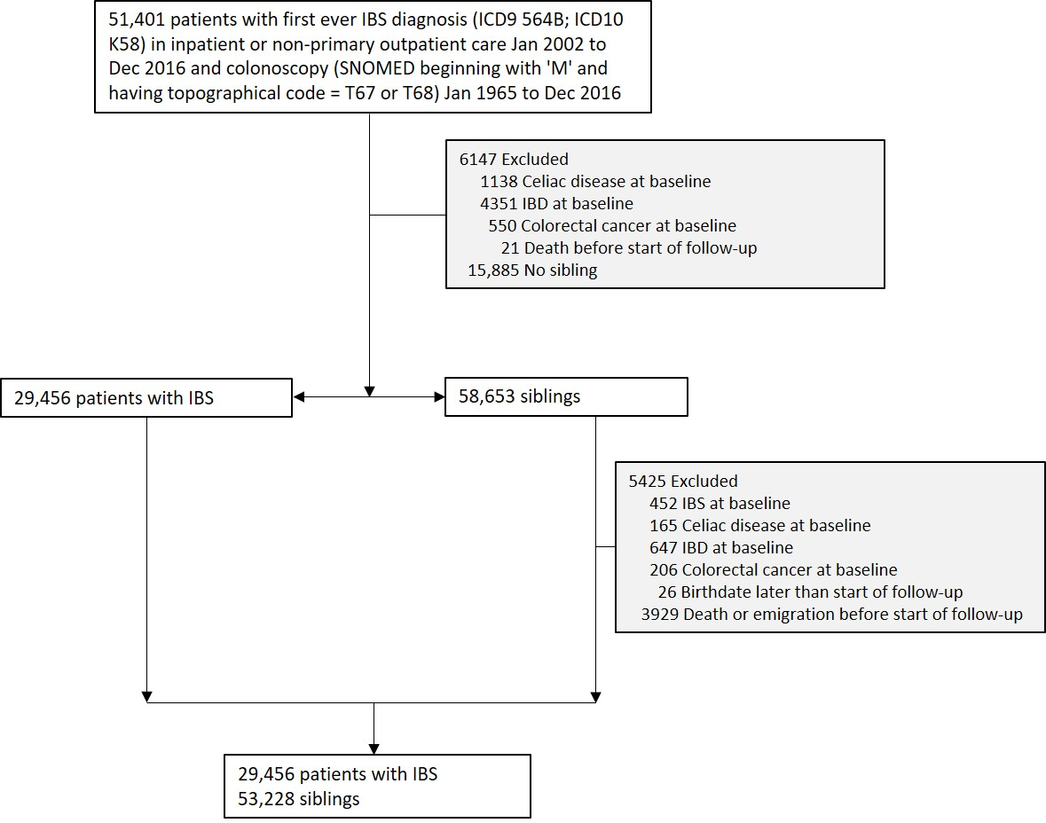
Figure S5 Flow chart of identified IBS patients and their siblings
IBS, irritable bowel syndrome; IBD, inflammatory bowel disease; SNOMED, Systematized Nomenclature of Medicine

Table S8 IBS and siblings. Baseline characteristics of study cohort
Characteristic | Irritable bowel syndrome  (n=29,456) | Siblings  (n=53,228)
Female, no. (%) | 20 725 (70.4%) | 26 339 (49.5%)
Male, no (%) | 8731 (29.6%) | 26 889 (50.5%)
Age
Mean (SD) | 42.3 (16.4) | 43.7 (16.9)
Median (IQR) | 41.0 (27.8-55.7) | 43.9 (29.5-57.7)
Range, min-max | 0.2-84.4 | 0.3-84.5
Categories, no. (%)
<18y | 840 (2.9%) | 2896 (5.4%)
18y - <30y | 7845 (26.6%) | 10 920 (20.5%)
30y - <40y | 5510 (18.7%) | 9195 (17.3%)
40y - <50y | 5198 (17.6%) | 9571 (18.0%)
50y - <60y | 4695 (15.9%) | 9560 (18.0%)
60y - <70y | 4000 (13.6%) | 8194 (15.4%)
≥70y | 1368 (4.6%) | 2892 (5.4%)
Country of birth, no (%)
Nordic country | 28 694 (97.4%) | 51 375 (96.5%)
Other | 762 (2.6%) | 1849 (3.5%)
Missing | 0 (0.0%) | 4 (0.0%)
Level of education, no (%)
≤9 years | 4856 (16.5%) | 11 311 (21.3%)
10-12 years | 14 111 (47.9%) | 24 687 (46.4%)
>12 years | 10 235 (34.7%) | 16 162 (30.4%)
Missing | 254 (0.9%) | 1068 (2.0%)
Start year of follow-up
2002-2005 | 6021 (20.4%) | 11 045 (20.8%)
2006-2010 | 10 318 (35.0%) | 18 965 (35.6%)
2011-2016 | 13 117 (44.5%) | 23 218 (43.6%)
Time to register-based definition of IBS onset*
(time in years between first IBS diagnosis and biopsy)
Mean (SD) | 2.7 (4.7)
Median (IQR) | 0.3 (0.0-3.4)
Range, min-max | 0.0-45.1
Disease history within 5 years before start of follow-up,
no. (%)
Cardiovascular disease (CVD) | 2822 (9.6%) | 4959 (9.3%)
Myocardial infarction (MI) | 154 (0.5%) | 356 (0.7%)
Cardiovascular disease in inpatient care | 1084 (3.7%) | 2025 (3.8%)
Cancer | 4139 (14.1%) | 6691 (12.6%)
Diabetes | 536 (1.8%) | 944 (1.8%)
Neurologic disease | 2199 (7.5%) | 3715 (7.0%)

SD, standard deviation; IQR, interquartile range. *Or time between biopsy and first IBS diagnosis (biopsy could occur before or after IBS diagnosis).
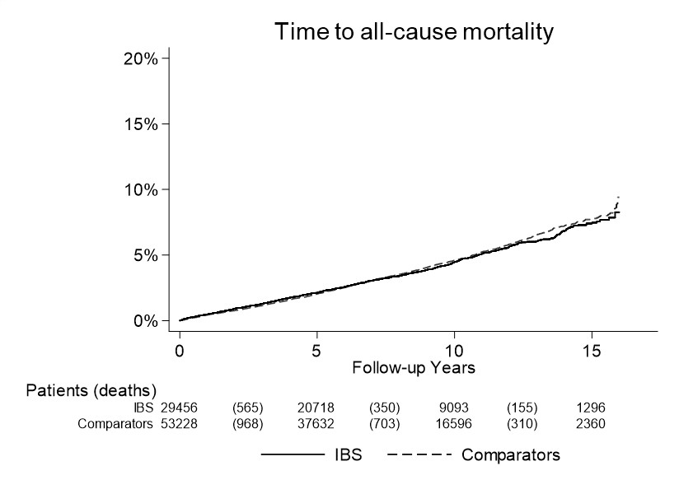
Figure S6 Kaplan-Meier survival curves of time to all-cause mortality (follow-up until Dec 31, 2017) in patients with IBS and their siblings (comparators)

IBS, irritable bowel syndrome

Table S9 Sibling analyses. Risk of all-cause mortality overall and by subgroups in patients with IBS and siblings (comparators)
Group | N (%) |  | Time at risk (years) |  | N events |  | Incidence rate (95% CI) |  | HR*  (95%CI) | HR**  (95%CI)
 | IBS | Comparators | IBS | Comparators | IBS | Comparators | IBS | Comparators
Overall | 29 456 (100.0%) | 53 228 (100.0%) | 230 398 | 418 359 | 1075 (3.6%) | 1992 (3.7%) | 4.7 (4.4-4.9) | 4.8 (4.6-5.0) | 1.08 (1.00-1.17) | 1.09 (1.00-1.18)
Follow-up
0-<1y | 29 456 (100.0%) | 53 228 (100.0%) | 29 355 | 53 049 | 140 (0.5%) | 227 (0.4%) | 4.8 (4.0-5.6) | 4.3 (3.7-4.8) | 1.17 (0.94-1.45) | 1.14 (0.91-1.43)
1-5y | 29 274 (99.4%) | 52 863 (99.3%) | 121 260 | 219 828 | 515 (1.8%) | 917 (1.7%) | 4.2 (3.9-4.6) | 4.2 (3.9-4.4) | 1.12 (1.00-1.25) | 1.12 (1.00-1.26)
>5y | 20 718 (70.3%) | 37 632 (70.7%) | 99 287 | 181 019 | 510 (2.5%) | 1024 (2.7%) | 5.1 (4.7-5.6) | 5.7 (5.3-6.0) | 1.02 (0.91-1.15) | 1.04 (0.92-1.16)
Sex
Women | 20 725 (70.4%) | 26 339 (49.5%) | 162 053 | 208 536 | 664 (3.2%) | 825 (3.1%) | 4.1 (3.8-4.4) | 4.0 (3.7-4.2) | 1.13 (1.00-1.28) | 1.13 (0.99-1.29)
Men | 8731 (29.6%) | 26 889 (50.5%) | 68 345 | 209 824 | 411 (4.7%) | 1167 (4.3%) | 6.0 (5.4-6.6) | 5.6 (5.2-5.9) | 1.29 (1.08-1.53) | 1.30 (1.09-1.55)
Age
<18y | 840 (2.9%) | 2896 (5.4%) | 6 373 | 23 197 | 2 (0.2%) | 8 (0.3%) | 0.3 (0.0-0.7) | 0.3 (0.1-0.6) | 0.28 (0.03-2.54) | -
18y -<30y | 7845 (26.6%) | 10 920 (20.5%) | 60 232 | 82 878 | 40 (0.5%) | 40 (0.4%) | 0.7 (0.5-0.9) | 0.5 (0.3-0.6) | 1.74 (1.01-2.98) | 2.15 (1.13-4.10)
30y - <40y | 5510 (18.7%) | 9195 (17.3%) | 45 764 | 76 255 | 54 (1.0%) | 70 (0.8%) | 1.2 (0.9-1.5) | 0.9 (0.7-1.1) | 1.10 (0.69-1.77) | 1.06 (0.63-1.79)
40y - <50y | 5198 (17.6%) | 9571 (18.0%) | 42 586 | 80 292 | 119 (2.3%) | 165 (1.7%) | 2.8 (2.3-3.3) | 2.1 (1.7-2.4) | 1.28 (0.94-1.76) | 1.29 (0.94-1.78)
50y - <60y | 4695 (15.9%) | 9560 (18.0%) | 39 126 | 79 623 | 211 (4.5%) | 442 (4.6%) | 5.4 (4.7-6.1) | 5.6 (5.0-6.1) | 0.91 (0.72-1.14) | 0.96 (0.76-1.21)
60y - <70y | 4000 (13.6%) | 8194 (15.4%) | 29 401 | 60 941 | 421 (10.5%) | 831 (10.1%) | 14.3 (13.0-15.7) | 13.6 (12.7-14.6) | 1.03 (0.88-1.21) | 1.02 (0.87-1.19)
≥70y | 1368 (4.6%) | 2892 (5.4%) | 6 917 | 15 173 | 228 (16.7%) | 436 (15.1%) | 33.0 (28.7-37.2) | 28.7 (26.0-31.4) | 1.11 (0.86-1.43) | 1.14 (0.88-1.48)
Year
2002-2005 | 6021 (20.4%) | 11 045 (20.8%) | 81 090 | 148 238 | 347 (5.8%) | 671 (6.1%) | 4.3 (3.8-4.7) | 4.5 (4.2-4.9) | 1.02 (0.89-1.17) | 1.03 (0.89-1.18)
2006-2010 | 10 318 (35.0%) | 18 965 (35.6%) | 93 926 | 171 968 | 424 (4.1%) | 825 (4.4%) | 4.5 (4.1-4.9) | 4.8 (4.5-5.1) | 1.05 (0.93-1.19) | 1.06 (0.93-1.20)
2011-2016 | 13 117 (44.5%) | 23 218 (43.6%) | 55 382 | 98 154 | 304 (2.3%) | 496 (2.1%) | 5.5 (4.9-6.1) | 5.1 (4.6-5.5) | 1.21 (1.04-1.41) | 1.21 (1.04-1.41)
Country of birth
Nordic | 28 694 (97.4%) | 51 375 (96.5%) | 224 700 | 404 476 | 1063 (3.7%) | 1972 (3.8%) | 4.7 (4.4-5.0) | 4.9 (4.7-5.1) | 1.08 (1.00-1.17) | 1.09 (1.01-1.18)
Other | 762 (2.6%) | 1849 (3.5%) | 5 698 | 13 856 | 12 (1.6%) | 20 (1.1%) | 2.1 (0.9-3.3) | 1.4 (0.8-2.1) | 0.71 (0.30-1.69) | 0.87 (0.30-2.54)
Level of education
≤9 years | 4856 (16.5%) | 11 311 (21.3%) | 38 418 | 91 202 | 325 (6.7%) | 804 (7.1%) | 8.5 (7.5-9.4) | 8.8 (8.2-9.4) | 0.99 (0.82-1.20) | 0.99 (0.81-1.20)
10-12 years | 14 111 (47.9%) | 24 687 (46.4%) | 111 027 | 196 258 | 488 (3.5%) | 808 (3.3%) | 4.4 (4.0-4.8) | 4.1 (3.8-4.4) | 1.13 (0.96-1.32) | 1.12 (0.95-1.31)
>12 years | 10 235 (34.7%) | 16 162 (30.4%) | 79 584 | 124 947 | 253 (2.5%) | 358 (2.2%) | 3.2 (2.8-3.6) | 2.9 (2.6-3.2) | 1.05 (0.83-1.33) | 1.00 (0.79-1.27)
Missing | 254 (0.9%) | 1068 (2.0%) | 1 370 | 5 952 | 9 (3.5%) | 22 (2.1%) | 6.6 (2.3-10.9) | 3.7 (2.2-5.2) | - | -
IBS
Diagnosis before biopsy | 14 524 (49.3%) | 26 313 (49.4%) | 116 660 | 211 439 | 422 (2.9%) | 883 (3.4%) | 3.6 (3.3-4.0) | 4.2 (3.9-4.5) | 0.96 (0.85-1.08) | 0.96 (0.85-1.09)
Diagnosis after biopsy | 14 220 (48.3%) | 25 591 (48.1%) | 108 321 | 196 760 | 632 (4.4%) | 1063 (4.2%) | 5.8 (5.4-6.3) | 5.4 (5.1-5.7) | 1.19 (1.07-1.32) | 1.20 (1.07-1.33)
Comorbidity
CVD | 2822 (9.6%) | 4959 (9.3%) | 22 014 | 38 732 | 123 (4.4%) | 215 (4.3%) | 5.6 (4.6-6.6) | 5.6 (4.8-6.3) | 1.51 (0.87-2.63) | 1.50 (0.83-2.68)
MI | 154 (0.5%) | 356 (0.7%) | 1 187 | 2 652 | 5 (3.2%) | 22 (6.2%) | 4.2 (0.5-7.9) | 8.3 (4.8-11.8) | - | -
CVD inpatient | 1084 (3.7%) | 2025 (3.8%) | 8 347 | 15 671 | 53 (4.9%) | 102 (5.0%) | 6.3 (4.6-8.1) | 6.5 (5.2-7.8) | 1.00 (0.32-3.10) | 1.17 (0.31-4.41)
Cancer | 4139 (14.1%) | 6691 (12.6%) | 31 487 | 50 753 | 263 (6.4%) | 370 (5.5%) | 8.4 (7.3-9.4) | 7.3 (6.5-8.0) | 1.58 (1.09-2.29) | 1.64 (1.13-2.40)
*Conditioned on matching set
**Conditioned on matching set and adjusted for education and baseline medical comorbidities (cancer, diabetes, CVD, and neurologic disease)
IBS, irritable bowel syndrome; CVD, cardiovascular disease; MI, myocardial infarction; SD, standard deviation; IQR, interquartile range

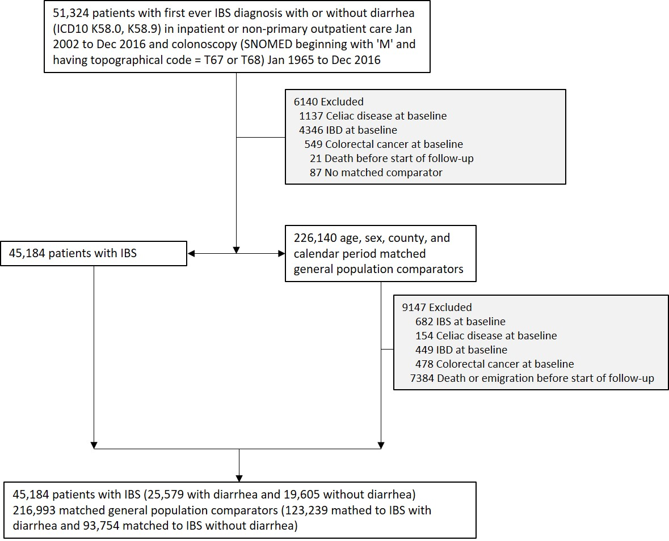
Figure S7 Flow chart of identified patients with IBS subtype (IBS-D and IBS non-D) and their matched comparators
IBS, irritable bowel syndrome; IBD, inflammatory bowel disease; SNOMED, Systematized Nomenclature of Medicine

Table S10 IBS subtype (IBS-D and IBS non-D). Baseline characteristics of study cohort
Characteristic | IBS with diarrhea (IBS-D)  (n=25,579) | Matched comparators  (n=123,239) | IBS without diarrhea (IBS non-D)  (n=19,605) | Matched comparators  (n=93,754)
Female, no. (%) | 17 472 (68.3%) | 84 188 (68.3%) | 14 504 (74.0%) | 69 387 (74.0%)
Male, no (%) | 8107 (31.7%) | 39051 (31.7%) | 5101 (26.0%) | 24 367 (26.0%)
Age
Mean (SD) | 45.4 (18.1) | 44.7 (17.8) | 46.9 (18.4) | 46.1 (18.0)
Median (IQR) | 43.8 (29.7-59.5) | 43.2 (29.3-58.7) | 46.2 (31.2-61.5) | 45.5 (30.8-60.5)
Range, min-max | 0.6-99.8 | 0.6-99.9 | 0.2-96.0 | 0.0-96.0
Categories, no. (%)
<18y | 552 (2.2%) | 2783 (2.3%) | 510 (2.6%) | 2603 (2.8%)
18y - <30y | 6002 (23.5%) | 29 609 (24.0%) | 3998 (20.4%) | 19 678 (21.0%)
30y - <40y | 4595 (18.0%) | 22 584 (18.3%) | 3145 (16.0%) | 15 383 (16.4%)
40y - <50y | 4218 (16.5%) | 20 572 (16.7%) | 3387 (17.3%) | 16 545 (17.6%)
50y - <60y | 4017 (15.7%) | 19 522 (15.8%) | 3151 (16.1%) | 15 323 (16.3%)
60y - <70y | 3468 (13.6%) | 16 574 (13.4%) | 3009 (15.3%) | 14 039 (15.0%)
≥70y | 2727 (10.7%) | 11 595 (9.4%) | 2405 (12.3%) | 10 183 (10.9%)
Country of birth, no (%)
Nordic country | 23 360 (91.3%) | 106 063 (86.1%) | 17 380 (88.7%) | 81 075 (86.5%)
Other | 2219 (8.7%) | 17 174 (13.9%) | 2225 (11.3%) | 12 676 (13.5%)
Missing | 0 (0.0%) | 2 (0.0%) | 0 (0.0%) | 3 (0.0%)
Level of education, no (%)
≤9 years | 4813 (18.8%) | 23 979 (19.5%) | 3916 (20.0%) | 19 213 (20.5%)
10-12 years | 12 062 (47.2%) | 54 399 (44.1%) | 8964 (45.7%) | 41 290 (44.0%)
>12 years | 8435 (33.0%) | 42 368 (34.4%) | 6473 (33.0%) | 31 302 (33.4%)
Missing | 269 (1.1%) | 2493 (2.0%) | 252 (1.3%) | 1949 (2.1%)
Start year of follow-up
2002-2005 | 5471 (21.4%) | 26 577 (21.6%) | 4236 (21.6%) | 20 454 (21.8%)
2006-2010 | 9181 (35.9%) | 44 276 (35.9%) | 6757 (34.5%) | 32 389 (34.5%)
2011-2016 | 10 927 (42.7%) | 52 386 (42.5%) | 8612 (43.9%) | 40 911 (43.6%)
Time to register-based definition of IBS onset*
(time in years between first IBS diagnosis and biopsy)
Mean (SD) | 2.6 (4.7) |  | 3.5 (5.1)
Median (IQR) | 0.3 (0.0-3.0) |  | 0.9 (0.1-5.1)
Range, min-max | 0.0-39.1 |  | 0.0-45.1
Disease history within 5 years before start of follow-up,
no. (%)
Cardiovascular disease (CVD) | 3680 (14.4%) | 9084 (7.4%) | 3134 (16.0%) | 7345 (7.8%)
Myocardial infarction (MI) | 231 (0.9%) | 688 (0.6%) | 155 (0.8%) | 526 (0.6%)
Cardiovascular disease in inpatient care | 1557 (6.1%) | 4242 (3.4%) | 1210 (6.2%) | 3353 (3.6%)
Cancer | 4281 (16.7%) | 10 402 (8.4%) | 3827 (19.5%) | 8661 (9.2%)
Diabetes | 676 (2.6%) | 1918 (1.6%) | 454 (2.3%) | 1433 (1.5%)
Neurologic disease | 2605 (10.2%) | 5913 (4.8%) | 2102 (10.7%) | 4753 (5.1%)

SD, standard deviation; IQR, interquartile range. *Or time between biopsy and first IBS diagnosis (biopsy could occur before or after IBS diagnosis).

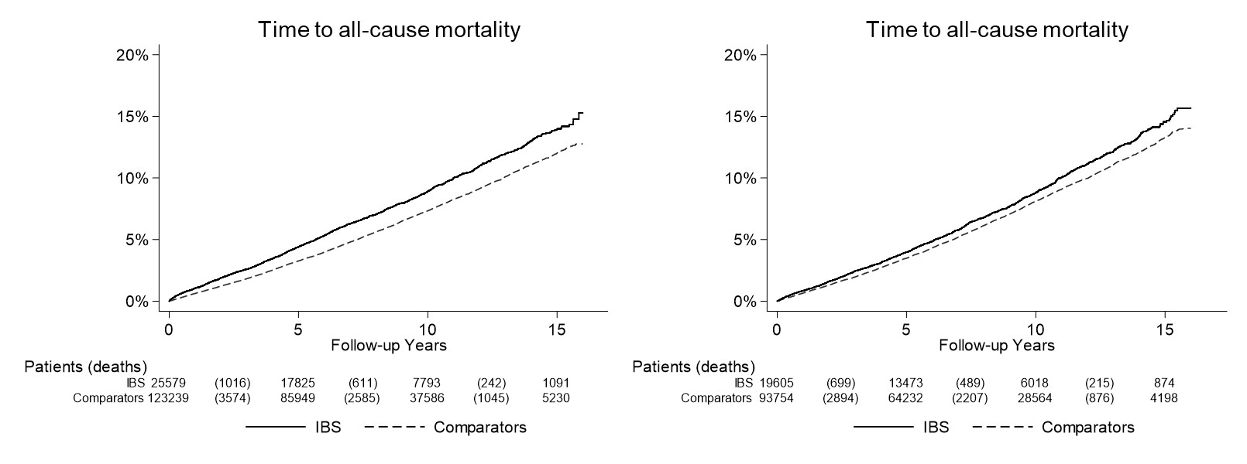
Figure S8 Kaplan-Meier survival curves of time to all-cause mortality (follow-up until Dec 31, 2017) in patients
with IBS and diarrhea (left panel) and IBS without diarrhea (right panel)

IBS, irritable bowel syndrome; CVD, cardiovascular disease

Table S11 Risk of all-cause mortality overall and by subgroups in patients with IBS with diarrhea (IBS-D) and matched general population comparators
Group | N (%) |  | Time at risk (years) |  | N events |  | Incidence rate (95% CI) |  | HR*  (95%CI) | HR**  (95%CI)
 | IBS | Comparators | IBS | Comparators | IBS | Comparators | IBS | Comparators
Overall | 25 579 (100.0%) | 123 239 (100.0%) | 198 034 | 954 995 | 1876 (7.3%) | 7231 (5.9%) | 9.5 (9.0-9.9) | 7.6 (7.4-7.7) | 1.17 (1.11-1.24) | 1.01 (0.96-1.07)
Follow-up
0-<1y | 25 579 (100.0%) | 123 239 (100.0%) | 25 405 | 122 507 | 268 (1.0%) | 757 (0.6%) | 10.5 (9.3-11.8) | 6.2 (5.7-6.6) | 1.52 (1.32-1.75) | 1.19 (1.02-1.39)
1-5y | 25 270 (98.8%) | 121 784 (98.8%) | 104 343 | 502 843 | 912 (3.6%) | 3428 (2.8%) | 8.7 (8.2-9.3) | 6.8 (6.6-7.0) | 1.17 (1.09-1.27) | 0.98 (0.90-1.06)
>5y | 17 825 (69.7%) | 85 949 (69.7%) | 85 071 | 410 602 | 860 (4.8%) | 3657 (4.3%) | 10.1 (9.4-10.8) | 8.9 (8.6-9.2) | 1.09 (1.01-1.18) | 1.00 (0.92-1.09)
Sex
Women | 17 472 (68.3%) | 84 188 (68.3%) | 136 546 | 656 859 | 1159 (6.6%) | 4787 (5.7%) | 8.5 (8.0-9.0) | 7.3 (7.1-7.5) | 1.08 (1.01-1.16) | 0.94 (0.88-1.01)
Men | 8107 (31.7%) | 39 051 (31.7%) | 61 488 | 298 135 | 717 (8.8%) | 2444 (6.3%) | 11.7 (10.8-12.5) | 8.2 (7.9-8.5) | 1.35 (1.24-1.48) | 1.15 (1.05-1.26)
Age
<18y | 552 (2.2%) | 2783 (2.3%) | 4 139 | 20 637 | 3 (0.5%) | 7 (0.3%) | 0.7 (0.0-1.5) | 0.3 (0.1-0.6) | 1.96 (0.50-7.57) | 2.69 (0.49-14.88)
18y -<30y | 6002 (23.5%) | 29 609 (24.0%) | 45 931 | 223 379 | 37 (0.6%) | 93 (0.3%) | 0.8 (0.5-1.1) | 0.4 (0.3-0.5) | 1.97 (1.34-2.91) | 2.01 (1.29-3.14)
30y - <40y | 4595 (18.0%) | 22 584 (18.3%) | 37 740 | 183 298 | 61 (1.3%) | 139 (0.6%) | 1.6 (1.2-2.0) | 0.8 (0.6-0.9) | 2.11 (1.55-2.86) | 2.02 (1.45-2.81)
40y - <50y | 4218 (16.5%) | 20 572 (16.7%) | 34 307 | 166 559 | 96 (2.3%) | 333 (1.6%) | 2.8 (2.2-3.4) | 2.0 (1.8-2.2) | 1.42 (1.13-1.78) | 1.21 (0.95-1.54)
50y - <60y | 4017 (15.7%) | 19 522 (15.8%) | 33 865 | 164 433 | 213 (5.3%) | 958 (4.9%) | 6.3 (5.4-7.1) | 5.8 (5.5-6.2) | 1.07 (0.92-1.24) | 0.90 (0.77-1.06)
60y - <70y | 3468 (13.6%) | 16 574 (13.4%) | 26 308 | 126 435 | 434 (12.5%) | 1807 (10.9%) | 16.5 (14.9-18.0) | 14.3 (13.6-15.0) | 1.14 (1.03-1.27) | 0.95 (0.85-1.07)
≥70y | 2727 (10.7%) | 11 595 (9.4%) | 15 744 | 70 254 | 1032 (37.8%) | 3894 (33.6%) | 65.6 (61.6-69.5) | 55.4 (53.7-57.2) | 1.14 (1.05-1.22) | 0.99 (0.91-1.07)
Year
2002-2005 | 5471 (21.4%) | 26 577 (21.6%) | 70 873 | 342 589 | 666 (12.2%) | 2881 (10.8%) | 9.4 (8.7-10.1) | 8.4 (8.1-8.7) | 1.08 (0.99-1.18) | 0.98 (0.89-1.07)
2006-2010 | 9181 (35.9%) | 44 276 (35.9%) | 81 529 | 392 620 | 776 (8.5%) | 3030 (6.8%) | 9.5 (8.8-10.2) | 7.7 (7.4-8.0) | 1.14 (1.05-1.24) | 0.98 (0.90-1.07)
2011-2016 | 10 927 (42.7%) | 52 386 (42.5%) | 45 631 | 219 786 | 434 (4.0%) | 1320 (2.5%) | 9.5 (8.6-10.4) | 6.0 (5.7-6.3) | 1.42 (1.27-1.59) | 1.14 (1.01-1.29)
Country of birth
Nordic | 23360 (91.3%) | 106 063 (86.1%) | 180 762 | 832 117 | 1783 (7.6%) | 6729 (6.3%) | 9.9 (9.4-10.3) | 8.1 (7.9-8.3) | 1.18 (1.12-1.25) | 1.02 (0.96-1.08)
Other | 2219 (8.7%) | 17 174 (13.9%) | 17 271 | 122 865 | 93 (4.2%) | 502 (2.9%) | 5.4 (4.3-6.5) | 4.1 (3.7-4.4) | 0.92 (0.57-1.49) | 0.69 (0.40-1.20)
Level of education
≤9 years | 4813 (18.8%) | 23 979 (19.5%) | 36 672 | 185 421 | 746 (15.5%) | 3283 (13.7%) | 20.3 (18.9-21.8) | 17.7 (17.1-18.3) | 1.11 (1.00-1.23) | 0.94 (0.84-1.05)
10-12 years | 12 062 (47.2%) | 54 399 (44.1%) | 93 720 | 430 727 | 763 (6.3%) | 2663 (4.9%) | 8.1 (7.6-8.7) | 6.2 (5.9-6.4) | 1.25 (1.13-1.39) | 1.06 (0.95-1.19)
>12 years | 8435 (33.0%) | 42 368 (34.4%) | 66 180 | 324 411 | 330 (3.9%) | 1118 (2.6%) | 5.0 (4.4-5.5) | 3.4 (3.2-3.6) | 1.17 (0.97-1.41) | 0.95 (0.78-1.16)
Missing | 269 (1.1%) | 2493 (2.0%) | 1 461 | 14 436 | 37 (13.8%) | 167 (6.7%) | 25.3 (17.2-33.5) | 11.6 (9.8-13.3) | 2.16 (0.88-5.31) | 2.73 (1.00-7.50)
Comorbidity
CVD | 2377 (9.3%) | 10 643 (8.6%) | 18 114 | 82 058 | 184 (7.7%) | 688 (6.5%) | 10.2 (8.7-11.6) | 8.4 (7.8-9.0) | 1.02 (0.90-1.17) | 0.98 (0.86-1.12)
MI | 147 (0.6%) | 765 (0.6%) | 1 050 | 5 949 | 15 (10.2%) | 50 (6.5%) | 14.3 (7.1-21.5) | 8.4 (6.1-10.7) | 1.30 (0.51-3.30) | 1.69 (0.48-5.97)
CVD inpatient | 1104 (4.3%) | 4723 (3.8%) | 8 416 | 36 147 | 78 (7.1%) | 304 (6.4%) | 9.3 (7.2-11.3) | 8.4 (7.5-9.4) | 0.97 (0.80-1.17) | 0.90 (0.73-1.09)
Cancer | 3430 (13.4%) | 14 190 (11.5%) | 25 449 | 107 433 | 437 (12.7%) | 1242 (8.8%) | 17.2 (15.6-18.8) | 11.6 (10.9-12.2) | 1.10 (0.93-1.30) | 1.01 (0.85-1.21)
*Conditioned on matching set
**Conditioned on matching set and adjusted for education and baseline medical comorbidities (cancer, diabetes, CVD, and neurologic disease)
IBS, irritable bowel syndrome; CVD, cardiovascular disease; MI, myocardial infarction; SD, standard deviation; IQR, interquartile range

Table S12 Risk of all-cause mortality overall and by subgroups in patients with IBS without diarrhea (IBS non-D) and matched general population comparators
Group | N (%) |  | Time at risk (years) |  | N events |  | Incidence rate (95% CI) |  | HR*  (95%CI) | HR**  (95%CI)
 | IBS | Comparators | IBS | Comparators | IBS | Comparators | IBS | Comparators
Overall | 19 605 (100.0%) | 93 754 (100.0%) | 151 340 | 721 541 | 1411 (7.2%) | 6003 (6.4%) | 9.3 (8.8-9.8) | 8.3 (8.1-8.5) | 1.01 (0.95-1.08) | 0.90 (0.84-0.96)
Follow-up
0-<1y | 19 605 (100.0%) | 93 754 (100.0%) | 19 491 | 93 192 | 166 (0.8%) | 609 (0.6%) | 8.5 (7.2-9.8) | 6.5 (6.0-7.1) | 1.14 (0.96-1.36) | 0.95 (0.79-1.15)
1-5y | 19 400 (99.0%) | 92 653 (98.8%) | 79 519 | 379 111 | 650 (3.4%) | 2816 (3.0%) | 8.2 (7.5-8.8) | 7.4 (7.2-7.7) | 0.99 (0.91-1.08) | 0.86 (0.78-0.94)
>5y | 13 473 (68.7%) | 64 232 (68.5%) | 65 007 | 309 673 | 712 (5.3%) | 3109 (4.8%) | 11.0 (10.1-11.8) | 10.0 (9.7-10.4) | 1.00 (0.92-1.09) | 0.91 (0.83-1.00)
Sex
Women | 14 504 (74.0%) | 69 387 (74.0%) | 111 769 | 533 871 | 990 (6.8%) | 4145 (6.0%) | 8.9 (8.3-9.4) | 7.8 (7.5-8.0) | 1.02 (0.95-1.10) | 0.90 (0.84-0.97)
Men | 5101 (26.0%) | 24 367 (26.0%) | 39 572 | 187 671 | 421 (8.3%) | 1858 (7.6%) | 10.6 (9.6-11.7) | 9.9 (9.5-10.4) | 0.99 (0.88-1.10) | 0.88 (0.78-0.99)
Age
<18y | 510 (2.6%) | 2603 (2.8%) | 3 879 | 19 481 | 0 (0.0%) | 8 (0.3%) | 0.0 (0.0-0.0) | 0.4 (0.1-0.7) | 0.00 (0.00-.) | 0.00 (0.00-.)
18y -<30y | 3998 (20.4%) | 19 678 (21.0%) | 30 771 | 148 866 | 17 (0.4%) | 72 (0.4%) | 0.6 (0.3-0.8) | 0.5 (0.4-0.6) | 1.12 (0.66-1.91) | 0.97 (0.54-1.75)
30y - <40y | 3145 (16.0%) | 15 383 (16.4%) | 25 752 | 123 732 | 27 (0.9%) | 100 (0.7%) | 1.0 (0.7-1.4) | 0.8 (0.6-1.0) | 1.35 (0.88-2.08) | 1.15 (0.72-1.85)
40y - <50y | 3387 (17.3%) | 16 545 (17.6%) | 27 762 | 135 644 | 67 (2.0%) | 245 (1.5%) | 2.4 (1.8-3.0) | 1.8 (1.6-2.0) | 1.41 (1.07-1.85) | 1.12 (0.83-1.51)
50y - <60y | 3151 (16.1%) | 15 323 (16.3%) | 26 138 | 125 960 | 125 (4.0%) | 729 (4.8%) | 4.8 (3.9-5.6) | 5.8 (5.4-6.2) | 0.82 (0.68-0.99) | 0.68 (0.56-0.84)
60y - <70y | 3009 (15.3%) | 14 039 (15.0%) | 22 409 | 105 247 | 340 (11.3%) | 1461 (10.4%) | 15.2 (13.6-16.8) | 13.9 (13.2-14.6) | 1.10 (0.98-1.24) | 0.95 (0.84-1.08)
≥70y | 2405 (12.3%) | 10 183 (10.9%) | 14 629 | 62 612 | 835 (34.7%) | 3388 (33.3%) | 57.1 (53.2-60.9) | 54.1 (52.3-55.9) | 0.99 (0.91-1.07) | 0.89 (0.82-0.97)
Year
2002-2005 | 4236 (21.6%) | 20 454 (21.8%) | 55 026 | 263 280 | 557 (13.1%) | 2494 (12.2%) | 10.1 (9.3-11.0) | 9.5 (9.1-9.8) | 0.97 (0.88-1.07) | 0.88 (0.79-0.97)
2006-2010 | 6757 (34.5%) | 32 389 (34.5%) | 60 508 | 288 418 | 564 (8.3%) | 2409 (7.4%) | 9.3 (8.6-10.1) | 8.4 (8.0-8.7) | 1.01 (0.92-1.12) | 0.89 (0.81-0.99)
2011-2016 | 8612 (43.9%) | 40 911 (43.6%) | 35 806 | 169 844 | 290 (3.4%) | 1100 (2.7%) | 8.1 (7.2-9.0) | 6.5 (6.1-6.9) | 1.10 (0.96-1.26) | 0.95 (0.83-1.10)
Country of birth
Nordic | 17 380 (88.7%) | 81 075 (86.5%) | 134 880 | 631 234 | 1314 (7.6%) | 5597 (6.9%) | 9.7 (9.2-10.3) | 8.9 (8.6-9.1) | 1.00 (0.94-1.06) | 0.89 (0.83-0.95)
Other | 2225 (11.3%) | 12 676 (13.5%) | 16 460 | 90 289 | 97 (4.4%) | 406 (3.2%) | 5.9 (4.7-7.1) | 4.5 (4.1-4.9) | 0.89 (0.57-1.39) | 0.72 (0.42-1.23)
Level of education
≤9 years | 3916 (20.0%) | 19 213 (20.5%) | 30 358 | 149 634 | 581 (14.8%) | 2796 (14.6%) | 19.1 (17.6-20.7) | 18.7 (18.0-19.4) | 1.04 (0.92-1.17) | 0.93 (0.82-1.05)
10-12 years | 8964 (45.7%) | 41 290 (44.0%) | 70 241 | 323 557 | 528 (5.9%) | 2246 (5.4%) | 7.5 (6.9-8.2) | 6.9 (6.7-7.2) | 0.97 (0.86-1.10) | 0.83 (0.73-0.94)
>12 years | 6473 (33.0%) | 31 302 (33.4%) | 49 235 | 237 521 | 277 (4.3%) | 836 (2.7%) | 5.6 (5.0-6.3) | 3.5 (3.3-3.8) | 1.18 (0.95-1.45) | 0.98 (0.78-1.23)
Missing | 252 (1.3%) | 1949 (2.1%) | 1 507 | 10 829 | 25 (9.9%) | 125 (6.4%) | 16.6 (10.1-23.1) | 11.5 (9.5-13.6) | - | -
Comorbidity
CVD | 3134 (16.0%) | 7345 (7.8%) | 21 932 | 48 986 | 536 (17.1%) | 1580 (21.5%) | 24.4 (22.4-26.5) | 32.3 (30.7-33.8) | 0.89 (0.77-1.04) | 0.84 (0.72-0.98)
MI | 155 (0.8%) | 526 (0.6%) | 895 | 3 453 | 51 (32.9%) | 195 (37.1%) | 57.0 (41.3-72.6) | 56.5 (48.5-64.4) | 1.00 (0.25-4.00) | 0.65 (0.03-12.98)
CVD inpatient | 1210 (6.2%) | 3353 (3.6%) | 8 096 | 21 762 | 363 (30.0%) | 1112 (33.2%) | 44.8 (40.2-49.5) | 51.1 (48.1-54.1) | 0.92 (0.73-1.15) | 0.84 (0.66-1.06)
Cancer | 3827 (19.5%) | 8661 (9.2%) | 26 601 | 58 775 | 492 (12.9%) | 1070 (12.4%) | 18.5 (16.9-20.1) | 18.2 (17.1-19.3) | 0.88 (0.73-1.07) | 0.87 (0.71-1.05)
*Conditioned on matching set
**Conditioned on matching set and adjusted for education and baseline medical comorbidities (cancer, diabetes, CVD, and neurologic disease)
IBS, irritable bowel syndrome; CVD, cardiovascular disease; MI, myocardial infarction; SD, standard deviation; IQR, interquartile range

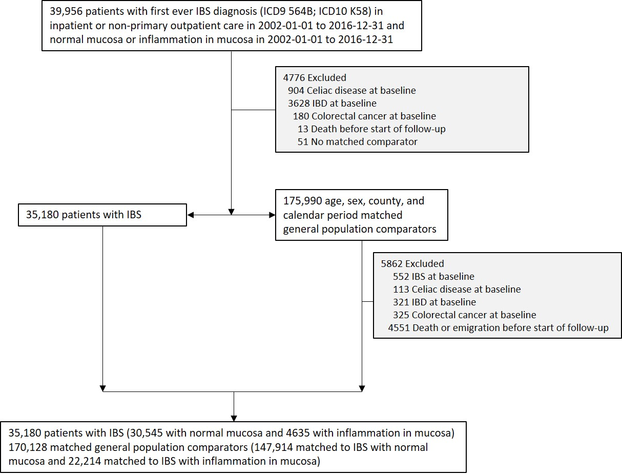
Figure S9 IBS and underlying histopathology (normal mucosa vs. inflammation). Flow chart of identified patients and their matched comparators

IBS, irritable bowel syndrome; IBD, inflammatory bowel disease

Table S13 IBS and underlying histopathology (normal mucosa vs. inflammation). Baseline characteristics of study cohort
Characteristic | IBS and normal mucosa  (n=30,545) | Matched comparators  (n=147,914) | IBS and inflammation in mucosa (n=4635) | Matched comparators  (n=22,214)
Female, no. (%) | 21 506 (70.4%) | 104 110 (70.4%) | 3257 (70.3%) | 15 595 (70.2%)
Male, no (%) | 9039 (29.6%) | 43 804 (29.6%) | 1378 (29.7%) | 6619 (29.8%)
Age
Mean (SD) | 42.9 (17.3) | 42.4 (17.0) | 48.4 (18.8) | 47.7 (18.5)
Median (IQR) | 40.9 (28.1-56.1) | 40.4 (27.8-55.3) | 48.4 (32.5-63.5) | 47.5 (32.1-62.5)
Range, min-max | 0.2-96.5 | 0.0-96.7 | 0.7-95.0 | 0.6-95.3
Categories, no. (%)
<18y | 810 (2.7%) | 4088 (2.8%) | 114 (2.5%) | 601 (2.7%)
18y - <30y | 8103 (26.5%) | 39 951 (27.0%) | 878 (18.9%) | 4295 (19.3%)
30y - <40y | 5859 (19.2%) | 28 814 (19.5%) | 687 (14.8%) | 3378 (15.2%)
40y - <50y | 5335 (17.5%) | 26 021 (17.6%) | 755 (16.3%) | 3703 (16.7%)
50y - <60y | 4458 (14.6%) | 21 733 (14.7%) | 777 (16.8%) | 3742 (16.8%)
60y - <70y | 3634 (11.9%) | 17 169 (11.6%) | 755 (16.3%) | 3611 (16.3%)
≥70y | 2346 (7.7%) | 10 138 (6.9%) | 669 (14.4%) | 2884 (13.0%)
Country of birth, no (%)
Nordic country | 27 407 (89.7%) | 126 008 (85.2%) | 4267 (92.1%) | 19 585 (88.2%)
Other | 3138 (10.3%) | 21 902 (14.8%) | 368 (7.9%) | 2628 (11.8%)
Missing | 0 (0.0%) | 4 (0.0%) | 0 (0.0%) | 1 (0.0%)
Level of education, no (%)
≤9 years | 5365 (17.6%) | 26 673 (18.0%) | 1010 (21.8%) | 4984 (22.4%)
10-12 years | 14 344 (47.0%) | 65 650 (44.4%) | 2157 (46.5%) | 9941 (44.8%)
>12 years | 10 485 (34.3%) | 52 381 (35.4%) | 1406 (30.3%) | 6823 (30.7%)
Missing | 351 (1.1%) | 3210 (2.2%) | 62 (1.3%) | 466 (2.1%)
Start year of follow-up
2002-2005 | 5485 (18.0%) | 26 885 (18.2%) | 1054 (22.7%) | 5125 (23.1%)
2006-2010 | 10 853 (35.5%) | 52 633 (35.6%) | 1712 (36.9%) | 8232 (37.1%)
2011-2016 | 14 207 (46.5%) | 68 396 (46.2%) | 1869 (40.3%) | 8857 (39.9%)
Time to register-based definition of IBS onset*
(time in years between first IBS diagnosis and biopsy)
Mean (SD) | 2.2 (4.1) |  | 2.6 (4.5)
Median (IQR) | 0.3 (0.0-2.6) |  | 0.5 (0.0-3.4)
Range, min-max | 0.0-42.7 |  | 0.0-34.8
Disease history within 5 years before start of follow-up,
no. (%)
Cardiovascular disease (CVD) | 3900 (12.8%) | 9526 (6.4%) | 842 (18.2%) | 1859 (8.4%)
Myocardial infarction (MI) | 188 (0.6%) | 612 (0.4%) | 69 (1.5%) | 169 (0.8%)
Cardiovascular disease in inpatient care | 1420 (4.6%) | 4085 (2.8%) | 404 (8.7%) | 920 (4.1%)
Cancer | 4655 (15.2%) | 12175 (8.2%) | 843 (18.2%) | 2055 (9.3%)
Diabetes | 697 (2.3%) | 2025 (1.4%) | 126 (2.7%) | 371 (1.7%)
Neurologic disease | 3054 (10.0%) | 6853 (4.6%) | 539 (11.6%) | 1156 (5.2%)

SD, standard deviation; IQR, interquartile range. *Or time between biopsy and first IBS diagnosis (biopsy could occur before or after IBS diagnosis).

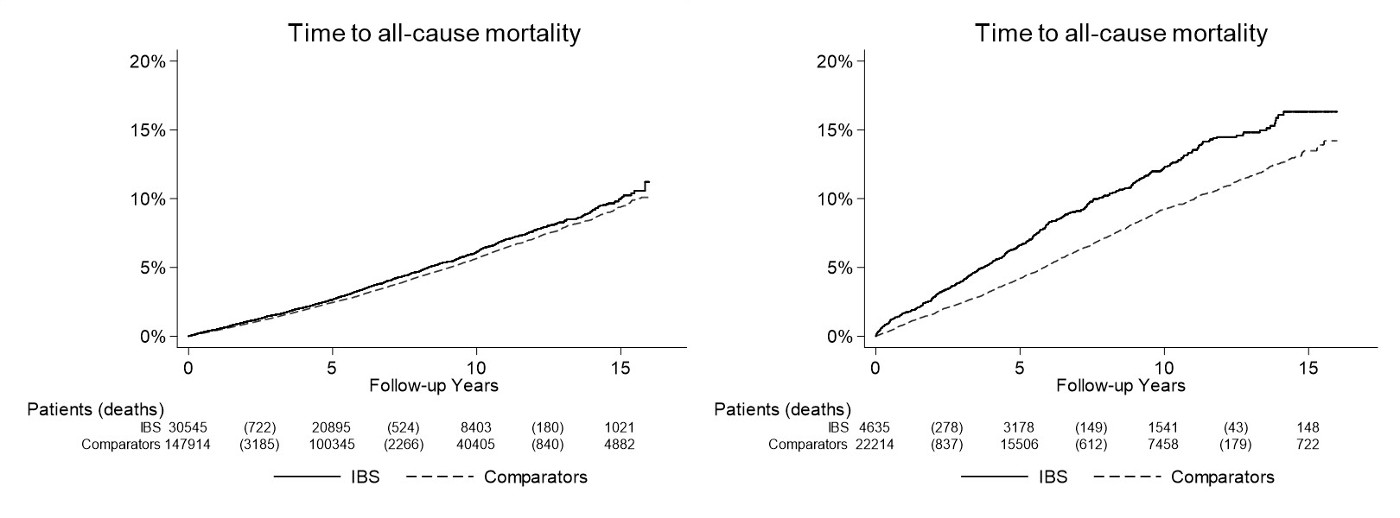
Figure S10 IBS and underlying histopathology (normal mucosa vs. inflammation). Kaplan-Meier survival curves of time to all-cause mortality (follow-up until Dec 31, 2017) in patients with IBS and normal mucosa (left panel) and IBS with inflammation in mucosa (right panel)

IBS, irritable bowel syndrome; CVD, cardiovascular disease

Table S14 Risk of all-cause mortality overall and by subgroups in patients with IBS and normal mucosa and matched general population comparators
Group | N (%) |  | Time at risk (years) |  | N events |  | Incidence rate (95% CI) |  | HR*  (95%CI) | HR**  (95%CI)
 | IBS | Comparators | IBS | Comparators | IBS | Comparators | IBS | Comparators
Overall | 30 545 (100.0%) | 147 914 (100.0%) | 229 251 | 1 103 361 | 1432 (4.7%) | 6314 (4.3%) | 6.2 (5.9-6.6) | 5.7 (5.6-5.9) | 1.01 (0.96-1.08) | 0.88 (0.83-0.94)
Follow-up
0-<1y | 30 545 (100.0%) | 147 914 (100.0%) | 30 430 | 147 108 | 157 (0.5%) | 638 (0.4%) | 5.2 (4.4-6.0) | 4.3 (4.0-4.7) | 1.09 (0.91-1.30) | 0.88 (0.73-1.06)
1-5y | 30 322 (99.3%) | 146 322 (98.9%) | 124 028 | 596 647 | 708 (2.3%) | 3095 (2.1%) | 5.7 (5.3-6.1) | 5.2 (5.0-5.4) | 1.01 (0.93-1.10) | 0.86 (0.79-0.94)
>5y | 20 895 (68.4%) | 100 345 (67.8%) | 94 358 | 453 581 | 710 (3.4%) | 3129 (3.1%) | 7.5 (7.0-8.1) | 6.9 (6.7-7.1) | 1.03 (0.94-1.12) | 0.94 (0.86-1.03)
Sex
Women | 21 506 (70.4%) | 104 110 (70.4%) | 161 449 | 776 709 | 924 (4.3%) | 4217 (4.1%) | 5.7 (5.4-6.1) | 5.4 (5.3-5.6) | 0.97 (0.90-1.04) | 0.85 (0.79-0.92)
Men | 9039 (29.6%) | 43 804 (29.6%) | 67 802 | 326 652 | 508 (5.6%) | 2097 (4.8%) | 7.5 (6.8-8.1) | 6.4 (6.1-6.7) | 1.10 (1.00-1.22) | 0.95 (0.85-1.06)
Age
<18y | 810 (2.7%) | 4088 (2.8%) | 6 027 | 30 097 | 3 (0.4%) | 11 (0.3%) | 0.5 (0.0-1.1) | 0.4 (0.1-0.6) | 1.40 (0.38-5.08) | 1.79 (0.37-8.55)
18y -<30y | 8103 (26.5%) | 39 951 (27.0%) | 60 131 | 291 671 | 43 (0.5%) | 132 (0.3%) | 0.7 (0.5-0.9) | 0.5 (0.4-0.5) | 1.56 (1.10-2.21) | 1.47 (0.99-2.16)
30y - <40y | 5859 (19.2%) | 28 814 (19.5%) | 45 980 | 223 172 | 61 (1.0%) | 164 (0.6%) | 1.3 (1.0-1.7) | 0.7 (0.6-0.8) | 1.82 (1.35-2.45) | 1.66 (1.21-2.29)
40y - <50y | 5335 (17.5%) | 26 021 (17.6%) | 41 902 | 203 504 | 89 (1.7%) | 382 (1.5%) | 2.1 (1.7-2.6) | 1.9 (1.7-2.1) | 1.16 (0.92-1.47) | 0.98 (0.77-1.26)
50y - <60y | 4458 (14.6%) | 21 733 (14.7%) | 35 555 | 172 071 | 180 (4.0%) | 1003 (4.6%) | 5.1 (4.3-5.8) | 5.8 (5.5-6.2) | 0.85 (0.73-1.00) | 0.73 (0.62-0.87)
60y - <70y | 3634 (11.9%) | 17 169 (11.6%) | 26 056 | 123 099 | 355 (9.8%) | 1636 (9.5%) | 13.6 (12.2-15.0) | 13.3 (12.6-13.9) | 1.02 (0.91-1.15) | 0.84 (0.74-0.95)
≥70y | 2346 (7.7%) | 10 138 (6.9%) | 13 599 | 59 747 | 701 (29.9%) | 2986 (29.5%) | 51.5 (47.7-55.4) | 50.0 (48.2-51.8) | 0.97 (0.89-1.06) | 0.86 (0.79-0.95)
Year
2002-2005 | 5485 (18.0%) | 26 885 (18.2%) | 71 808 | 347 121 | 486 (8.9%) | 2294 (8.5%) | 6.8 (6.2-7.4) | 6.6 (6.3-6.9) | 0.96 (0.87-1.06) | 0.86 (0.77-0.96)
2006-2010 | 10 853 (35.5%) | 52 633 (35.6%) | 97 443 | 468 313 | 624 (5.7%) | 2738 (5.2%) | 6.4 (5.9-6.9) | 5.8 (5.6-6.1) | 1.03 (0.94-1.12) | 0.90 (0.82-0.99)
2011-2016 | 14 207 (46.5%) | 68 396 (46.2%) | 60 000 | 287 927 | 322 (2.3%) | 1282 (1.9%) | 5.4 (4.8-6.0) | 4.5 (4.2-4.7) | 1.08 (0.95-1.22) | 0.90 (0.78-1.02)
Country of birth
Nordic | 27 407 (89.7%) | 126 008 (85.2%) | 206 114 | 952 514 | 1356 (4.9%) | 5828 (4.6%) | 6.6 (6.2-6.9) | 6.1 (6.0-6.3) | 1.03 (0.97-1.10) | 0.90 (0.84-0.96)
Other | 3138 (10.3%) | 21 902 (14.8%) | 23 137 | 150 820 | 76 (2.4%) | 486 (2.2%) | 3.3 (2.5-4.0) | 3.2 (2.9-3.5) | 0.61 (0.38-0.97) | 0.51 (0.30-0.87)
Level of education
≤9 years | 5365 (17.6%) | 26 673 (18.0%) | 40 512 | 200 587 | 521 (9.7%) | 2703 (10.1%) | 12.9 (11.8-14.0) | 13.5 (13.0-14.0) | 0.93 (0.82-1.06) | 0.80 (0.70-0.91)
10-12 years | 14 344 (47.0%) | 65 650 (44.4%) | 108 399 | 499 726 | 596 (4.2%) | 2462 (3.8%) | 5.5 (5.1-5.9) | 4.9 (4.7-5.1) | 1.07 (0.96-1.20) | 0.91 (0.81-1.03)
>12 years | 10 485 (34.3%) | 52 381 (35.4%) | 78 292 | 384 840 | 290 (2.8%) | 1013 (1.9%) | 3.7 (3.3-4.1) | 2.6 (2.5-2.8) | 1.16 (0.96-1.40) | 0.96 (0.79-1.17)
Missing | 351 (1.1%) | 3210 (2.2%) | 2 048 | 18 207 | 25 (7.1%) | 136 (4.2%) | 12.2 (7.4-17.0) | 7.5 (6.2-8.7) | 1.72 (0.43-6.84) | 2.51 (0.56-11.30)
Comorbidity
CVD | 3900 (12.8%) | 9526 (6.4%) | 26 515 | 63 497 | 518 (13.3%) | 1559 (16.4%) | 19.5 (17.9-21.2) | 24.6 (23.3-25.8) | 0.76 (0.65-0.89) | 0.72 (0.61-0.85)
MI | 188 (0.6%) | 612 (0.4%) | 1 130 | 4 009 | 56 (29.8%) | 179 (29.2%) | 49.6 (36.6-62.6) | 44.7 (38.1-51.2) | 1.09 (0.27-4.39) | 0.63 (0.03-13.56)
CVD inpatient | 1420 (4.6%) | 4085 (2.8%) | 9 453 | 26 539 | 329 (23.2%) | 1059 (25.9%) | 34.8 (31.0-38.6) | 39.9 (37.5-42.3) | 0.69 (0.55-0.88) | 0.65 (0.51-0.84)
Cancer | 4655 (15.2%) | 12 175 (8.2%) | 31 437 | 81 397 | 456 (9.8%) | 1102 (9.1%) | 14.5 (13.2-15.8) | 13.5 (12.7-14.3) | 0.85 (0.70-1.04) | 0.79 (0.64-0.97)
*Conditioned on matching set
**Conditioned on matching set and adjusted for education and baseline medical comorbidities (cancer, diabetes, CVD, and neurologic disease)
IBS, irritable bowel syndrome; CVD, cardiovascular disease; MI, myocardial infarction; SD, standard deviation; IQR, interquartile range

Table S15 Risk of all-cause mortality overall and by subgroups in patients with IBS and inflammation in mucosa and matched general population comparators
Group | N (%) |  | Time at risk (years) |  | N events |  | Incidence rate (95% CI) |  | HR*  (95%CI) | HR**  (95%CI)
 | IBS | Comparators | IBS | Comparators | IBS | Comparators | IBS | Comparators
Overall | 4635 (100.0%) | 22 214 (100.0%) | 36 023 | 174 932 | 470 (10.1%) | 1631 (7.3%) | 13.0 (11.9-14.2) | 9.3 (8.9-9.8) | 1.35 (1.21-1.50) | 1.16 (1.04-1.30)
Follow-up
0-<1y | 4635 (100.0%) | 22 214 (100.0%) | 4 586 | 22 077 | 78 (1.7%) | 190 (0.9%) | 17.0 (13.2-20.8) | 8.6 (7.4-9.8) | 1.81 (1.39-2.37) | 1.38 (1.03-1.86)
1-5y | 4554 (98.3%) | 21 940 (98.8%) | 18 675 | 90 602 | 253 (5.6%) | 800 (3.6%) | 13.5 (11.9-15.2) | 8.8 (8.2-9.4) | 1.43 (1.24-1.66) | 1.22 (1.04-1.42)
>5y | 3178 (68.6%) | 15 506 (69.8%) | 15 766 | 76 966 | 192 (6.0%) | 794 (5.1%) | 12.2 (10.5-13.9) | 10.3 (9.6-11.0) | 1.21 (1.02-1.43) | 1.12 (0.93-1.33)
Sex
Women | 3257 (70.3%) | 15 595 (70.2%) | 25 598 | 123 715 | 304 (9.3%) | 1120 (7.2%) | 11.9 (10.5-13.2) | 9.1 (8.5-9.6) | 1.27 (1.11-1.45) | 1.14 (0.99-1.31)
Men | 1378 (29.7%) | 6619 (29.8%) | 10 425 | 51 217 | 166 (12.0%) | 511 (7.7%) | 15.9 (13.5-18.3) | 10.0 (9.1-10.8) | 1.53 (1.27-1.84) | 1.23 (1.01-1.50)
Age
<18y | 114 (2.5%) | 601 (2.7%) | 818 | 4 261 | 0 (0.0%) | 1 (0.2%) | 0.0 (0.0-0.0) | 0.2 (0.0-0.7) | - | -
18y -<30y | 878 (18.9%) | 4295 (19.3%) | 7 207 | 34 558 | 5 (0.6%) | 15 (0.3%) | 0.7 (0.1-1.3) | 0.4 (0.2-0.7) | 1.55 (0.56-4.28) | 1.44 (0.33-6.34)
30y - <40y | 687 (14.8%) | 3378 (15.2%) | 5 861 | 28 709 | 9 (1.3%) | 26 (0.8%) | 1.5 (0.5-2.5) | 0.9 (0.6-1.3) | 1.73 (0.81-3.70) | 1.60 (0.61-4.20)
40y - <50y | 755 (16.3%) | 3703 (16.7%) | 6 300 | 30 998 | 25 (3.3%) | 51 (1.4%) | 4.0 (2.4-5.5) | 1.6 (1.2-2.1) | 2.43 (1.50-3.95) | 1.79 (1.02-3.14)
50y - <60y | 777 (16.8%) | 3742 (16.8%) | 6 552 | 31 693 | 43 (5.5%) | 164 (4.4%) | 6.6 (4.6-8.5) | 5.2 (4.4-6.0) | 1.24 (0.88-1.74) | 0.97 (0.67-1.40)
60y - <70y | 755 (16.3%) | 3611 (16.3%) | 5 576 | 27 319 | 110 (14.6%) | 382 (10.6%) | 19.7 (16.0-23.4) | 14.0 (12.6-15.4) | 1.38 (1.11-1.72) | 1.20 (0.95-1.52)
≥70y | 669 (14.4%) | 2884 (13.0%) | 3 709 | 17 393 | 278 (41.6%) | 992 (34.4%) | 75.0 (66.1-83.8) | 57.0 (53.5-60.6) | 1.29 (1.12-1.49) | 1.13 (0.97-1.32)
Year
2002-2005 | 1054 (22.7%) | 5125 (23.1%) | 13 443 | 65 338 | 134 (12.7%) | 584 (11.4%) | 10.0 (8.3-11.7) | 8.9 (8.2-9.7) | 1.05 (0.86-1.28) | 0.89 (0.72-1.10)
2006-2010 | 1712 (36.9%) | 8232 (37.1%) | 15 036 | 73 394 | 217 (12.7%) | 731 (8.9%) | 14.4 (12.5-16.4) | 10.0 (9.2-10.7) | 1.46 (1.24-1.71) | 1.30 (1.10-1.54)
2011-2016 | 1869 (40.3%) | 8857 (39.9%) | 7 544 | 36 200 | 119 (6.4%) | 316 (3.6%) | 15.8 (12.9-18.6) | 8.7 (7.8-9.7) | 1.62 (1.30-2.02) | 1.30 (1.03-1.64)
Country of birth
Nordic | 4267 (92.1%) | 19 585 (88.2%) | 33 296 | 155 563 | 451 (10.6%) | 1536 (7.8%) | 13.5 (12.3-14.8) | 9.9 (9.4-10.4) | 1.34 (1.20-1.50) | 1.15 (1.02-1.29)
Other | 368 (7.9%) | 2628 (11.8%) | 2 727 | 19 365 | 19 (5.2%) | 95 (3.6%) | 7.0 (3.8-10.1) | 4.9 (3.9-5.9) | 2.93 (0.75-11.50) | -
Level of education
≤9 years | 1010 (21.8%) | 4984 (22.4%) | 7 458 | 39 154 | 217 (21.5%) | 814 (16.3%) | 29.1 (25.2-33.0) | 20.8 (19.4-22.2) | 1.43 (1.17-1.75) | 1.22 (0.99-1.50)
10-12 years | 2157 (46.5%) | 9941 (44.8%) | 17 090 | 80 133 | 179 (8.3%) | 572 (5.8%) | 10.5 (8.9-12.0) | 7.1 (6.6-7.7) | 1.45 (1.17-1.81) | 1.17 (0.92-1.47)
>12 years | 1406 (30.3%) | 6823 (30.7%) | 11 162 | 53 230 | 68 (4.8%) | 208 (3.0%) | 6.1 (4.6-7.5) | 3.9 (3.4-4.4) | 0.95 (0.61-1.50) | 0.55 (0.31-0.95)
Missing | 62 (1.3%) | 466 (2.1%) | 313 | 2 415 | 6 (9.7%) | 37 (7.9%) | 19.2 (3.8-34.5) | 15.3 (10.4-20.3) | 1.04 (0.19-5.65) | 1.40 (0.20-9.79)
Comorbidity
CVD | 842 (18.2%) | 1859 (8.4%) | 5 236 | 12 341 | 237 (28.1%) | 455 (24.5%) | 45.3 (39.5-51.0) | 36.9 (33.5-40.3) | 1.39 (1.10-1.76) | 1.28 (1.00-1.64)
MI | 69 (1.5%) | 169 (0.8%) | 375 | 1 074 | 24 (34.8%) | 54 (32.0%) | 64.0 (38.4-89.6) | 50.3 (36.9-63.7) | 4.00 (0.45-35.79) | 1.9724E9 (0.00-.)
CVD inpatient | 404 (8.7%) | 920 (4.1%) | 2 347 | 5 806 | 170 (42.1%) | 315 (34.2%) | 72.4 (61.6-83.3) | 54.3 (48.3-60.2) | 1.38 (0.99-1.94) | 1.30 (0.91-1.85)
Cancer | 843 (18.2%) | 2055 (9.3%) | 5 782 | 14 140 | 146 (17.3%) | 309 (15.0%) | 25.3 (21.2-29.3) | 21.9 (19.4-24.3) | 1.09 (0.78-1.53) | 0.91 (0.63-1.32)
*Conditioned on matching set and adjusted
**Conditioned on matching set and adjusted for education and baseline medical comorbidities (cancer, diabetes, CVD, and neurologic disease)
IBS, irritable bowel syndrome; CVD, cardiovascular disease; MI, myocardial infarction; SD, standard deviation; IQR, interquartile range

