Supplementary table 1: Donor causes of death

Cause of death | D_ANTI+-NAT+  R_HCV-  (N=210) | D_ANTI+-NAT+  R_HCV+  (N=1148) | D_ANTI+NAT-  R_HCV-  (N=191) | D_ANTI+NAT-  R_HCV+  (N=516) | D_ANTI-NAT-  R_HCV+  (N=6321) | D_ANTI-NAT-  R_HCV-  (N=16338)
Anoxia* | 144 (69%) | 778 (68%) | 138 (72%) | 329 (64%) | 2335 (37%) | 6062 (37%)
Cerebrovascular / Stroke | 29 (14%) | 161 (14%) | 30 (16%) | 100 (19%) | 1977 (31%) | 4843 (30%)
Head Trauma | 34 (16%) | 181 (16%) | 19 (10%) | 79 (15%) | 1861 (29%) | 5004 (31%)
Others | 3 (1%) | 28 (2%) | 4 (2%) | 8 (2%) | 148 (2%) | 429 (3%)

- P <0.0001 among groups (anoxia due to drug overdose)

Supplementary table 2: Causes of death among recipients
Response | D_ANTI+NAT- | D_ANTI+-NAT+ | D_ANTI+NAT- | D_ANTI+-NAT+ | D_ANTI-NAT- | D_ANTI-NAT-
 | R_HCV- | R_HCV- | R_HCV+ | R_HCV+ | R_HCV+ | R_HCV-
 | (N=191) | (N=210) | (N=516) | (N=1148) | (N=6321) | (N=16338)
Death (N) | 12 | 13 | 51 | 107 | 650 | 1477
Cardiovascular | 0 (0%) | 4 (31%) | 9 (18%) | 24 (22%) | 119 (18%) | 365 (25%)
Respiratory failure | 1 (8%) | 1 (8%) | 4 (8%) | 8 (7%) | 44 (7%) | 113 (8%)
Graft failure | 2 (17%) | 1 (8%) | 3 (6%) | 5 (5%) | 56 (9%) | 104 (7%)
Hemorrhage | 0 (0%) | 0 (0%) | 2 (4%) | 5 (5%) | 18 (3%) | 69 (5%)
Malignancy | 1 (8%) | 1 (8%) | 20 (39%) | 26 (24%) | 135 (21%) | 129 (9%)
Immunosuppressive drug related | 0 (0%) | 0 (0%) | 0 (0%) | 0 (0%) | 0 (0%) | 3 (0%)
Renal failure | 0 (0%) | 0 (0%) | 0 (0%) | 2 (2%) | 6 (1%) | 13 (1%)
Operative | 2 (17%) | 2 (15%) | 2 (4%) | 6 (6%) | 58 (9%) | 173 (12%)
Infection | 3 (25%) | 4 (31%) | 3 (6%) | 14 (13%) | 77 (12%) | 235 (16%)
Other/Unknown | 3 (25%) | 0 (0%) | 8 (16%) | 17 (16%) | 137 (21%) | 273 (18%)

Supplementary table 3: Multivariate analysis: Risk factors for graft and patient survival:

Effect | DF | Graft Survival |  | Patient Survival
 |  | Wald Chi-Square | Pr > ChiSq | Wald Chi-Square | Pr > ChiSq
Group | 5 | 5.471 | 0.361 | 5.640 | 0.343
Age | 1 | 43.056 | <.0001 | 48.802 | <.0001
BMI | 3 | 24.801 | <.0001 | 23.580 | <.0001
Karnofsky Performance Status | 2 | 67.801 | <.0001 | 70.074 | <.0001
Dialysis prior to transplant | 1 | 41.068 | <.0001 | 42.961 | <.0001
Type 2 diabetes | 1 | 3.855 | 0.05 | 4.095 | 0.043
Ascites- moderate to severe | 1 | 3.978 | 0.046 | 4.343 | 0.037
HE stage 3 or 4 | 1 | 25.379 | <.0001 | 25.870 | <.0001
Albumin | 1 | 7.117 | 0.008 | 7.649 | 0.006
Donor Diabetes | 2 | 11.976 | 0.003 | 10.354 | 0.006
Donor Risk Index (DRI) | 1 | 5.814 | 0.016 | 5.633 | 0.018

Supplementary table 4: Causes of graft loss among recipients
Cause of graft failure | D_ANTI+NAT-/R_HCV- | D_ANTI+-NAT+/R_HCV- | D_ANTI+NAT-/R_HCV+ | D_ANTI+-NAT+/R_HCV+ | D_ANTI-NAT-/R_HCV+ | D_ANTI-NAT-/R_HCV- | Total
Infection | 0 | 0 | 3 | 6 | 28 | 64 | 101
Primary non-Function | 0 | 0 | 1 | 3 | 25 | 56 | 85
Chronic rejection | 0 | 1 | 1 | 5 | 12 | 36 | 55
Hepatic Artery Thrombosis | 0 | 0 | 0 | 2 | 16 | 27 | 45
Recurrent disease, NON-HEPATITIS | 0 | 0 | 2 | 3 | 18 | 21 | 44
Acute rejection | 1 | 1 | 0 | 1 | 11 | 26 | 40
Diffuse Cholangiopathy | 2 | 0 | 0 | 2 | 3 | 19 | 26
Other Vascular Thrombosis | 0 | 0 | 0 | 0 | 11 | 12 | 23
HEPATITIS recurrent | 0 | 0 | 1 | 2 | 10 | 4 | 17
Primary graft failure | 0 | 0 | 0 | 0 | 1 | 2 | 3
HEPATITIS DeNovo | 0 | 0 | 0 | 0 | 1 | 0 | 1
Vascular thrombosis | 0 | 0 | 0 | 0 | 1 | 0 | 1
Total | 3 | 2 | 8 | 24 | 137 | 267 | 441

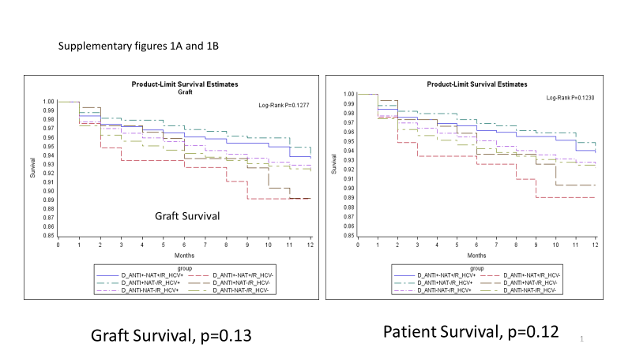

Supplementary figure 1A and 1B: One year graft and patient survival among 6 groups without adjusting for other risk factors

